MDMPI Mobile App
Logistics Process Flow and System Narrative
Process Documentation (Quality Management System)
Document No.
Revision | 0
Effective Date
Application Version | 1.1.104
Platforms | Android
Department | Logistics
Prepared by | Jay Bryan C. Abaoag
Reviewed by
Approved by
Controlled document. Printed copies are uncontrolled unless stamped.

Table of Contents
1. Purpose 3
2. Scope 3
3. Definitions 3
4. Users and Roles 4
5. System Overview 5
6. Common Process Steps 5
6.1 Signing in and onboarding 5
6.2 Main navigation 6
6.3 Viewing and filtering requests 6
6.4 Creating a request 6
6.5 Acting on a request 7
6.6 Cancelling a request 7
6.7 Text-message notifications 7
6.8 Proof of delivery 7
6.9 Working offline and uploading pending data 7
7. Process Flow per Request Category 8
7.1 Standard Delivery 8
7.2 Hotline Direct 9
7.3 Pull Out / Return 9
7.4 Stock Receive 10
7.5 Pick Up 11
7.6 Air / Sea / Land 12
7.7 Air / Sea / Land provincial extension 13
7.8 Back Load 14
8. Status Reference 14
9. Exceptions and Support 15
10. Related Documents 15
11. Revision History 16

1. Purpose
This document describes how the Logistics Department uses the MDMPI Mobile App to record and complete its day-to-day delivery, pull-out, pick-up and freight transactions. It presents the process flow of the system and a narrative of how each user works through it, from signing in to the final status of a request.
It is intended for inclusion in the Quality Management System documentation as the process description for the mobile application. It is written as a plain user walkthrough; detailed role permissions are documented separately in the Logistics Role-Based User Manual.

2. Scope
The document covers the Logistics workflows of the MDMPI Mobile App on Android and Windows:
- Signing in, first-time onboarding and the main navigation.
- Creating, viewing and filtering requests in the seven request categories: Standard Delivery, Pull Out / Return, Pick Up, Air / Sea / Land, Air / Sea / Land HD, Hotline Direct and Stock Receive.
- Moving each request through its statuses, including the transport, proof-of-delivery and provincial delivery steps.
- Exceptions: cancellation, Back Load (whole request) and item-level backload, lost items, paused trips.
- Text-message notifications, live delivery tracking, offline work and the upload of pending data.
The following are outside the scope of this document: the Collection, Service and InHouse department workflows; system administration and support tools (Hard Reset Refresh, Local Storage Viewer, outbox retry), which are covered by the Logistics Admin Guide; and the technical architecture of the application, which is covered by the Developer Guide.

3. Definitions
Term | Meaning in the MDMPI Mobile App
Request | A single Logistics transaction (one delivery, pull-out, pick-up or freight movement) identified by a transaction ID. Every request has a client, one or more document references and a status.
Request category | The type of request. Each category has its own tab on the Request screen and its own status flow: Standard Delivery, Pull Out / Return, Pick Up, Air / Sea / Land, Air / Sea / Land HD, Hotline Direct, Stock Receive.
Status | The current stage of a request, for example New Request, Item Prepared, For Delivery, Delivered. The status decides which role can act next and which button appears.
Role | The function assigned to a user account: Request, Release, Courier, Provincial, HD, Viewer or Admin. A user may hold several roles.
Document reference | The reference number of the source document that a request fulfils: Delivery Receipt (DR), Sales Invoice (SI) or Purchase Order (PO). Entered through the "Add Document Reference" screen.
Item / scanned item | A stock line captured from the Stock Issue Slip through the in-app scanner: Part No., Serial No., PTN and, optionally, Item Code.
Trip ticket, driver, helper, vehicle | The transport details entered before a request can leave the warehouse. The driver and helper together are the assigned crew.
Request Transport | The courier screen for a delivery: map with route, Dispatch, receiver details, signature, proof photos, Items to Deliver checklist and Drop Off.
Proof of delivery | The receiver name, receiver signature and up to three photos captured when a request is dropped off.
Back Load | A request (or individual items of a request) that returns to the warehouse instead of being delivered. A whole-request Back Load is recorded with a reason from a fixed list and can be reprocessed later.
Lost items | Items on a Pull Out / Return request that could not be pulled out from the client, recorded with a reason each.
Server data / Local data | Request lists can be read from the server (live) or from the copy stored on the device. Local data is used when connectivity is poor.
Outbox | The device-side queue of signatures and proof images that could not be uploaded yet. Pending items are uploaded by an operations admin from Settings.
SMS notification | The text message the app sends to the request contacts when a request changes status. Sent from the Android device.

4. Users and Roles
Every Logistics account is assigned one or more roles. The role decides which action button appears when the user opens a request. When a user has more than one role, the app automatically uses the role that can act on the current status; if none of the user's roles can act, the request opens read-only.
Role | What the role does in the process
Request | Creates new requests in any category and monitors their progress. Does not change statuses.
Release | Warehouse processing: prepares and packs items, enters trip ticket, driver, helper and vehicle, hands over to the guard or to the courier, and receives items for Pick Up and Air / Sea / Land.
Courier | Dispatches, transports and delivers. Captures receiver, signature and proof photos. Records lost items and paused trips on Pull Out / Return. Only the driver or helper assigned to a request can act on it.
Provincial | Continues Air / Sea / Land requests through the provincial leg: Provincial Pick Up, Provincial In Transit, Provincial Delivered.
HD | May create requests on the Air / Sea / Land HD tab (urgent freight). Otherwise follows the Air / Sea / Land rules.
Viewer | Read-only. Can open lists, filter and view request details and proof.
Admin | Operations support through the Settings tools (Upload Data, Hard Reset Refresh, outboxes, Contact Directory). Admin alone does not grant status actions.

5. System Overview
Figure 1 shows the overall process. A user signs in, completes the one-time onboarding, and lands on the main navigation. A Request user creates a request, which starts at New Request. Release prepares or packs the items and enters the transport details. The assigned courier dispatches, transports and delivers, capturing proof at drop-off. Each status change is saved to the server and, on Android, sent as a text message to the request contacts. Proof that cannot be uploaded immediately waits in the outbox.
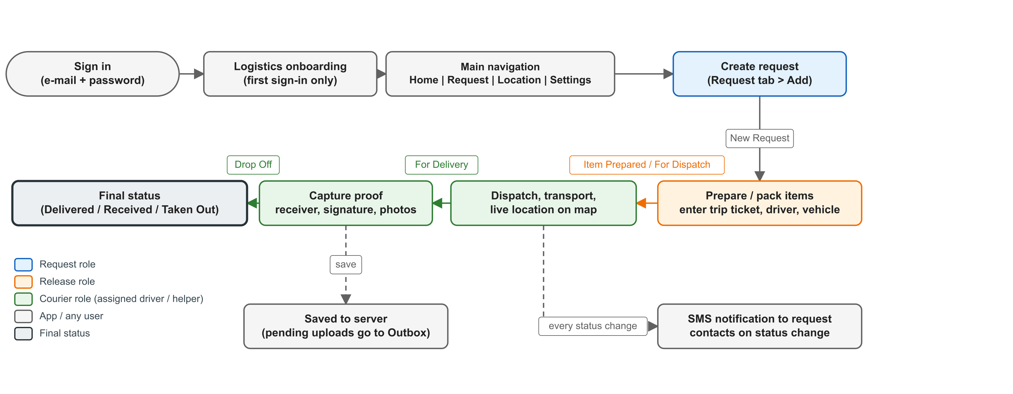
Figure 1. Overall Logistics process in the MDMPI Mobile App

6. Common Process Steps
The steps in this section are the same for every request category. The category-specific status flows follow in Section 7.

6.1 Signing in and onboarding
- Open the MDMPI Mobile App. The splash screen shows the MDMPI logo for a few seconds.
- On first run, Android asks for storage, location, camera and SMS permissions. Windows asks for location and camera. Allow them; the app needs them for proof photos, live tracking and text messages.
- On the Log In screen enter your e-mail and password and tap Log In. Tick Remember Me? to keep your e-mail on the device. Use Forget Password? to receive a password-reset e-mail; use Create Account only when instructed by IMS.
- If your e-mail address has not been verified yet, the app shows the verification screen. Verify from the e-mail you received and return to the app.
- The app then loads reference data and shows "Loading ... (n/6)" for Clients, Users, User Profile, Requesters, Item Categories and Form Categories. Wait for it to finish; if the device is offline, cached data is used.
- On your first sign-in the Logistics onboarding shows three short slides ("Welcome to MDMPI APP!", "Add Your Deliveries", "Track Your Deliveries"). Tap Next or Skip. The onboarding does not appear again on that device.
- The main navigation opens.

6.2 Main navigation
The bottom bar has four tabs:
Tab | What the user does there
Home | Greeting, "How would you like to start?" shortcuts to each request form, and an activity dashboard of request counts that can be filtered by date and status.
Request | The work area. One tab per request category (swipe or tap to change), request cards, quick filters, a custom filter panel, a Server / Local data switch, and the add (+) button for users who may create requests.
Location | Live map of couriers who are currently on a delivery (For Delivery). Tap a vehicle to see the request, its status, Dispatch and En Route times, and to Call the courier.
Settings | Account and profile, Upload Data, Hard Reset Refresh, Realtime Location Saver, Contact Directory, Developer Tools (support use only) and Logout.

6.3 Viewing and filtering requests
- Open the Request tab and select the request category.
- Scroll the request cards. Each card shows the client, document references, delivery or pick-up date and the current status.
- Use the quick filters (status, date) or open the custom filter panel to filter by date range, status, item category, client name or document reference. Available filters depend on the category.
- Pull down to refresh the list. Use the Server / Local switch in the top bar to read from the server (default) or from the device copy when the signal is poor.
- Tap a card to open the request details. The details show the client, document references, dates, transport details, proof and, where applicable, backloaded or lost items. The action button for your role appears at the bottom when the current status allows you to act.

6.4 Creating a request
- On the Request tab select the category and tap the add (+) button. (The button is shown to the Request role; Couriers also see it on the Hotline Direct tab, and the Air / Sea / Land HD tab requires the HD role.) The same forms can be opened from the Home shortcuts.
- Fill in the form. Common fields: Requested By, Client (address and phone number are filled automatically), Item Category and the target date. Category-specific fields are listed in Section 7.
- Tap "Add Document Reference (n)" to open the document reference screen and enter the DR / SI / PO numbers, then return to the form. Document references are required except for Stock Receive.
- Where the form shows "Add Item (n)", scan the Stock Issue Slip with the in-app scanner or enter the items (Part No., Serial No., PTN, Item Code optional). Repeated scans of the same line are merged.
- Tap Create Request. The request is saved with status New Request, the form is cleared, and the request appears at the top of the category list. On Android a text message announcing the new request is sent to the request contacts.

6.5 Acting on a request
Each status has exactly one next action and one role that may perform it. Open the request card, check the current status, and tap the action button for your role (for example "Prepare Item", "Set For Pull Out", "Dispatch"). Where the step needs more information (trip ticket, receiver name, signature, photo), the app asks for it before it changes the status and refuses to continue until the required fields are complete. After saving, confirm that the new status is visible on the card before leaving the screen.
If no action button appears, the current status belongs to another role, you are not the assigned crew for that request, or another user is the assigned preparer. Do not attempt to work around this; ask the operations admin to check the assignment.

6.6 Cancelling a request
- Long-press the request card and choose Cancel.
- Select the reason from the "Select Reason" list. A reason is required.
- Confirm. The request status becomes Cancelled and a text message is sent to the request contacts.
Requests in a final status (Delivered, Received, Taken Out, Provincial Delivered, Back Load, Cancelled) cannot be cancelled.

6.7 Text-message notifications
On Android the app sends a text message to the request contacts each time a request changes status. The message includes the client, all document references, the new status and the target or dispatch date. When a Standard Delivery or Hotline Direct request is dispatched (For Delivery) the message also lists the document references being delivered. While the messages are sent the screen shows progress per recipient, then a full-screen "Message Sent!" confirmation that closes by itself. No action is required from the user. A message can be re-sent from the request details if a recipient did not receive it.

6.8 Proof of delivery
Proof is captured on the device at the moment of hand-over, for the transaction that is open on screen:
- Receiver name (or guard / recipient name for Air / Sea / Land).
- Receiver signature, drawn on the signature pad ("Capture Signature"; tap again to redo).
- Proof photos: up to three photos of the delivered items or the signed documents, taken with the camera.
- Position and time are recorded automatically when the trip starts and ends.
Proof is never reused from another transaction. If the upload of a signature or photo fails, the app keeps it on the device and shows a message that it will be uploaded later; the operations admin releases it from the Signature Outbox or Image Outbox.

6.9 Working offline and uploading pending data
- Status changes need an internet connection; the app shows "No Internet" if the device is offline. Lists can still be read by switching to Local data.
- When connectivity returns, refresh the list and repeat the action. Do not create duplicate updates while a save is still in progress.
- Proof images and signatures that could not be uploaded wait in the outbox. Settings > Upload Data pushes locally modified requests to the server.
- Report the exact error text to the operations admin if a save keeps failing.

7. Process Flow per Request Category
Each subsection gives the status flow diagram, the step table and a short narrative. Status names are shown exactly as they appear in the app. "Assigned crew" means the driver or helper entered on the request.

7.1 Standard Delivery
Standard Delivery is the main delivery process: goods are prepared in the warehouse, dispatched with a trip ticket, transported with live location tracking and delivered against the receiver's signature and photos.
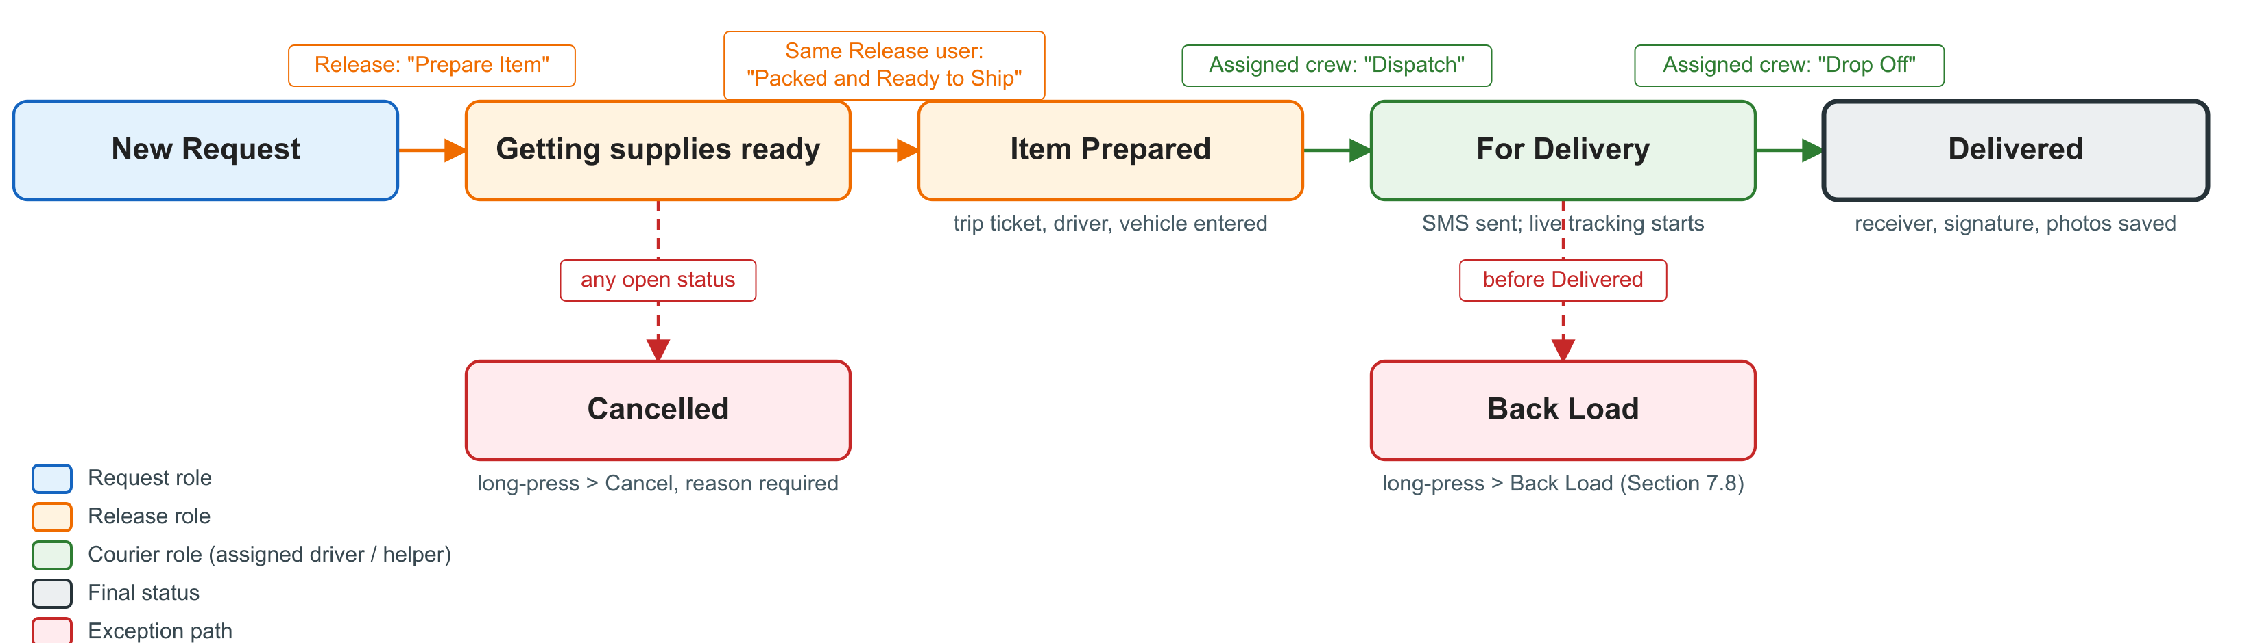
Figure 2. Standard Delivery and Hotline Direct status flow
Form fields: Requested By, Client, Item Category, Shipping Method (Land / Air / Sea), Delivery Terms (Full / Partial), Delivery Date, Priority (Rush / High / Medium / Low), Recipient Name (optional), Recipient Contact Details (optional), document references, scanned items.
Step | Status change | Who | What the user does in the app
1 | New Request (created) | Request | Fills in the Standard Delivery form (Section 6.4) and taps Create Request.
2 | New Request → Getting supplies ready | Release | Opens the request and taps "Prepare Item". The app records who is preparing and when.
3 | Getting supplies ready → Item Prepared | Release (same user as step 2) | Enters the Trip Ticket Number, selects the Driver, Helper and Vehicle (driver and helper must differ), then taps "Packed and Ready to Ship". The driver and helper can be changed later from the request details.
4 | Item Prepared → For Delivery | Courier (assigned crew) | Opens the request, which shows the Request Transport screen: map with route, ETA and distance. Corrects the destination by search or by tapping the map if needed, and may open Waze or Google Maps for turn-by-turn navigation. Taps "Dispatch". Live location sharing starts and the request appears on the Location map; the text message is sent to the request contacts.
5 | For Delivery → Delivered | Courier (assigned crew) | At the client: in "Items to Deliver", unticks any item the client does not receive and enters a reason for each; enters the Receiver name; taps "Capture Signature" and has the receiver sign; takes up to three Proof of Delivery photos; taps "Drop Off". The app refuses Drop Off until receiver, signature, at least one photo and every backload reason are present. Tracking stops and the request shows Delivered with a read-only "Backloaded Items" list when items were unticked.
- | Any open status → Cancelled | Release / Courier | Long-press the card, Cancel, select the reason (Section 6.6).
- | Any open status → Back Load → New Request | Any user with access | Long-press the card, Back Load, choose the reason and new delivery date, "Submit Back Load". Later, tap the request and "Reprocess" to start it again (Section 7.8).

Narrative. A Request user in the office receives the client order and creates the Standard Delivery request, attaching the DR / SI / PO numbers and scanning the Stock Issue Slip. In the warehouse a Release user takes the request, taps "Prepare Item" and picks the stock. When the goods are packed the same Release user enters the trip ticket, driver, helper and vehicle and marks the request "Packed and Ready to Ship"; the request is now Item Prepared and visible to the assigned crew only. The driver opens it, checks the route on the map and taps "Dispatch": the status changes to For Delivery, the request contacts receive the text message and the vehicle appears on the Location map for the office to follow. At the client's site the driver reviews the Items to Deliver, records anything refused with a reason, enters the receiver's name, collects the signature, photographs the delivered goods and taps "Drop Off". The request is Delivered; the proof and the delivery position and time are saved to the server.

7.2 Hotline Direct
Hotline Direct is the urgent variant of Standard Delivery. It uses the same form, the same Request Transport screen and the same status flow (Figure 2). It is listed on its own tab so urgent deliveries are not mixed with the regular queue. Two differences apply:
- A Courier can create a Hotline Direct request directly from the tab (the add button is shown to Couriers as well as to the Request role).
- The Courier who created the request can also perform the first step (New Request → Getting supplies ready) instead of waiting for Release.
All other steps, proof requirements, text messages and item-level backload rules are identical to Section 7.1. Always check the tab name before acting, because Standard Delivery and Hotline Direct requests appear in separate lists.

7.3 Pull Out / Return
Pull Out / Return brings stock back from a client site. Release prepares the trip, the courier drives it, and any item that could not be collected is recorded as a lost item with a reason.
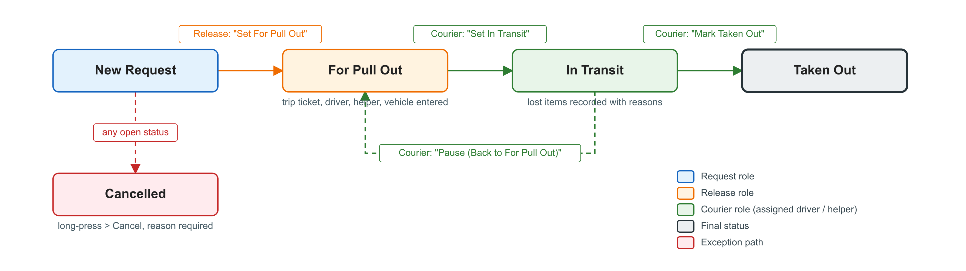
Figure 3. Pull Out / Return status flow
Form fields: Requested By, Client, Client Contact Person, Item Category, IRRF Number, IRRF Date, Pull Out Date, Reason for Return, document references (required), scanned items.
Step | Status change | Who | What the user does in the app
1 | New Request (created) | Request | Fills in the Pull Out / Return form, adds the document references and the items to be pulled out, taps Create Request.
2 | New Request → For Pull Out | Release | Opens the request, enters the Trip Ticket, Driver, Helper and Vehicle and taps "Set For Pull Out". The courier cannot depart until this is done.
3 | For Pull Out → In Transit | Courier | Taps "Set In Transit" when leaving for the client. The start time is recorded.
3a | In Transit → For Pull Out (pause) | Courier | If the trip is interrupted, taps "Pause (Back to For Pull Out)". The start time is cleared and recorded again on the next departure.
4 | In Transit → Taken Out | Courier | At the client, reviews the item list. Items that could not be pulled out are marked as Lost Items with a reason each ("Why was this item not pulled out?"). Taps "Mark Taken Out". The lost-item list is saved first; if that save fails the status does not change and the entries are kept.
- | Any open status → Cancelled | Release / Courier | Long-press the card, Cancel, select the reason.

Narrative. The Request user records the client's return using the IRRF number and date, the reason for return and the items expected. Release plans the trip by entering the trip ticket, driver, helper and vehicle and sets the request For Pull Out. The courier departs and sets it In Transit. If the trip has to be interrupted the courier pauses it, which returns the request to For Pull Out until the next departure. At the client the courier checks the items against the list, records any item that is missing or refused as a lost item with its reason, and marks the request Taken Out.

7.4 Stock Receive
Stock Receive records incoming stock from clients or returns arriving at the warehouse. It is a simplified variant of Pull Out / Return: the same form is used, but there is no item list, no lost-item recording, and document references are optional.
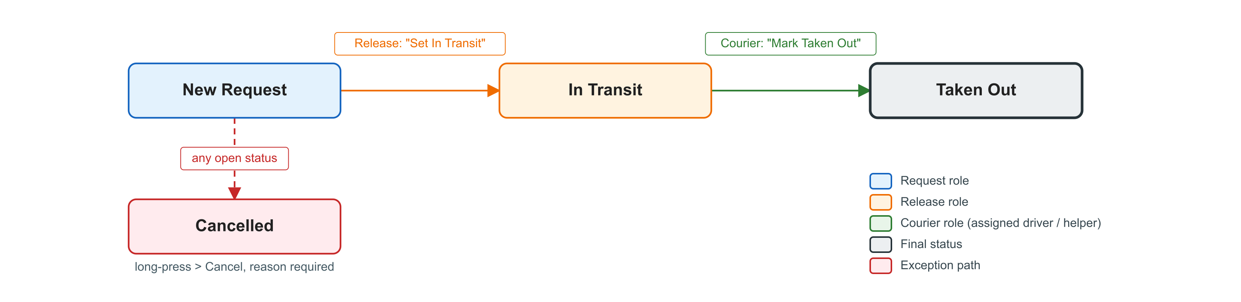
Figure 4. Stock Receive status flow
Step | Status change | Who | What the user does in the app
1 | New Request (created) | Request | Fills in the Stock Receive form (same layout as Pull Out / Return, without items) and taps Create Request. Document references may be left empty.
2 | New Request → In Transit | Release | Taps "Set In Transit" when the stock is on its way to the warehouse.
3 | In Transit → Taken Out | Courier | Taps "Mark Taken Out" when the stock has been received.
- | Any open status → Cancelled | Release / Courier | Long-press the card, Cancel, select the reason.

7.5 Pick Up
Pick Up covers requests where the warehouse prepares the items and the client or its representative collects them, instead of a delivery. It is a single-role process: Release performs every step from New Request to Received. Courier and Viewer see Pick Up requests read-only.
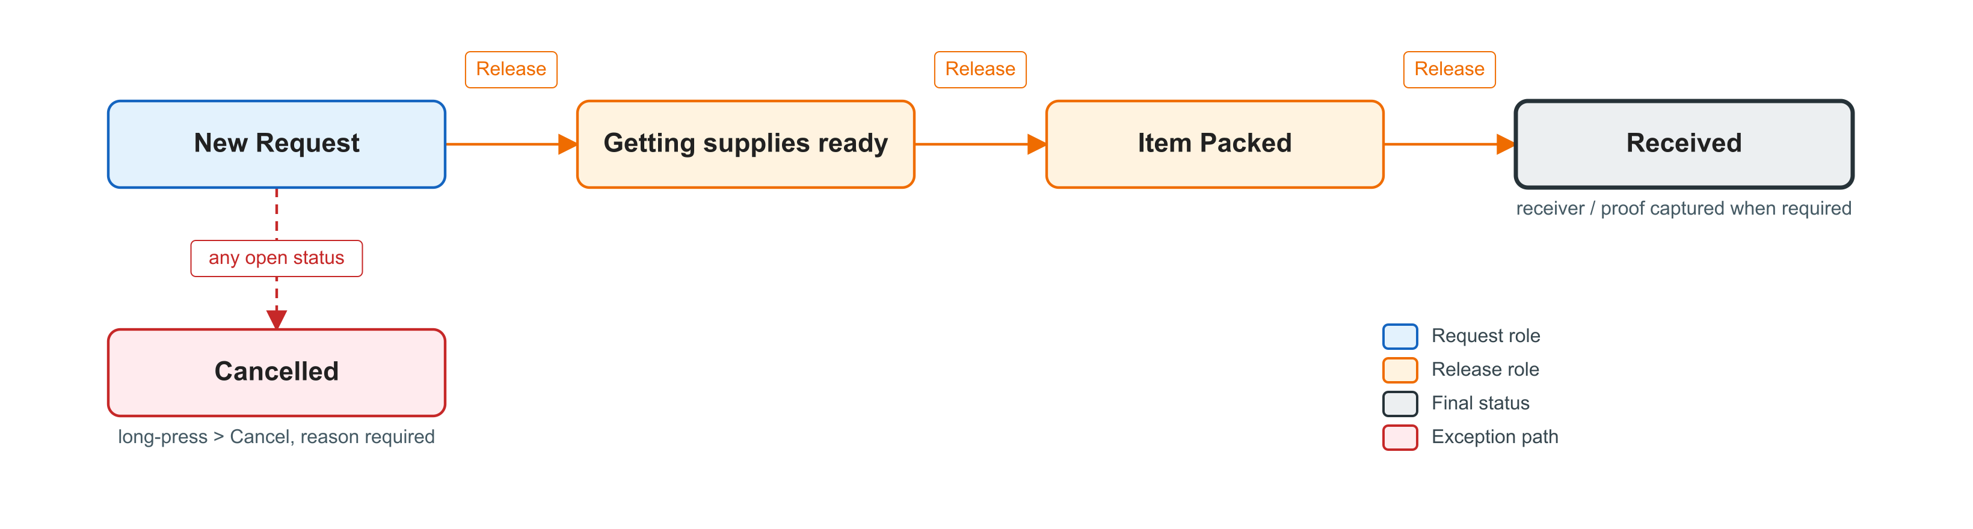
Figure 5. Pick Up status flow
Form fields: Client, Item Categories (more than one may be selected), Pick-Up Date, at least one document reference.
Step | Status change | Who | What the user does in the app
1 | New Request (created) | Request | Fills in the Pick Up form and taps Create Request.
2 | New Request → Getting supplies ready | Release | Opens the request and moves it to Getting supplies ready to start picking.
3 | Getting supplies ready → Item Packed | Release | Moves the request to Item Packed when the items are ready for collection.
4 | Item Packed → Received | Release | When the items are collected, enters the receiver details and signature where the screen asks for them, and moves the request to Received. Confirms that Received is shown before leaving the request.
- | Any open status → Cancelled | Release | Long-press the card, Cancel, select the reason.

7.6 Air / Sea / Land
Air / Sea / Land handles freight shipments. Release prepares and packs the shipment and then chooses how it leaves the warehouse: endorsed to the guard for collection by the forwarder, received directly against a waybill, or dispatched with a company vehicle. Shipments that continue to a provincial destination are completed by the Provincial role (Section 7.7).
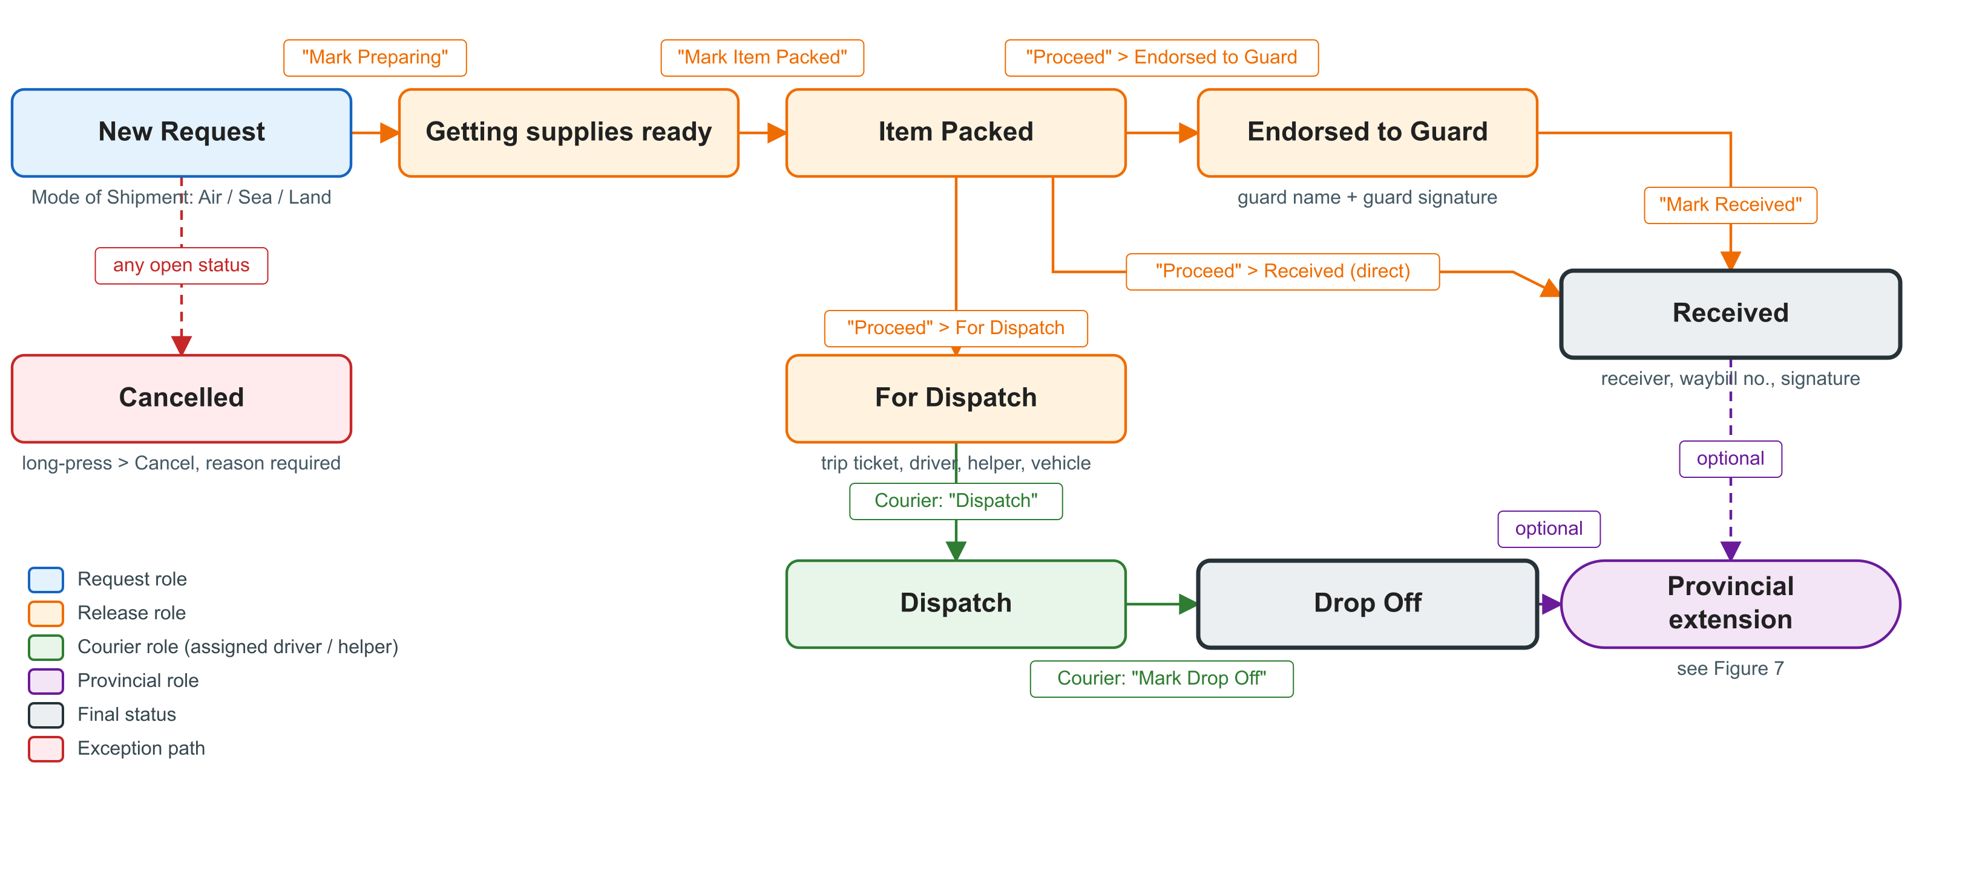
Figure 6. Air / Sea / Land and Air / Sea / Land HD status flow
Form fields: Client, Item Category, Pick-Up Date, Mode of Shipment (Air / Sea / Land, required and fixed after creation), document references.
Step | Status change | Who | What the user does in the app
1 | New Request (created) | Request | Fills in the Air / Sea / Land form, selects the Mode of Shipment and taps Create Request.
2 | New Request → Getting supplies ready | Release | Taps "Mark Preparing".
3 | Getting supplies ready → Item Packed | Release | Taps "Mark Item Packed" when the shipment is packed.
4 | Item Packed → one of three branches | Release | In the request, opens Select Status, chooses the next step and taps "Proceed": (a) Endorsed to Guard: enters the Guard Name and captures the guard's signature. (b) Received: enters the Receiver Name and Waybill Number and captures the receiver's signature. (c) For Dispatch: enters Trip Ticket No, Driver, Helper and Vehicle.
5a | Endorsed to Guard → Received | Release | When the forwarder collects the shipment from the guard, taps "Mark Received" and completes the receiver details.
5b | For Dispatch → Dispatch | Courier | Taps "Dispatch" when leaving with the shipment.
6b | Dispatch → Drop Off | Courier | Taps "Mark Drop Off" at the destination (port, airport or forwarder).
- | Received / Drop Off → provincial leg | Provincial | Optional continuation, Section 7.7.
- | Any open status → Cancelled | Release / Courier | Long-press the card, Cancel, select the reason.

Narrative. The Request user creates the freight request and states whether it ships by air, sea or land. Release marks it preparing, then packed. From Item Packed, Release decides the hand-over: if the forwarder collects at the gate, the shipment is endorsed to the guard with the guard's name and signature and later marked Received when it is picked up; if the forwarder's representative receives it directly, Release records the receiver, the waybill number and the signature; if a company vehicle takes it to the port or airport, Release enters the trip details and the courier dispatches and drops it off. Received and Drop Off are the final statuses unless the shipment continues to a provincial destination.

Air / Sea / Land HD
Air / Sea / Land HD is the urgent (Hotline Direct) variant of Air / Sea / Land, shown on its own tab. It follows the same form, status flow (Figure 6) and role rules. The only difference is that creating a request on the HD tab requires the HD role.

7.7 Air / Sea / Land provincial extension
When a freight shipment is delivered onward by a provincial team, the Provincial role continues the same request from Received or Drop Off through three further statuses. Provincial Delivered is then the final status.
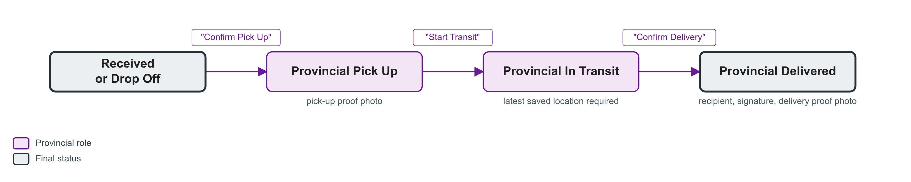
Figure 7. Air / Sea / Land provincial extension
Step | Status change | Who | What the user does in the app
1 | Received / Drop Off → Provincial Pick Up | Provincial | Collects the shipment at the provincial port or forwarder, takes the pick-up proof photo and taps "Confirm Pick Up".
2 | Provincial Pick Up → Provincial In Transit | Provincial | Taps "Start Transit". The app needs the latest saved device location; the Realtime Location Saver in Settings must be switched on beforehand.
3 | Provincial In Transit → Provincial Delivered | Provincial | At the recipient, enters the Recipient Name, captures the recipient's signature, takes the delivery proof photo and taps "Confirm Delivery".

7.8 Back Load
Back Load handles goods that come back to the warehouse instead of being delivered. There are two forms of it, both for Standard Delivery and Hotline Direct requests:
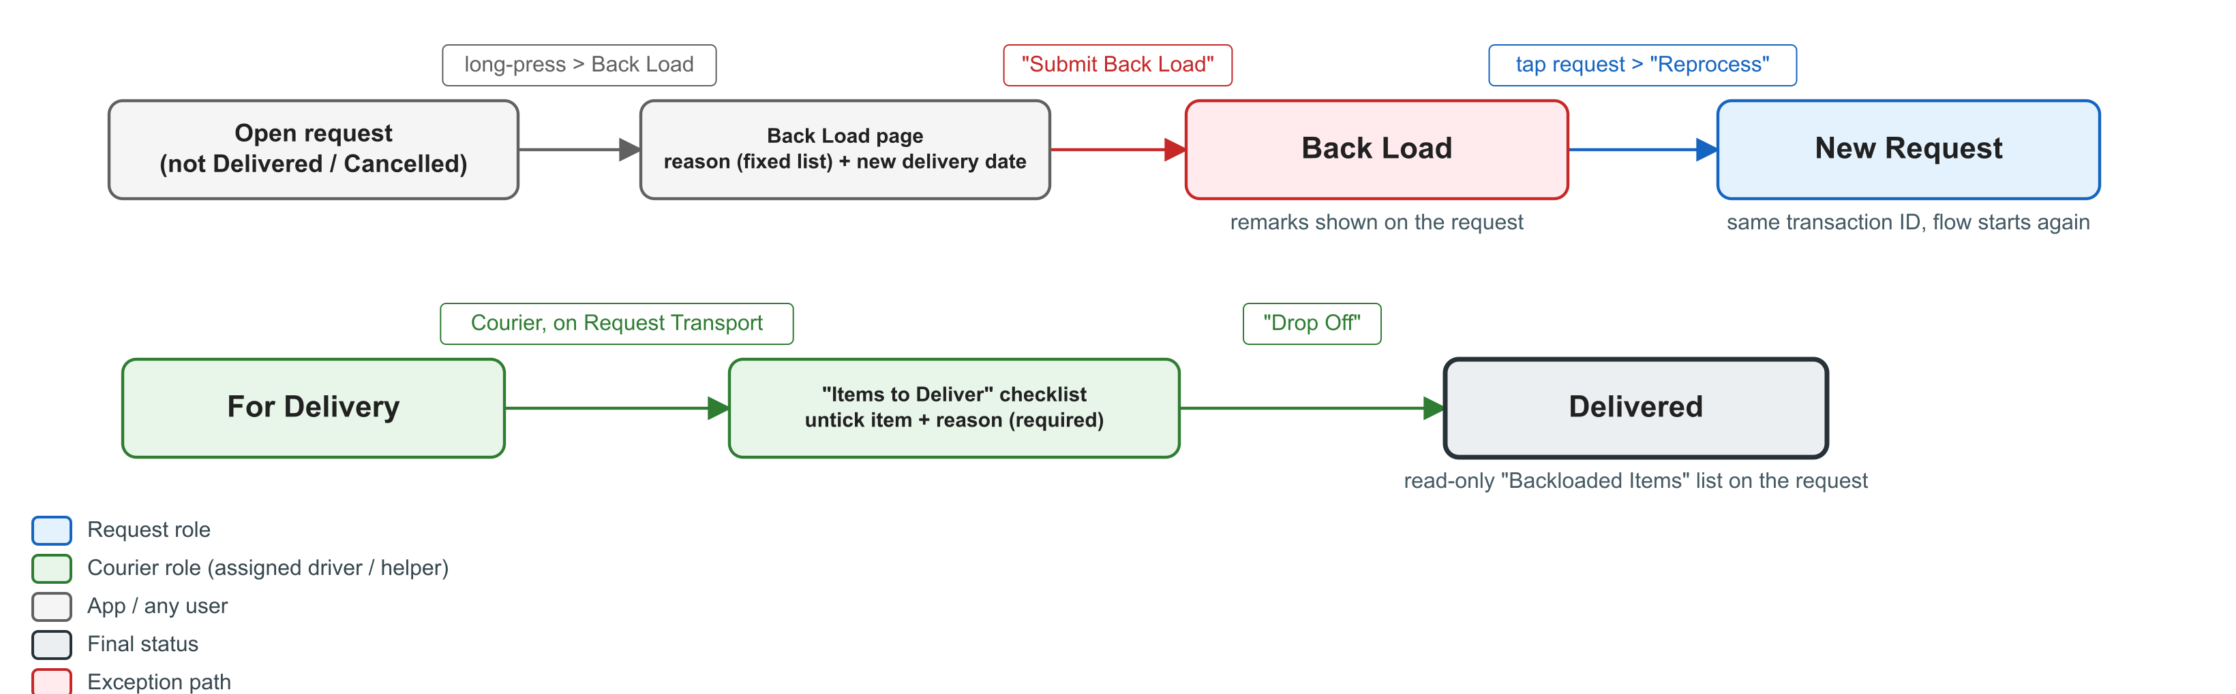
Figure 8. Whole-request Back Load (top) and item-level backload at drop-off (bottom)

Whole-request Back Load
- Long-press the request card (the request must not be Delivered, Cancelled or already Back Load) and choose Back Load. The Back Load page opens with the request details for review.
- Select the Reason for Back Load from the fixed list: Wrong item, Time constraint, Unavailable customer, Refused delivery, Reroute, Expiry not expected.
- Enter the New Delivery Date and tap "Submit Back Load". The status becomes Back Load and the reason is shown on the request. A request may carry several Back Load entries over time.
- To deliver again, tap the request and tap "Reprocess". The request returns to New Request under the same transaction ID and goes through the normal flow (Section 7.1).

Item-level backload at drop-off
When only some items are refused, the courier does not back-load the whole request. On the Request Transport screen at For Delivery, the "Items to Deliver" checklist lists every item; the courier unticks the items the client will not receive and enters a reason for each ("Why is this item being backloaded?"). "Drop Off" stays blocked until every unticked item has a reason. The request completes as Delivered and shows a read-only "Backloaded Items" list.

8. Status Reference
Request category | Statuses in order | Final status
Standard Delivery | New Request → Getting supplies ready → Item Prepared → For Delivery → Delivered | Delivered
Hotline Direct | New Request → Getting supplies ready → Item Prepared → For Delivery → Delivered | Delivered
Pull Out / Return | New Request → For Pull Out → In Transit → Taken Out (In Transit may pause back to For Pull Out) | Taken Out
Stock Receive | New Request → In Transit → Taken Out | Taken Out
Pick Up | New Request → Getting supplies ready → Item Packed → Received | Received
Air / Sea / Land, Air / Sea / Land HD | New Request → Getting supplies ready → Item Packed → Endorsed to Guard → Received; or Item Packed → Received; or Item Packed → For Dispatch → Dispatch → Drop Off | Received or Drop Off
Provincial extension | Received or Drop Off → Provincial Pick Up → Provincial In Transit → Provincial Delivered | Provincial Delivered
Back Load (Standard Delivery, Hotline Direct) | Any open status → Back Load → (Reprocess) New Request | Back Load until reprocessed
All categories | Any open status → Cancelled | Cancelled

9. Exceptions and Support
Situation | What the user does
The action button does not appear on a request | Check the request category and current status. The step may belong to another role, another preparer, or another crew. Refresh the list. If it is still missing, ask the operations admin to verify the account roles and the driver / helper assignment.
Cannot mark Item Prepared | Confirm the trip ticket, driver and vehicle are entered and that you are the user who tapped "Prepare Item".
Cannot Dispatch or Drop Off | Confirm you are the assigned driver or helper. For Dispatch, confirm that a route is found (correct the address if not). For Drop Off, confirm receiver, signature, at least one photo and a reason for every unticked item.
Provincial "Start Transit" is refused | Switch on Realtime Location Saver in Settings, wait for a location update, and try again.
Save fails or "No Internet" | Wait for connectivity, refresh, and repeat the action once. Do not repeat it while a save is still running. Report the exact error text if it keeps failing.
Proof is missing on the server after Drop Off | The signature or photo is waiting in the outbox. Ask the operations admin to retry it from Settings > Developer Tools > Signature Outbox / Image Outbox.
Request list looks out of date or a category is missing | Pull to refresh or switch to Server data. If still wrong, the operations admin refreshes the category from Settings > Hard Reset Refresh.
Wrong request was cancelled or back-loaded | A Back Load request can be reprocessed to New Request. A cancellation cannot be reversed in the app; report it to the operations admin.
Text message not received by a contact | Re-send the message from the request details, or check the contact number in Settings > Contact Directory.

General rules: act only on the transaction that is open on screen; complete every required field before saving; never reuse proof from another transaction; use only the approved cancellation and Back Load reasons; and never share your password or customer data when reporting a problem. Developer Tools under Settings are for operations admins and IMS support only.

10. Related Documents
- Logistics User Guide (docs/application/USER_GUIDE.md)
- Logistics Role-Based User Manual (docs/application/LOGISTICS_ROLE_USER_MANUAL.md)
- Android Logistics Workflow and User-Role Presentation (docs/application/ANDROID_LOGISTICS_WORKFLOW_PRESENTATION.md)
- Logistics Admin Guide (docs/application/ADMIN_GUIDE.md)
- Module documentation: Standard Delivery, Hotline Direct, Pull Out / Return, Stock Receive, Pick Up, Air / Sea / Land, Back Load (docs/modules/)

11. Revision History
Revision | Date | Description | Prepared by
0 | 2026-09-10 | Initial issue, based on application version 1.1.104.

