WORLD-BUILDING AND SYSTEM DESIGN REFERENCE
THE PANMAGICON
A comprehensive guide to the Eightfold magic system
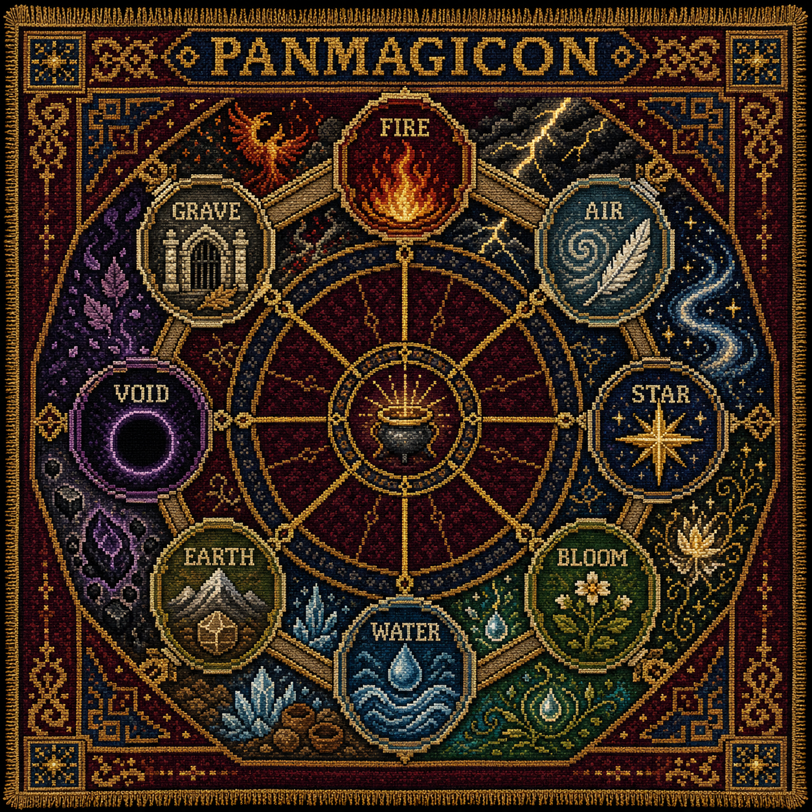
Review Edition 1.0
A coherent working canon, designed to invite revision

How to review this guide
Design thesis Magic becomes difficult when it must hold more relationships, conditions and consequences at once. Expertise is expressed through composition, precision and responsibility rather than access to a larger list of locked spells.
This document consolidates the current Panmagicon into one reviewable rules framework. It distinguishes established principles from implementation choices that may still be tuned. The system is intended for a strategy game, role-playing setting or narrative world in which magic operates at personal, battlefield, institutional and world scale.

Contents
- Part I - Foundations: design goals, the Forging and the Eightfold cosmology
- Part II - Magical grammar: Aspects, Schools, traces and formula notation
- Part III - Composite phenomena: all 28 two-Aspect families
- Part IV - Difficulty: Tension Profiles, payment, failure and consequence
- Part V - Practitioners: faculties, pattern familiarity and the Eight Proofs
- Part VI - Institutions: traditions, rituals, artifice and blood praxis
- Part VII - Application: counter-magic, strategic scale and worked formulae
- Part VIII - Balance principles and open review decisions
- Appendix A - The complete 8 x 8 Aspect and School discipline reference
- Appendix B - Glossary and compact formula template

Current status
The cosmology, inverse School structure, trace model, Tension Profile and practitioner progression form a coherent core. Exact numerical costs, combat timings, resource yields and national content remain intentionally unspecified so they can be calibrated to the final game or story format.
PART I
FOUNDATIONS
What the Panmagicon is, why it exists and what symmetry means

1. Design intent
The Panmagicon is both a cosmology and a practical grammar for magic. It must be symmetrical enough to understand, extensive enough to reward discovery, and asymmetrical enough in use to support distinct cultures and strategies.
- Symmetrical opportunity. Every Aspect must support combat, defence, information, infrastructure, economy and high-order ritual play, although it reaches those functions differently.
- Compositional depth. Spells arise from combinations of Aspect, School, conditions, scale and carrier rather than from an isolated catalogue of effects.
- Consequences without moral scripting. Every magical act leaves a trace and a School remainder. Their practical and ethical meaning depends on context.
- Difficulty through authorship. More destructive magic is not automatically more difficult. Precision, duration, autonomy and contradiction can make a gentle effect extraordinarily demanding.
- Expertise through responsibility. Masters are distinguished by their ability to diagnose, redirect and safely shed Tension, not merely by larger reserves of power.
- Divergent teaching. Rival traditions can use the same underlying grammar while disagreeing about purpose, acceptable payment and the proper destination of consequences.

2. The Forging of the Panmagicon
Before the Panmagicon, magic existed as thousands of local arts: storm songs, hereditary fire names, burial obligations, sacred geometry, spirit bargains and practical taboos. These arts could be powerful, but they were difficult to compare, teach or reproduce outside their native conditions.
The Panmagicon was forged twice. It was first made as an octagonal instrument whose outer leaves represented the Aspects and whose inner mechanisms represented magical operations. It was then impressed upon magic as a shared law, making previously private arts commensurable.
Contribution | Worldly act | Metaphysical completion
Body | Earth supplied ore, anvil and durable form. | Bloom allowed the instrument to grow beyond its makers.
Working | Fire made incompatible materials mutable. | Grave gave memory of success, failure and discarded formulae.
Motion | Air fed the furnace and moved the celestial mechanisms. | Star connected each symbol to the reality it represented.
Tempering | Water quenched and stabilised every completed alignment. | Void kept the symbols distinct so that meaning did not collapse into total possibility.

The price of universality Each Forger surrendered the private name of an art. Magic became teachable to strangers, but some pre-Forging traditions accuse the Panmagicon of turning a living plurality into a beautiful cage.
Blood entered the quenching basin, but received no position on the wheel. In the resulting system, blood is not a fundamental Aspect. It is proof of embodiment, identity and payment, and can be used as a praxis across any Aspect.

3. The Eightfold cosmology
The wheel contains two symmetrical quaternities. The four Elements determine what worldly reality is made from and how it behaves. The four Mysteries determine what reality means, how it persists and what becomes of it.
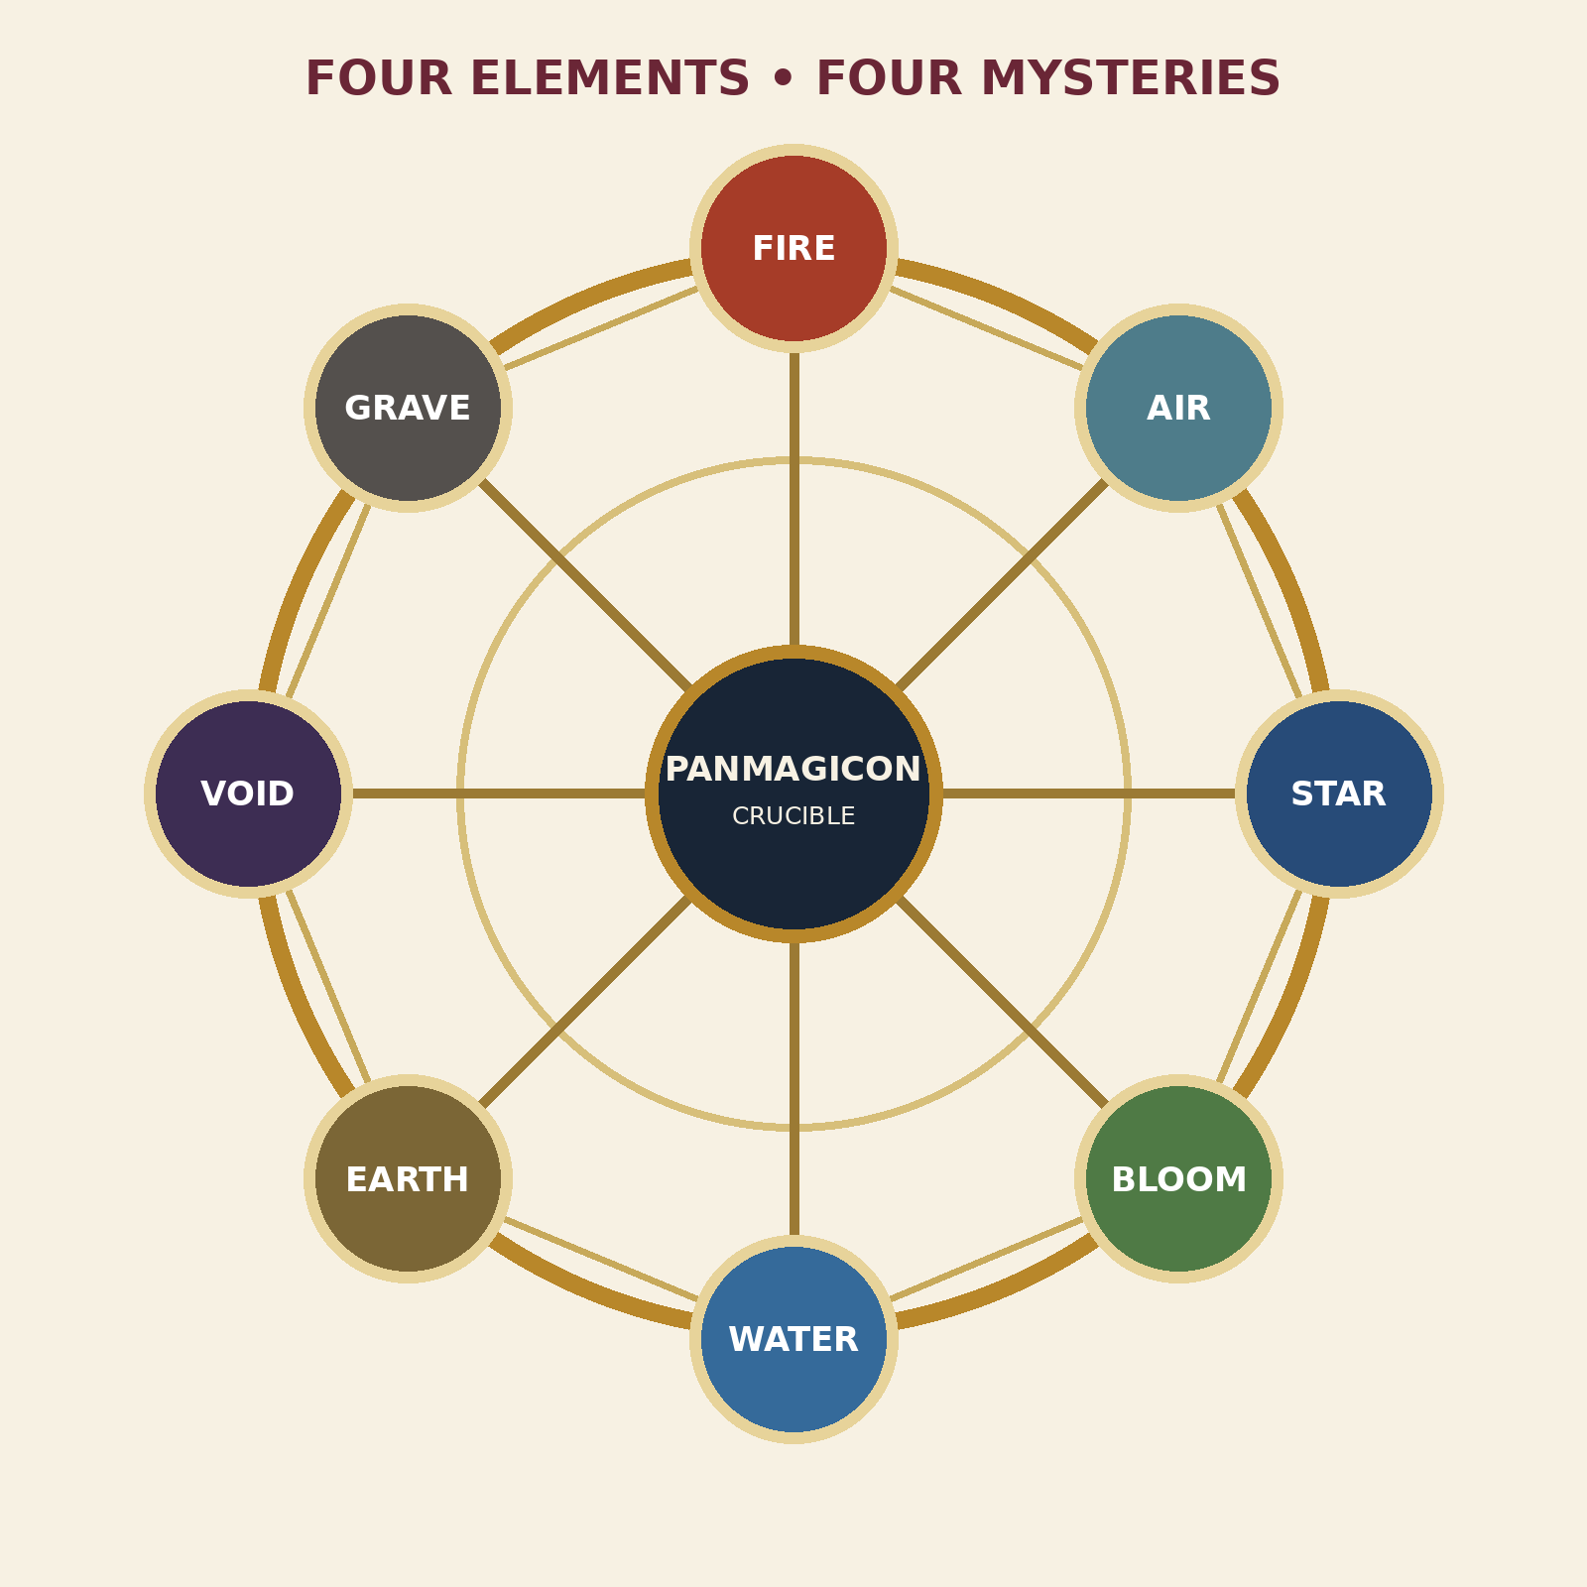
Figure 1. The Eightfold wheel and its four opposed axes.
Opposed axis | First principle | Counter-principle | Paradox domain
Thermal | Fire: release and excitation | Water: flow and equalisation | Steam, pressure, quenching and phase exchange
Material | Air: motion and diffusion | Earth: mass and structure | Gravity, resonance, sand and seismic motion
Living | Bloom: generation and adaptation | Grave: completion and inheritance | Rot, fungi, resurrection and life cycles
Ontological | Star: pattern and connection | Void: absence and severance | Gates, nonspace, erased destiny and reality boundaries

4. The eight Aspects

4.1 Fire (Element)
Principle: Release, excitation, heat, light, appetite and acceleration.
Opposite: Water
Temperament: Wants to act immediately and move outward. Naturally suited to Evocation.
Characteristic trace: Consumed fuel, excess heat, smoke, hunger and accelerated exhaustion.
Doctrinal expressions: Hearth (stewardship), Pyre (warfare), and Sun (mystery).

4.2 Water (Element)
Principle: Flow, cohesion, pressure, dissolution, reflection and equalisation.
Opposite: Fire
Temperament: Wants to redistribute difference and follow available channels. Naturally suited to Enchantment and Restoration.
Characteristic trace: Redistributed moisture, pressure imbalances, erosion, dilution and local thirst.
Doctrinal expressions: Well (stewardship), Deluge (warfare), and Mirror (mystery).

4.3 Air (Element)
Principle: Motion, breath, sound, weather, diffusion and freedom.
Opposite: Earth
Temperament: Wants to move, communicate and escape containment. Naturally suited to Evocation and Divination.
Characteristic trace: Altered pressure, disturbed weather, displaced sound, breathlessness and turbulent wakes.
Doctrinal expressions: Breath (stewardship), Tempest (warfare), and Horizon (mystery).

4.4 Earth (Element)
Principle: Mass, structure, mineral, endurance, boundary and material memory.
Opposite: Air
Temperament: Wants to remain, bear weight and preserve form. Naturally suited to Enchantment and Abjuration.
Characteristic trace: Accumulated stress, displaced mass, weight, fractures and exhausted mineral structure.
Doctrinal expressions: Forge (stewardship), Bastion (warfare), and Deep (mystery).

4.5 Bloom (Mystery)
Principle: Life, generation, fertility, adaptation, differentiation and proliferation.
Opposite: Grave
Temperament: Wants to grow, diversify and occupy opportunity. Naturally suited to Conjuration, Alteration and Restoration.
Characteristic trace: Consumed nutrients, mutation, invasive growth, hunger and competition for living space.
Doctrinal expressions: Grove (stewardship), Fang (warfare), and Spring (mystery).

4.6 Grave (Mystery)
Principle: Death, completion, decay, inheritance, residue and memory.
Opposite: Bloom
Temperament: Wants processes to conclude and leave meaningful remains. Naturally suited to Divination, Restoration and Abjuration.
Characteristic trace: Decay, ancestral claims, emotional residue, unfinished memory and a tendency toward stillness.
Doctrinal expressions: Ancestor (stewardship), Rot (warfare), and Underworld (mystery).

4.7 Star (Mystery)
Principle: Pattern, relation, distance, naming, fate and the disembodied soul.
Opposite: Void
Temperament: Wants to connect each thing to its proper place and meaning. Naturally suited to Divination and Conjuration.
Characteristic trace: New correspondences, visibility, sympathetic links, attention and entangled destinies.
Doctrinal expressions: Measure (stewardship), Gate (warfare), and Oracle (mystery).

4.8 Void (Mystery)
Principle: Absence, severance, silence, isolation, negation and the outside.
Opposite: Star
Temperament: Wants relations to cease and distinctions to become absolute. Naturally suited to Veiling and Abjuration.
Characteristic trace: Gaps in memory or causality, frayed relationships, silence, null zones and missing context.
Doctrinal expressions: Veil (stewardship), Maw (warfare), and Beyond (mystery).
PART II
MAGICAL GRAMMAR
How Aspects become effects through inverse Schools and consequential operations

5. What a School is
An Aspect is a noun or principle. A School is a verb. Schools do not own particular elements, moral alignments or visual effects. They describe the operation performed upon one or more Aspect Threads.
Core formula Aspect Threads + School Turns + conditions + carrier = a magical Pattern. The resulting consequence is Aspect trace multiplied by School remainder.
School | Inverse | Operation | Inevitable remainder
Conjuration | Abjuration | Makes something present or accessible. | Displacement: what arrives is taken from a place, possibility or prior condition.
Abjuration | Conjuration | Excludes, dismisses, severs or keeps something beyond a boundary. | Accumulation: rejected force gathers at the boundary or is driven elsewhere.
Alteration | Restoration | Changes identity, form, behaviour or state. | Drift: the subject remembers prior states or continues changing after the intended moment.
Restoration | Alteration | Returns a subject toward a prior, proper or ideal condition. | Ambiguity: the magic must decide which past or ideal is authoritative.
Evocation | Enchantment | Releases a power into immediate action. | Recoil: force passes through the caster, source or environment before reaching its target.
Enchantment | Evocation | Binds power into persistence, habit, aura or obligation. | Dependency: the effect needs fuel, attention, an anchor or a continuing relationship.
Divination | Veiling | Establishes an informative connection and makes a pattern legible. | Reciprocity: observation creates a link through which the observer may also be known.
Veiling | Divination | Conceals, confuses or severs an informative connection. | Omission: concealed things also become harder for allies, records and sometimes the caster to recover.

6. The four inverse School axes

Presence
Conjuration makes present; Abjuration excludes or dismisses.
Balance consequence: Neither creates a free result. Arrival displaces; exclusion accumulates.

Identity
Alteration changes; Restoration returns toward an earlier or proper state.
Balance consequence: Alteration creates drift. Restoration creates disputes about which state is true.

Force
Evocation releases; Enchantment binds and persists.
Balance consequence: Release recoils. Binding develops dependencies and pressure.

Knowledge
Divination connects and reveals; Veiling obscures and severs informational relation.
Balance consequence: Observation is reciprocal. Concealment creates genuine omission.

7. Formula notation
A usable notation should communicate what a working manipulates, how it behaves, and where its difficulty lies. It should not require a unique rule entry for every variation.
Field | Meaning | Example
Threads | Aspect and relative dominance | Water 3 + Void 2
Turns | Ordered School operations | Divination > Abjuration > Enchantment
Knots | Target rules and exceptions | Enemies only; spare living tissue
Carrier | Who or what holds the active pattern | Caster, circle, relic, site or institution
Tension Profile | Difficulty shape across eight measures | Threads 2, Span 2, Fineness 3
Trace plan | Intended destination of consequence | Heatstone sink; watershed redistribution

Example notation WHITE SILENCE | Water 3 + Void 2 | Evocation | Battlefield span | Immediate hold | Spare living tissue | Thermal trace redirected into three prepared heatstones.

8. Grain and against-grain magic
Every Aspect has a temperament. Working with its grain is efficient but amplifies its characteristic trace. Working against the grain creates higher Tension, yet often produces the most valuable infrastructure and control effects.
Evoking Fire is straightforward because Fire wants release. Enchanting Fire is difficult because the working must persuade release to become persistence. The difficulty is what makes perpetual furnaces and contained artificial suns significant achievements.
A School affinity is therefore not an exclusive spell list or damage bonus. It changes Tension, typical failure and the kind of preparation required.
PART III
COMPOSITE PHENOMENA
How two Aspects produce families of effects rather than fixed sub-elements

9. Principles of composition
A composite is not a ninth Aspect. It is a maintained relationship between two or more Threads. The School determines how the relationship is expressed, while relative Aspect strength determines which side dominates.
- Balanced composites express the equilibrium of both parents.
- Dominant composites express one Aspect acting through the medium or resistance of the other.
- Opposed composites carry additional Contradiction but generate especially transformative phenomena.
- Adjacent, cross-wheel and triadic combinations are available; adjacency is a teaching convenience, not a metaphysical prohibition.
- The same composite can support all eight Schools. Fire + Water is not merely Steam Evocation; it also supports healing, barriers, engines, scrying and veiling.

10. The six Element combinations
Pair | Family | Phenomena | Principal risk
Fire + Water | Thermal Exchange | Steam, pressure, boiling, condensation, quenching and controlled heat transfer. | A true opposition. Instability appears as pressure, flash boiling or violent cooling.
Fire + Air | Stormfire | Lightning, plasma, smoke, combustion waves and explosive acceleration. | Fast propagation and severe recoil; disturbances travel farther than intended.
Fire + Earth | Forge | Magma, metal, ceramics, furnaces, volcanic shaping and tempering. | Stress becomes trapped in material and may emerge later as fracture or eruption.
Water + Air | Weather | Rain, mist, snow, clouds, currents and atmospheric moisture. | Regional redistribution can produce drought, pressure shifts or unintended storms elsewhere.
Water + Earth | Formed Water | Ice, clay, mud, sediment, erosion and crystal growth. | The result struggles between flow and permanence; cracks and creep are common traces.
Air + Earth | Resonant Matter | Sand, dust, sound through stone, gravity effects and seismic motion. | A true opposition. Momentum and stress accumulate until released through movement or collapse.

11. The six Mystery combinations
Pair | Family | Phenomena | Principal risk
Bloom + Grave | The Living Cycle | Fungi, rot, disease, reincarnation, resurrection and ecological succession. | A true opposition. Identity, timing and the boundary between life and inheritance become unstable.
Bloom + Star | Living Pattern | Dreams, souls, hereditary destiny, living constellations and guided evolution. | Life may begin adapting toward the prediction rather than the world that actually exists.
Bloom + Void | Pruning | Dormancy, sterility, selective extinction, hungerless life and controlled absence in ecosystems. | Removal can propagate through kinship and ecology, deleting more than the intended trait.
Grave + Star | Ancestral Pattern | Lineage memory, funerary prophecy, constellated ancestors and inherited obligations. | The dead gain stronger claims over descendants and unfinished destinies.
Grave + Void | Oblivion | Erased remains, soulless undeath, forgotten deaths and final dissolution. | Memory and meaning disappear with matter, making repair or mourning difficult.
Star + Void | Threshold | Gates, folded distance, reality anchoring, erased destinies and impossible boundaries. | A true opposition. Misalignment produces nonspace, missing time or severed identity.

12. The sixteen Element and Mystery crossings
Pair | Family | Phenomena | Principal risk
Fire + Bloom | Vital Flame | Vitality, fever, rapid metabolism, phoenixes and explosive growth. | Growth consumes fuel and may continue as hunger, fever or uncontrolled renewal.
Fire + Grave | Ash | Cremation, ruin, funerary flame, cinder spirits and phoenix cycles. | Destroyed things leave potent residue that attracts memory and repetition.
Fire + Star | Solar Art | Sunlight, revelation, celestial fire, beacons and radiant naming. | Illumination attracts attention and makes concealment or neutrality difficult.
Fire + Void | Black Flame | Consumed heat, lightless burning, cauterised magic and annihilation. | The fire may devour its own evidence, fuel and causal explanation.
Water + Bloom | Wellspring | Healing, fertility, blood, sap, regenerative pools and living rivers. | Healing redistributes vitality and can spread disease or invasive growth with equal efficiency.
Water + Grave | Brine | Poison, drowned dead, preservation, marsh decay and memory carried by rivers. | What water preserves may return incomplete, bitter or claimed by the dead.
Water + Star | Mirror | Scrying pools, tides, navigation, reflected souls and distant communication. | The viewed location gains a reflected path back to the observer.
Water + Void | Frost | Abyssal cold, arrested motion, still water, thermal absence and suspended change. | Heat is not destroyed cleanly; it is displaced or leaves a thermal shadow.
Air + Bloom | Breath | Pollen, flight, living weather, voice, scent and animation through respiration. | Life spreads beyond intended boundaries and competes for breath or atmosphere.
Air + Grave | Last Breath | Plague, choking, ghostly voices, death winds and carried decay. | The air remembers endings and may repeat them along its route.
Air + Star | Horizon | Prophecy, messages, celestial winds, navigation and spatial travel. | Routes become correspondences that can be followed in both directions.
Air + Void | Vacuum | Silence, suffocation, invisible severance and motion without a medium. | Nearby sound, pressure and connection drain into the created absence.
Earth + Bloom | Living Earth | Fertile soil, living wood, flesh-golems and self-repairing structures. | The structure develops needs, instincts and ecological consequences.
Earth + Grave | Tomb | Bone, fossils, ruins, preserved remains and monuments of inheritance. | Structures accumulate ancestral claims and resist repurposing or forgetting.
Earth + Star | Ley | Runes, crystals, maps, ley lines and architecture aligned to cosmic pattern. | Every stable alignment also becomes a route, signal or target for distant forces.
Earth + Void | Nullstone | Seals, anti-magical chambers, crushing absence and structures outside correspondence. | The material becomes difficult to remember, repair, move or relate to its surroundings.

13. Dominance and ratio
Opposition | First dominates | Equilibrium | Second dominates
Fire / Water | Boiling and evaporation | Steam and pressure | Quenching and condensation
Air / Earth | Erosion and levitation | Sand, resonance and seismic motion | Gravity and compression
Bloom / Grave | Regeneration and return | Cycles, fungi and metamorphosis | Rot, blight and extinction
Star / Void | Anchoring and manifestation | Gates and folded distance | Banishment and erasure

Ratios may change while a composite is active. A master can begin with Water-dominant mist, increase Fire to create steam, release pressure through Evocation, then return to Water dominance as cooling rain without casting four unrelated spells.
PART IV
DIFFICULTY AND CONSEQUENCE
Tension replaces rigid spell levels with multidimensional magical labour

14. The Tension Profile
A working is difficult when the caster must maintain more independent relationships. Each spell has a profile rather than a single level. Two workings of equal total difficulty can demand completely different kinds of expertise.
Measure | What it describes | What increases it
Threads | Number and incompatibility of Aspects carried simultaneously. | Add an Aspect, especially an opposed one.
Turns | Number and order of School operations in the formula. | Divine a target, Alter it, then Enchant the change.
Knots | Conditions, exceptions and dependencies. | Affect enemies, but not allies, animals or stored grain.
Span | Range, area and number of simultaneous subjects. | Extend a spell from a person to an army or province.
Hold | Duration and resistance to natural decay. | Maintain an effect for a season instead of a minute.
Fineness | Precision, discrimination and control over intensity. | Freeze a weapon without freezing the hand holding it.
Agency | Ability to react, choose or continue without supervision. | Make rain adjust itself to each crop and road.
Contradiction | Opposed Aspects, against-grain operations and impossible clauses. | Sustain Fire and Water in equilibrium or preserve living death.

Key consequence Subtle magic can be harder than destructive magic. A hurricane may have enormous Span and force but little Fineness. Rain that nourishes selected crops, avoids roads and adapts for seven days requires a much richer weave.

15. Capacity, excess and payment
Practitioners possess a capacity profile shaped by Aspect Attunement, School Discipline and Weavecraft. Whenever a formula exceeds personal capacity, its excess Tension must be carried elsewhere.
Payment | How it carries Tension | Trade-off
Time | Slow casting permits repeated correction and reduces pressure on Turns and Fineness. | Interruptible; tied to timing and preparation.
Assistants | Different practitioners carry separate Threads, Span or Knots. | Coordination failure can split the formula.
Essence | Condensed resonance absorbs trace, recoil or contradiction. | Extraction creates environmental and political costs.
Anchors | Objects, creatures and sites carry Hold or Agency. | Damage or dependency of the anchor threatens the working.
Research | Established formulae reduce Novelty and identify failure points. | Less adaptable outside documented conditions.
Restriction | Location, target, timing or material limits reduce required Knots. | The effect becomes conditional and exploitable.
Sacrifice | Body, memory, identity, resources or relationships absorb excess. | The cost is direct, lasting and ethically visible.
Consequence | Unresolved Tension is accepted as backlash, trace or regional debt. | The spell succeeds by making something else bear the failure.

16. Failure as controlled shedding
Magic should rarely resolve as a single success or failure check. When a weave overloads, one part begins to tear. Experienced practitioners detect the failing dimension and deliberately sacrifice a less important property.
Failure | What happens | Experienced response
Threads tear | An Aspect drops out, dominates or contaminates another Thread. | Release the secondary Aspect or lower its ratio.
Turns slip | School operations occur incompletely or out of order. | Collapse to the earliest stable operation.
Knots loosen | Exceptions stop applying. | Reduce the target set before discrimination fails.
Span collapses | Area or range contracts unpredictably. | Choose a safe centre and surrender the outer region.
Hold frays | Duration shortens or pulses. | End the effect cleanly rather than prolonging instability.
Fineness blurs | Intensity and target precision are lost. | Reduce power or choose a broader harmless result.
Agency escapes | The working interprets its task independently. | Break the anchor or remove adaptive clauses.
Contradiction snaps | Opposed Aspects separate violently. | Let one side dominate and direct the release.

17. Trace, remainder and magical debt
An Aspect trace is what that power changes in the world. A School remainder is the structural consequence of the operation. Their intersection determines immediate fallout. Repeated redirection into the same place creates magical debt.
A city may appear magically clean because every spell directs trace into a municipal sink. Such infrastructure does not remove consequence. It concentrates it into heat vaults, dream reservoirs, sacrificial wetlands, ancestral archives or forgotten null districts that eventually demand maintenance and political attention.
Conservation principle Expertise can reduce waste and choose the destination of consequence, but no recognised School can make a consequential act entirely consequence-free.
PART V
PRACTITIONERS
Experience, specialisation, repertoire and proof of competence

18. Three faculties of practice
Faculty | Governs | Typical novice limitation | Mastery expression
Attunement | Which Aspects can be perceived and carried | Recognises only obvious active manifestations | Reads faint traces, ratios and environmental resonance
Discipline | Which Schools can be applied cleanly | Depends on literal formulae and prescribed gestures | Changes operations, reverses Turns and manages remainder
Weavecraft | How much Tension can be organised | Loses control as conditions accumulate | Composes, compresses and safely sheds complex patterns

19. Novice and experienced behaviour
Novice | Experienced practitioner
Casts a memorised formula | Understands why the formula works and which clauses are optional
Uses one Aspect at a time | Braids Aspects into a controllable composite
Treats outcome as success or failure | Chooses which property to sacrifice under overload
Produces consequences locally | Redirects consequences into prepared sinks
Needs explicit words, gestures and diagrams | Compresses familiar Patterns into smaller actions
Stops when conditions change | Rewrites ratios, Turns and Knots while the weave is active
Dispels by overpowering | Unpicks the sustaining knot or dependency
Exhausts personal capacity first | Uses tools, terrain, institutions and assistants strategically

20. Pattern familiarity
Stage | Meaning
Draft | Requires complete notation, prescribed materials and generous preparation. Novelty adds Tension.
Practised | Reliable under normal conditions. Some gestures and supports can be omitted.
Tempered | Failure points are understood. Range, duration and intensity can be varied safely.
Signature | The Pattern is instinctive and can be compressed, reversed or adapted during casting. It leaves a recognisable personal signature.

Repeated use can also carve a groove. A practitioner who solves every problem through Fire Evocation may become remarkably efficient, but Fire's temperament begins leaking into unrelated work. Their Water boils readily, their Divinations arrive as flashes and their Enchantments develop appetites.

21. The Eight Proofs
The Panmagicon recognises demonstrations of competence rather than a universal experience level. Hearing and Holding are foundational; later Proofs may be pursued in orders determined by tradition.
Proof | Demonstration
Hearing | Perceive an Aspect and distinguish its current presence from its residual trace.
Holding | Sustain a direct effect without uncontrolled discharge or collapse.
Turning | Apply more than one School operation to the same Thread.
Braiding | Produce a stable composite from multiple Aspects.
Anchoring | Transfer Hold or Agency into an object, creature, site or institution.
Redirection | Choose where a spell's trace and School remainder are deposited.
Unweaving | Dismantle one's own or another practitioner's magic without merely overpowering it.
Reconciliation | Sustain opposed Aspects without allowing either to erase the other.

A military academy may prioritise Turning, Braiding and Unweaving. A village tradition may value Anchoring, Restoration and Redirection. Some Void monasteries demand Unweaving before permitting Conjuration. Panmagicon scholars often call Reconciliation the highest Proof, while conservative orders consider it irresponsible.
PART VI
TRADITIONS AND INSTITUTIONS
How one grammar produces rival magical cultures

22. Divergent doctrine
Every Aspect supports three broad orientations. These are not locked character classes. They are institutional answers to what an Aspect is for, which consequences are acceptable and who should bear them.
Aspect | Stewardship | Warfare | Mystery
Fire | Hearth | Pyre | Sun
Water | Well | Deluge | Mirror
Air | Breath | Tempest | Horizon
Earth | Forge | Bastion | Deep
Bloom | Grove | Fang | Spring
Grave | Ancestor | Rot | Underworld
Star | Measure | Gate | Oracle
Void | Veil | Maw | Beyond

Stewardship: Infrastructure, healing, economy, protection and sustainable consequence management.
Warfare: Speed, battlefield control, denial, siege and acceptance of concentrated trace.
Mystery: Summoning, cosmology, divination, transformation and high-order ritual risk.
A civilisation can maintain rival orders. Supporting several doctrines increases flexibility but requires teachers, sites, records and separate methods of trace disposal. Deep commitment produces capstone techniques; syncretism creates broader but less perfected practice.

23. Artifice
Artifice is not a School. It is the craft of assigning parts of a Tension Profile to a material anchor. An artefact may hold duration, agency, target definitions, a repeating sequence of Turns or a reservoir for trace.
Anchor type | What it carries | Typical vulnerability
Tool or weapon | Fineness, repeated Evocation, target constraints | Wear, theft and habitual trace
Vessel or engine | Hold, contradiction, stored essence | Pressure, fuel dependency and rupture
Construct | Agency, Span and repeated conditional action | Interpretation drift and broken command relations
Building or monument | Large Span, persistent warding and institutional memory | Structural stress and political ownership
Landscape site | Regional ritual, seasonal Hold and consequence sinks | Ecological debt and loss of portability

24. Ritual
Ritual is also not a School. It is an architecture that distributes difficulty through time, people, place, repetition and astronomical relation. Ritual allows low-capacity practitioners to participate in great works, but it increases coordination and interruption risk.
A ritual circle should divide named responsibilities rather than supply anonymous bonus points. One practitioner may carry Water, another maintain the Enchantment Turn, a third monitor Divination feedback, and a fourth manage the trace sink. If one role fails, the resulting failure has a predictable shape.

25. Blood praxis
Foundational maxim Blood is not a Power. Blood is proof that power has been paid for.
Blood can serve as essence, sympathetic address, identity anchor, sacrifice or consequence sink for any Aspect. It is especially efficient when a formula needs embodiment, lineage, consent, kinship or a uniquely identified subject.
Its danger is not that Blood constitutes an intrinsically evil element. Its danger is that it makes payment immediate, transferable and politically exploitable. Institutions may distinguish voluntary tithe, inherited obligation, battlefield taking, judicial sacrifice, predatory extraction and medical donation.
Blood Fire burns vitality; Blood Water manipulates circulation and inheritance carried in fluid; Blood Star binds names and lineages; Blood Void can sacrifice memory, relationship or recognised identity. The praxis crosses the wheel rather than occupying a station on it.

26. Essence and magical infrastructure
Essence is condensed resonance used to carry excess Tension, absorb trace or permit effects beyond a caster's immediate environment. It should not operate as consequence-free mana. Gathering it changes the site from which it is taken.
Aspect | Sources | Extraction externality
Fire | Volcanoes, kilns, lightning scars, great acts of release | Fuel loss, drought, accelerated decay
Water | Springs, confluences, deep currents, seasonal floods | Drying, pressure change, altered watersheds
Air | Storms, high places, resonant chambers, migration routes | Stillness, pressure disruption, displaced weather
Earth | Faults, ore seams, ancient masonry, load-bearing sites | Subsidence, depletion, accumulated stress
Bloom | Births, thriving ecosystems, seed banks, adaptation events | Nutrient drain, sterility, invasive growth
Grave | Burial grounds, ruins, endings, ancestral archives | Unrest, forgotten inheritance, accelerated decay
Star | Observatories, crossings, vows, celestial alignments | Visibility, entanglement, attracted attention
Void | Null zones, abandoned names, severed places, impossible gaps | Fraying context, silence, missing memory

PART VII
APPLICATION
Counter-magic, strategic scale and representative workings

27. Counter-magic
Countering a spell is not limited to opposing its Aspect. Practitioners may attack its source, operation, anchor, conditions or consequence plan.
Method | Approach | Trade-off
Oppose the Aspect | Water suppresses Fire; Earth arrests Air; Grave checks Bloom; Void severs Star. | Fast but risks paradox and hard opposition.
Reverse the School | Bind an Evocation, reveal a Veil, Alter a Restoration target. | Requires correct diagnosis of the active Turn.
Break a Knot | Change allegiance, name, terrain or other target condition. | Elegant but only works when the condition is known.
Overload the carrier | Damage an artefact, disrupt a circle or exhaust a site. | Can release stored trace catastrophically.
Poison the trace plan | Block or redirect the intended consequence sink. | May preserve the spell while making its cost unacceptable.
Unweave | Dismantle the Pattern in reverse order. | Slow, difficult and safest when performed by an expert.

28. Scales of practice
Scale | Reach | Typical support
Cantrip | Personal, immediate and low consequence | Usually one Thread and one direct Turn
Spell | Tactical or practical working | Carried primarily by one practitioner
Working | Prepared battlefield, workshop or community effect | Uses essence, assistants or an anchor
Rite | Army, city, province or season | Distributed through ritual architecture
Wonder | Lasting regional or world alteration | Requires institutions, unique sites and explicit long-term debt

Scale changes logistics rather than granting a separate category of magic. A Fire Evocation can light a lamp, burn a formation or awaken a volcano. The grammar remains recognisable while Span, Hold, trace and required infrastructure change.

29. Worked formulae

White Silence
Formula: Water + Void; Evocation with optional Enchantment
Effect: Removes heat and motion from a battlefield region. A brief version flash-freezes exposed surfaces; an enchanted version creates a preservation field.
Tension: Threads 2; Span 2; Fineness 1; Contradiction 1. Additional Fineness is required to spare skin, living tissue or selected equipment.
Consequence: Heat is displaced rather than destroyed. Poorly directed trace produces a thermal shadow, delayed thaw or dangerous heating elsewhere.

Merciful Rain
Formula: Water + Air + Bloom; Conjuration followed by Enchantment
Effect: Produces gentle rain across friendly farmland, adjusting itself to crops while avoiding roads, buildings and hostile territory.
Tension: Threads 3; Turns 2; high Span, Hold, Knots, Fineness and Agency. Its kindness makes it harder than an indiscriminate storm.
Consequence: Moisture and pressure must come from somewhere. The ritual needs a mapped watershed and prepared atmospheric sinks.

Boiler-Heart
Formula: Fire + Water; Enchantment anchored through Artifice
Effect: A compact engine that maintains a controlled thermal gradient to power machinery, heat a district or drive a vessel.
Tension: Moderate Threads and Contradiction, high Hold. Artifice carries the continuing pattern so the operator need not sustain it personally.
Consequence: Fuel, water and pressure remain real obligations. Neglected dependencies become hunger, scaling, pressure accumulation or rupture.

Ashen Phoenix
Formula: Fire + Grave + Bloom; Conjuration and Restoration
Effect: Calls a creature whose death becomes the seed of its next body. It can also restore a burned ecosystem from its ash memory.
Tension: Threads 3; Turns 2; high Agency and Contradiction. Identity must be knotted carefully across each death and return.
Consequence: Each rebirth inherits residue from prior lives. Without Grave discipline, memory overwhelms the new body; without Bloom, renewal becomes mere haunting.

The Impossible Gate
Formula: Star + Void; Conjuration, Abjuration and Enchantment
Effect: Makes two remote boundaries adjacent while excluding the distance between them, then holds that exception open.
Tension: Opposed Threads, three Turns, high Hold and Fineness. A mapped name or destination anchor sharply reduces Novelty.
Consequence: Misalignment produces missing time, exchanged identities, reciprocal routes or a region of nonspace around the anchor.

30. Why novices remain useful
A master can improvise, compress and redirect. A disciplined group of novices can still perform great magic when supplied with a proven formula, clear roles, prepared anchors and enough time. This preserves the strategic importance of schools, temples, guilds and state infrastructure.
Novices are cheaper, numerous and replaceable, but inflexible under disruption. Masters are rare, independent and adaptive, but represent concentrated political and military risk. Neither simply replaces the other.
PART VIII
BALANCE AND REVIEW
What keeps the system fair, legible and open to divergent play

31. Balance invariants
- No Aspect owns an entire strategic function. Each reaches mobility, defence, information, economy and warfare through its own grammar.
- Opposition grants leverage, not immunity. A stronger or better-prepared Pattern may overcome its counter-principle.
- Composite magic gains versatility and identity, not an automatic raw-power bonus.
- Summons consume command, supply, anchor capacity or continuing obligation.
- Persistent Enchantments require dependency, upkeep or a vulnerable carrier.
- Large effects externalise cost through sites, populations, ecosystems or institutions.
- High mastery improves control, compression and consequence placement more than damage output.
- Every formula can be attempted beyond personal capacity if excess Tension is visibly paid elsewhere.
- Hard effects remain legible through Threads, Turns, Knots and carriers so opponents can reason about counterplay.
- Consequences cannot be removed from the fiction merely because they have been abstracted in the mechanics.

32. Content-production rule
The 8 x 8 Aspect and School matrix yields 64 foundational disciplines. A production catalogue can place three landmark Patterns in each discipline, for 192 core formulae. Scaling, ratios, carriers, doctrines and Knots then create variety without requiring hundreds of unrelated spell exceptions.
Content should be audited by role rather than raw spell count. Every Aspect needs credible tactical pressure, protection, reconnaissance, infrastructure, economy, mobility or reach, counterplay and late-game purpose.

33. Review decisions still open
Decision | Review question
Numerical model | Should Tension be rated 0-3 per measure, use thresholds, dice pools, action points or a deterministic budget?
Practitioner creation | How much Attunement is innate, inherited, taught, purchased or granted by entities?
Essence economy | How visible should extraction externalities be at tactical and strategic scales?
Consequence timing | Which traces resolve immediately, accumulate as debt or emerge only when an anchor fails?
Ritual interruption | How much of a failed rite is recoverable by an expert, and which roles can be substituted?
Doctrine commitment | When does deep specialisation unlock a capstone, and what is surrendered through syncretism?
Pre-Forging magic | Does genuinely unclassifiable magic survive outside the Panmagicon, or is that a dangerous historical claim?
Ethical systems | Should laws and reputations judge the visible payment, the intended effect or the final consequence?

34. Recommended prototype slice
- Implement four Aspects first: Fire, Water, Star and Void. This tests a worldly opposition and a metaphysical opposition.
- Implement all eight Schools for those Aspects rather than many spells in only Evocation and Conjuration.
- Build three composite families: Fire + Water, Water + Void and Star + Void.
- Model Threads, Span, Hold, Fineness and Contradiction before adding the remaining Tension measures.
- Give every spell a trace destination and at least one controllable failure mode.
- Test one novice, one specialist and one master against the same formulae and crisis scenarios.
- Add Artifice through the Boiler-Heart and Ritual through Merciful Rain.
- Audit whether mastery produces more meaningful decisions rather than merely larger numbers.
PART APPENDIX A
THE 64 DISCIPLINES
A complete Aspect by School reference for content design

Each table shows the characteristic application and consequence of applying every School to one Aspect. These are discipline identities, not exhaustive spell lists.

Fire
School | Characteristic application | Characteristic consequence
Conjuration | Call flame, cinder servants or concentrated heat into presence. | Heat and fuel are displaced from another source.
Abjuration | Burn away curses, intrusions, cold or unwanted material. | Rejected force returns as stored heat or ash.
Alteration | Change ignition, combustion, temperature or material temper. | Subjects overheat, become hungry for fuel or continue accelerating.
Restoration | Rekindle dormant heat, retemper metal or reverse thermal damage. | The chosen former state may restore old flaws as well as strength.
Evocation | Release flame, light, heat or explosive force. | Recoil cools the source, exhausts the caster or ignites the surroundings.
Enchantment | Bind fire into weapons, furnaces, courage or persistent radiance. | The effect develops continuing fuel and containment needs.
Divination | Read smoke, burns, heat gradients and moments of illumination. | Observation brightens the connection and may reveal the diviner.
Veiling | Hide heat and light through smoke, ember suppression or black flame. | The concealment creates blindness, cold pockets or missing evidence.

Water
School | Characteristic application | Characteristic consequence
Conjuration | Call water, mist, currents or fluid spirits. | Atmosphere, aquifers or distant watersheds become drier.
Abjuration | Exclude water, poison, pressure or unwanted fluid movement. | Rejected volume and pressure accumulate elsewhere.
Alteration | Change phase, viscosity, salinity, flow or dissolving power. | The fluid remembers its old course and may revert unpredictably.
Restoration | Rehydrate, cleanse, return a river to its course or restore fluid balance. | Earlier impurities, floods or biological contents may also return.
Evocation | Release jets, waves, pressure bursts and sudden currents. | The source suffers recoil, erosion or abrupt pressure loss.
Enchantment | Bind healing pools, protective currents and self-filling vessels. | The enchantment continually demands water or redistributes it nearby.
Divination | Scry through reflection, current, taste and carried memory. | The observed place gains a reflective route back.
Veiling | Conceal with mist, washed scent, blurred reflection or fluid identity. | Names, tracks and friendly recognition may wash away too.

Air
School | Characteristic application | Characteristic consequence
Conjuration | Call wind, breath, voices or atmospheric spirits. | Pressure and breathable air are displaced from another region.
Abjuration | Exclude sound, gas, missiles, scent or hostile weather. | Rejected motion accumulates around the boundary.
Alteration | Change pressure, buoyancy, voice, drag or the path of motion. | Movement continues after control ends or produces turbulent drift.
Restoration | Return breath, restore a voice or settle damaged weather patterns. | The restored pattern may reintroduce old winds and carried contaminants.
Evocation | Release gusts, thunder, pressure blades and kinetic force. | Recoil displaces the caster or disturbs a much larger air mass.
Enchantment | Bind flight, favourable winds, resonant speech or circulating air. | The effect needs open routes and resists confinement.
Divination | Read messages, echoes, weather, scent and distant vibration. | Information travels both ways along the established current.
Veiling | Suppress sound, scent, wake and atmospheric disturbance. | The veiled region may lose warning signals and breathable circulation.

Earth
School | Characteristic application | Characteristic consequence
Conjuration | Call stone, mineral, ore or simple earthen constructs. | Mass is displaced, leaving hollows, subsidence or depleted seams.
Abjuration | Raise walls, seals, foundations and immovable boundaries. | Stress accumulates in the barrier and adjacent ground.
Alteration | Shape stone, metal, density, hardness and terrain. | Material memory pulls the subject toward its former structure.
Restoration | Repair buildings, rejoin fractures and return land to stable form. | Old stresses and buried defects may be restored with the shape.
Evocation | Release shards, seismic force, sudden weight and moving ground. | Momentum remains in the earth as aftershocks and structural fatigue.
Enchantment | Bind endurance, fortification, load-bearing and material memory. | The anchor becomes rigid, heavy and resistant to later alteration.
Divination | Read ore, tremors, footprints, ruins and mineral memory. | The reader becomes perceptible to deep or buried things.
Veiling | Conceal through burial, stone likeness and broken material traces. | Hidden subjects become difficult to move, retrieve or distinguish from terrain.

Bloom
School | Characteristic application | Characteristic consequence
Conjuration | Call plants, beasts, tissue, seed and living servants. | Nutrients and reproductive potential are displaced from nearby life.
Abjuration | Reject disease, parasites, foreign tissue and invasive life. | The excluded life seeks another host or ecological niche.
Alteration | Mutate bodies, instincts, growth and adaptation. | Change continues through inheritance, appetite or uncontrolled variation.
Restoration | Heal, regenerate and return organisms toward viable form. | The chosen healthy state is ambiguous and may overgrow.
Evocation | Release thorns, spores, growth bursts and animal force. | Rapid life consumes nutrients and oxygen abruptly.
Enchantment | Bind fertility, adaptation, symbiosis and living protection. | The effect develops needs and may evolve beyond its original purpose.
Divination | Read health, lineage, instinct, ecology and reproductive potential. | Observed life becomes subtly responsive to the observer's expectations.
Veiling | Hide through camouflage, mimicry, dormancy and ecological belonging. | Identity blurs with the host environment or species.

Grave
School | Characteristic application | Characteristic consequence
Conjuration | Call ancestors, remains, death echoes and funerary servants. | The dead gain presence, claims and opportunities to remain.
Abjuration | Conclude hauntings, dismiss the dead and end lingering processes. | Unresolved memory accumulates at the boundary of dismissal.
Alteration | Change age, decay, bone, residue and the pace of ending. | The subject inherits qualities of previous decay states.
Restoration | Recover memory, reconstruct remains or return a dead identity. | It is unclear which remembered version of the person returns.
Evocation | Release withering, fear, decay and the force of endings. | The caster and landscape inherit exhaustion and residue.
Enchantment | Bind curses, ancestral guardians and persistent funerary duties. | The enchantment develops claims based on inheritance and remembrance.
Divination | Read the past, last impressions, remains and ancestral memory. | The dead become aware that they are remembered.
Veiling | Conceal death, erase funerary signs or quiet remembered presence. | Mourning, inheritance and historical knowledge may disappear too.

Star
School | Characteristic application | Characteristic consequence
Conjuration | Call remote presence, astral images, named beings and celestial patterns. | A route of correspondence remains open in both directions.
Abjuration | Return things to their proper place or sever them by true name. | The rejected target strains against the imposed cosmic order.
Alteration | Change distance, relation, probability, name and destiny. | New correspondences entangle unrelated lives and events.
Restoration | Return a name, orbit, fate or soul to its proper pattern. | The definition of proper may privilege an older destiny over present choice.
Evocation | Release starlight, radiant pattern and sudden alignment. | The event becomes visible to distant observers and powers.
Enchantment | Bind wards, communions, oaths and shared destinies. | Participants remain linked and inherit one another's consequences.
Divination | Read fate, distance, names, souls and celestial relation. | Observation forms a reciprocal sympathetic link.
Veiling | Misdirect names, routes, fate and celestial attention. | The veiled subject may lose beneficial connections and recognition.

Void
School | Characteristic application | Characteristic consequence
Conjuration | Call an absence, aperture, null anomaly or being from beyond relation. | Reality is displaced and the absence may begin consuming context.
Abjuration | Erase, banish, isolate or sever a sustaining connection. | The removed relationship leaves a gap that nearby patterns may fall into.
Alteration | Hollow matter, silence properties and remove selected relations. | The subject becomes difficult to define, repair or remember.
Restoration | Return a place or object to an empty, untouched or unconnected state. | Everything added since that state risks being treated as foreign.
Evocation | Release null pulses, silence and momentary cancellation. | Nearby magic, memory and causality suffer collateral gaps.
Enchantment | Bind null zones, perfect seals and persistent absence. | The anchor and surroundings gradually lose context and connection.
Divination | Read absences, blind spots, broken links and things omitted from reality. | The act of noticing may give the absent thing a route back.
Veiling | Create profound concealment, forgetting and informational severance. | The caster may also lose access to the hidden subject.

PART APPENDIX B
GLOSSARY AND FORMULA TEMPLATE
Compact language for reviewing and authoring Panmagicon content

Glossary
Term | Definition
Aspect | One of the eight fundamental principles: Fire, Water, Air, Earth, Bloom, Grave, Star or Void.
Element | A worldly Aspect governing substance or physical behaviour.
Mystery | A metaphysical Aspect governing meaning, life, death, relation or absence.
School | An inverse magical operation applied to one or more Aspect Threads.
Thread | An active contribution of an Aspect within a Pattern.
Turn | One School operation in an ordered formula.
Knot | A condition, exception, target rule or dependency.
Pattern | A complete spell formula containing Threads, Turns, Knots, carrier and consequence plan.
Composite | A maintained relationship between multiple Aspect Threads.
Temperament or grain | The natural direction in which an Aspect prefers to behave.
Trace | The characteristic environmental or metaphysical change left by an Aspect.
Remainder | The unavoidable structural consequence of a School operation.
Tension | The labour of maintaining a Pattern's relationships and constraints.
Carrier | The caster, object, creature, site, circle or institution holding part of the Pattern.
Anchor | A carrier specifically used to preserve Hold, Agency, identity or a trace reservoir.
Essence | Condensed Aspect resonance used to carry Tension or consequence.
Debt | Accumulated trace or remainder that has been redirected but not resolved.
Proof | A recognised demonstration of practical magical competence.
Praxis | A cross-Aspect method of payment or practice, such as blood magic.
Paradox | A stable working that sustains opposed Aspects or contradictory clauses.

Formula review template
Field | Review prompt
Name | Clear, memorable working name
Purpose | What problem the Pattern is intended to solve
Threads | Aspects, ratings and dominance ratios
Turns | Ordered School operations
Knots | Targets, exclusions, conditions and dependencies
Carrier | Who or what carries the active Pattern
Tension Profile | Threads, Turns, Knots, Span, Hold, Fineness, Agency and Contradiction
Supports | Time, assistants, essence, anchors, research and restrictions
Trace | Aspect traces produced and their intended destinations
Remainder | School remainders and how they manifest
Failure shedding | Which properties may be safely sacrificed first
Counterplay | Ways to oppose, reverse, unweave or disrupt the carrier
Doctrine variants | How Stewardship, Warfare and Mystery traditions reinterpret it
Scale variants | Cantrip, Spell, Working, Rite and Wonder forms

Closing proposition
The Panmagicon A novice is distinguished by what they can produce. A master is distinguished by what they can preserve, exclude, revise and take responsibility for.
The system's symmetry is therefore not sameness. It is an assurance that every principle participates in the same grammar, pays by the same conservation law and remains capable of surprising expression through composition.

