Final Project proposal

Android

Professor: Charles Hoot

Team: Enid Maharjan, Noah Chase

Name of the Application: Emergency Button

This application is used in security purpose. By pressing the button, user can connect to nearest hospital, police station and fire station. User’s current location can be send to family members at regular interval SMS and automatically dials 911.

Layouts and Description:

User Registration: Basic Details of the user such as Name & Phone No with details of three Family Members. Direct Login and details will be saved.

Emergency Button: Gets activated by pressing home button n times or shouting "Help", after which the app sends Emergency SMS to members and dials 911 automatically, and a loud alarm will be triggered and at regular intervals SMS of current location.

Edit Member Details: User can edit member details.

Hospital: View nearest hospital with the use of Google Place API and display on a map with directions and with contact details.

Police Station: View nearest Hospital with the use of Google Place API and display on a map with directions and with contact details.

Fire Station: View nearest Fire Station with the use of Google Place API and display on a map with directions and with contact details.

Front End: Android

Back End: Java, MySQL, Asp.net with c#, firebase

Risk Components: We are working with multiple APIs. Mostly consisting of Google Login Authorization and Google Map API. Likewise, we might use some more API which we are current doing research on.

Require functionality:

1) Map, Database for user login and storing the user information,

2) Descriptions of data to be entered into the system

3) Descriptions of operations performed by each screen

4) Security requirements

* Admin need to login with their valid login credentials in order to access the system
* View User: All the registered user’s details can be viewed by admin.

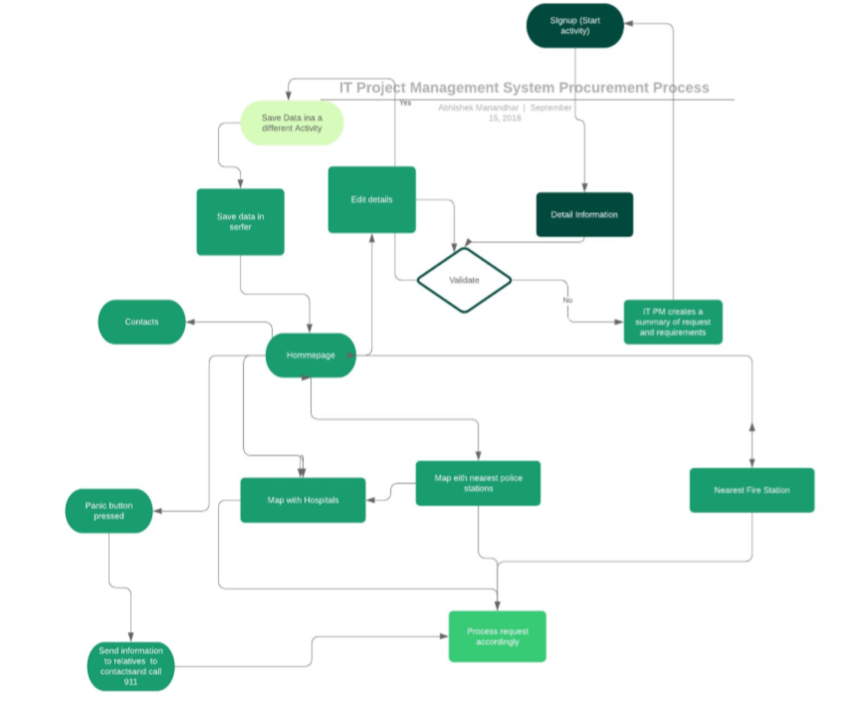

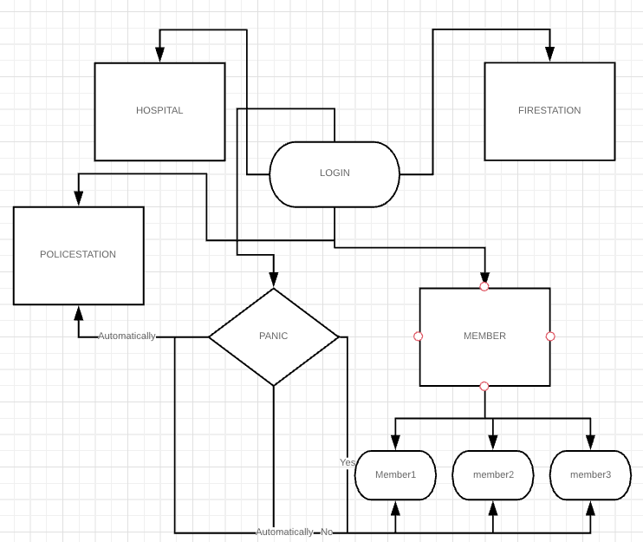

Currently working ER_Diagram