FT2 — FAST TIGERS TRAINING
UI / UX BRAND GUIDELINES — v2.0
Implementation reference for AI-assisted UI/UX development • September 2026

1. Brand North Star
FT2 should feel like a premium soccer performance tool: fast, clear, athletic, modern, confident, and easy to use on a phone. The visual language should be disciplined and purposeful, with strong hierarchy and minimal visual noise.
- Performance first — every element supports planning, discovery, decision-making, or action.
- Clean over decorative — whitespace, typography, hierarchy, and restrained color do the visual work.
- Bold but readable — strong sports character without sacrificing scanning speed.
- Purposeful color — phase colors identify practice structure; neon yellow identifies FT2/high-priority actions.
- Consistency beats novelty — reuse established components, spacing, states, and tokens.
- Mobile first — design and test at 375–430px before considering larger layouts.

2. Core + Neutral Color Tokens
Token | Hex | Purpose
FT2 Yellow | #F7FF00 | Primary CTA / logo field / high-priority action
Primary Dark | #0B0F1A | Dark-mode page background
Dark Surface | #111827 | Dark cards, sheets, inputs
Dark Gray | #1F2937 | Dark borders / muted surfaces
Primary Text | #0F172A | Light-mode headings / primary text
Secondary Text | #64748B | Supporting text / metadata
Muted Text | #94A3B8 | Low-emphasis / dark-mode secondary
Light Surface | #FFFFFF | Cards, sheets, inputs
Light Background | #F8FAFC | Light-mode page background
Light Border | #E5E7EB | Borders / dividers

3. Six Practice Phase Colors
Phase | Gradient | Hex values | Purpose
01 Warmup | #FF6B6B → #FF8A3C | #FF6B6B / #FF8A3C | Energy / activation
02 Athletic | #FF8A3C → #F97316 | #FF8A3C / #F97316 | Movement / athleticism
03 Duels | #7C3AED → #A855F7 | #7C3AED / #A855F7 | 1v1 / 2v2 / competition
04 Rondos | #06B6D4 → #0EA5E9 | #06B6D4 / #0EA5E9 | Possession / connection
05 Small Sided Games | #10B981 → #22C55E | #10B981 / #22C55E | Game realism / transition
06 Scrimmage | #F59E0B → #EAB308 | #F59E0B / #EAB308 | Play / bring it together

4. Typography — Selected System
Selected pairing: Barlow Condensed + Inter.
Role | Font | Weight | Size | Line height | Color
H1 / Page title | Barlow Condensed | Bold | 28–32px | 32–38px | #0F172A / #FFFFFF
H2 / Section title | Barlow Condensed | Bold/Semibold | 20–24px | 24–30px | #0F172A / #FFFFFF
H3 / Card title | Barlow Condensed | Semibold | 17–20px | 21–24px | #0F172A / #FFFFFF
Body | Inter | Regular | 14–16px | 20–24px | #0F172A / #F8FAFC
Body emphasis | Inter | Medium/Semibold | 14–16px | 20–24px | #0F172A / #FFFFFF
Metadata | Inter | Regular/Medium | 12–13px | 16–18px | #64748B / #94A3B8
Button | Inter | Semibold | 14–16px | 18–20px | #0B0F1A / #FFFFFF
Label | Inter | Medium/Bold | 11–13px | 14–16px | #64748B / #94A3B8
Barlow Condensed provides the athletic identity; Inter carries functional information. Never use condensed display type for paragraphs, long instructions, or dense metadata.

5. Logo Specification
Primary logo: square neon-yellow field with a bold, slightly italicized black FT2 lettermark. The master asset is exactly 1:1 and intended for app icons, headers, splash screens, and brand moments.
Property | Specification
Master assets | FT2_logo_1024x1024.png and FT2_logo_1024x1024.svg
Canvas | 1024 × 1024px, 1:1
Background | #F7FF00
Lettermark | #000000
Lettermark style | Bold / heavy / slightly italicized
Corner radius | ~110px on 1024px master; scale proportionally
Clear space | Minimum 20% of logo width on all sides
Minimum digital size | 32 × 32px
Do not | Distort, add shadows, add soccer balls/shields, or change aspect ratio

6. Buttons
Component | Background | Text | Radius | Height | Use
Primary CTA | #F7FF00 | #0B0F1A | 10–12px | 44–48px | One dominant action per screen
Secondary | #111827 | #FFFFFF | 10–12px | 44–48px | Important but non-primary action
Tertiary / Outline | #FFFFFF / transparent | #0F172A | 10–12px | 44–48px | Lower-emphasis action
Destructive | #EF4444 | #FFFFFF | 10–12px | 44–48px | Delete/remove only
Section Add | Neutral / section-tinted | #section start color | 8–10px | 32–36px | Compact '+ Add Exercise' inside phase row
Interactive hit areas should be at least 44×44px even when the visible control is smaller.

7. Inputs, Filters, Tags
Component | Specification
Search | 44–48px high; #FFFFFF/#111827 surface; #E5E7EB/#1F2937 border; 10–12px radius; Inter 14–16px
Focused input | Clearly visible focus state; do not rely on color alone
Quick Filter | 32–36px pill; one active filter; horizontal scroll on mobile
Advanced Filters | Bottom sheet/modal; Training Dimensions, technical/tactical/physical/cognitive tags, format, engagement, duration, difficulty, location
Tag / pill | Compact; neutral by default; section color only when meaningful
Dropdown | 44–48px high; label + selected value + chevron

8. Cards + Section Rows
Token | Light | Dark
Card background | #FFFFFF | #111827
Card border | #E5E7EB | #1F2937
Card radius | 12–16px | 12–16px
Shadow | 0 1px 2px rgba(0,0,0,.04) | 0 2px 8px rgba(0,0,0,.20)
Section row | ~64px minimum | ~64px minimum
Phase number tile | ~52×46px; section gradient | ~52×46px; section gradient
Section row hierarchy: [01] [Phase name + X exercises · X min] [+ Add Exercise] [>]. The count/time line is always visible once exercises exist. Surrounding cards remain neutral so the phase color remains meaningful.

9. Practice Progress Line
The practice progress indicator is a thin performance line, not a large progress card.
Property | Exact specification
Height | 2–3px
Track — light | #E5E7EB
Track — dark | #1F2937
Radius | 999px
Fill | Multi-stop FT2 phase gradient
Transition | 250–350ms ease
Adjacent text | Inter 12–13px: “X / X min planned” + “X min remaining”
Recommended CSS fill: linear-gradient(90deg, #FF6B6B 0%, #FF8A3C 20%, #7C3AED 40%, #06B6D4 60%, #10B981 80%, #F59E0B 100%). Use this gradient specifically for progress/momentum; do not use it indiscriminately elsewhere.

10. Icons
Use one consistent outline icon family. Default stroke 2px, rounded caps/joins, 20–24px for navigation/actions and 16–20px for inline metadata. Core icons: Home, Search/Exercises, Sessions/Calendar, Settings, Add, Edit/Pencil, Chevron, Filter, Bookmark, and Sparkles for Quick Pick.

11. Navigation
Property | Specification
Height | ~64px plus device safe area
Light background | #FFFFFF
Dark background | #0B0F1A or #111827
Inactive | Light: #64748B; Dark: #94A3B8
Active | Established FT2 active accent
Icon | 20–24px outline
Label | 11–12px Inter Medium

12. Quick Pick vs Balance My Practice
Feature | Purpose | Where it belongs
✨ Quick Pick | “What should I add to this section?” Exercise-level recommendation. | Inside Add Exercise / section selection
⚖ Balance My Practice | “What is missing from the whole practice?” Practice-level analysis and recommendation. | Builder/review level, strongest on Review Session
Quick Pick should automatically know the current section and normally return exactly three relevant options. Balance My Practice should analyze the whole session before recommending changes.

13. Practice Workflow
Recommended architecture: Build New Session → Practice Setup → Build Session → Review Session.
- Practice Setup: name, date, target duration, location, optional template.
- Build Session: assemble exercises into the six phases; do not repeat setup controls as a large form.
- Review Session: show practice summary, phase/time breakdown, Training Profile, Balance My Practice, final edits, and save.
- Do not force the coach through a six-step wizard; sections are structure, not mandatory steps.

14. Sample Session — Canonical Visual Reference
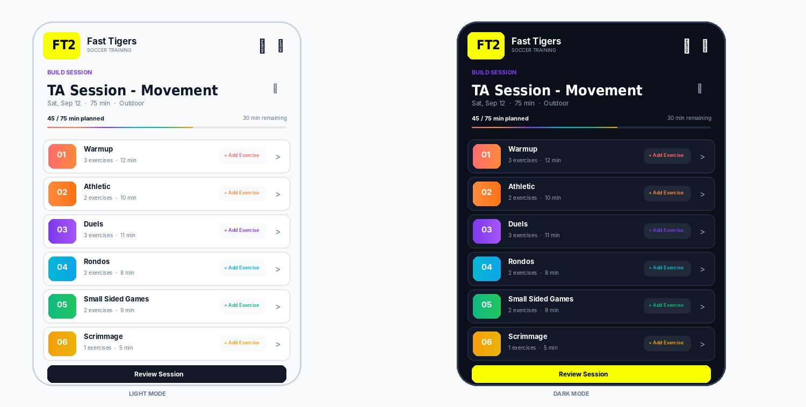
Canonical sample: “TA Session - Movement.” Keep the small pencil/edit icon immediately beside the title; show date, target duration, and location; use the 2–3px progress line; show “X exercises · X min” beneath every section heading; place “+ Add Exercise” immediately before the chevron on each section row; place “Review Session” beneath Scrimmage.
Sample session data is illustrative. The layout, hierarchy, color behavior, typography, and component relationships are the reference.

15. Spacing System
Use an 8px base grid. Preferred values: 4, 8, 12, 16, 24, 32, 40, 48px.
Use | Value
Micro gap | 4px
Tight gap | 8px
Standard gap | 12–16px
Section separation | 24px
Major separation | 32px
Page horizontal padding | 16px
Card padding | 12–16px

16. Radius + Shadow
Element | Radius | Shadow
Inputs / small controls | 10–12px | None or very subtle
Cards / section rows | 12–16px | 0 1px 2px rgba(0,0,0,.04)
Sheets / modals | 16–24px | 0 8px 24px rgba(0,0,0,.12)
Pills | 999px | None
Primary buttons | 10–12px | Minimal

17. State + Feedback Rules
State | Guideline
Default | Neutral surface, clear label
Hover | Subtle only; mobile cannot depend on hover
Pressed | Small visual change; 100–200ms
Selected | Clear border/background/icon state; never color alone
Disabled | Reduced emphasis without becoming unreadable
Loading | Preserve layout; use restrained skeleton/spinner
Success / Warning / Error | Use color plus text/icon
Empty | Explain what is missing and give the next action

18. Accessibility + Readability
- Maintain strong text/background contrast; avoid light gray body copy on white.
- Never communicate meaning with color alone; pair with text, icon, number, or state.
- Use ~44×44px minimum touch targets.
- Do not shrink type to fit more content; remove or collapse low-value information first.
- Support system text scaling where practical.
- Provide visible focus states for keyboard/desktop use.
- Test light and dark modes on real devices.
- Keep mobile descriptions concise and scannable.

19. Motion + Interaction
- Use purposeful 150–350ms transitions.
- Animate state changes: adding, expanding, filtering, saving, navigating.
- Avoid decorative motion that competes with coaching content.
- After adding an exercise, immediately update exercise count, section time, and total planned time.
- Preserve scroll position when practical.

20. AI Development Rules — Non-Negotiable
- Reuse existing FT2 components before creating new ones.
- Use exact tokens in this document; do not invent colors, radii, typography, shadows, or spacing values without a clear reason.
- Use Barlow Condensed + Inter consistently.
- Preserve the six-section practice structure.
- Do not create duplicate practice, exercise, template, or autosave data models.
- Keep business logic and visual styling separated where architecture permits.
- Design mobile-first at 375–430px and verify both ends of that range.
- Keep one dominant CTA per screen.
- Do not overload cards with every available tag or metadata field.
- Test empty, populated, loading, error, selected, light, and dark states where applicable.
- Do not silently change unrelated behavior while making visual changes.
- After implementation, report files changed, components changed, data-flow changes, and assumptions.

21. New-Screen AI Prompt Checklist
When asking an AI to build a new FT2 screen, provide: screen purpose; primary user action; required content; existing components to reuse; exact tokens; light/dark requirements; target mobile width; interaction states; and explicit instruction not to break unrelated functionality.
Preferred instruction: “Use the FT2 design system exactly. Reuse existing components and data models. Implement the requested screen without changing unrelated behavior. Follow the color, typography, spacing, radius, icon, accessibility, and interaction tokens in this guide.”

22. Visual QA Checklist
- Works at 375px, 390px, and 430px.
- Primary action is obvious immediately.
- Typography hierarchy is clear.
- Saturated colors are purposeful and limited.
- Six phase colors are used consistently.
- Text is readable in both modes.
- Touch targets are large enough.
- Empty/loading/error states preserve layout.
- Existing FT2 components are reused.
- The screen still feels like FT2 without the logo.

23. FT2 Visual Essence
FAST • CLEAR • ATHLETIC • MODERN • CONFIDENT
PLAN • TRAIN • IMPROVE • REPEAT

