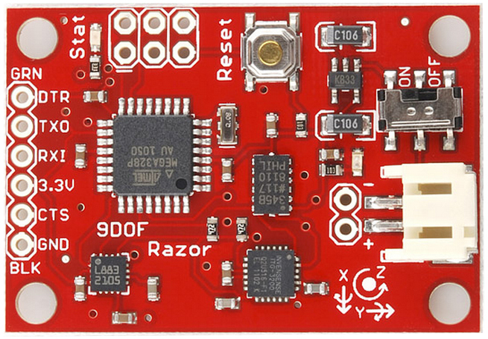

The IMU was never actually used for controls, as we had planned. Time was very limited and this was a low priority on our list. In terms of functionality, it is entirely unnecessary; however, it could add some very interesting capabilities to the drone with the included gyroscope, magnetometer, and accelerometer.

Although it wasn’t used, we have a program (imu.py) that collects data from each of the 9DOF sensor readings and displays them to the console in real time, based upon this video: <https://www.youtube.com/watch?v=BRhQeZoEr0U>

The Rx and Tx pins were connected to the Beaglebone according to the pinout diagram found in the Sensors.pdf document.