NOTICE: This guide assumes the use of a TP-LINK Wifi Adapter, model no. TL-WN7200ND. If you do not have the exact model, this exact same process outlined below should work as long as your adapter has a Ralink chipset (prefix = RT) and has access point capability.

Before Wireless Capability

To connect your Beaglebone to the internet (so that you can download packages), follow the steps below:

1. Plug the Beaglebone into an internet capable router via Ethernet cable
2. Plug the 5V power adapter into the Beaglebone
3. Check the list of devices connected to your network. If you’re using a NETGEAR router, this can be done by visiting routerlogin.net. On this list, you’ll see a device labeled as “ALARM.” This is the Beaglebone! It should have an IP address next to it that will be something like 198.162...
4. In putty (or something like it) use the IP address (or “alarm” should work to, in the same field) to establish a connection.
5. login as: root
6. password for root: root
7. Good to go!

User Guide by TP-Link:

<http://www.tp-link.com/resources/document/TL-WN7200ND_V1_User_Guide_1910010859.pdf>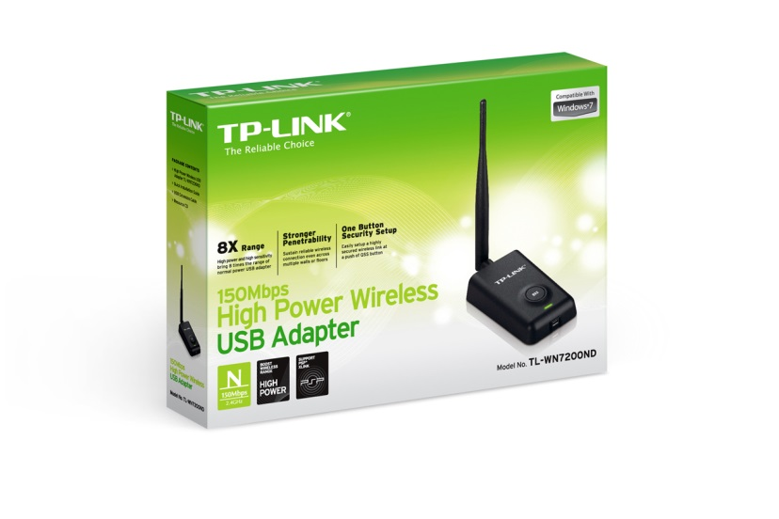

Driver Details

When you first connect the wifi adapter via the micro-USB cable, the LED will most likely begin to blink slowly. If this occurs, it means that the driver has been installed correctly and the device is recognized. If this happens, you’re good to go! The driver required for this adapter is native to the Arch distribution (distro) our team is using, so this *should* be plug and play. If you’re using our setup, it will be.

To check driver status, typing

# dmesg | grep usbcore

Should return something like “usbcore: registered new interface driver rtl8187” if it worked correctly.

OPTIONAL: Using the Adapter as a Router for an Internet Connection when in SSH

This mode may be helpful at first when you don’t have to worry about portability. If you don’t like working while being connected to a router, skip this section. The usefulness of this method as opposed to just using the AP (Access Point) comes from the fact that you don’t have to enable internet sharing amongst your ports.

With this setup, you plug the Beaglebone’s Ethernet port into a router, and the adapter into the USB port of the Beaglebone. This will enable you to connect to your Beaglebone wirelessly through the preexisting wifi network you have setup for that router (using the same SSID and password).

This configuration was set up using steps entirely from the ArchWiki at this link:

<https://wiki.archlinux.org/index.php/Wireless_network_configuration#Manual_setup>

Get required packages:

# pacman –S iw wireless_tools wpa_supplicant

Before continuing to the next step, check the name of the wifi interface. By default, it will most likely be wlan0, which is used in the commands below. To check this interface, type the command below and read the output. Interface names *usually* start with a ‘w’.

# ip link

Set the adapter to ad-hoc mode so the adapter can share a peer-to-peer connection with your router. Then, type the following commands to set the interface up and match it to your personal network: **Notice the subtle difference between the ‘1(one)’ and the ‘l(L)’, the top portion of the one is bent downward.

# iw dev wlan0 set type ibss

# ip link set wlan0 up

# wpa_supplicant –D nl80211,wext –I wlan0 –c <(wpa_passphrase “*Your_SSID*” “*Your_key*”) –B

“–B” allows the process to run in the background so you can do other things while connected to the internet.

# dhcpcd wlan0

The LED on the adapter should now be blinking quickly to indicate data transmission/reception.

# iw dev wlan0 link

The output of this will show you whether the link is actually up or not.

How to Setup a Customizable Access Point

Get required packages:

# pacman –S hostapd dnsmasq iptables brctl dhclient

A detailed guide for setup and configuration, as well as customization options, from installation, can all be found here:

<https://github.com/oblique/create_ap>

Our method utilized the WPA + WPA2 passphrase:

# create_ap wlan0 eth0 *MyAccessPoint* *MyPassPhrase*

“eth0” is there to set where the wlan0 interface will get internet connectivity, if one is available. Typing the line above will run the script. The script will not run again when you restart unless you type that line again. In order to set it to start at boot, type the following:

# systemctl enable create_ap

To configure what AP is being created by the script running on boot, using a program such as WinSCP, edit the file “create_ap.service” found in the bin under ~/root and change the “ExecStart” line. The command already there should look similar to the examples on the github page.

Your AP will only allow you to connect to the Beaglebone wirelessly and independent of any internet connection or router. To connect your AP to the internet, the Beaglebone will need to be connected via the Ethernet port to an internet-connected device with internet sharing enabled (laptop). You do not need an internet connection to SSH to the Beaglebone.

To enable Ethernet port internet sharing on a Windows computer, simply right-click the wifi icon in the bottom right corner and open the “Network and Sharing Center.” On the left side of that window, select to “Change adapter settings.” You should be in the Network Connections window now, under Control Panel\Network and Internet\Network Connections. Next, right-click on the adapter built into your laptop with the wifi connection on it and open “Properties.” Navigate to the “Sharing” tab and check the box next to enable Ethernet connection sharing. Your AP should now have internet access while your Ethernet cable is connected and you will be free to download packages.