DATA VISUALIZATION

FINAL PROJECT

TEAM G

Vratul Kapur

Paul Jacques-Mignault

Sheena Miles

Ashley O’Mahony

Stavros Tsentemeidis

Karl Westphal

Irune Maury Arrue

# Define the Objective

The dataset includes all current Airbnb listings in Amsterdam as of December 6th 2018, sourced from ‘insideairbnb.com’. The overarching objective of the visualization is to convey the best Airbnb listings for leisure travelers. The typical leisure traveler prefers staying within walking distance of major landmarks, i.e. between 500 meters and 2 kilometers of the said attractions, though not in their immediate vicinities as those tend to be crowded, noisy, and overpriced. It also shows home listings in the immediate vicinity (500 meters) of the top 10 tourist attractions, labeled as ‘Homes to avoid’.

Top 10 Attractions in Amsterdam[1]:

* The Rijksmuseum
* The Anne Frank Museum
* The Van Gogh Museum
* Vondelpark
* Dam Square
* The Royal Palace
* Rembrandt House Museum
* The Botanical Gardens & the Zoo
* The Old Church (Oude Kerk)
* The Jewish Historical Museum



# Explore the Data

The following visualizations were created with the Tufte theme in ggplot2.

See the following link for R codes: <https://github.com/paul-jm/DataViz_FinalProject>

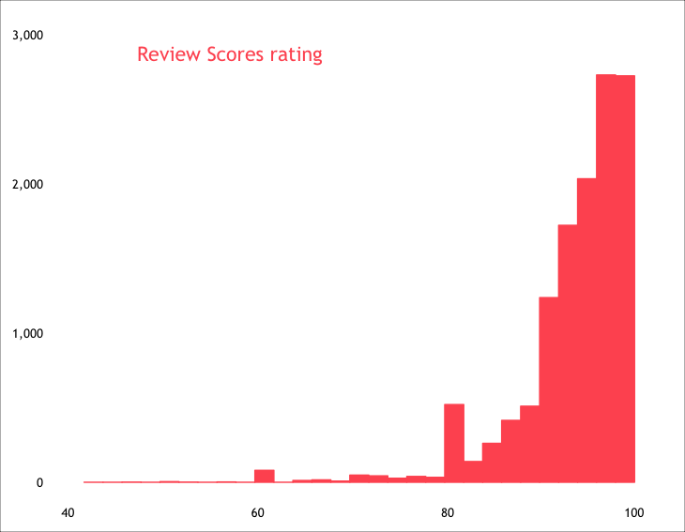

*Figure 1: Distribution of Listings by Scores Rating, out of 100*

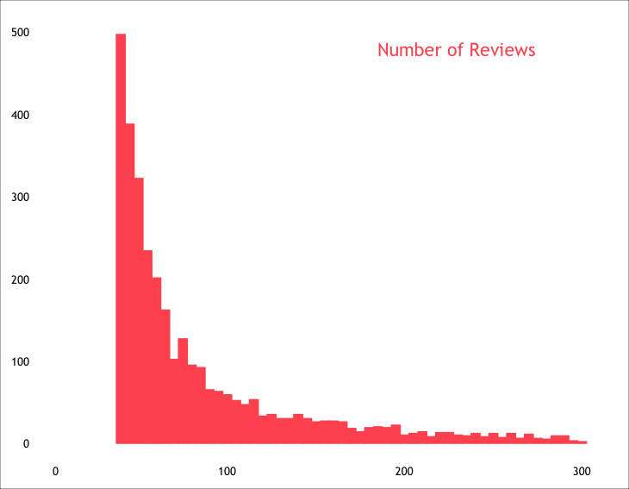

*Figure 2: Distribution of Listings by Number of Reviews*

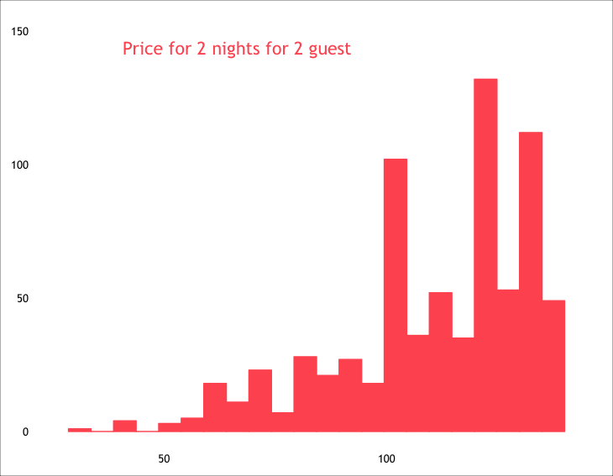

*Figure 3: Distribution of Listings by Price for 2 Nights for 2 Guests*

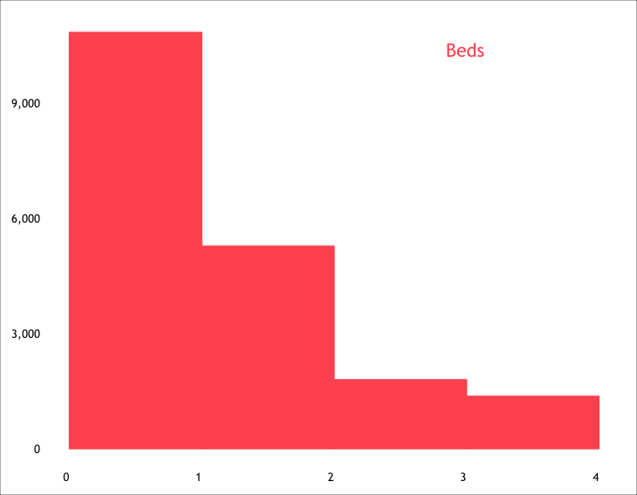

*Figure 4: Distribution of Listings by Price for 2 Nights for 2 Guests*

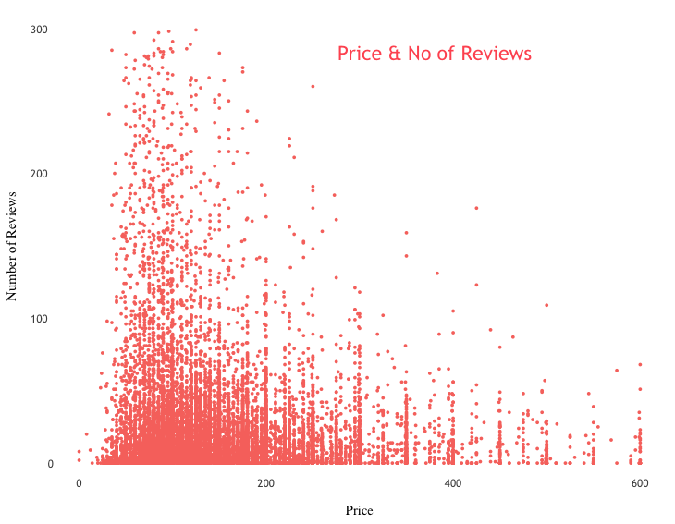

*Figure 5: Number of Reviews for Price of One-Night Stay*

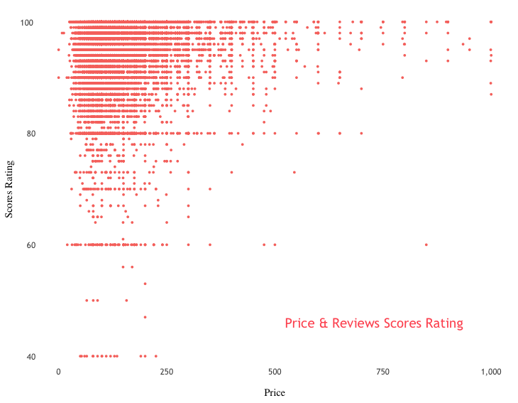

*Figure 6: Distribution of Scores Ratings per Price of One-Night Stay*

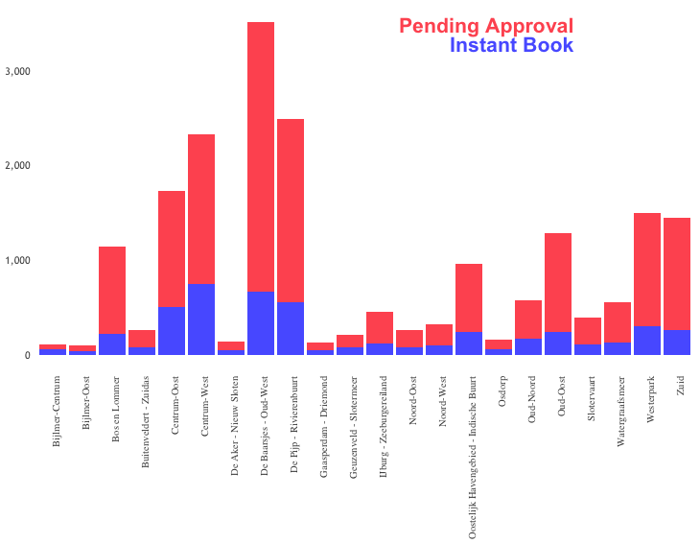

*Figure 7: Number of Listings – Breakdown of Type of Reservations per Neighbourhood*

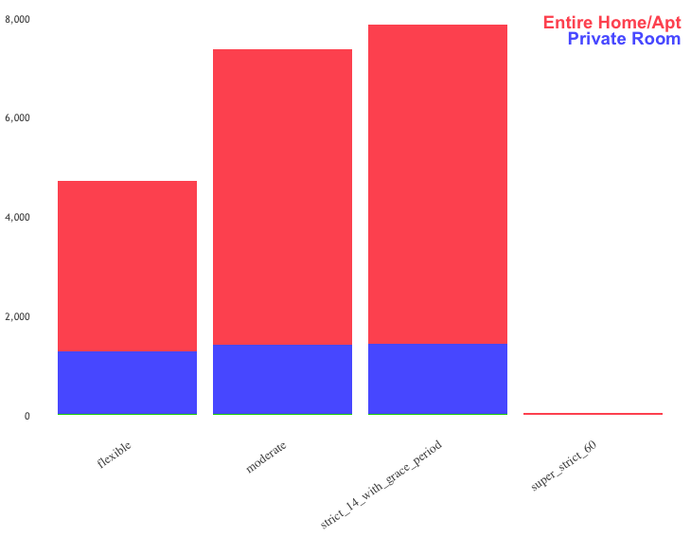

*Figure 8: Number of Listings – Breakdown of Type of Home by Cancellation Policy*

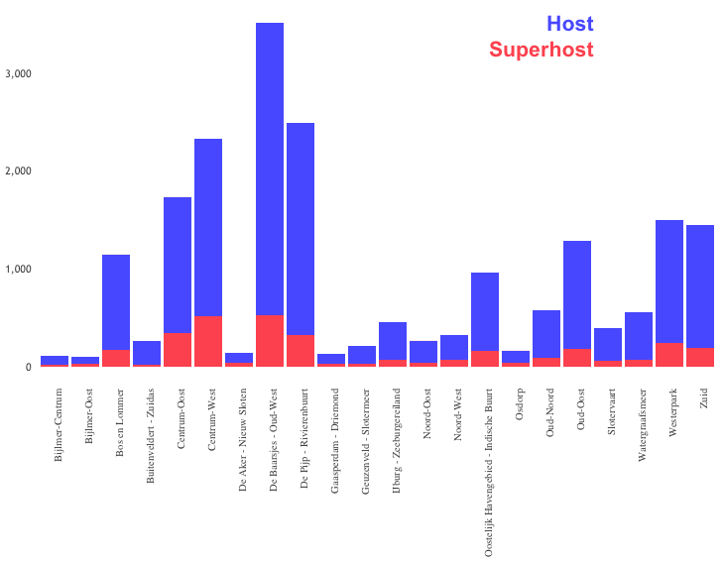

*Figure 9: Number of Listings – Breakdown of Type of Host per Neighbourhood*

# Design the Idea

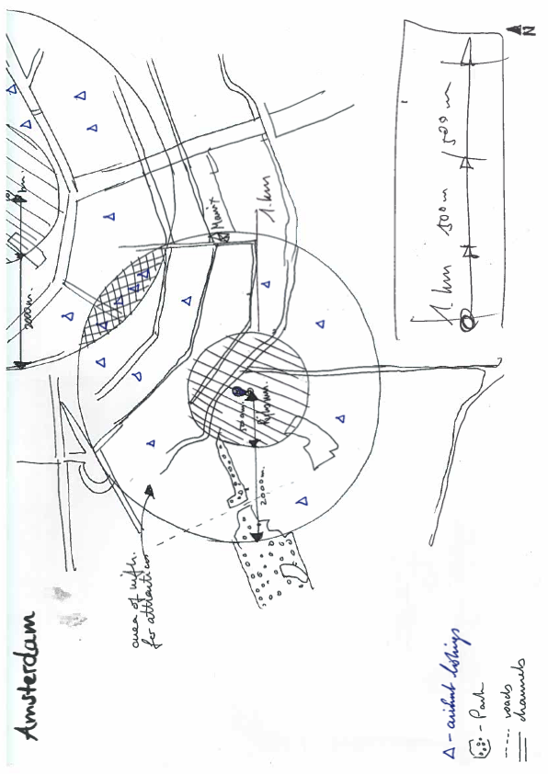

*Figure 10: Drawing of Potential Visualization – Preliminary Schema*

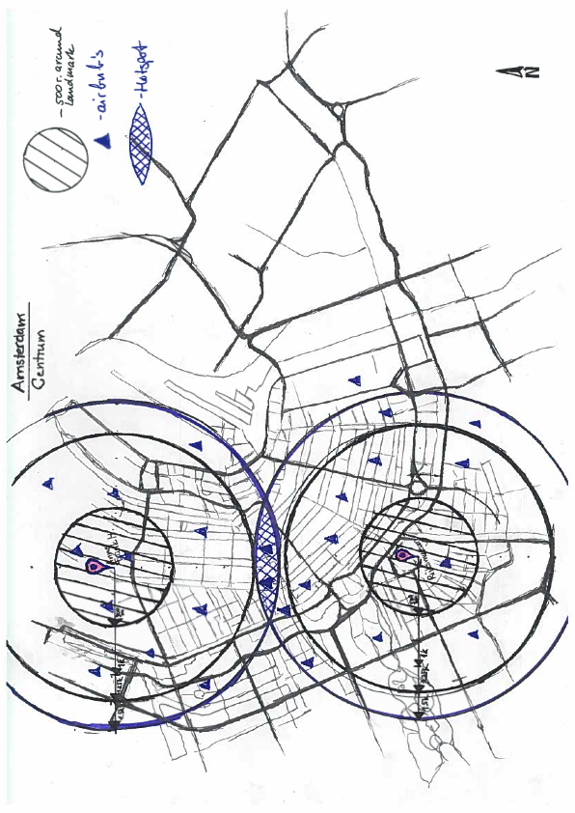

*Figure 11: Drawing of Potential Visualization – Finalized Schema*

# Implement the Idea

<https://ashomah.carto.com/builder/a56a6bea-803d-4d13-9bd0-0edbe6ec5601/embed>

# Review your Result

Firstly, in order to facilitate the visualization of all listings on the map, the dots do not overlap on the map. While this functionality makes the map less daunting, smaller dots are erased when zooming out. When trying to obtain a global picture of availabilities in Amsterdam, the user may underestimate the number of listings. Furthermore, not having dots overlap one another exacerbates their size discrepancies. Even when zooming in, small dots are barely perceivable by the human eye. If map allowed overlapping in dots, the user would also be losing out on information. The most easily accessed information would only be determined by the order of tuples in the dataset. Though, avoiding dot overlap presents drawbacks, it allows the user to perceive information when zooming in rather than hiding it completely.

Secondly, when removing all filters, all listings show up on the map with the dot’s visual encodings of position, colour, and size. It is not possible to filter out the dots which belonged to the ‘Areas to avoid’. Ideally, it would be best for the user to maintain some encoding to tell apart ‘Areas to avoid’.

Thirdly, the minimum distance setting for a radius around a dot in 500 meters. To enhance user interaction, the map could include a functionality to increase the desired radius, or even decreasing it below 500 meters.

1. Source : 17 Top-Rated Tourist Attractions in Amsterdam | PlanetWare. (n.d.). Retrieved from <https://www.planetware.com/tourist-attractions-/amsterdam-nl-nh-amst.htm>