Toolbox for optimizing bioretention cell surface and drainage areas

This document explains the code used in paper “*Optimizing surface and contributing areas of bioretention cells for stormwater runoff quality and quantity management”* (<https://doi.org/10.1016/j.jenvman.2017.11.064>).

The code works on Windows platform. EPA SWMM is used for modeling the hydrological processes of bioretention cells (<https://www.epa.gov/water-research/storm-water-management-model-swmm>).

1. “generate_rainfall.R” contains the code to generate random rainfall time series. The rainfalls are considered as superposition of some "base rainfalls" with varying peak intensity, duration, and occurring time. The rainfall generation process is controlled by a few parameters. The randomly-generated rainfalls are stored at “./data” folder. The following figure shows an example of randomly generated storm.

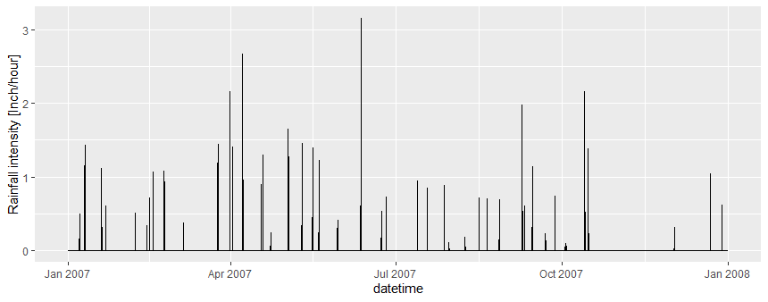

1. SWMM is used as computational engine, and the simulations are taken place inside “cluster” folders. Thus, the “swmm5.dll” and “swmm5.exe” files should be copied to each cluster folder (shown as the figure below).

