**Module 3: Git and Jenkins**

**Problem Statement**

Hooli Co. has put Harry and Kane to implement a new set of features in their feature software. Both started working separately, making their own copies of the same source code. Now, it has become difficult for them to track the changes they’ve made in the original code, and they are finding it difficult to merge their code together.

**Action Items**

* Create two separate branches from master
* Make changes in the same function of the source code in both the branches
* Merge branch1 into the master
* Try and merge branch2 into the master (merge conflict should arise)
* Install a merge tool of your choice and resolve the merge conflict using git merge tool command

**SOLUTION: -**

Creating two branches in Master.

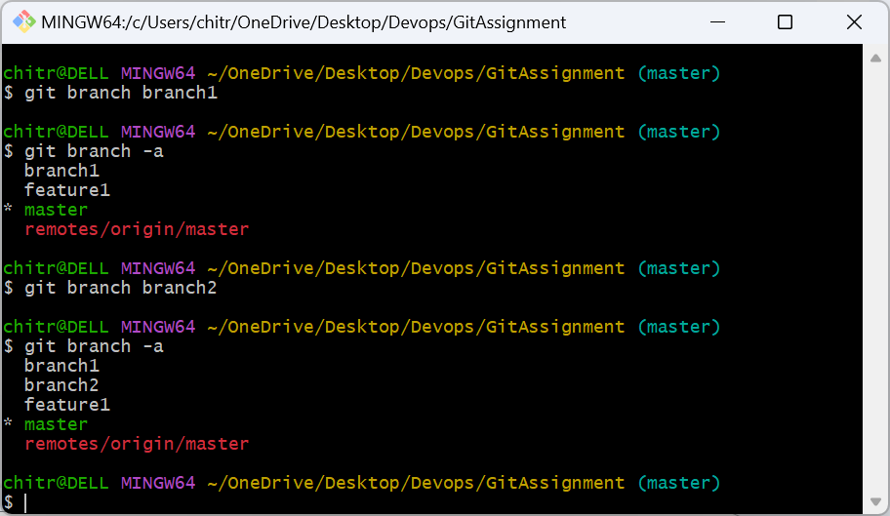

Added Branch1Test.txt in branch1 and committed.

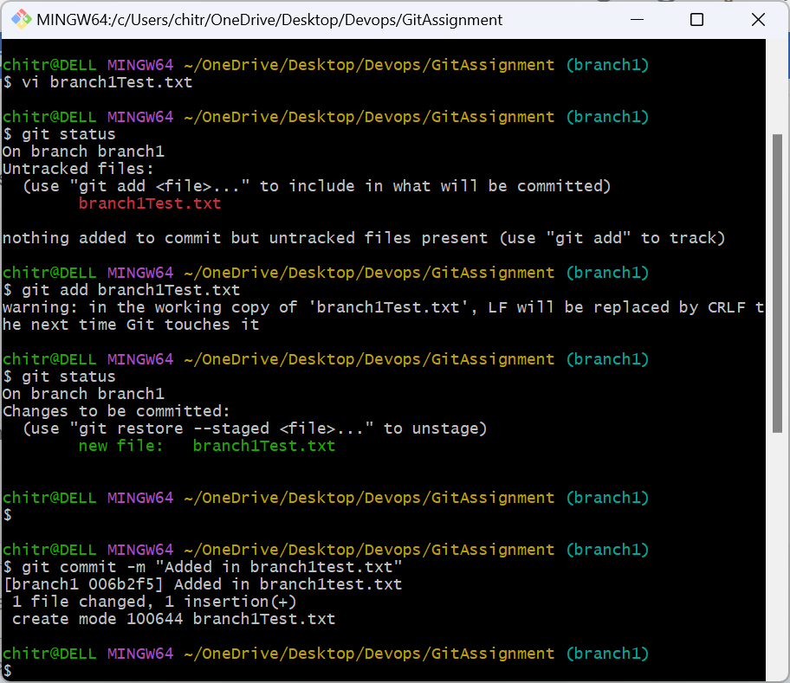

Added branch1Test.txt file in branch 2 and committed.

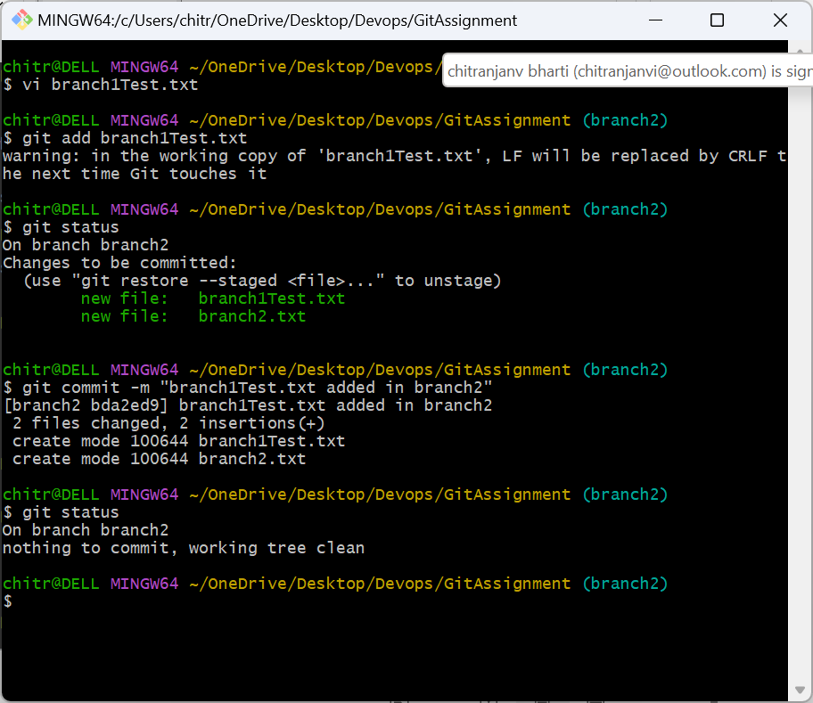

Merging branch1 and branch 2. It creates conflict.

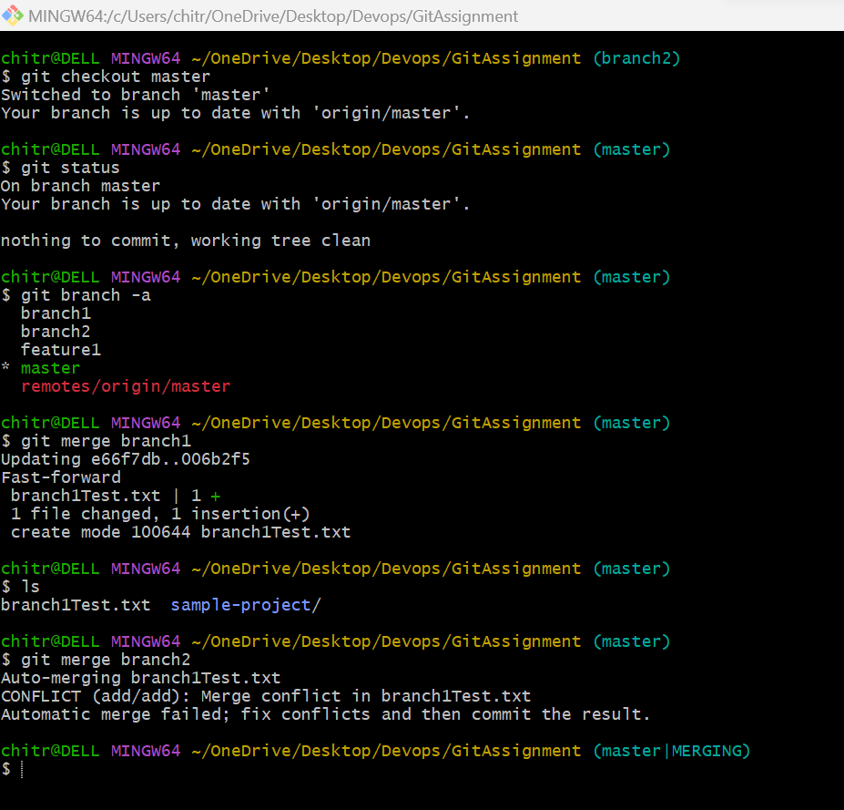

Resolving conflict using mergetool.

