1. Input: [“baseball”, “b,bas,ba,all,base,seb,ball”]

Output: base,ball

Split the first input based on the longest possibility match in second input

1. Write two best scenarios where inheritance can be used. Note: don’t simply say that we can call parent class methods and attributes.
2. Consider that you got a django application (customer) in github, that can be used in your project.

It has Customer model fields(name, address). the existing Customer model will not verify for special symbols of customer name field. Use Customer model and provide name validation for special symbols and add phone and email fields.

1. What is the best way handle the errors in djangorestapi. Marks will be considered based on the scenarios covered.
2. Draw memory organization diagram for the below code and write answer for print statement

a=1000

b=a

K=[a,b]

S=”abc”

L=[a,b,s,”de”,k]

L[-1][0]=3000

Print(l)

1. Define class can be create only one object. If the user create second object then it should return the first object
2. Write an output for below code.

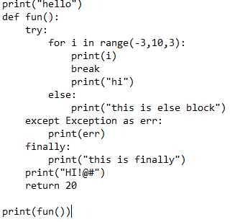

1. Explain how django rest framework authentication and authorization can be override.
2. What are all the ways we have to develop an API with django restframework. Talk about different classes we can use to develop an API.
3. 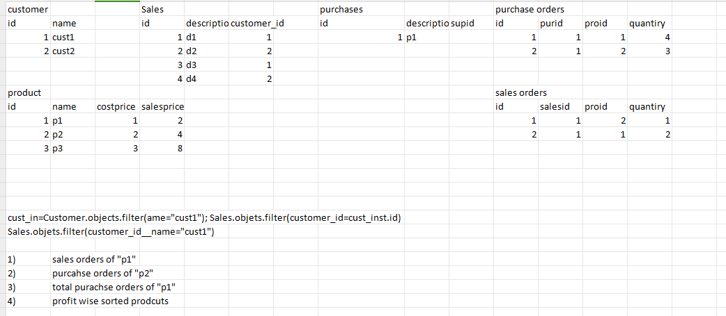tenth question ten marks. Above all 9 has 18 marks