REX SENSORS 0.1.0
User guide

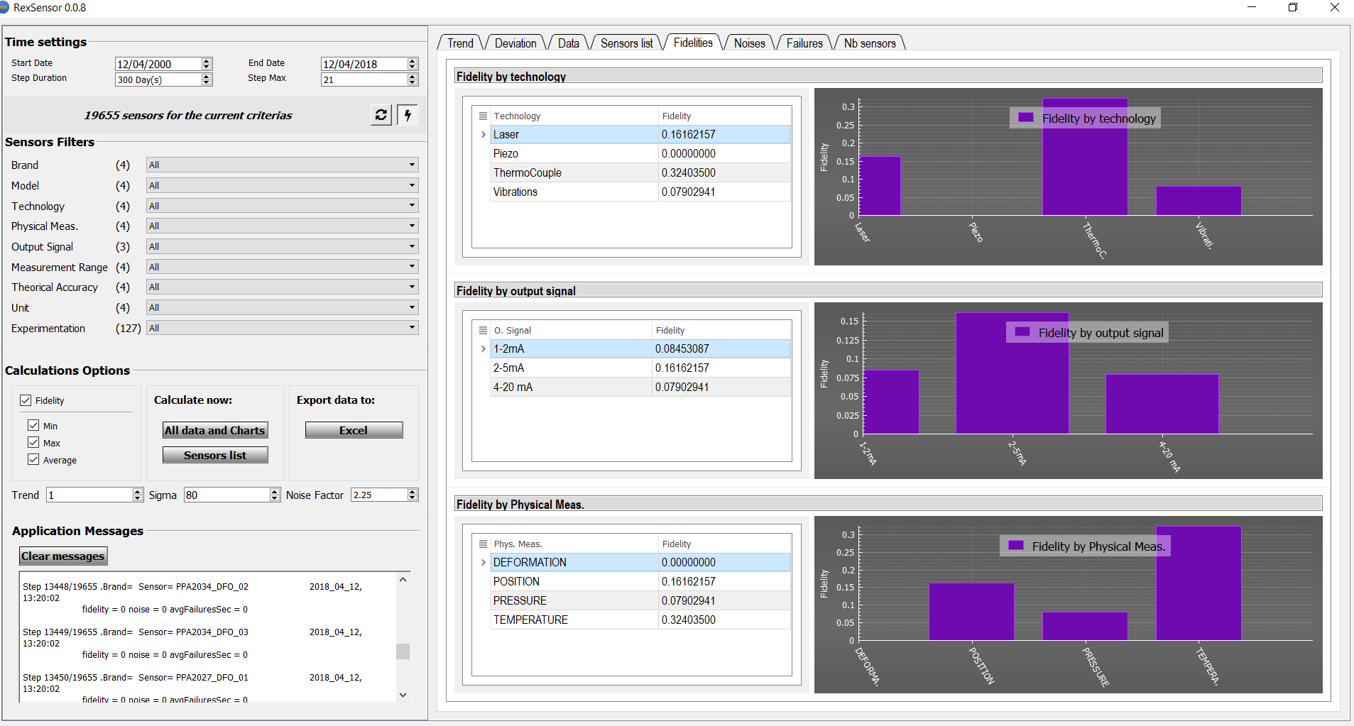

1. Summary 3
2. Files and dependences 4
3. Run the REX 4
4. Configure the databases. Paths, username, password, and options 5
a. Database configuration interface 5
b. Set the database paths in the settings file 5
c. Configure a remote database 5
d. Set the options : dead entities and Node with no sensor type 5
5. Configure the time period 6
6. Configure the criteria 6
7. View and operate on the selected sensors 7
8. Compute the step fidelity and noise for the selected sensor 7
9. View the sensors by brand, experimentation 8
10. Compute the step fidelity and noise for all sensors 8
11. Export to Excel 8
12. Available histograms and tables 9
13. How to zoom an area of histogram 9

Summary
The goal of this software is to perform a statistics analysis on sensors. The sensor is the lowest stage of the data acquisition; it measures the physical data. There are many kinds of sensors.
- Each sensor has a list of properties. These properties are available in ACQSENSORTYPE, G6 database
- Each sensor is represented by a code: measure point code (MP_CODE).
- A measure point is an entity, connected to an acquisition point (ACQPOINT) or a Node point.
- When a measure point is an ACQPOINT, it has an AP_CODE, “acquisition point code”. it attached to a sensor. This means, it is possible to find some measured values in the table of values (ACQVALUES).
- When a measure point is a NODE, it has a ND_CODE, “node code”. It is not necessary attached to a sensor. It values are calculated values, and stored in the NODERESULT. Per example, 3 sensors on a platform can be assigned to a node who will return the average temperature of this platform.
- A sensor can operate throughout a device. A device can contain many sensors. Per example, the same device can return the temperature and the pressure.
- A measure point can be associated to one ore many acquisition points, or nodes
- A sensor can be associated to one or many experiences
- The values sent by the sensor is stored in ACQVALUE for an acqPoint, NODERESULT for a Node

Files and dependences
Many drivers are uses by REX to perform the calculations and the graphics representation. We describe them on the following table. The application will not load if these drivers are absent.

Drivers descriptions
Driver | Role | Directory
qtndbgrid5.dll | QTitan datagrid. Useful to draw grids with many features on the panels | ./bin
qsqlfirebird.dll | Firebird library.  Useful for Database access | ./bin
Qt5Core.dll  Qt5Gui.dll  Qt5PrintSupport.dll  Qt5Sql.dll  Qt5Widgets.dll | Qt libraries  REX is built from these libraries | ./bin
msvcp120.dll  msvcr120.dll | Windows libraries | ./bin
qwindows.dll | Windows libraries | ./bin/platforms

Files descriptions
File | Role | Directory
Run.bat | Run the rexsensor.exe | Root
RexSensor.exe | Rex software | ./bin
RexSensor.ini | Contains the settings  automatically created with defaults settings by REX if not found | ./bin
RexSensor.dat | SQLite database  Is created by REX  No user action needed | ./bin
Log | Log files | ./RexLogs

Databases descriptions
File | Role | Directory
G6xxx.fdb | Contains the sensors data | In local or networwk
G7xxx.fdb | Contains the sensors descriptions, journals, experiences | In local or networwk

Run the REX
Go on Rex directory. Per example RexExec
Double click on Run.bat

Batch file | REX interface
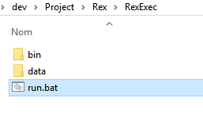 | 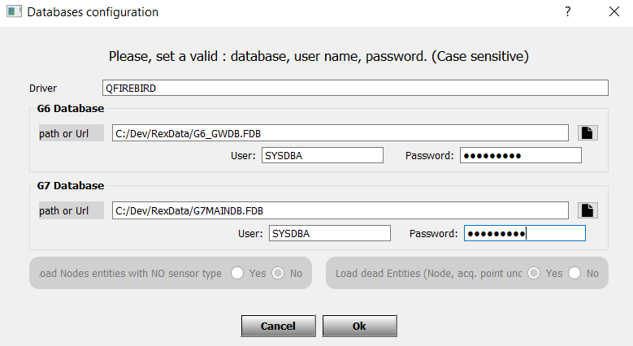

Configure the databases. Paths, username, password, and options

Database configuration interface
Once launched, REX reads the databases files path in RexSensor.ini.
If the database in RexSensor.ini are found, REX skips the database configuration and initializes the data
If no database path or if the paths are wrong, an interface is displayed to set the paths

RexSensor.ini | Graphic configuration
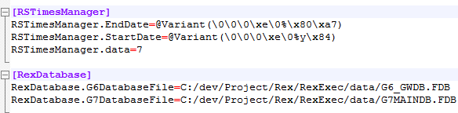 | 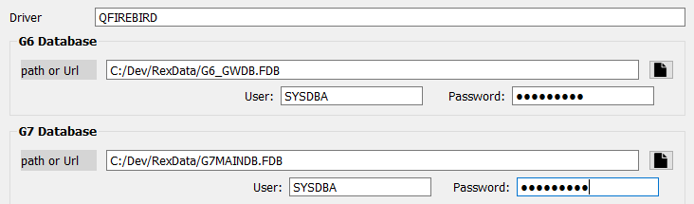

- Add the G6 database path
- Add the G7 database path
The graphic interface is displayed while the settings are incorrect. If you press on Cancel, the REX will be available.
If this account is not configured, no connection will be possible

Set the database paths in the settings file
Edit the settings file /bin/RexSensors.ini
Go on the section [RexDatabase] and write the paths

Configure a remote database
To configure the remote database, you must ensure that there is a Firebird server on the remote computer.
Get the full path of the remote database. Example C:\data\ G7database.fbd
In the database interface configuration, join the server name and the full path with the “:”
Example : “serverName: C:\data\G7database.fbd”, “10.140.20.67: C:\data\G7database.fbd”

Set the options: dead entities and Node with no sensor type
The options allow you to exclude some type on entities
- Dead entities: entities who are not relied to a NODE or an ACQPOINT
- Nodes without sensor type : in some cases, some data coming from sensors can be stored as NODE, even they need to be seen in the REX. Rex offers the possibility to treat them. Nevertheless, you can choose to avoid NODE who are not representing a sensor. Just choose Exclude Nodes With no sensor type = TRUE

Select NO to exclude Nodes not relied to a sensor (AST_CODE is Null) | Select No to exclude entities not relied to a Node and AcqPoint (AP_CODE and ND_CODE are null)
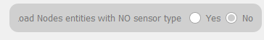 | 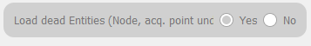

Configure the time period
- Go on “Time” panel and set a period. Start date and end date
- Select the step duration with the spin box
- The maximum step duration is 360 days
- The maximum step is automatically updated (“Step Max”) when the step duration is modified

Time settings panel
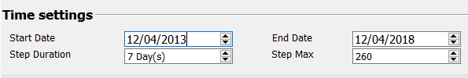

Configure the criteria
To select the sensors, you must configure a period and the filters.
- Go on “Filters” panel and select the criteria
  - Brand, model, Measurement range, output signal, unit, experience, technology, theorical accuracy
  - These criteria are available in the table ACQSENSORTYPE in the G7 database

Filters panel | icon
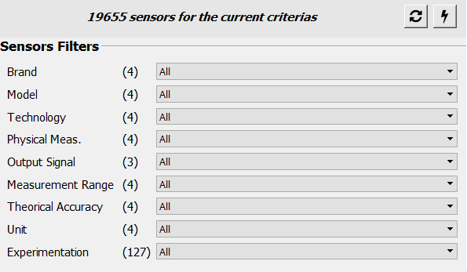 | - The number of items is display for each filter  - Press on the first left top button to reset the filters to ALL  - Press on the top right button to use dynamic filters. This means, when you select a value in a filter, the other filters are automatically updated to the remaining possibilities.  - But you will need to reset the filter to exit from the dynamic filters.

Use “All” to include all values of the sensor property. (all brand, all models etc.)

The sensor type table in G7 database
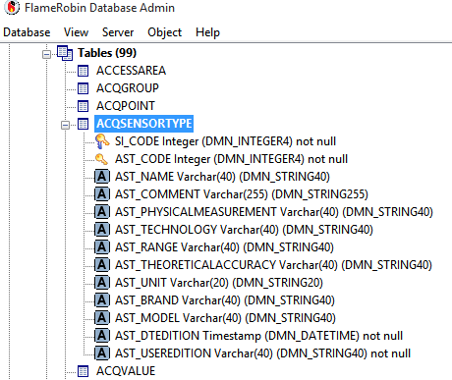

View and operate on the selected sensors
All sensors in according with the criteria can be accessed on the “Trend” panel. Select the sensor in the combo box
acqPoint is selected : NO calculator icon on the right | NODE is selected : calculator icon on the right
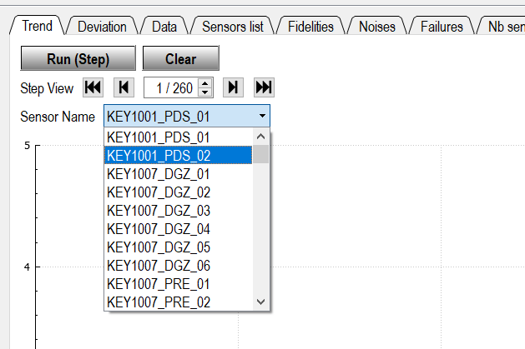 | 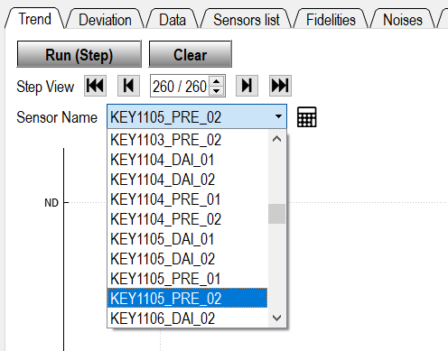

Compute the step fidelity and noise for the selected sensor
Press on the button “Run”
If no data, the message “No data between” the period will be displayed
If data are available, the curve will be displayed.
You can navigate on steps by the “Next” button
To view the average fidelity, press on “
Rex curves | Options panel
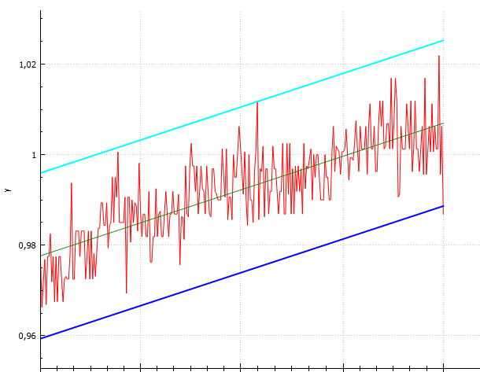 | 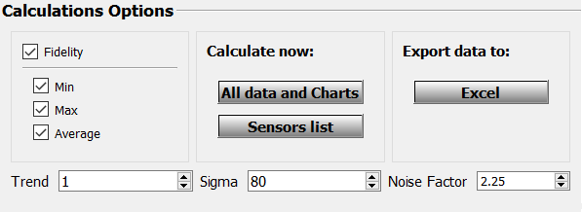
You can modify the trend, sigma, noise factor on the “Options” area
The fidelity is viewable on the “messages panel”

View the sensors by brand, experimentation
Go on the “Calculations” area
Press on “sensors list
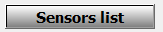
The sensors list page is displayed. You can select the list to show with the combo box
Sensors list
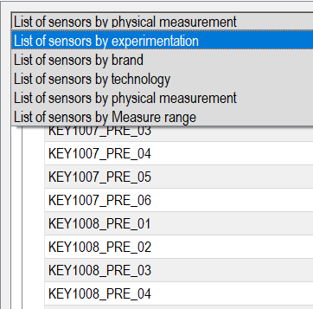

Compute the step fidelity and noise for all sensors
- Go on the panel “Calculations”
- Press on “Data and Charts”
- The panel “Data is displayed
- A progress bar showed the level of the operations
- When calculations are finished
  - the data grid “Data” is filled
  - the histograms are available
Progress bar | Data panel with calculations
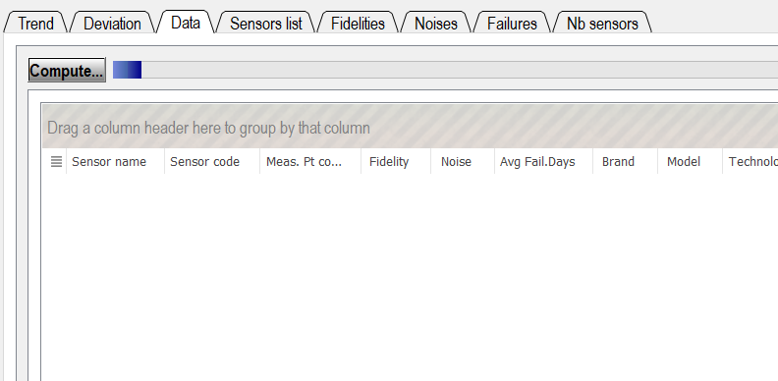 | 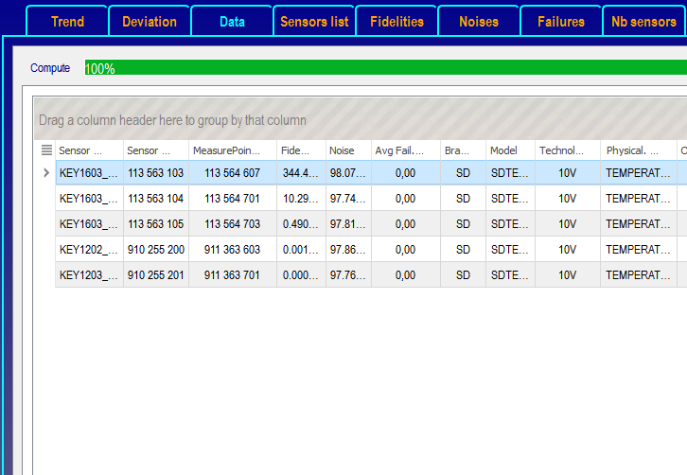

Export to Excel
go on the “Exports” area and press the button “Excel”. You will be asked to set the path

Available histograms and tables
All histograms and the associated are built from the statistic table “Data”
Statistics and histograms
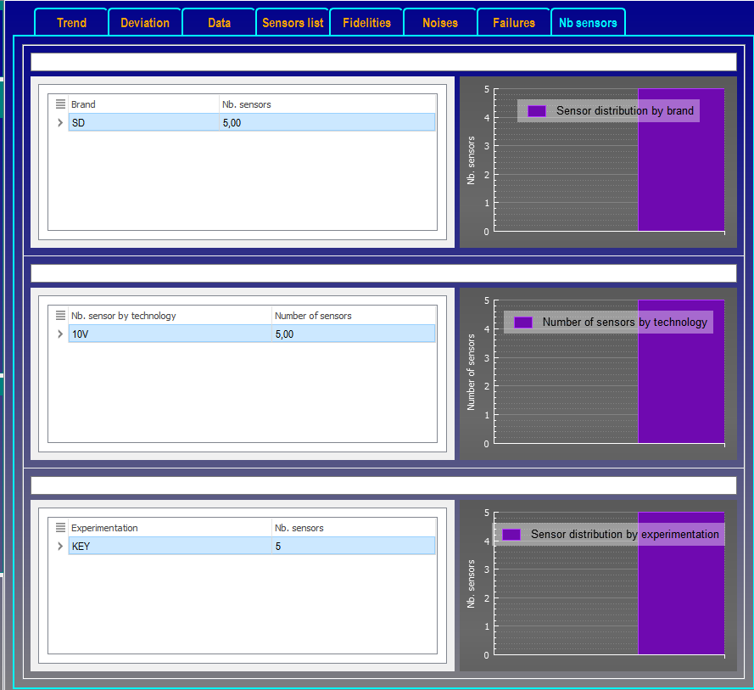
are many fields in the databases, the role of the xml files is to tell which fields are available, and what is the role. Below, we explain how these tables are generated

Table and histogram | How it is generated
Fidelities  - Fidelity by technology  - Fidelity by output signal  - Fidelity by physical measurement | - “Group by” sensor property on “Data” table  - Fidelity by sensor property = average Fidelity of sensors with this property  sensor property is “Technology”, “output signal”, “physical measurement”
Noises  - Noise by technology  - Noise by output signal  - Noise by physical measurement | - “Group by” sensor property on “Data” table  - Noise by sensor property = average Noise of sensors with this property  - sensor property is “Technology”, “output signal”, “physical measurement”
Failures  - Failures by technology  - Failures by output signal  - Failures by physical measurement | - “Group by” sensor property on “Data” table  - Failure by sensor property = average failure of sensors with this property  - sensor property is “Technology”, “output signal”, “physical measurement”  - the MTBF is computed as:  MTBF = NB sensors in failures with this property /  number sensors with this property
NB sensors | The same aggregation is done by number of sensors by brand, experimentation, sensor property

How to zoom an area of histogram
Click the mouse arrow on the area you want to zoom
Scroll the mouse, forward to increase the zoom, backward to decrease the zoom

