REX SENSORS 0.0.2
Developper guide

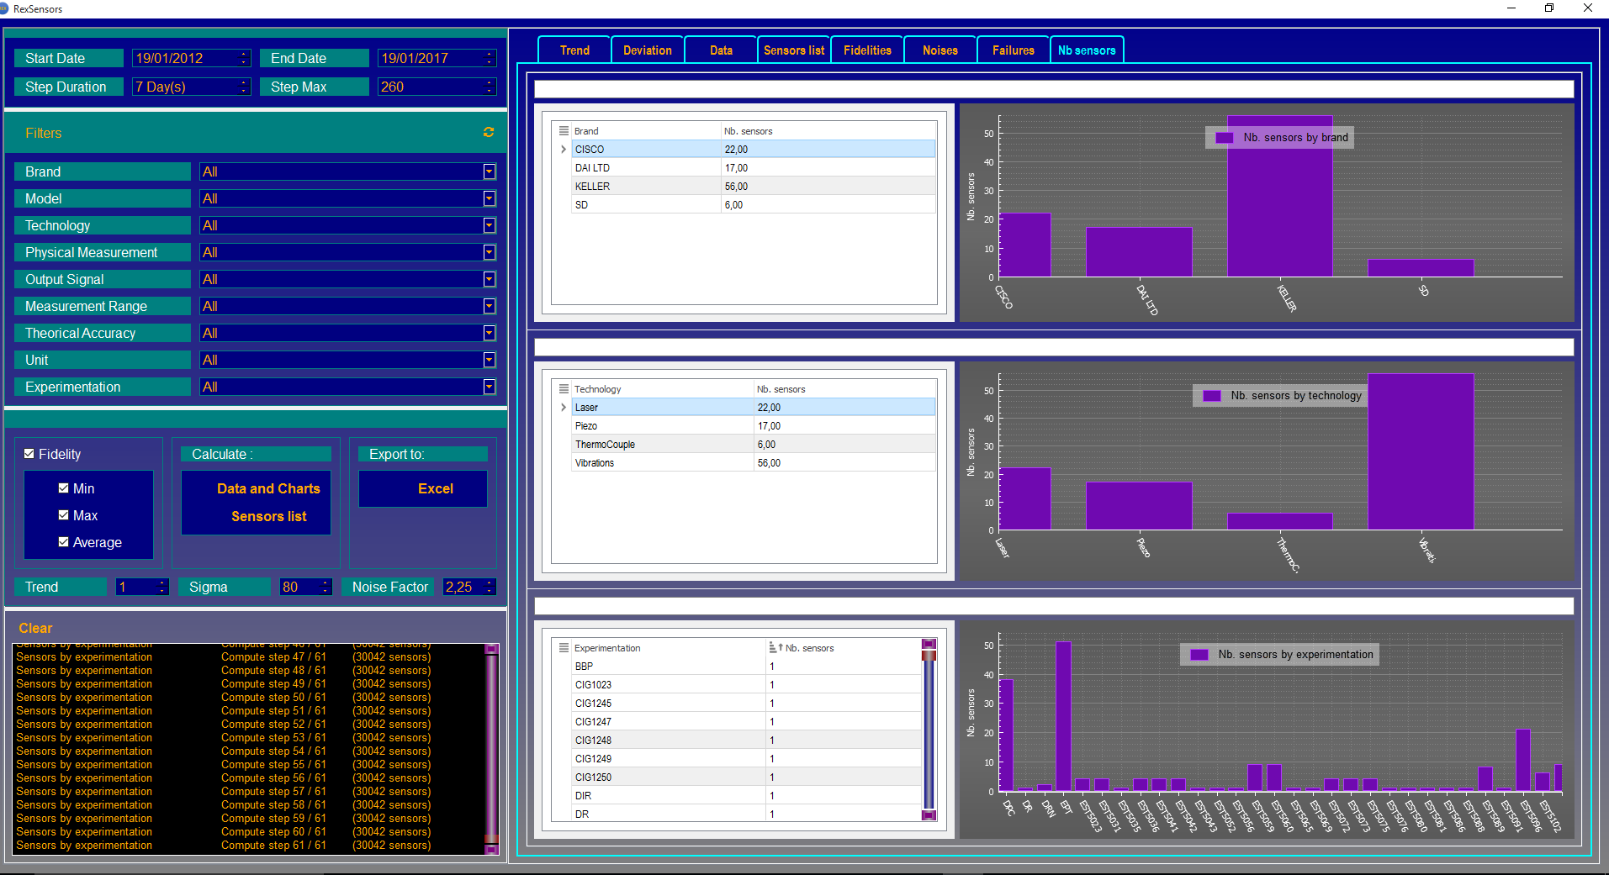

1. List of modules 3
• Files and dependences 5
2. Environment modules 6
3. Configure Qt creator environnement 6
4. How to build the package 6
1. Sequences diagrams 7
a. Filters manager 7

List of modules

RSTimesManager  (Widget) | 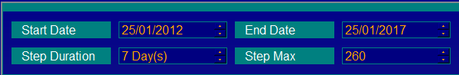 | Period configuration
RSFiltersManager  (Widget) | 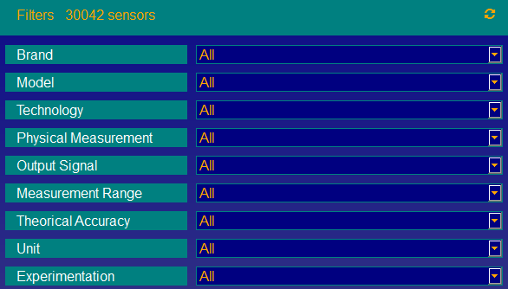 | On any changement in the combo boxes:  - Build the query  - Emit a signal to inform that the filters has changed  - The logic catches the signal and update the graph view
RSOptionsManager  (Widget) | 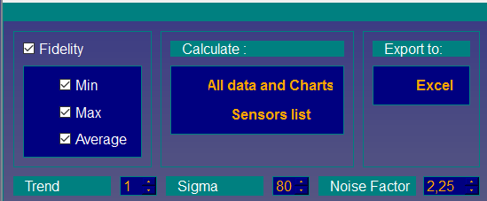 | Manage calculation:  - Min/Max/Average fidelity options  - Trend sigma noise factor options  - Calculate all fidelities, noise  - Display sensors distributions
RSDatabaseConfig | 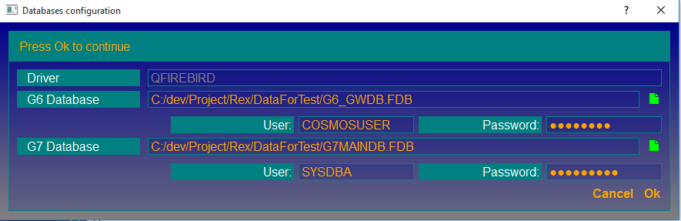 | Manage the popup window. So the user can set the database configuration. The paths and login are returned by the getters
RSLogger | Singleton | Log the messages on the logFile. the file is cleared over 500Mo. You can set a log level in the run.bat file. Set REXLOGLEVEL = 1
RSDatabaseAccess | Singleton | Manage all accesses to the databases. Open, close, queries
RSDataManager | Singleton | Less used. Store the common data. The role of this class have been reduced by the interfaces. So each module stores it data and can return a value throughout an interface
RSExportToExcel | Class | Used to export data to excel.
Signaler | Singleton | Used to emit the signals. Only the logic class is connected to its signals.
RSFidelityComputation | Class | Contains methods to compute the fidelity and noise
RSFidelityAndNoise | Class | Compute the fidelity and noise
RSDataComputation | Class | Manage the RSFidelityAndNoise. Because it is possible to compute all fidelities or a single fidelity. Depending of the situation, runFidelityNoiseAndMtbfCalculations will be call to make calculations on a list of sensors, computeFidelityNoiseStepAndInitGraphView will compute the fidelity and create the graphic
RSGlobalMethods | Singleton | Contains some common mathematical methods for computing the fidelities and noises. (Matrix, interpolation, etc..)
RexDataGrid  RexDataGridModel. | 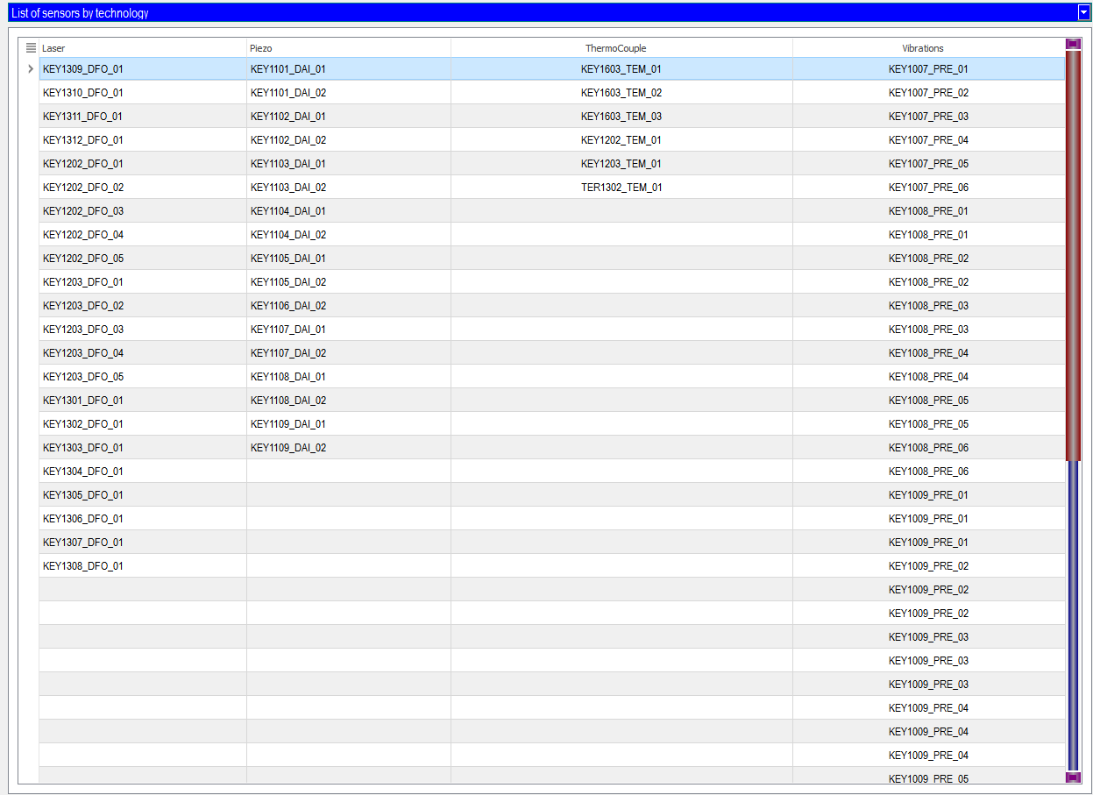 | QTitan datagrid and the model to use
RSGraphView | 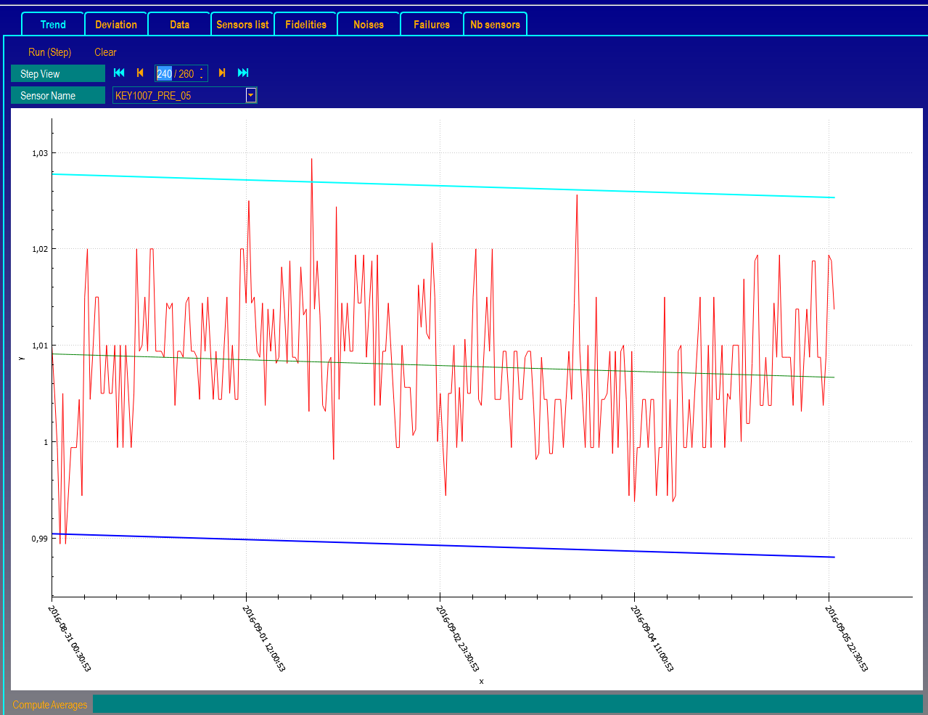 | Manage graphics and datagrid  Trends  Deviation  Sensors list  Data  Histograms  This module is drive by the logicActionManager
RSMessageView | 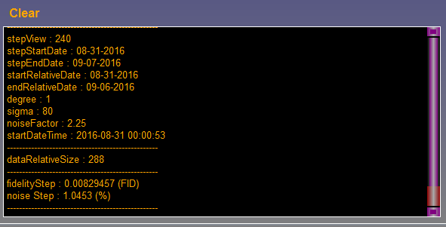 | Singleton  Call to display messages on the interface  Method showData()
RSMainWindow  (Widget) |  | A container  - Contains all independents graphics interfaces above  - Initialize all modules and singleton  - Initialize the databases on the start  - deletes the singletons on close

Files and dependences
Many drivers are uses by REX to perform the calculations and the graphics representation. We describe them on the following table

Drivers descriptions
Driver | Role | Directory
qtndbgrid5.dll | QTitan datagrid. Useful to draw grids with many features on the panels | ./bin
qsqlfirebird.dll | Firebird library.  Useful for Database access | ./bin
Qt5Core.dll  Qt5Gui.dll  Qt5PrintSupport.dll  Qt5Sql.dll  Qt5Widgets.dll | Qt libraries  REX is built from these libraries | ./bin
msvcp120.dll  msvcr120.dll | Windows libraries | ./bin
qwindows.dll | Windows libraries | ./bin/platforms

Files descriptions
File | Role | Directory
Run.bat | Run the rexsensor.exe | Root
RexSensor.exe | Rex software | ./bin
RexSensor.ini | - Contains the settings  - automatically created with defaults settings by REX if not found | ./bin
RexSensor.dat | SQLite database  Is created by REX  No user action needed | ./bin
Log | Log files | ./RexLogs

Environment modules

REX developer directory
Entity | Type | Role
RSDesktop | Directory | Contains the source code
QCustomPlot | Directory | class for curves and histograms
QtAwesome | Directory | classes for graphic interfaces
GSL | Directory | the mathematic library
Drivers | Directory | contains the useful drivers (dll). These drivers will be copy in the same directory as RexSensor.exe
msvc120_x86, msvc120_x64 | Directory | contains libXL and QTitandatagrid libraries (include, lib, bin)
RexUserGuide.doc | File | User guide
buildPackage.bat | File | Build the package RexExec
run.bat | File | Start RexSensor.exe

Configure Qt creator environnement
- Launch QtCreator
- Set the release mode and open the panel “project”
- Edit the batch file and paste the lines below

GSL_DIR=C:\dev\Project\Rex\GSL\gsl\include\
PATH=${PATH};C:\Qt\Qt5.5.0_x86\5.5\msvc2013\bin; C:\dev\Project\Rex\GSL\gsl\include\;C:\dev\Project\Rex\msvc120_x86\bin\msvc120_x86\release;
QMAKEFEATURES=C:\dev\Project\Rex\msvc120_x86\features

Replace the path C:\dev\Project\Rex by your own.

You can now compile REX

How to build the package
Just run the batch file buildPackage.bat

Sequences diagrams

