NAME: Son Tang

ID: A11370127

LOGIN: cs12shb

1. What command line is used to create the javadoc documentation in HW1/doc?

javadoc –d doc Counter.java

2. What command­line flag is used to to create the author and version entries for the class?

-version -author

3. In your HW1Answers file tell us if the command line properly runs the code. If it does not run the code, briefly describe why.

The command lines A and C run properly. Command line B does not run properly because the path does not lead to the junit jar file, so the system could not find TestRunner. Command line D does not run properly because the system does not know which TestRunner class to run.

4. From the unix command line, how would you run all tests defined in CounterTest.java in the JUnit’s swingui?

Just change junit.textui.TestRunner to junit.swingui.TestRunner:

java -cp '.:/usr/share/java/junit.jar' junit.swingui.TestRunner CounterTest

5. cp and classpath are “commandline switches” to the java and javac command to set Java’s classpath. What is another way to set the classpath without using a commandline switch? (hint: read

http://docs.oracle.com/javase/tutorial/essential/environment/paths.html)

Another way to set the classpath is to navigate to the full path of the executable every time you run it.

6. Take a screenshot of your code loaded into Eclipse.

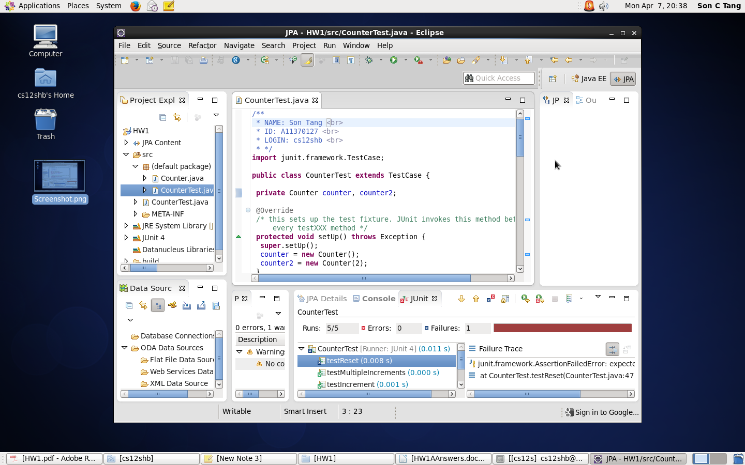

7. In Eclipse, Where did you specify the classpath to find the junit.jar file?



You choose the JUnit to use when you create the JUnit class. Alternately, you can specify the classpath of junit.jar by pressing the Add External JARs button in the Classpath tab of the Run Configurations of Junit.