System:

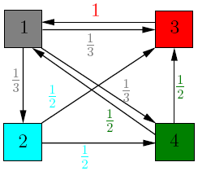

Adjacency Matrix:

|  |  |  |  |  |  |  |  |  |  |
| --- | --- | --- | --- | --- | --- | --- | --- | --- | --- |
|  |  |  |  |  |  |  |  |  |  |
|  |  | **j** | **1** | **2** | **3** | **4** | **Incoming Links** |  |  |
| **i** |  |
|  |  | **1** | 0 | 0 | 1 | 1 | 2 | **1** |  |
|  |  | **2** | 1 | 0 | 0 | 0 | 1 | **2** |  |
|  |  | **3** | 1 | 1 | 0 | 1 | 3 | **3** |  |
|  |  | **4** | 1 | 1 | 0 | 0 | 2 | **4** |  |
|  | **Outgoing Links** | | 3 | 2 | 1 | 2 |  |  |  |
|  |  |  | **1** | **2** | **3** | **4** |  |  |  |
|  |  |  |  |  |  |

Transition Matrix:

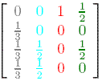

$$A=\left[\begin{matrix}0 & 0 & 1 & \frac{1}{2} \\ \frac{1}{3} & 0 & 0 & 0 \\ \frac{1}{3} & \frac{1}{2} & 0 & \frac{1}{2} \\ \frac{1}{3} & \frac{1}{2} & 0 & 0\end{matrix}\right]$$