Forerunner Mobilizer Dashboards

Introduction
Dashboards are a new feature added in version 3. The Dashboard feature allows the user to select multiple reports to be displayed on a single page.

The dashboard feature is extensible and optionally localizable. New dashboard templates can be added and styled based upon CSS styles. New dashboards will show up in the UI and become integral parts of the Mobilizer application. This document describes how to add new dashboard templates.

Below you will find two main sections:
How to Create your First Dashboard
This section covers all the information you will need to create, view and edit dashboards
How to Add a New Dashboard Template
This section covers how to extend Mobilizer to include new dashboard templates

How to Create your First Dashboard
Dashboards can be created in any folder in Mobilizer. You can create the dashboard in the root folder if you like. You cannot create dashboards in either the favorites or recent views.

Then do following:
- The Create Dashboard UI is part of the Admin UI. Select the “Settings” button on the toolbar to enable the Admin UI.
- Make sure the “Admin UI” checkbox in the “User Settings” dialog is checked
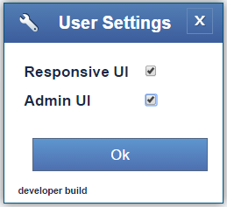

- Navigate to the folder where you would like to create your dashboard.
- Select ”Menu” à “Create Dashboard”
- In the “Create Dashboard” dialog, enter your dashboard name and select a layout template, then press “Save”.
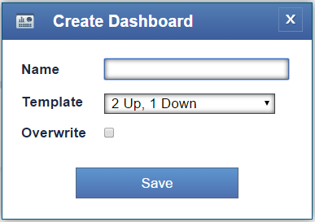

This will bring up the Dashboard editor view. For example, a side by side would look like this:
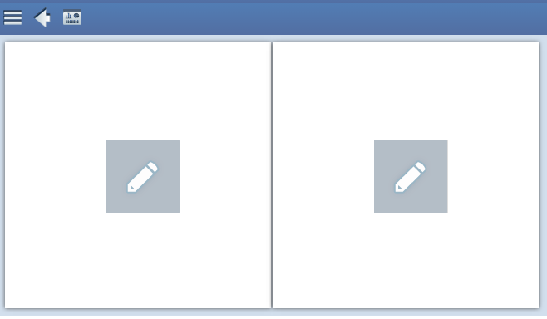

Press the “Edit” button in the middle of each report box to bring up the “Edit View” dialog:
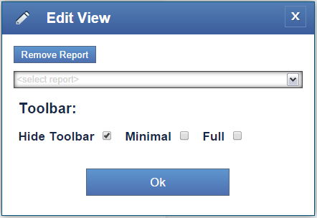

Select the report you would like and which type of toolbar to display, then press “Ok”.

Once you have your reports set up, you can view your new dashboard by selecting the “View Dashboard” button on the toolbar.

You are done!

If you go back to your folder you will see your newly created dashboard, which looks like this:
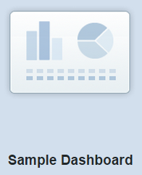
Selecting a dashboard will open it in View mode. If you have the “Admin UI” Setting selected, you can then switch to Edit mode by selecting the “Edit Dashboard” button. You can toggle between the Edit and View modes.

If you only want to create and use dashboards you are done. However if you would like to extend Mobilizer with additional dashboard templates, the following sections describe how you can do that.

How to Add a New Dashboard Template
The set of dashboards known to Mobilizer in the “Create Dashboard” dialog is controlled by the file dashboards-en.txt. This file is installed with Mobilizer and contained in the folder …\Forerunner\Dashboards\dashboards and looks like this:
{
"templates": {
"2Up1Down": "2 Up, 1 Down",
"2Up2Down": "2 Up, 2 Down",
"SideBySide": "Side by Side"
}
}

This is a JSON object where the “templates” member describes the list of available templates. Each template is described by a key value pair such as this:
"2Up1Down": "2 Up, 1 Down",

Where “2Up1Down” refers to the name of the dashboard template file and “2 Up, 1 Down” is the text displayed in the Mobilizer UI in the “Create Dashboard” dialog, “Template” field.

So to add a new template to the drop down you would need to do the following:
- Create a new key value pair in the dashboards-en.txt file
- Create a new dashboard template file. In the case above the file would be called “2Up1Down-en.txt”
That is it you’re done.

Dashboard Markup
Each dashboard template file contains a snippet of html which is used by Mobilizer to define the layout and styling of the template. For instance, the file “2Up1Down-en.txt” contains the following html:
<div class="fr-2up1down">
<table class="fr-dashboard-full-width-table">
<tr>
<td>
<div id="Report1" class="fr-dashboard-report-id fr-dashboard-report-container" />
<div id="Report2" class="fr-dashboard-report-id fr-dashboard-report-container" />
</td>
</tr>
</table>
<div id="Report3" class="fr-dashboard-report-id fr-dashboard-report-container" />
</div>
In the example above, note that each report slot must be marked with the classes:
fr-dashboard-report-id
Used to identify a report slot, this call does not have any CSS styles
fr-dashboard-report-container
Used to style the report slot

Styling a Dashboard
The class fr-dashboard-report-container is used to define the styles for a report slot and is defined in the file: dashboards.css which is in the folder …\Forerunner\Dashboard\css.

Localization
Currently all dashboard files default to English. It is possible to add language specific versions if needed. Simply create any language specific variant you need, e.g., “dashboards-es.txt” would be for Spanish, and add them to the dashboards folder. Mobilizer will automatically pick up language variants based upon the browser settings.

