# General

So you are going to work for us?

# Spring

## Will it work or not?

@Controller class MySpringBean {

@Autowire MyAnotherBean field;

}

@Controller class MyAnotherBeanA extends MyAnotherBean {}

@Controller class MyAnotherBeanB extends MyAnotherBean {}

## Ways to handle exception without try-catch

@Service class MySevice {

@ExceptionHandler(RuntimeException.class) void handle() {}

}

@Controller class EH implements HandlerExceptionResolver {

resolveEx() {}

}

@ControllerAdvice class GlobalEh {

@ExeptionHandler()

resolveEx() {}

}

@Controller class EHInterceptor implements HandlerInterceptor {}

## Null view

class MyController implements Controller {

ModelAndView handlerequest(req, res) {

return null;

}

}

//also ask what spring will do if we return normal ModelAndView – it will resolve view and put data to response

# Java

== VS equals

String s1 = “a1”, s2=”a2”; s1==s2

Object o1 = null; o2 = new SomeClass(); o1.equals(o2), o1==o2; o2=null, o1==o2//true

Sort array

Public MyClass {void make(){}} – what visibility level does method have without any access modifiers?

Find max in array - O(?)

HashMap#get – O(?) //O(1) – O(n)

Class MyR implements Runnable {}

(new MyR()).run() VS (new Thread(new MyR())).start()

SPI (Service provide interface)? //loader = ServiceLoader(MyClass.class); loader.iterator()

Statefull VS stateless

# Servlet/JSP

Servlet VS Jsp

1xx, 2xx, 3xx, 4xx, 5xx http codes?

What does browser do with 302 code? //Location

GET VS POST? Else? //PUT, DELETE

## Servlet registration

<servlet>

<servlet-name>register</servlet-name>

<servlet-class>…</servlet-class>

</servlet>

<servlet-mapping>

<servlet-name>register</servlet-name>

<url-pattern>/blue/*</ url-pattern >

</servlet-mapping>

## Right way of catching exception in filter

class MyFilter implements Filter {

void init() {}

void doFilter(req, res, chain) throws ServletException {

try {

chain.doDilter(req, res)

} catch (ServletException e) {

throw e;

} catch (Exception) {

throw new ServletException(e);

}

}

}

## Order of filters

<filterMapping/>

## Forward VS Redirect

Forward – on a server, servlet forward, same request to different URL without browser notification

Redirect – via 302 using browser, new request is created so we cannot access to data from first request

# SQL

Find max in table column

Joins definition (eiler circles)

Make join //select * from Person inner join City on Person.CityId = City.Id

# Html/Css

Fixed VS absolute

<section><article><header> do we have these tags in html4?

Link js only for ie? <!—[if IE]><script ….> </script><!endif]-->

Ccs hack for ie? .style{_background:#F00}

Graceful degradation?

Visibility:hidden VS display:none //not occupy space

# JS

‘use strint’; x = 5; //error in ff44, chrome48, ie10

== VS ===

sourceMaps

(function() {

function my() {

alert(‘hello’);

}

window.myAPI = my;

})(); //js closure

Show alert with vertical scroll value

<body onscroll=”myscroll();”/>

var timeout

function my scroll() {

clearTimeout(timeout)

timeout = setTimeout(function() {

alert(document.body.scrollTop);

}, 500);

}

Write program with text and button on button click the text should appear

localStorage? //setItem

XSS/ CSRF protection way //recheck your knowledge

Cross domain ajax call? //yes if server provide x-domain or proxy

# GWT

Acess to js

static native void method() /*-{

$wnd.alert(‘q’);

}-*/;

EventBus

Can we use 2 super dev mode simultaneously //-codeServerPort 9901

Simple task to write panel, label, button and click on button

UIBinder

If we have a lot of data what type of widget should we use //Cell Tablem cell widget

GWT.create(MyInterface.class) what we need to do to create interface?

# JQuery

<div class=’somename’/> //$(‘.somename’);

<div class=’some.name’/> //$(‘.some\\.name’);

$(selector).toogle();

.position() VS .offset() //relative to parent, to document

# Patterns

## MVC

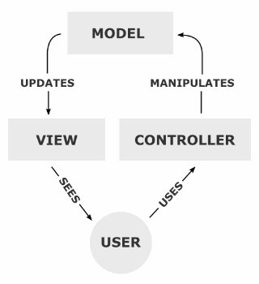

MVC is complex pattern. It consists from Observer (Model notifies View) and Strategy (View chooses Controller)

### Strategy

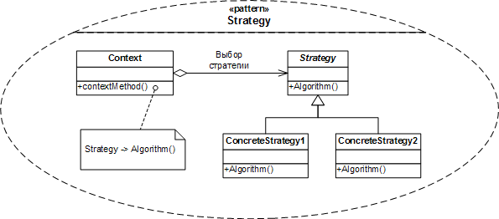

### Observer

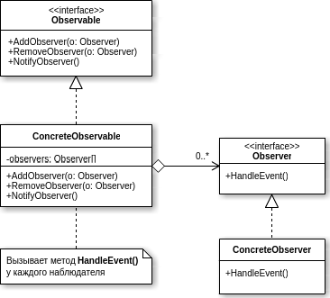

## Singelton

Complex variant:

public class Singelton {

private static Singelton INSTANCE = null;

public static Singelton getSingelton() {

if (INSTANCE == null) {

synchronized (INSTANCE) {

if (INSTANCE == null) {

INSTANCE = new Singelton();

}

}

}

return INSTANCE;

}

}