**Homework_Lesson_37**

Задание:

1. Создать конфигурацию для GCP Storage. Добавить модуль, который будет отвечать за доп. параметры бакета (имя, размер, файлы для закачки)

2. Используйте созданный модуль в основной конфигурации для развертывания инфраструктуры.

3. Настройте удаленное хранение tfstate в Terraform, используя GCP Storage в связке с CloudSQL

4. Перенесите свою существующую инфраструктуру на удаленное хранение стейта.

5. Создать в ручном режиме любой ресурс (лучше всего бакет либо ВМ) и импортируйте его в свою конфигурацию.

**Создадим бакет для хранения состояния Terraform (tfstate) и добавим создание Cloud SQL экземпляра**

gcpa4607@tms:~/HW37$ terraform apply

Terraform used the selected providers to generate the following execution plan. Resource actions are

indicated with the following symbols:

+ create

Terraform will perform the following actions:

# google_sql_database.appdb will be created

+ resource "google_sql_database" "appdb" {

+ charset = (known after apply)

+ collation = (known after apply)

+ deletion_policy = "DELETE"

+ id = (known after apply)

+ instance = "tf-cloudsql-db"

+ name = "appdb"

+ project = (known after apply)

+ self_link = (known after apply)

}

# google_sql_database_instance.db will be created

+ resource "google_sql_database_instance" "db" {

+ available_maintenance_versions = (known after apply)

+ connection_name = (known after apply)

+ database_version = "POSTGRES_15"

+ deletion_protection = true

+ dns_name = (known after apply)

+ encryption_key_name = (known after apply)

+ first_ip_address = (known after apply)

+ id = (known after apply)

+ instance_type = (known after apply)

+ ip_address = (known after apply)

+ maintenance_version = (known after apply)

+ master_instance_name = (known after apply)

+ name = "tf-cloudsql-db"

+ private_ip_address = (known after apply)

+ project = (known after apply)

+ psc_service_attachment_link = (known after apply)

+ public_ip_address = (known after apply)

+ region = "europe-north1"

+ self_link = (known after apply)

+ server_ca_cert = (known after apply)

+ service_account_email_address = (known after apply)

+ replica_configuration (known after apply)

+ settings {

+ activation_policy = "ALWAYS"

+ availability_type = "ZONAL"

+ connector_enforcement = (known after apply)

+ disk_autoresize = true

+ disk_autoresize_limit = 0

+ disk_size = (known after apply)

+ disk_type = "PD_SSD"

+ pricing_plan = "PER_USE"

+ tier = "db-f1-micro"

+ user_labels = (known after apply)

+ version = (known after apply)

+ backup_configuration (known after apply)

+ ip_configuration (known after apply)

+ location_preference (known after apply)

}

}

# google_sql_user.usersvc will be created

+ resource "google_sql_user" "usersvc" {

+ host = (known after apply)

+ id = (known after apply)

+ instance = "tf-cloudsql-db"

+ name = "appuser"

+ password = (sensitive value)

+ project = (known after apply)

+ sql_server_user_details = (known after apply)

}

# module.app_bucket.google_storage_bucket.bucket will be created

+ resource "google_storage_bucket" "bucket" {

+ force_destroy = true

+ id = (known after apply)

+ labels = (known after apply)

+ location = "EUROPE-NORTH1"

+ name = "my-unique-app-bucket-1234"

+ project = (known after apply)

+ public_access_prevention = (known after apply)

+ self_link = (known after apply)

+ storage_class = "STANDARD"

+ uniform_bucket_level_access = (known after apply)

+ url = (known after apply)

+ soft_delete_policy (known after apply)

+ versioning (known after apply)

+ website (known after apply)

}

# module.app_bucket.google_storage_bucket_object.initial["welcome.txt"] will be created

+ resource "google_storage_bucket_object" "initial" {

+ bucket = "my-unique-app-bucket-1234"

+ content = (sensitive value)

+ content_type = (known after apply)

+ crc32c = (known after apply)

+ detect_md5hash = "different hash"

+ id = (known after apply)

+ kms_key_name = (known after apply)

+ md5hash = (known after apply)

+ media_link = (known after apply)

+ name = "welcome.txt"

+ output_name = (known after apply)

+ self_link = (known after apply)

+ source = "welcome.txt"

+ storage_class = (known after apply)

}

Plan: 5 to add, 0 to change, 0 to destroy.

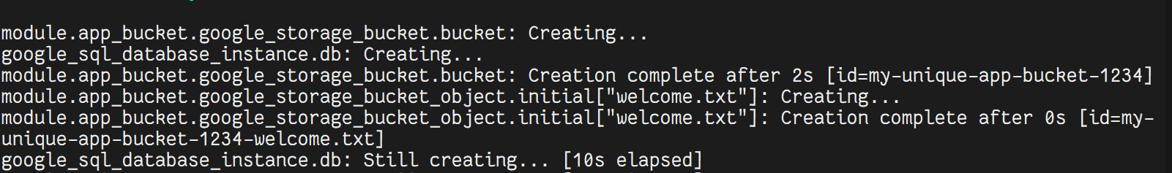

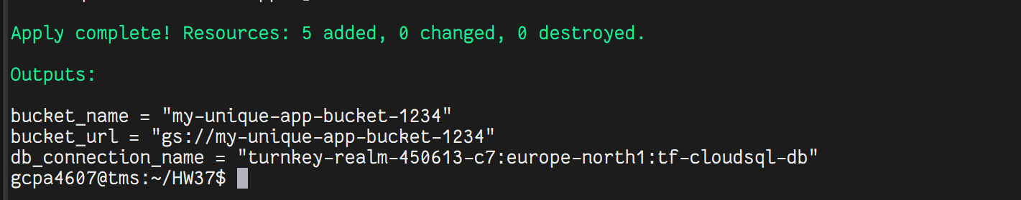

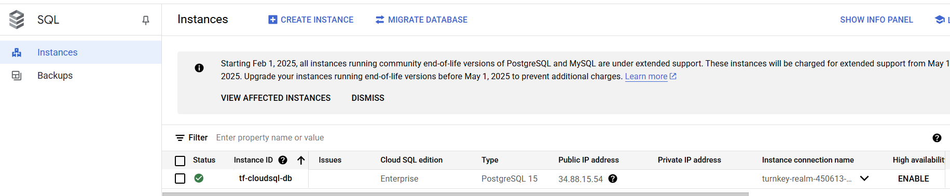

В процессе Terraform создал бакет и загрузил в него начальный welcome.txt