ISO 15189 Compliance of LLM-Generated Medical Laboratory QMS Documents: Claude Opus 4.6 vs. GPT-5.4 Across Prompting Configurations
Author: Sidi Liu¹
Affiliation: ¹ Department of Laboratory Medicine, West China Hospital Xiamen, Sichuan University, Xiamen, Fujian 361024, China
Corresponding author: Sidi Liu, lllsssddd@icloud.com, ORCID: 0009-0006-1695-5372
Short title: Prompting strategies for ISO 15189 document compliance
Keywords: ISO 15189; medical laboratory; quality management system; large language model; prompt engineering; LLM-as-judge; expert validation
Abstract
Objectives: To compare ISO 15189:2022 compliance of LLM-generated QMS documents across prompting configurations and characterise LLM-as-judge biases.
Methods: We generated 486 QMS documents using Claude Opus 4.6 (9 configurations × 15 tasks × 3 replicates = 405) and GPT-5.4 (81 for cross-model validation), spanning four prompt-content dimensions (rules, document skeleton, detailed content, worked examples; 0–56,000 tokens). Compliance was rated on a 0–5 Likert scale via three tiers: an automated rule-based scorer, dual LLM-as-judge review (864 ratings), and blinded review of 10 stratified-sampled documents by three qualified ISO 15189 internal auditors. Ablation effects used Mann–Whitney U with BH correction and bootstrap 95% CIs; inter-rater reliability used ICC variants.
Results: At the LLM-judge tier, only the rules component produced a significant compliance gain (Δ = +0.511; BH-adjusted p < 0.001). C_full (~56,000 tokens) scored 3.22–4.56 with Claude vs. 1.40–1.84 with GPT-5.4. Both LLM judges rated Claude-generated outputs ~0.30 points higher (Panickssery: +0.29 Claude, −0.30 GPT), concentrated at C_full and incompatible with classical self-preference. Expert inter-rater agreement was excellent [ICC(2,k) = 0.982]; Claude–expert agreement was moderate [ICC(3,1) = 0.548] and GPT–expert poor [ICC(3,1) = 0.217]; LLM judges overestimated experts by 0.52–0.90 points. The LLM-favoured H4_sop_only (~2,000 tokens) fell to fifth of seven under expert review (3.20), whereas template-anchored F_template, H2_keep_examples, and G_template_rules ranked highest (4.06–4.24).
Conclusions: Optimal configuration depends on evaluation tier: minimal prompts (~1,000–2,000 tokens) for exploratory drafts; template-anchored prompts (~15,000–16,000 tokens) for accreditation submission; C_full (~56,000 tokens) avoided with GPT-5.4. LLM-as-judge may support first-pass screening; expert final review remains indispensable.
1. Introduction
ISO 15189:2022 *Medical laboratories — Requirements for quality and competence* [7] is the international standard for medical laboratory accreditation, and its adoption by Chinese medical laboratories has continued to expand under the China National Accreditation Service for Conformity Assessment (CNAS) framework [14]. The corresponding national implementation document, CNAS-CL02:2023, was issued in parallel. Such standards prescribe what laboratories must achieve, not how to achieve it, requiring each laboratory to construct an independent quality management system (QMS) documentation set comprising a quality manual, procedure documents, and standard operating instructions. Based on the corresponding author's experience as an ISO 15189 internal auditor, such a system in a typical tertiary-level hospital clinical laboratory contains on the order of 100–300 controlled documents and spans structural organisation, clause-to-document mapping, form numbering, and responsibility assignment; manual drafting by an in-house quality team typically takes several months, followed by multiple rounds of internal audit before finalisation. Laboratories pursuing CNAS accreditation typically engage external technical experts or trainers to guide this process.
The advancement of large language models (LLMs) has raised the possibility of automating substantial portions of this workload. State-of-the-art models such as Claude Opus 4.6 and GPT-5.4 have demonstrated competence in long-document generation, structured output, and the use of domain-specific terminology [1, 2], and LLMs have been applied to scientific research [8] and medical question answering [9]. However, the optimal system-prompt design for producing compliant and operationally usable QMS documents has not been systematically investigated. Two contrasting approaches have emerged in practice: a full-context approach that loads all potentially relevant material—the ISO standard text, CNAS criteria, an existing document library, and worked examples—into the system prompt, often exceeding 50,000–100,000 tokens; and a minimal-prompt approach that supplies only rule constraints and section skeletons, relying on the model's internalised knowledge for content generation, with prompts limited to a few thousand tokens. Empirical evidence supporting either approach remains limited, as existing surveys of LLM behaviour and prompting [4, 12] have focused on general-purpose tasks and have not systematically compared specialised regulatory-document scenarios such as QMS authoring.
A second, more fundamental concern relates to the evaluation methodology itself. LLM-generated outputs are now most commonly assessed using the LLM-as-judge paradigm, in which a separate LLM serves as the rater [5]. Long-form text generation evaluation [10] and large-scale human-preference benchmarking [11] have emerged as the principal evaluation paradigms in this literature. Prior work has documented that LLM judges tend to exhibit a self-preference bias, favouring outputs produced by models within their own family [6]. However, whether and how this bias manifests in specialised regulatory domains such as medical laboratory QMS, and how it propagates into configuration-comparison conclusions, has not been empirically characterised.
To address these gaps, the present study generated 486 QMS documents, collected 864 LLM-judge ratings, and obtained 30 blinded expert ratings to investigate the following research questions: (i) Which components of a system-prompt configuration—rules, document skeleton, detailed content, or worked examples—contribute most to the compliance of LLM-generated QMS documents? (ii) What is the minimum effective token budget? (iii) Does the optimal configuration generalise across generation models (Claude Opus 4.6 vs GPT-5.4)? (iv) What is the magnitude of LLM-judge self-preference bias in this domain? (v) Across a multi-tier evaluation framework combining automated scoring, LLM judges, and expert ratings, which configuration is the most robust?
2. Materials and methods
2.1 Configuration design
Nine prompt configurations were designed by systematic substitution along four prompt-content dimensions—rules, document skeleton, detailed content, and worked examples—varied across operationally relevant levels: three levels (absent / partial / full) for rules and document skeleton, and binary (absent / present) for detailed content and worked examples (Figure 1). Two minimal configurations served as baselines: A_bare (0 tokens; no system prompt) and B_simple (~300 tokens; a brief task instruction containing six numbered constraints—language, file structure, standard citations, terminology, expression style, and numbering—coded as the partial level of the rules dimension). C_full (~56,000 tokens) represented the full-context input strategy, comprising the laboratory profile and the full set of SOPs concatenated into a single context block; because no standalone enforcement-oriented rule block was supplied, C_full was also coded as the partial level of the rules dimension. E_rules_v2 (~1,200 tokens) contained only the rules component; F_template (~15,000 tokens) contained the complete document template without rules; G_template_rules (~16,000 tokens) combined the rules component with the template; H2_keep_examples (~25,000 tokens) extended G_template_rules with worked examples; H3_skeleton (~5,000 tokens) preserved the module skeleton while removing detailed content; and H4_sop_only (~2,000 tokens) retained only the single SOP skeleton most relevant to the requested task. The letter D is intentionally skipped in the alphabetic sequence: an earlier D_rules variant was deprecated after expert validation identified terminology errors and was replaced by E_rules_v2; the gap is retained to preserve the chronological identifier scheme.
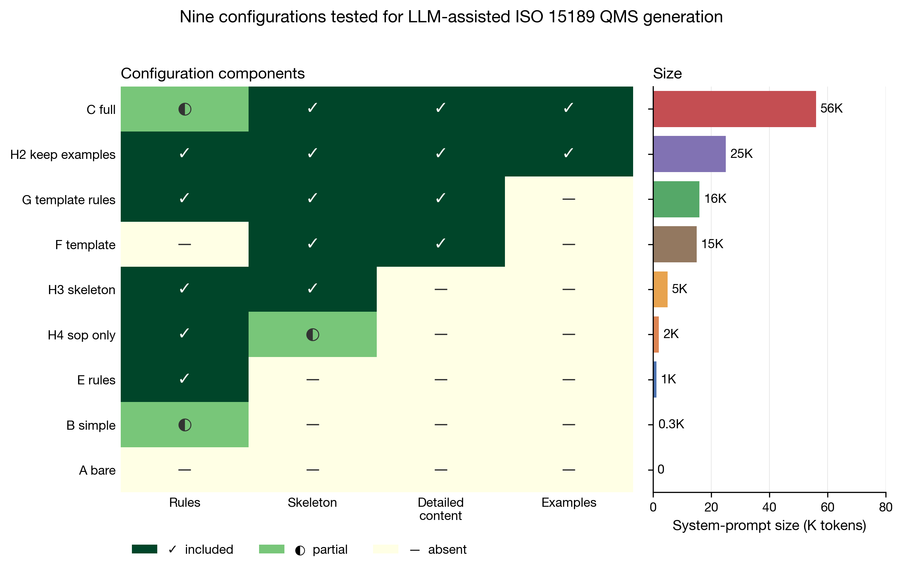
Figure 1. The nine prompt configurations evaluated in the study. Left panel: inclusion of each configuration across the four prompt-content dimensions (rules, document skeleton, detailed content, worked examples); ✓ = full inclusion, ◐ = partial inclusion, — = absent. Right panel: total system-prompt size of each configuration, expressed in thousands of tokens (cl100k_base tokenizer).
The rules component was derived from a curated rules.md file (~1,200 tokens) and refined through domain-expert review. Three incorrect terminology mappings were removed (instrument → equipment; calibrator product → calibrator; inter-laboratory comparison → proficiency testing) and three target terms were corrected (specimen → sample; test item → measurand; linear range → reportable range); arrows denote the non-preferred → ISO 15189-preferred direction. The final rule set retained 10 verified terminology mappings and seven categories of prohibited vague expressions. The document skeleton was extracted from the institutional template library using a custom *strip_to_skeleton* algorithm, which preserved section headings, each section's introductory paragraph, and form-numbering schemes, while removing verbatim clause excerpts, detailed tabular content, worked examples, step-by-step procedures, and fenced code blocks (markdown ... constructs enclosing process diagrams, JSON snippets, or pseudocode).
All token counts reported in this study were computed using the cl100k_base tokenizer (OpenAI tiktoken library); for mixed Chinese–English medical text, this tokenizer typically differs from the Anthropic-native tokenizer by ≤10% and was used as a reproducible approximation.
2.2 Generation models and tasks
The primary experiment used Claude Opus 4.6 (Anthropic, San Francisco, CA, USA), accessed through the Claude Code Agent interface (Anthropic's command-line agent framework) operated in text-generation mode: sub-agents returned text-only responses and no agentic tool calls (file system, web access, code execution) were performed during document generation, although the Claude Code framework's tool definitions remain present in the framework-level system prompt (see §4.5 limitation xiii). The model was evaluated across 9 prompting configurations, 15 QMS authoring tasks, and 3 independent replicates per cell, yielding 405 documents. The 15 tasks were stratified by CNAS audit scenarios into three classes of five tasks each: Class A (document drafting; e.g., personnel-training and competence-evaluation control procedures), Class B (system operation; e.g., annual internal-audit checklists), and Class C (audit simulation; e.g., review reports for internal quality-control procedure documents). The full task list and the original prompts are openly archived in the GitHub repository under task_messages/ and configs/. For cross-model validation, GPT-5.4 (OpenAI, San Francisco, CA, USA) was accessed through the official openai Python SDK (v2.30.0) configured with the AIHubMix endpoint (https://aihubmix.com) as the base URL; this routing was used because direct access to the OpenAI API was unavailable from the authors' geographic region during the study period. (Output directories use a legacy gpt4o_* prefix carried over from an earlier scripting iteration; the actual runtime model in all calls was GPT-5.4 as supplied to the SDK model parameter.) GPT-5.4 was evaluated on the same 9 configurations across one representative task from each class (A1, B1, and C1, defined as the first task in each class by index) with 3 replicates, yielding 81 documents. Both models received identical system-prompt configurations within each experimental cell and were run with identical generation parameters: temperature = 1.0 and max_tokens = 12,000; all other generation parameters used model defaults. The relatively high sampling temperature was chosen to reflect realistic interactive use, and three independent replicates per cell were included to capture the resulting stochastic variability. All API calls were executed between 2 April 2026 and 14 April 2026.
2.3 Three-tier evaluation framework
Compliance was evaluated through a complementary three-tier framework: an automated rule-based scorer (Tier 1), dual LLM-as-judge review (Tiers 2a and 2b), and independent blinded expert review (Tier 3). All three tiers reported scores on a common 0–5 integer scale; Tier 1 used an algorithmic rubric tailored to features that can be reliably detected by rule-based code, whereas Tiers 2 and 3 shared the descriptive five-dimensional rubric defined in Table 1.
2.3.1 Tier 1 — Automated compliance scoring
A Python automated compliance scorer (auto_scorer.py, openly released; see Data availability) rated all 486 documents on three primary dimensions, which were combined into a weighted composite score.
Format. Required section headings were matched against task-class-specific lists (Class A procedure documents: 8 sections; Class B checklists/reports: 6 sections; Class C audit reports: 7 sections; common synonyms accepted), with additional checks for numbering depth and empty sections. Documents missing ≥3 required sections scored 1; those missing exactly one section scored 3.
Clause coverage. Regular-expression matching identified ISO 15189:2022 clause identifiers from chapters 4–8 (e.g., 5.4.1), filtered by a ±40-character context window to suppress spurious matches. Documents citing ≥10 unique clauses with at least one CNAS-CL02:2023 reference scored 5; documents containing no standard reference scored 1.
Terminology compliance. This dimension internally aggregates two complementary checks. (i) *Terminology mapping*: a 14-term mapping table aligned with the ISO 15189:2022 / CNAS-CL02:2023 vocabulary was applied; for example, 分析前过程 ("pre-analytical process") → 检验前过程 ("pre-examination process"), 标本 ("specimen") → 样品 ("sample"), and 不确定度 ("uncertainty") → 测量不确定度 ("measurement uncertainty"). Context-exclusion rules were applied to avoid false positives — for instance, 不确定度 occurring within the longer phrase 测量不确定度 was not flagged. (ii) *Vague-expression detection*: stock vague expressions characteristic of low-quality QMS drafts—including 及时 ("in a timely manner"), 相关人员 ("relevant personnel"), and 定期 ("periodically")—were detected using two complementary filters: a compound-word whitelist and a 30-character trailing window for explicit frequency quantifiers (e.g., a phrase anchored to "weekly" or "annually" was not flagged).
Composite score. The three measured dimensions were combined into a weighted aggregate (auto_weighted) using format = 0.18, clause coverage = 0.22, and terminology = 0.13 — three of the seven weights defined in the WEIGHTS dictionary of auto_scorer.py. The remaining four entries of the dictionary (logical consistency = 0.18, operability = 0.10, safety compliance = 0.09, and manual-revision burden = 0.10; sum = 0.47) are vestigial entries from an earlier seven-dimension scoring plan that was superseded by the three-tier framework described in §2.3; they are not part of auto_weighted and therefore do not contribute to the Tier 1 ranking. The three implemented weights sum to 0.53, so auto_weighted has a theoretical range of [0, 2.65] on the 0–5 score scale. This sub-unit weight sum is a purely cosmetic feature of the scoring scale: rescaling every weight by 1/0.53 to renormalise to unit sum (≈ 0.34, 0.42, and 0.25 for format, clause coverage, and terminology, respectively) is a positive linear transformation of auto_weighted and therefore preserves both the per-configuration mean ordering and the min-max normalisation used to construct the composite ranking in §3.1 (Spearman ρ = 1.00 by construction). All Tier 1 rankings reported in §3 are consequently invariant to the choice between the original and the unit-sum weighting schemes.
2.3.2 Tier 2 — LLM-as-judge
Two LLM judges were deployed in a 2 × 2 symmetric cross-model design—Claude-generated × Claude-judge, Claude-generated × GPT-judge, GPT-generated × Claude-judge, and GPT-generated × GPT-judge—enabling orthogonal decomposition of self-preference bias.
Tier 2a (Claude-as-judge). Claude Opus 4.6 served as judge under a "CNAS chief assessor" role prompt (the JUDGE_PROMPT_TEMPLATE defined in gpt_cnas_judge.py, identical to the prompt used in Tier 2b), scoring each document on the five-dimensional rubric (Table 1) on a 0–5 scale. Generation parameters were temperature = 1.0 and max_tokens = 4,096; one rating was produced per document via a single API call. A total of 378 Claude-judge ratings were obtained, distributed as: 270 ratings covering the six core configurations (A_bare, B_simple, C_full, E_rules_v2, F_template, G_template_rules) × 15 tasks × 3 replicates of Claude-generated documents (per-document raw JSON fully released); 81 ratings covering all 9 configurations × A1/B1/C1 × 3 replicates of GPT-generated documents (archived as aggregated means; see §4.5, Limitation x); and 27 ratings covering the H-group configurations (H2_keep_examples, H3_skeleton, H4_sop_only) × A1/B1/C1 × 3 replicates of Claude-generated documents (also archived as aggregated means).
Tier 2b (GPT-as-judge). GPT-5.4, accessed through the AIHubMix endpoint as described in §2.2, served as judge using exactly the same prompt, rubric, and 0–5 scale as Tier 2a, with identical generation parameters (temperature = 1.0, max_tokens = 4,096). All 486 generated documents were rated (405 Claude-generated + 81 GPT-generated), with one rating per document; per-document raw JSON files are fully retained and openly released. We verified that no judge output was truncated by the max_tokens cap: all 486 GPT-judge per-paper JSON files parsed successfully (zero parse errors), and the longest per-dimension reason string observed across both judges was 43 characters, well within the prompt-imposed 40-character soft cap and far below the 4,096-token output budget.
Combined, Tiers 2a and 2b yielded 864 LLM-judge ratings (378 Claude-judge + 486 GPT-judge). The asymmetric counts reflect that the Claude judge was not run on the H-group × full-15-task subset or on the complete GPT-generated set (see §4.5, Limitation x); critically, all four 2 × 2 cells were populated, although some at aggregated-mean level only (see §4.5, Limitation x), ensuring that the self-preference bias decomposition could be performed at the cell-mean level.
Scoring scale. Each dimension was scored on a 0–5 integer scale: 5 = fully compliant (5-point anchor in Table 1); 4 = mostly compliant (between the 5- and 3-point anchors, minor issues only); 3 = partially compliant (3-point anchor); 2 = noticeably non-compliant (between the 3- and 1-point anchors); 1 = severely non-compliant (1-point anchor); and 0 = the dimension could not be evaluated because the document was essentially absent or non-substantive (e.g., the model returned only a planning query rather than the requested document). The 5/3/1 anchor descriptors were issued in identical wording to all judges (LLM and human); the intermediate scores 2 and 4 were assigned when the document fell between two adjacent anchors.
Table 1. Five-dimensional descriptive rubric shared by Tiers 2a, 2b, and 3.
Dimension | Anchor at 5 | Anchor at 3 | Anchor at 1
Clause coverage | All "shall" requirements of the relevant clauses are operationalised through concrete measures | Major clauses are covered but with omissions or surface-level treatment | Most clauses are merely cited without implementation, or major omissions are evident
Operability | Every step has a named role (job title), a quantified deadline, and an explicit output (form ID) | Most steps are actionable; a few remain vague | Pervasive use of "in a timely manner", "relevant personnel", and "periodically" without operational detail
Internal consistency | All referenced documents and forms appear in the corresponding sections; responsibilities are cleanly assigned | A few dangling references or minor textual contradictions | Many dangling references or conflicting responsibility assignments
PDCA closure | An explicit Plan–Do–Check–Act chain with execution records, effectiveness evaluation, non-conformity handling, and improvement | P–D–C are present but A (improvement/feedback) is missing | Execution steps only; no checking or improvement
Professional depth | Contains laboratory-specific detail (e.g., Westgard rules, measurement uncertainty, Sigma metrics, HIL indices, blind testing, PCR zoning, cold chain) | Some professional flavour, but largely generic | Generic content equally applicable to any laboratory

2.3.3 Tier 3 — Expert review
Three qualified ISO 15189 internal auditors independently scored 10 blinded, stratified-randomly sampled documents using the same five-dimensional rubric (Table 1) as the LLM judges. Rater 1 was the first author, a qualified ISO 15189 internal auditor; Raters 2 and 3 were qualified ISO 15189 internal auditors from the same institution. To minimise self-influence, Rater 1 completed scoring without inspecting any Tier 1 or Tier 2 outputs in advance; the Tier 1/2 outputs for the sampled papers were reviewed only after all three rater sheets had been submitted. The three raters scored independently and without communication; Raters 2 and 3 completed their scoring with no access to Rater 1's ratings, and the three rating sets were merged only after all submissions had been received. Written informed consent was obtained from Raters 2 and 3 before scoring. During scoring, the experts were free to consult the complete texts of ISO 15189:2022 and CNAS-CL02:2023, including their annexes.
Sampling strategy. Ten documents were drawn from the 486-document pool by stratified random sampling with a fixed Python random seed (seed = 42), stratified across seven configurations × Class A procedure-document tasks (A1, A2, A3) — yielding a 21-stratum frame. The seven configurations selected at this tier (A_bare, C_full, E_rules_v2, F_template, G_template_rules, H2_keep_examples, H4_sop_only) differ from the six-configuration set used at Tier 2a (§2.3.2): B_simple was excluded from the expert sample as a redundant low-quality baseline next to A_bare, H3_skeleton was excluded as a near-duplicate of H4_sop_only at the per-stratum sample size, and H2_keep_examples and H4_sop_only were added as informative endpoints of the H series. The sample size of 10 was chosen to balance expert workload against stratification coverage; not all 21 strata are represented in the final sample (one or two documents per realised stratum). Class A was chosen because it constitutes the most stable and audit-relevant document type in CNAS reviews; cross-class generalisation is acknowledged as a limitation in §4.5.
Conflict-of-interest declaration. None of the three raters has any commercial, research, or consulting relationship with Anthropic, OpenAI, or any other LLM provider; none received funding or in-kind support from these entities for this study.
Pre-scoring calibration. No formal pre-scoring calibration session was conducted; the three raters scored independently using only the published five-dimensional rubric (Table 1) and the ISO 15189:2022 / CNAS-CL02:2023 standards. The absence of formal calibration is acknowledged as a methodological limitation in §4.5 (xii).
Blinding procedure. Blinding was implemented at four levels (script: prepare_blind_review.py, openly released):
(i) *File renaming.* Each sampled document was copied from its original path outputs/{group}/{group}-{task}-{rep}.md to a flat anonymised series paper_01.md … paper_10.md, removing the configuration-group and replicate identifiers from both the filename and the directory structure presented to the experts.
(ii) *Content sanitisation.* An automated text scan of all 10 blinded files confirmed zero occurrences of any model identifier ("Claude", "GPT", "Opus") or configuration-group token ("H4", "C_full", "G_template", "F_template", "H2_keep", "E_rules_v2", "A_bare", "H3_skeleton") within the document body, ensuring that the model and configuration source could not be inferred from the text.
(iii) *Order randomisation.* The assignment of (group, task, replicate) triples to paper_01–paper_10 was shuffled using a fixed Python random seed (seed = 42), producing an identical presentation order for all three experts. Only the task category (e.g., "Personnel training and competence-evaluation control procedure") was disclosed in the rating sheet, because this information is intrinsic to the document content and necessary for assessment; the underlying configuration group remained hidden.
(iv) *Key isolation.* The (paper_id → group, task, replicate) mapping (blind_review/key.json) was sealed before scoring began and was unsealed only after all three expert rating sheets had been submitted.
2.4 Statistical analysis
2.4.1 Pairwise group comparisons and multiplicity correction
Pairwise between-configuration comparisons were performed using two-sided Mann–Whitney U tests (scipy.stats.mannwhitneyu, scipy v1.10.1) on per-document GPT-judge scores, with each configuration contributing n = 45 ratings (15 tasks × 3 replicates). Multiplicity within the four-component ablation was controlled by the Benjamini–Hochberg false-discovery-rate (FDR) procedure (statsmodels.stats.multitest.multipletests (statsmodels v0.14.6), method = fdr_bh; α = 0.05). FDR was preferred over Bonferroni correction because the four pre-specified contrasts share overlapping configurations (e.g., G_template_rules appears in both the *detailed content* and *worked examples* contrasts) and are therefore not statistically independent; under such structured testing, the Benjamini–Hochberg procedure provides a more powerful yet still rigorous control of the expected proportion of false discoveries. Bootstrap 95% confidence intervals for each Δ effect estimate were computed using the nonparametric percentile method with B = 10,000 resamples and a fixed seed (42), drawing each group's resamples independently with replacement (numpy random.choice); the lower and upper interval limits were taken as the 2.5th and 97.5th percentiles of the resampled Δ distribution. The bootstrap reference implementation is provided in bootstrap_ci.py of the released code repository.
2.4.2 Quantification of configuration-component effects
The four configuration-component effects were defined through targeted pairwise contrasts, each designed to isolate one dimension while holding the remaining three as constant as possible:
- *rules*: E_rules_v2 vs A_bare
- *document skeleton*: H4_sop_only vs E_rules_v2
- *detailed content*: G_template_rules vs H3_skeleton
- *worked examples*: H2_keep_examples vs G_template_rules
For each contrast, the effect size Δ was defined as a simple arithmetic mean difference, Δ = mean(group_B) − mean(group_A), where each group mean was the unweighted average of the 45 per-document GPT-judge scores in the corresponding configuration. No covariates, random effects, weighting, or shrinkage were applied. The same 45-per-configuration sample served as input to the Mann–Whitney U test reported alongside each Δ. L9 orthogonal-array decomposition, least-squares-means estimation, and mixed-effects modelling were not used, as the targeted-contrast scheme provides a more transparent and directly interpretable estimate for the substitution contrasts of interest.
2.4.3 Inter-rater agreement
Inter-rater agreement was characterised using three complementary measures, each reported in full because they capture distinct aspects of agreement: Pearson correlation captures linear association while tolerating systematic shifts between raters; Spearman correlation captures rank-order agreement without assuming linearity; and intraclass correlation coefficients (ICCs) quantify reliability under the standard framework of Shrout and Fleiss [13]. Four ICC variants were applied:
- ICC(2,1) — single-rater absolute agreement, two-way random effects;
- ICC(3,1) — single-rater consistency, two-way mixed effects;
- ICC(2,k) — k-rater averaged absolute agreement;
- ICC(3,k) — k-rater averaged consistency.
The single-rater variants ICC(2,1) and ICC(3,1) were used for pairwise comparisons (e.g., expert mean vs each LLM judge, and pairwise comparisons within the expert panel), whereas the k-rater averaged variants ICC(2,k) and ICC(3,k) (k = 3) were used to characterise the overall reliability of the three-expert panel. All ICCs were computed using the pingouin Python library (v0.6.1).
2.4.4 Self-preference bias
For each model M ∈ {Claude Opus 4.6, GPT-5.4} acting as judge, the self-preference bias was quantified following the classical convention of Panickssery et al. [6] — same judge, different generators:
bias_M = mean(judge = M, generator = M) − mean(judge = M, generator = M′),
where M′ denotes the counterpart model. Positive values indicate that judge M rates outputs from its own generator family more favourably than outputs from the counterpart generator; negative values indicate the converse. As a sensitivity check, we additionally computed an alternative cross-judge formulation — same generator, different judges (bias_M = mean(judge = M, generator = M) − mean(judge = M′, generator = M)) — and obtained values of +0.464 (Claude) and −0.472 (GPT), preserving the sign and direction of the classical estimates (+0.294 and −0.301) reported in §3.4.
2.4.5 Note on the experimental design
The nine evaluated configurations do not constitute a Taguchi L9 orthogonal array. They were instead designed as a structured subset of the four-dimensional configuration space (rules, document skeleton, detailed content, worked examples), in which dimensions are varied across operationally relevant levels: three levels (absent / partial / full) for rules and document skeleton, and binary (absent / present) for detailed content and worked examples. Configurations were selected to isolate each dimension through the targeted pairwise contrasts described in §2.4.2 rather than to satisfy the balanced-orthogonality criteria of an L9 design. Δ effect estimates therefore correspond to the specific configuration pairs listed in §2.4.2 and are not reweighted to a balanced full-factorial reference.
3. Results
3.1 Configuration ranking under the combined automated and LLM-judge evaluation
Across the 405 Claude Opus 4.6–generated documents, the nine configurations were ranked using a composite score that combined the Tier 1 automated scorer mean and the Tier 2 LLM-judge mean (averaged across the Claude and GPT judges); each component was min-max normalised to [0, 1] across the nine configurations and then averaged with equal weight. From highest to lowest composite score, the ranking was: H4_sop_only (~2,000 tokens; 0.994), H3_skeleton (~5,000 tokens; 0.869), G_template_rules (~16,000 tokens; 0.851), H2_keep_examples (~25,000 tokens; 0.759), E_rules_v2 (~1,200 tokens; 0.729), C_full (~56,000 tokens; 0.493), F_template (~15,000 tokens; 0.345), B_simple (~300 tokens; 0.227), and A_bare (0 tokens; 0.000). H4_sop_only therefore achieved the highest composite score at only ~2,000 tokens — well below the template-anchored configurations (G_template_rules ~16,000; H2_keep_examples ~25,000) and the full-context C_full (~56,000); as reported in §3.5, however, this ranking did not survive expert evaluation.
3.2 Four-component substitution-contrast ablation
All four ablation effects are reported with raw p-values, Benjamini–Hochberg–adjusted p-values, and 95% bootstrap confidence intervals (B = 10,000 resamples; seed = 42). The rules component was the only factor reaching significance after correction (Δ = +0.511; 95% CI [+0.28, +0.75]; raw p < 0.001; BH-adjusted p < 0.001). The document-skeleton component (Δ = +0.213; 95% CI [+0.05, +0.39]; raw p = 0.055; BH-adjusted p = 0.11) showed a directionally positive effect; although the bootstrap CI excludes zero, the BH-adjusted p does not reach the 0.05 threshold. This discrepancy reflects that the CI was computed on the simple mean difference whereas inference used the rank-based Mann–Whitney U test; we therefore interpret the skeleton effect as suggestive evidence requiring independent replication. Detailed content (G_template_rules vs H3_skeleton: Δ = −0.031; 95% CI [−0.19, +0.12]; raw p = 0.79; BH-adjusted p = 0.79) and worked examples (H2_keep_examples vs G_template_rules: Δ = −0.053; 95% CI [−0.21, +0.11]; raw p = 0.46; BH-adjusted p = 0.61) showed no detectable contribution. As a descriptive supplementary contrast outside the four-component BH set, H4_sop_only and H3_skeleton did not differ (Δ = −0.009; raw p = 0.80; reported uncorrected), suggesting that, at the LLM-judge tier, the task-specific SOP skeleton (~2,000 tokens) and the full module skeleton (~5,000 tokens) are functionally equivalent. The ablation results reported in this section pertain to the LLM-judge tier (specifically the Tier 2b GPT-judge ratings, per §2.4.1); the corresponding expert-tier comparisons are presented in §3.5.
3.3 2 × 2 symmetric cross-model validation
Figure 2 displays the 2 × 2 symmetric design—Claude-generated × Claude-judge, Claude-generated × GPT-judge, GPT-generated × Claude-judge, and GPT-generated × GPT-judge—evaluated on the 9 configurations across the three representative tasks (A1, B1, C1) with three replicates per cell. The full-context configuration C_full (~56,000 tokens) exhibited a sharp drop in evaluated compliance when generated by GPT-5.4: the GPT-generated × Claude-judge mean was 1.40 and the GPT-generated × GPT-judge mean was 1.84 on the 0–5 Likert scale, whereas the same C_full configuration generated by Claude Opus 4.6 yielded cross-evaluated mean scores in the range 3.22–4.56 across the two judges. This pattern indicates that the apparent usability of the ~56,000-token full-context configuration is specific to Claude Opus 4.6 and does not generalise to GPT-5.4 within the parameters tested. Qualitative inspection of the GPT-generated C_full outputs by the authors identified three recurrent failure modes: instruction-following degradation, in which early constraints stated in the system prompt were no longer reflected in later sections of the output; structural breakdown, manifesting as inconsistent section ordering, missing required headings, or numbering errors; and clause-citation confusion, including the use of incorrect, mismatched, or fabricated ISO 15189:2022 clause identifiers. These failure modes were not observed in the corresponding Claude Opus 4.6 outputs.
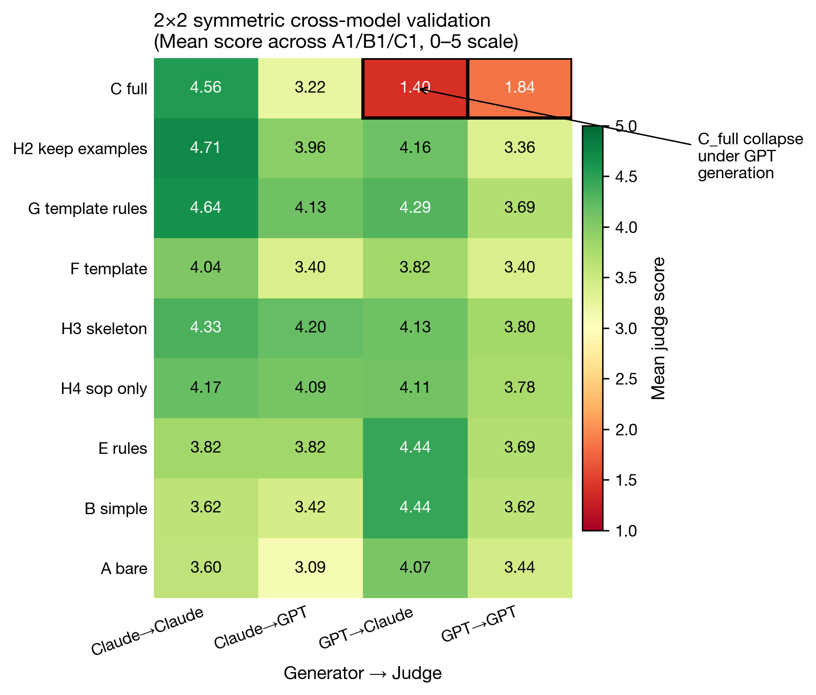
Figure 2. Heatmap of the 2 × 2 cross-model symmetric design. Cells show the mean compliance score (0–5 Likert scale) across the three representative tasks (A1, B1, C1) for each of the nine configurations (rows) crossed with the four generator–judge combinations (columns). C_full exhibits a marked drop in the two GPT-generated columns (1.40 and 1.84, indicated by black-bordered cells), in sharp contrast with the two Claude-generated columns (Claude-judge × Claude-generated = 4.56; GPT-judge × Claude-generated = 3.22).
3.4 Self-preference bias of LLM judges
Computed using the Panickssery classical formula defined in §2.4.4 (bias_M = mean(judge = M, generator = M) − mean(judge = M, generator = M′)), the mean bias of the Claude judge across the nine configurations was +0.294 on the 0–5 Likert scale (positive in 6 of 9 configurations; the largest single-configuration value, +3.156, occurred at C_full). The mean bias of the GPT judge was −0.301 (negative in 6 of 9 configurations, with positive values at A_bare and B_simple and zero at F_template). The two judges therefore agreed in direction: across configurations, both effectively rated Claude-generated outputs approximately 0.30 points higher than GPT-generated outputs, despite using nominally opposite-signed self-preference indices. When C_full was excluded as the dominant outlier, the Claude-judge mean bias attenuated to −0.064 (median across the nine configurations: +0.200) and the GPT-judge mean bias attenuated to −0.167 (median: −0.311), indicating that the Panickssery indices reported above are disproportionately driven by C_full, where the long-context failure modes documented in §3.3 amplify cross-judge disagreement.
By construction, this opposite-signed pattern is incompatible with the classical self-preference phenomenon, in which each judge would inflate ratings of its own family — a pattern that would produce same-signed positive biases for both judges. Instead, the observed pattern is compatible with two non-mutually-exclusive interpretations: (a) a genuine generation-level quality difference between Claude Opus 4.6 and GPT-5.4 under the parameters tested, consistent with the C_full failure modes documented in §3.3; and (b) systematic style or format preferences shared by both judges that favour the Claude-generated phrasing. Because the Tier 3 expert sample (n = 10) consisted entirely of Claude-generated documents (§2.3.3), the present study cannot empirically discriminate between these two interpretations; we identify this as a key direction for follow-up validation (§4.5, Limitation i).
To examine configuration ranking after removing same-judge self-evaluation, we re-ranked the nine configurations using only cross-model evaluations, retaining for each configuration the per-document Claude-judge → GPT-generated and GPT-judge → Claude-generated mean scores and averaging the two. Under this debiased ranking, the top four configurations on the 0–5 Likert scale were G_template_rules (4.211), H3_skeleton (4.167), E_rules_v2 (4.133), and H4_sop_only (4.100); their largest pairwise difference was Δ = 0.111, indicating that the four were statistically indistinguishable. C_full dropped from sixth in the §3.1 composite ranking to ninth (mean = 2.310), confirming that the high LLM-judge rating of C_full under Claude generation was substantially driven both by Claude-judge inflation of its family's output and by the inability of GPT-5.4 to produce usable output at the ~56,000-token configuration (§3.3).
3.5 Expert-tier validation
Inter-rater agreement among the three experts was excellent: ICC(2,k) = 0.982 (95% CI [0.95, 1.00]) and ICC(3,k) = 0.981. The pairwise single-rater agreements were ICC(2,1) = 0.948 (R1 vs R2), 0.928 (R1 vs R3), and 0.969 (R2 vs R3) — all in the "excellent" range (> 0.90 by the Cicchetti benchmark [15]). This level of agreement indicates that the five-dimensional rubric (Table 1) was highly reproducible across raters; however, because all three raters were affiliated with the same institution, the observed reliability may overestimate the agreement achievable across institutions (see §4.5, Limitation ii).
Agreement between the expert mean and the two LLM judges was substantially lower (Figure 3). The Claude judge yielded ICC(3,1) = 0.548 (p = 0.04), Pearson r = 0.573, and Spearman ρ = 0.509; the GPT judge yielded ICC(3,1) = 0.217 (p = 0.26) and Pearson r = 0.259. On the 0–5 Likert scale, both LLM judges systematically overestimated the expert-determined compliance scores: by 0.905 points for the Claude judge and by 0.525 points for the GPT judge (mean difference defined as expert − LLM judge, yielding values of −0.905 and −0.525, respectively). Claude–expert agreement was therefore at a moderate level, whereas GPT–expert agreement was poor.
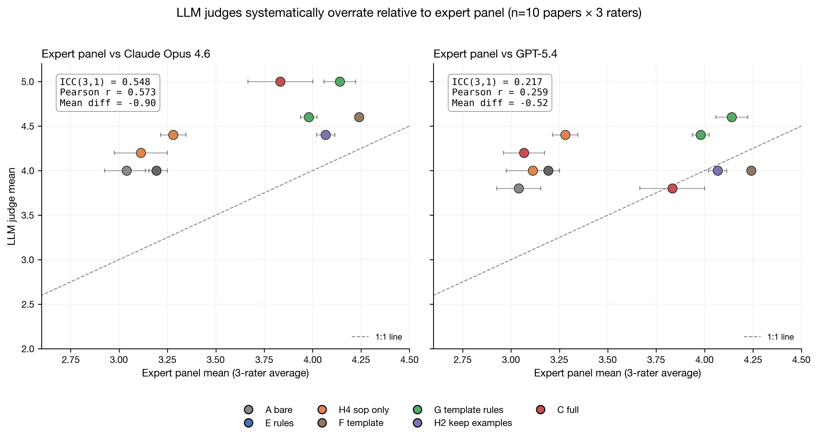
Figure 3. Systematic overestimation of compliance scores by the LLM judges relative to the three-rater expert panel (n = 10 documents × 3 raters). Horizontal axis: mean rating of the three experts. Vertical axis: LLM-judge rating. Left: Claude Opus 4.6 as judge [ICC(3,1) = 0.548; Pearson r = 0.573; mean difference (expert − Claude) = −0.905]. Right: GPT-5.4 as judge [ICC(3,1) = 0.217; Pearson r = 0.259; mean difference (expert − GPT) = −0.525]. Dashed line: 1:1 perfect agreement. Markers are colour-coded by configuration (legend inset).
When ranked by the expert mean across the seven sampled configurations (10 documents in total; per-stratum n = 1 or 2), the configurations ordered from highest to lowest were: F_template 4.24 (n = 1), H2_keep_examples 4.07 (n = 1), G_template_rules 4.06 (n = 2), C_full 3.45 (n = 2), H4_sop_only 3.20 (n = 2), E_rules_v2 3.19 (n = 1), and A_bare 3.04 (n = 1). The configuration ranked first at the LLM-judge tier — H4_sop_only (~2,000 tokens) — fell to fifth of seven (the third position from the bottom) under expert evaluation, only 0.16 points above the no-prompt baseline A_bare. The largest LLM-judge overestimation was observed for C_full and H4_sop_only (mean difference = expert − LLM-judges mean = −1.00 and −1.05, respectively), suggesting that although these two configurations achieve structural completeness and terminological compliance — the dimensions most readily captured by automated and LLM-based scoring — they lack the clinical-practice depth that is detectable only by expert reviewers. The three top-ranked configurations under expert evaluation (F_template, H2_keep_examples, G_template_rules) were all template-anchored configurations containing detailed content, indicating that the apparent token efficiency of skeleton-only configurations at the LLM-judge tier does not translate into expert-validated compliance. Given the small per-stratum sample (n = 1 or 2), these expert rankings should be treated as exploratory and warrant replication with a larger expert sample.
3.6 Token size and compliance scores: divergent relationships across evaluation tiers
Figure 4 plots compliance scores against system-prompt token size for the three evaluators, all derived from the n = 10 expert-blinded subset (seven configurations; per-stratum n = 1 or 2). At the LLM-judge tier, the Claude-judge curve generally increased with token size, peaking at 4.90 at C_full (~56,000 tokens) with a small dip at H2_keep_examples; the GPT-judge curve peaked at G_template_rules (~16,000 tokens; 4.50) and was relatively flat (~4.0) at both ends of the token range, including C_full. At the expert tier, the curve peaked in the template region (F_template at ~15,000 tokens, expert mean = 4.24; G_template_rules at ~16,000 tokens, 4.06) and declined at both extremes, falling to ~3.20 at H4_sop_only (~2,000 tokens) and 3.45 at C_full (~56,000 tokens). The expert–LLM divergence followed a U-shaped pattern across the token axis: large at low-token configurations (gap ≈ 0.8–1.1 points at A_bare, E_rules_v2, and H4_sop_only) and again at the high-token extreme (gap ≈ 1.0 at C_full), but converging in the ~15,000–25,000-token template region (gap ≤ 0.6). Both LLM-judge curves placed the low-token region near or above the template region, whereas the expert curve placed the template region clearly above all other configurations. This pattern indicates that token-efficiency-oriented optimisation and clinical-usability-oriented optimisation correspond to two divergent optimisation objectives in the medical-laboratory QMS generation scenario; the Tier 2 LLM-judge perspective overestimates the quality of both short-prompt configurations and the C_full configuration relative to what the expert tier validates.
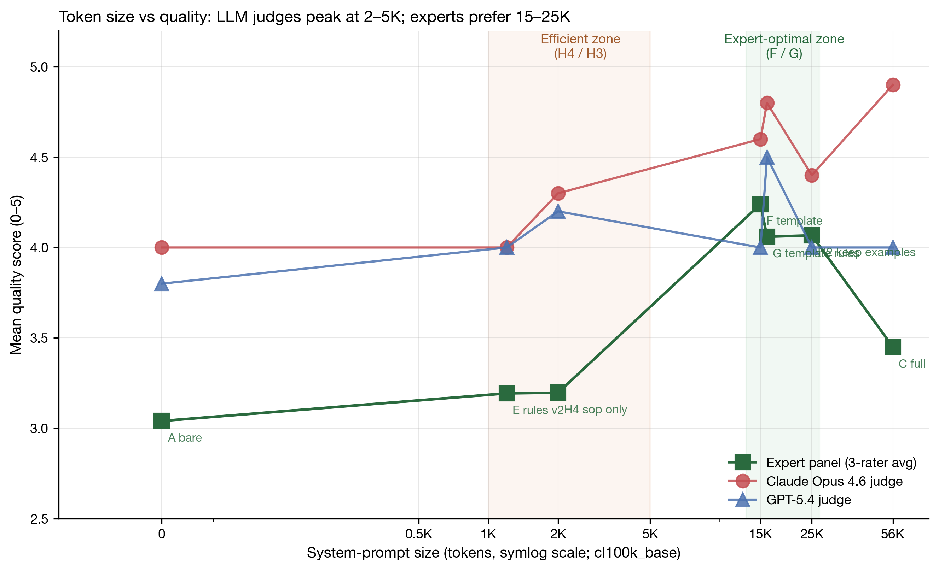
Figure 4. Compliance score (0–5 Likert) versus system-prompt token size, computed on the n = 10 expert-blinded subset (seven configurations; per-stratum n = 1 or 2). Horizontal axis: token count on a symmetric-logarithmic scale (cl100k_base tokenizer). All three curves are based on the same matched samples: solid green line with squares, three-rater expert mean; solid red line with circles, Claude Opus 4.6 judge applied to Claude-generated outputs; solid blue line with triangles, GPT-5.4 judge applied to Claude-generated outputs. Orange-shaded band: the token-efficient optimum identified by the LLM-judge tier (H4_sop_only / H3_skeleton). Green-shaded band: the clinical-usability optimum identified by expert evaluation (F_template / G_template_rules). Error bars are omitted because per-stratum n = 1 or 2; the corresponding LLM-versus-expert calibration scatter is shown in Figure 3.
4. Discussion
4.1 Prompt minimisation holds at the LLM-judge tier but not at the expert tier
The four-component ablation supports a parsimonious account at the LLM-judge tier: the rules component was necessary (BH-adjusted p < 0.001), the document-skeleton component contributed a directionally positive but non-significant effect (BH-adjusted p = 0.11), and neither detailed content nor worked examples produced detectable compliance gains (§3.2). This pattern aligns with the lost-in-the-middle phenomenon described by Liu et al. [3] — in which appending large volumes of contextual material to long prompts can dilute model attention and degrade output quality — and with prompt-engineering literature more broadly [12].
The expert-tier analysis qualifies this simplification (§3.5). Detailed content—the full document template embedded in F_template and G_template_rules—was associated with substantially higher expert-rated compliance than skeleton-only configurations: on the 0–5 Likert scale, F_template scored 4.24 (n = 1) and G_template_rules scored 4.06 (n = 2), compared with 3.20 (n = 2) for H4_sop_only, an apparent difference of approximately one point (these per-stratum samples are small and the comparison should therefore be interpreted as exploratory; see §3.5). A plausible explanation is that the model's internalised knowledge does not reliably cover the clinical-practice sub-scenarios required by ISO 15189:2022 and CNAS-CL02:2023—including, in our task set, emergency-sample handling, the acceptance of patient-self-collected specimens, qualification requirements for sample-courier personnel, and detailed criteria for sample rejection. When such sub-scenarios are not supplied explicitly through the system prompt, the model tends to default to generic procedural language that satisfies the structural and terminological criteria captured by automated and LLM-based scoring (§3.6) but lacks the operational depth that expert reviewers identify as the threshold for accreditation-grade documentation. Prompt minimisation is therefore appropriate when the goal is rapid drafting under LLM-only review, whereas template-anchored prompts are required when expert-validated compliance is the target.
4.2 The full-context trap is model-dependent
While template anchoring improves expert-rated compliance (§4.1), even maximally extending the prompt can be counter-productive when the underlying model lacks reliable long-context handling. C_full (~56,000 tokens) represents an intuitively safe configuration: it includes all potentially relevant material and reflects the common heuristic that providing more context produces more reliable output. In our data this heuristic was not borne out across the two generation models. Whereas Claude Opus 4.6 generation under C_full produced cross-evaluated mean scores of 3.22–4.56 on the 0–5 Likert scale (§3.3), GPT-5.4 generation under the same configuration produced scores of only 1.40–1.84 (based on 9 documents covering 3 representative tasks × 3 replicates), accompanied by the three recurrent failure modes documented in §3.3—instruction-following degradation, structural breakdown, and clause-citation confusion. A plausible explanation, consistent with the lost-in-the-middle phenomenon described by Liu et al. [3] and with the long-context benchmarks reported in the model vendors' technical documentation [1, 2], is that Claude Opus 4.6 maintained more stable attention over long contexts in the relevant length regime, whereas GPT-5.4, within the parameters tested here, did not preserve coherent compliance with system-prompt constraints at this scale.
The methodological implication is that any claim of the form "configuration X is acceptable" requires validation across multiple generation models. Single-model evaluation entangles configuration effects with idiosyncratic model characteristics—including long-context handling, instruction-following stability, and the degree of overlap between the model's training distribution and the target regulatory domain—and therefore provides no basis for cross-model extrapolation. We accordingly caution against the operational deployment of long-context QMS prompts (e.g., those approaching or exceeding ~50,000 tokens) under any LLM until the configuration has been validated for that specific model and version, particularly because long-context behaviour can change substantially between model families and even between successive versions of a single family.
4.3 Bias profile and appropriate use of LLM-as-judge
The present study quantified two distinct categories of rating bias. The first is a cross-judge directional pattern: both LLM judges rated Claude-generated outputs approximately 0.30 points higher than GPT-generated outputs on the 0–5 Likert scale (Panickssery classical estimates: +0.29 for the Claude judge and −0.30 for the GPT judge; §3.4). However, as detailed in §3.4, this population-level average was strongly leveraged by the C_full configuration; when C_full is excluded, the Claude-judge mean bias attenuates to −0.064 and the GPT-judge mean bias to −0.167, indicating that the cross-judge directional pattern is concentrated at the long-context configuration rather than constituting a uniform property of the LLM-as-judge framework. This opposite-signed pattern is incompatible with classical same-family self-preference—which would predict same-signed positive biases for both judges—and is therefore attributable either to a genuine generation-quality gap between Claude Opus 4.6 and GPT-5.4 or to judge-side preferences for the Claude-generated stylistic register that are shared by both LLM judges. As noted in §4.2 and §4.5(i), the present design—in which expert evaluation was restricted to Claude-generated documents—cannot fully disambiguate these interpretations, although the GPT-specific failure modes documented in §3.3 (instruction-following degradation, structural breakdown, and clause-citation confusion) provide indirect support for a genuine quality contribution. The second category is a systematic LLM–expert offset: both LLM judges overestimated expert-determined compliance by 0.52–0.90 points on the same scale (§3.5).
Translating these biases into operational guidance, the Claude judge—whose ranking achieved moderate agreement with the three-expert mean [ICC(3,1) = 0.548, p = 0.04]—may serve as a coarse first-pass filter in large-scale generation pipelines, screening out clearly low-quality outputs before expert review. The GPT judge's poor expert agreement [ICC(3,1) = 0.217, p = 0.26] precludes its use as a proxy for expert assessment in this domain. For documents intended for accreditation submission, formal QMS adoption, or operational deployment, expert final review remains indispensable. The configuration-level operational implications of these biases are summarised in §4.4 (Table 2).
4.4 Configuration recommendations stratified by use scenario
Synthesising the evidence from the three evaluation tiers, we summarise configuration recommendations for the principal QMS-generation use scenarios in Table 2. The recommendations reflect the key trade-off identified in §3.5 and §3.6: configurations that score highest at the LLM-judge tier (H4_sop_only, E_rules_v2) are the most token-efficient but lack the clinical-practice depth required for accreditation-grade documentation, whereas template-anchored configurations (F_template, G_template_rules) are penalised at the LLM-judge tier yet produce the highest expert-rated compliance.
Table 2. Configuration recommendations stratified by use scenario.
Use scenario | Recommended configuration | Tokens | Rationale | Trade-off
Rapid first-draft generation; internal iteration | H4_sop_only or E_rules_v2 | ~1,000–2,000 | Near-optimal at the LLM-judge tier; highest token efficiency | Requires manual supplementation of clinical detail
Batch drafting of multiple SOPs | H4_sop_only or H3_skeleton | ~2,000–5,000 | Task-specific skeleton plus rules | Requires manual supplementation of clinical detail
Formal documents for CNAS submission | G_template_rules | ~16,000 | Highest expert-rated compliance; cross-model robust | Higher token cost
Complete quality manual | F_template or G_template_rules | ~15,000–16,000 | Highest expert scores | Higher token cost
Not recommended | C_full | ~56,000 | Collapses under GPT-5.4 generation; lowest cross-evaluation rank under debiasing | —
Not recommended | A_bare, B_simple | 0–~300 | Insufficient prompt anchoring; below the practical compliance baseline | —

A practical end-to-end workflow emerging from these data is to: (i) generate a rapid first draft using H4_sop_only; (ii) supplement clinical-practice detail through manual review or targeted re-prompting; and (iii) regenerate or refine the final accreditation-grade document using G_template_rules.
4.5 Limitations
The present study has the following limitations.
(i) Limited expert sample, restricted to Claude-generated documents. The expert tier comprised three raters scoring 10 documents (per-stratum n = 1 or 2; see §3.5), all drawn from the Claude-generation pool; no GPT-generated documents underwent expert evaluation. The present design therefore supports only directional ranking conclusions for Claude-generated documents and does not permit strict statistical inference. Consequently, the §3.4 ambiguity between (a) a genuine generation-quality gap between Claude Opus 4.6 and GPT-5.4 and (b) shared judge-side stylistic preferences cannot be resolved within the present sample. Furthermore, the cross-judge bias estimates reported in §3.4 are strongly leveraged by the C_full configuration, which contributes the largest single-configuration value (+3.156) to the Claude-judge mean and −1.378 to the GPT-judge mean; future replication should therefore report per-configuration bias profiles separately to disentangle long-context-specific effects from configuration-independent judge preferences. All 10 sampled documents were Class A procedure documents (§2.3.3); cross-class generalisation to Class B (system operation) and Class C (audit simulation) tasks requires separate validation. Multi-centre validation with three to five raters scoring 30–50 documents per institution—including matched GPT-generated samples and Class B/C tasks—is a key direction for future work.
(ii) Same-institution agreement may overestimate generalisability. The very high agreement among the three experts [ICC(2,k) = 0.982] both supports the validity of the five-dimensional rubric and likely reflects shared professional culture, training lineage, and clause-interpretation habits within a single institution. The observed reliability may therefore overestimate cross-institution generalisability.
(iii) Dual role of the first author. The first author served both as Rater 1 and as study designer. To mitigate self-influence, Raters 2 and 3 completed their scoring without access to Rater 1's prior ratings, and the per-rater data are openly released for independent audit.
(iv) Shared rubric between expert and LLM tiers. The five-dimensional rubric was applied identically by LLM judges and expert raters, introducing a risk of shared-measurement bias. Future work should incorporate expert-native dimensions—such as operational implementability under departmental workflow constraints—that LLM judges are unlikely to have internalised from training data.
(v) Limited GPT-5.4 task coverage. Only the A1, B1, and C1 tasks were generated by GPT-5.4 (81 documents), restricting cross-model conclusions to a three-task subset.
(vi) Domain specificity. The findings are restricted to ISO 15189 medical-laboratory QMS documents; transferability to adjacent regulatory frameworks (e.g., ISO 17025 for testing and calibration laboratories, or ISO 9001 for general quality management) requires separate validation.
(vii) Restricted set of LLM judges. Only Claude Opus 4.6 and GPT-5.4 served as judges; whether the observed cross-judge directional bias and expert-overestimation pattern generalise to additional model families (e.g., Gemini, open-weight models) is unknown.
(viii) Single-language scope. All QMS documents were generated and evaluated in Chinese; the configuration effects and bias profiles in English or other languages have not been verified.
(ix) Model temporality. The conclusions reflect the specific model versions and parameters tested between 2 April 2026 and 14 April 2026; continued LLM iteration may require periodic re-validation.
(x) Asymmetric raw-data retention for cross-judge cells. Per-document raw scores for the Claude-judge × GPT-generated quadrant and for the Claude-judge × H-group × Claude-generated subset were archived only as aggregated means; the per-document JSON files were not retained. The full 2 × 2 self-preference matrix therefore cannot be independently recomputed at the per-document level, although per-document raw Claude-judge ratings for the six core configurations (A/B/C/E/F/G; 270 ratings) and all 486 GPT-judge per-document ratings are openly released.
(xi) Intra-judge reliability not assessed. Each LLM judge scored each document exactly once; judges were not asked to re-score documents for the quantification of intra-judge variance. Inter-judge reliability was captured indirectly via the 2 × 2 cross-comparison between the Claude and GPT judges and via the three-expert ICC analysis.
(xii) No pre-scoring expert calibration session. The three raters scored independently from the published rubric and the ISO 15189:2022 / CNAS-CL02:2023 standards, without a prior calibration session in which a small number of example documents would be jointly scored to align interpretation. The very high inter-rater agreement indicates that the rubric was sufficiently self-explanatory in the present institutional context, but a formal calibration step is recommended for replication in multi-centre studies.
(xiii) Claude Code Agent wrapper. Claude Opus 4.6 generation and Claude-judge ratings were performed via the Claude Code Agent interface rather than through a direct Anthropic SDK call. The Claude Code framework appends a constant framework-level system prompt (tool definitions and file-system guidance) to each user-supplied prompt; the absolute prompt length seen by the model is therefore larger than the per-configuration token counts reported in §2.1. Because this framework overhead is identical across all 9 configurations and across all judging calls, between-configuration relative comparisons and judge–expert agreement findings are unaffected, but exact reproduction of absolute scores requires the same Claude Code version. Re-running the same configurations through a direct Anthropic SDK call may yield slightly different absolute scores.
(xiv) AIHubMix routing not independently audited. GPT-5.4 was accessed via the AIHubMix proxy, which advertises transparent forwarding to the upstream OpenAI API. We did not independently verify response equivalence against direct OpenAI calls; subtle routing-level differences (request batching, header handling, regional routing) cannot be ruled out, although the GPT-5.4 model identifier was preserved end-to-end.
(xv) Temperature setting. All generations used temperature = 1.0 to reflect realistic interactive use. This introduces stochastic variance (mitigated by three replicates per cell) at the cost of strict bit-level reproducibility; future studies seeking deterministic comparison should re-run at temperature = 0.
5. Conclusions
The optimal prompt configuration for LLM-assisted ISO 15189 QMS document generation depends on the evaluation tier. At the LLM-judge tier, H4_sop_only (~2,000 tokens) achieved the highest composite score; under expert evaluation, however, the three highest-rated configurations were the template-anchored F_template (~15,000 tokens), H2_keep_examples (~25,000 tokens), and G_template_rules (~16,000 tokens) (mean = 4.06–4.24 on the 0–5 Likert scale), whereas H4_sop_only fell to fifth of seven configurations, only 0.16 points above the no-prompt baseline A_bare. Minimal-prompt configurations (H4_sop_only or E_rules_v2; ~1,000–2,000 tokens) are therefore appropriate for exploratory drafts that will undergo subsequent expert review, whereas template-anchored configurations (G_template_rules or F_template; ~15,000–16,000 tokens) are required for documents intended for CNAS or equivalent ISO 15189 accreditation submission. C_full (~56,000 tokens) should be avoided in the present setting, particularly when generation is performed by GPT-5.4, given the long-context failure modes documented in §3.3. LLM-as-judge methods may serve as a first-pass screening tool: the Claude judge showed moderate agreement with experts [ICC(3,1) = 0.548] and may be used as a cautious proxy, whereas the GPT-5.4 judge [ICC(3,1) = 0.217] was unsuitable for this purpose. Expert final review remains indispensable for any document intended for accreditation submission, formal QMS adoption, or operational deployment.
To our knowledge, this is the first systematic comparison of prompt-content effects on ISO 15189–compliant QMS document generation across two state-of-the-art LLMs and a three-tier evaluation framework; the findings provide an empirical foundation for prompt design guidelines in laboratory accreditation workflows.
Declarations
Research funding: The study received no external research funding.
Author contributions: Sidi Liu was solely responsible for the conceptualisation and design of the study, the conduct of all experiments, the data analysis, the drafting and finalisation of the manuscript, and takes full responsibility for the content of the article.
Competing interests: The author declares no competing interests.
Informed consent: Written informed consent was obtained from Raters 2 and 3 prior to their participation in the blinded expert review. The consent form described the study purpose, the intended use of the ratings, the data-handling and de-identification procedures, and the right to withdraw at any time.
Ethical approval: This study did not require formal ethical approval, because it did not involve patient data, biological samples, or human intervention. The QMS documents generated and evaluated used fictitious placeholder names (e.g., "Dr Li", "Dr Zhang") and contained no identifiable personal information. The inter-rater dataset was collected as methodological research from informed-consent volunteers; rater-level identifying data are stored under coded labels (Rater 1 / Rater 2 / Rater 3) in the released dataset.
Data availability: The 486 generated documents, 864 LLM-as-judge ratings, 30 blinded expert ratings, and all analysis code are openly available on GitHub (https://github.com/stttttte/iso15189-llm-config-experiment) under a dual licence: MIT for code and CC BY 4.0 for data. A versioned snapshot has been archived on Zenodo (DOI: [10.5281/zenodo.20091464](https://doi.org/10.5281/zenodo.20091464)).
Acknowledgements
The author thanks the two colleagues who participated in the blinded expert review (Raters 2 and 3) for providing an independent expert perspective with full informed consent.
References
1. Anthropic. Claude Opus 4.6 System Card. San Francisco (CA): Anthropic; 2025. Available at: https://www.anthropic.com/claude. [Accessed 9 May 2026].
2. OpenAI. GPT-5 System Card. San Francisco (CA): OpenAI; 2025. Available at: https://openai.com/index/gpt-5-system-card/. [Accessed 9 May 2026].
3. Liu NF, Lin K, Hewitt J, Paranjape A, Bevilacqua M, Petroni F, et al. Lost in the middle: how language models use long contexts. Trans Assoc Comput Linguist 2024;12:157–73.
4. Zhao WX, Zhou K, Li J, Tang T, Wang X, Hou Y, et al. A survey of large language models. arXiv preprint 2023; arXiv:2303.18223.
5. Zheng L, Chiang WL, Sheng Y, Zhuang S, Wu Z, Zhuang Y, et al. Judging LLM-as-a-judge with MT-Bench and Chatbot Arena. In: Advances in Neural Information Processing Systems 36 (NeurIPS 2023) Datasets and Benchmarks Track. 2023.
6. Panickssery A, Bowman SR, Feng S. LLM evaluators recognize and favor their own generations. arXiv preprint 2024; arXiv:2404.13076.
7. ISO 15189:2022. Medical laboratories — Requirements for quality and competence. Geneva: International Organization for Standardization; 2022.
8. Boiko DA, MacKnight R, Kline B, Gomes G. Autonomous chemical research with large language models. Nature 2023;624:570–8.
9. Jin D, Pan E, Oufattole N, Weng WH, Fang H, Szolovits P. What disease does this patient have? A large-scale open domain question answering dataset from medical exams. Appl Sci 2021;11:6421.
10. Tan H, Guo Z, Shi Z, Xu L, Liu Z, Li X, et al. ProxyQA: an alternative framework for evaluating long-form text generation with large language models. In: Proceedings of the 62nd Annual Meeting of the Association for Computational Linguistics (ACL 2024); 2024 Aug 11–16; Bangkok, Thailand. Stroudsburg (PA): Association for Computational Linguistics; 2024.
11. Chiang WL, Zheng L, Sheng Y, Angelopoulos AN, Li T, Li D, et al. Chatbot Arena: an open platform for evaluating LLMs by human preference. arXiv preprint 2024; arXiv:2403.04132.
12. Schulhoff S, Ilie M, Balepur N, Kahadze K, Liu A, Si C, et al. The prompt report: a systematic survey of prompting techniques. arXiv preprint 2024; arXiv:2406.06608.
13. Shrout PE, Fleiss JL. Intraclass correlations: uses in assessing rater reliability. Psychol Bull 1979;86:420–8.
14. Yang S, Zhou Y, Wang C, Luo M. The 'Double Helix' model of quality monitoring: risk mapping of quality management system during initial ISO 15189 implementation in a medical laboratory. PLoS One 2026;21:e0342129.
15. Cicchetti DV. Guidelines, criteria, and rules of thumb for evaluating normed and standardized assessment instruments in psychology. Psychol Assess 1994;6:284–90.
Word count (main text including references): ~5400 words
Tables: 1 (Table 2 — configuration recommendations stratified by scenario)
Figures: 4
References: 15

