Solenoid Driver
Last Edit; 20140524

Introduction
The Solenoid driver consists of two parts, a hardware schematic in DipTrace and the software component that runs on the propeller microcontroller.

The schematic for the solenoid driver is under the CERN Open Hardware license v1.2
The source code for the solenoid driver is under the GNU GPL v2

Hardware Overview
The goal of the solenoid is to control the high voltage power (solenoids, flashers, motors, etc). We are using the lower voltage of the microcontroller at 3.3v. We control the high power basically using an MOSFET driver (MCP1407) and an IRF640 MOSFET. This achieves low side switching (low side switching is where power (+) is continually run to the device (eg: solenoid), and when the solenoid driver closes the circuit and connects the ground (GND or -).

Low side switching as we are doing, is much easier to achieve than High side switching (where you continually connect GND and only connect the + as needed).

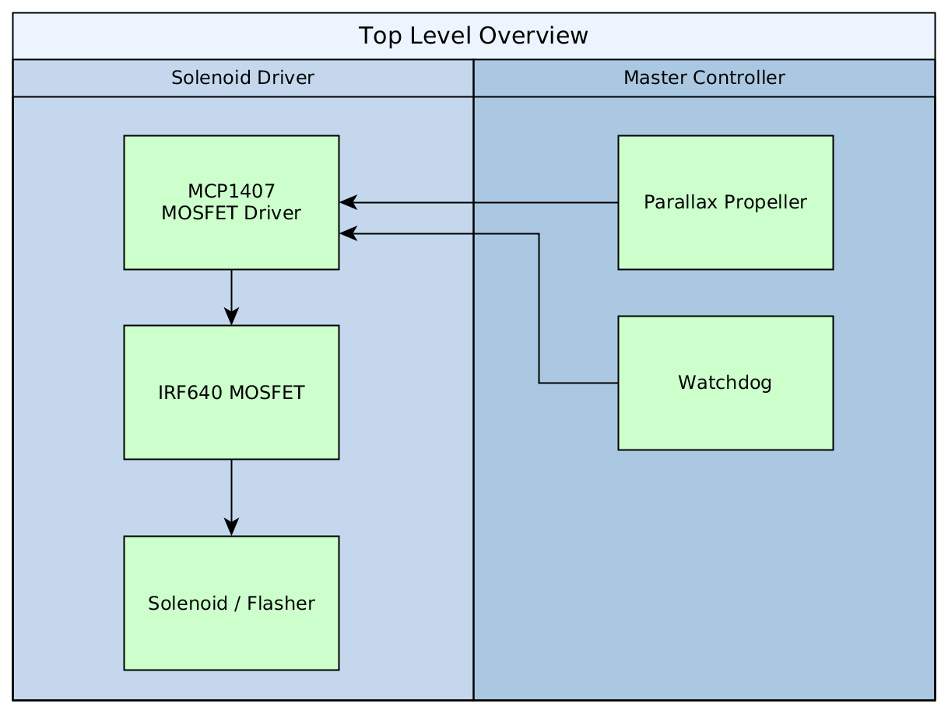
The propeller does the timings of all the 32 solenoids, it works in conjunction with the watchdog. The idea of the watchdog is to look over the propeller and make sure its not locked up. If the propeller locks up, the watchdog cuts off power to all the solenoids so things do not burn up and lock on.

The propeller has 8 internal cores that run simultaneously. We use core 0 to read 32 switch inputs from the Master Control board, as well as send the 32 outputs to the shift register chips that connect directly to the MOSFET Drivers. We use cores 1 thru 7 to do all the timings, they each time 5 solenoids, with the last timing just 2 to round us to 32 in total.

The propeller outputs to a bank of 4 shift registers, that are also tied directly to the watchdog output.

Software
The source code has been written for compilation with the PropGCC compiler, and has been designed to run completely inside its COG memory model (As small detour, the propeller has 3 or 4 memory models that PropGCC can use, if the code is small enough to fit inside the propellers cache, it can run as COG ram, if its larger than the memory space, it will be compiled into an intermediate byte code and retrieved from its EEPROM, this takes a substantial performance hit), it is also written to be lock free.

Power
There are two different power requirements for the solenoid driver. There is the lower voltage 3.3VDC driving the shift registers, and the higher 12VDC voltage driving the FET drivers. The FET drivers use a higher voltage to pump the MOSFET into action.

