**MIS181.9 Final Project – Project 1**

Magdaluyo, EJ

Maglaque, Miguel Paolo

Mantes, Migo

Samson, Stuart

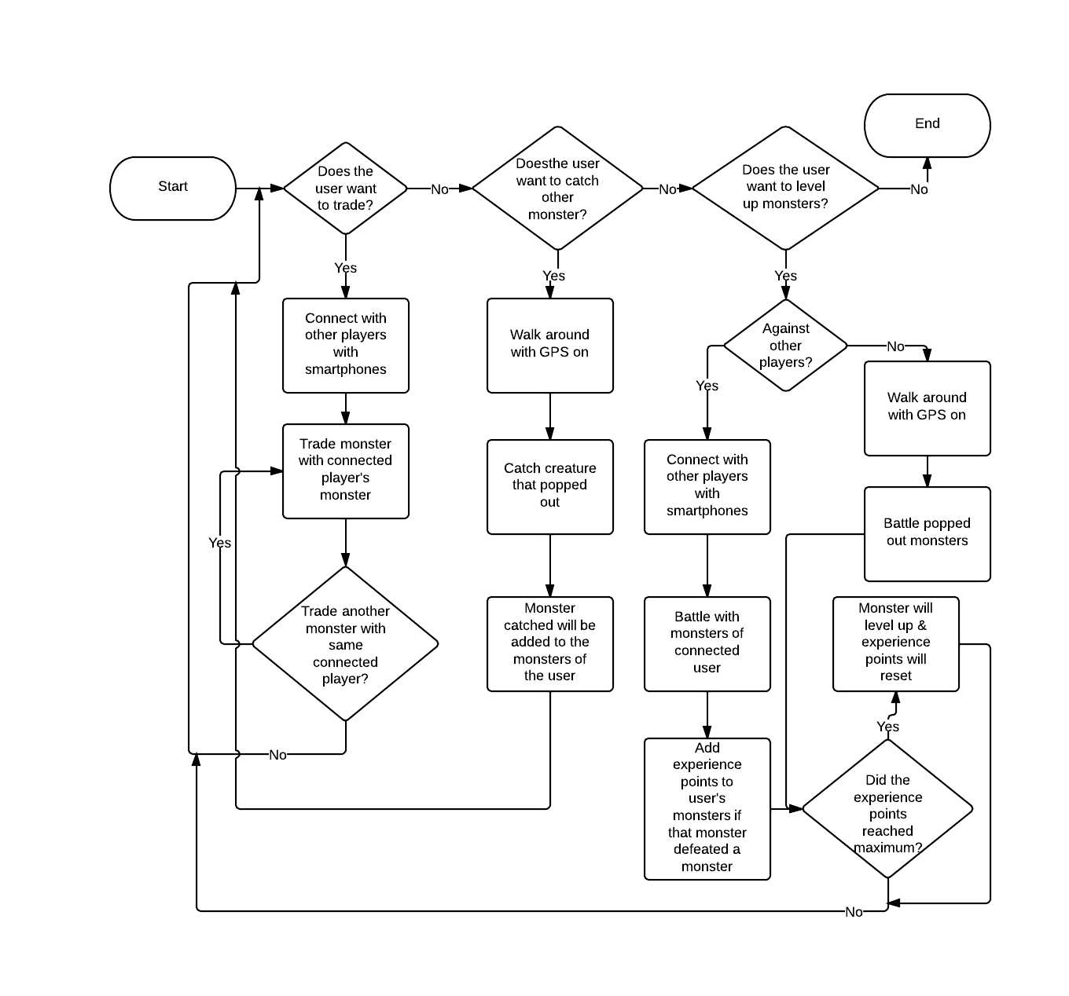**Flowchart:**

**Business Requirements:**

1. Before execution:  
   1) User must have a smartphone  
   2) That smartphone must have GPS, and it must be turned ON before while the application is running  
   3) The user must have the game application installed
2. Trading:  
   1) When two (2) players do a trade, only one (1) monster can be traded at a time (1 monster per player)  
   2) The user must have at least one (1) monster when he or she wants to trade
3. Battle
4. The users must carry with them at least one creature each.
5. Only one creature may be sent out at a time.