**Resultados en Modelos**

1. G3 ~ age,failures,studytime,traveltime

RMSE = 0.92 modelo lineal

OLS vs KKNN vs Elastic

Testeados con la misma respuesta de los datos

No vi el rmse de los otros.

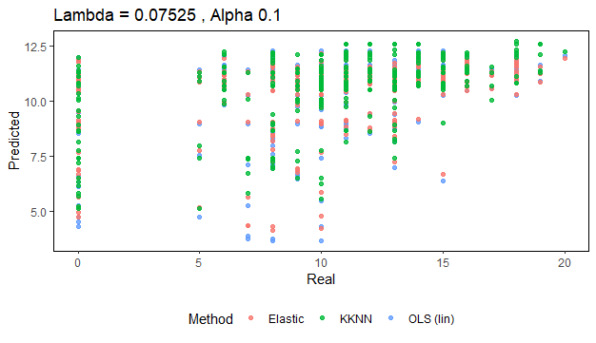

1. G3 ~ G1,G2, age,failures,studytime,traveltime

RMSE = 0.3810355 Lineal

No vi los otros

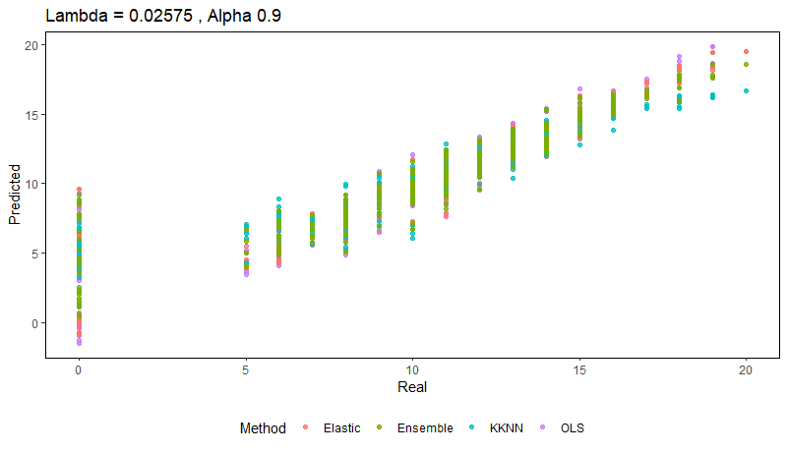

1. G3 ~ G1,G2

RMSE = 0.3854 lineal

No tengo pruebas pero tampoco dudas

1. G3 ~ G1,G2, age,failures,studytime,traveltime,absences

RMSE = 0.3763 Lineal

RMSE = 0.3469835 Random Forest

RMSE = 0.37784 Elastic

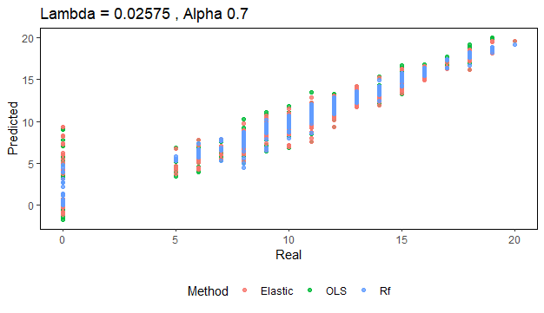

Hay++++

1. G3 ~ G1,G2, age,failures,studytime,traveltime

,absences +G1:G2+ failures:absences + traveltime:studytime

RMSE = 0.3669 Lineal

RMSE = 0.3740351 Elastic

RMSE = 0.3625836 Forest

RMSE = 0.434244 SVM

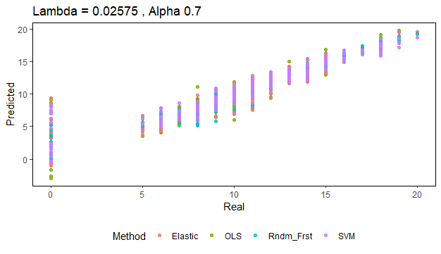

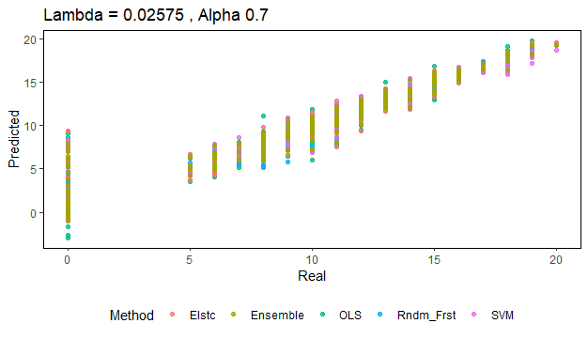

1. G3 ~ G1+G2+absences + absences:failure

RMSE = 0.3739011 Lineal

RMSE = 0.3755224 Elastic

RMSE = 0.3729 Forest

#aqui empezamos a usar factores, o sea sin data escalada

1. G3 ~ G2,G1,age,studytime,failures,traveltime

,absences,Medu,Fedu,famrel,freetime,goout,Dalc,Walc,health

RMSE = 0.3678 Lineal

RMSE = 0.3760 Elastic

RMSE = 0.5685 KNN

RMSE = 0.3514 Forest

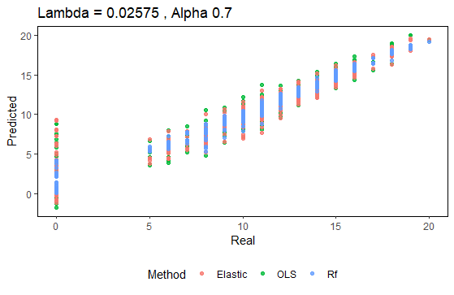

1. G3 ~ G2,G1,age,studytime,failures,traveltime

,absences,Medu,Fedu,famrel,freetime,goout,Dalc,Walc

RMSE = 0.3678 Lineal

RMSE = 0.3758 Elastic

RMSE = - KNN

RMSE = 0.3657 Forest

1. G3 ~ G2,G1,age,studytime,failures,traveltime

,absences,Medu,Fedu,famrel,freetime,goout,Walc

RMSE = 0.3690 Lineal

RMSE = 0.3760 Elastic

RMSE = - KNN

RMSE = 0.3506 Forest

1. G3 ~ G2,G1,age,studytime,failures,traveltime

,absences,Medu,Fedu,famrel,goout,Walc

RMSE = 0.3692 Lineal

RMSE = 0.3757 Elastic

RMSE = - KNN

RMSE = 0. 3476 Forest

1. G3 ~ G2,G1,age,studytime,failures,traveltime

,absences,famrel, goout,Walc

RMSE = 0.37065 Lineal

RMSE = 0.37479 Elastic

RMSE = 0.4973 KNN

RMSE = 0. 34278 Forest

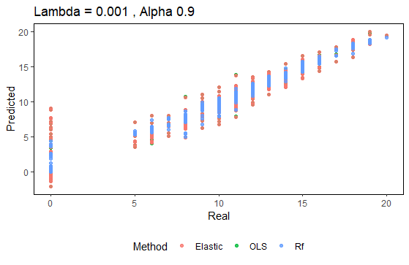

1. G3 ~ G2,G1,age,studytime,failures,traveltime

,absences,famrel,Walc

RMSE = 0.37100 Lineal

RMSE = 0.3744 Elastic

RMSE = KNN

RMSE = 0. 3425 Forest

1. G3 ~ G2,G1studytime,failures,traveltime

,absences,famrel,Walc

RMSE = 0.3734 Lineal

RMSE = 0.3749 Elastic

RMSE = KNN

RMSE = 0. 3597 Forest

1. G3 ~ G2,G1,age,failures,traveltime

,absences,famrel,Walc

RMSE = 0.3712 Lineal

RMSE = Elastic

RMSE = KNN

RMSE = 0. 3567 Forest

1. Mejor (ESTE ES EL MÁS ACOTADO!!)

G3 ~ G1,G2, age,failures,studytime,traveltime,absences

RMSE = 0.2513 Lineal

RMSE = 0.2922 Random Forest

RMSE = 0.2544 Elastic

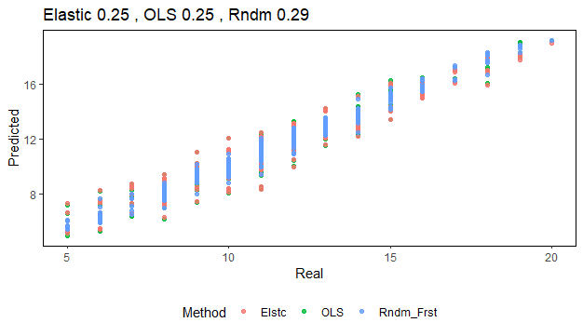

1. G3 ~ G1,G2, age,failures,studytime,traveltime

,absences +G1:G2+ failures:absences + traveltime:studytime

RMSE = 0.2499681 Lineal

RMSE = 0.296447 Random Forest

RMSE = 0.25458 Elastic

Al teste con la data nueva y comparando con G3t en Ensemble el Rndm es 0,25458 y el error porcentual es como del 3,327%.

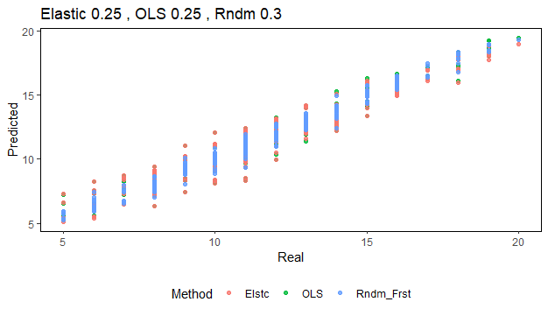

Al teste con la data nueva y comparando con G3train en Ensemble el RMSE es como 4 y el error porcentual es como del 34%.

Se ve así :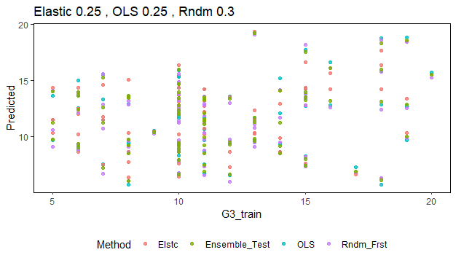

1. G3 ~ G1,G2, age,failures,studytime,traveltime,absences + G1:G2

RMSE = 0.2502 Lineal

RMSE = 0.2980 Random Forest

RMSE = 0.2513 Elastic

Redes neuronales

1. data_nn= data %>%

dplyr::select(,c("G2","G1","age","studytime","failures",

"G3","traveltime","absences","Medu",

"Fedu","famrel","freetime","goout"

,"Dalc","Walc","health"))

nn=neuralnet(G3 ~ .,data=data_scaled, hidden=10,act.fct = "logistic",

linear.output = TRUE,stepmax=10^5,threshold = 0.01)

Test

RaíZ Error Cuadrático Medio: 4.11626062121858

Error porcentual: 32.5147501475556"

Train

"RaíZ Error Cuadrático Medio: 0.314080081075223"

"Error porcentual: 2.05423360157281

1. G3 ~ G2,G1,age,studytime,failures,traveltime

,absences,Medu,Fedu,famrel,freetime,goout,Dalc,Walc,health (entrené con 200 noma)

RMSE = 0,245504 Lineal

RMSE = 0.2980 Random Forest

RMSE = 0.25552 Elastic