# Go to: <https://pyvisa.readthedocs.io/en/latest/> (use as reference)

# Install latest version of Python (from [here](https://www.python.org/downloads/))

# Install latest NI-VISA instrument drivers (from [here](https://www.ni.com/en/support/downloads/drivers/download.ni-visa.html#521671))

In Linux – download the drivers and run dpkg on the corresponding drivers (.deb on Ubuntu) – this should take you to the package manager page where you can install ‘NI-VISA-JAMMY-2023’ or similar

# Run the following commands:

py -m pip install -U pyvisa

py-m pip install -U pyvisa-py

In Linux run:

Sudo apt install python3-pyvisa

# Test install by running the commands stated on the main PyVISA page in Python:

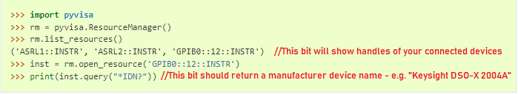

* If after running “rm.list_resources()”, all that is returned is “()”, confirm that the NI-VISA driver is properly installed
* If after running “import pyvisa” you get an error – confirm that step 4 has been done.
* If the SCPI “*IDN?” Query command works, you are good to go.

# Unsolved issues:

1. For step 4, these install commands need to be ran every time a user logs on of certain PCs. On my PC, I do not have to. Paul suggested a potential install location issue…
2. If the network interface is set to DHCP and assigns a new IP address to any of the pieces of test equipment at any time, the handle that your test equipment uses to communicate will change also. This is a pain in the arse, as it means you must change the handle for certain devices that include the IP address in theirs in your software each time. See below for an example of this type of handle (the one above it for the LCR meter is okay because it doesn’t use the IP address in it’s name:

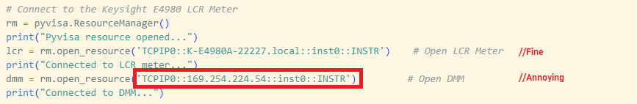

It would be useful to have set IP addresses for this reason, but we were struggling to change the USB-to-Ethernet adapter’s IP to a static one for some reason.

Help.