
Peer Tutors Website
Project Title: Peer Tutors Website
Name: Andinda Stuart
Student ID: 2024/bit/181/ps
Institution: Mbarara University of Science and Technology
Course: Web Designing
Instructor: Mr. Bwana Anthony

1. Introduction
The Peer Tutors Website is a simple web platform designed to connect students in need of academic assistance with fellow student tutors. The system allows students to register, log in, and submit tutoring requests, while tutors or administrators can view these requests and respond accordingly.

2. Technologies Used
- HTML5
- CSS3
- PHP
- MySQL
- JavaScript

3. Database Design
The system uses a MySQL database named 'peer_tutors_db'. It includes tables for users, tutoring requests, optional admin messages, and tutor assignments.
Page 1
Peer Tutors Website

4. Sample Code Snippets
Database Connection (db.php):
<?php $conn = new mysqli("localhost", "root", "", "peer_tutors_db"); if ($conn->connect_error) { die("Connection failed: " . $conn->connect_error); }
?>
User Registration (register.php):
<?php include 'db.php'; if ($_SERVER["REQUEST_METHOD"] == "POST") { $username = $_POST['username'];
$email = $_POST['email'];
$password = password_hash($_POST['password'], PASSWORD_DEFAULT);
$sql = "INSERT INTO users (username, email, password) VALUES ('$username', '$email',
'$password')"; if ($conn->query($sql) === TRUE) { echo "Registration successful."; } else { echo "Error: " . $conn->error; }
}
?>
5. Screenshots
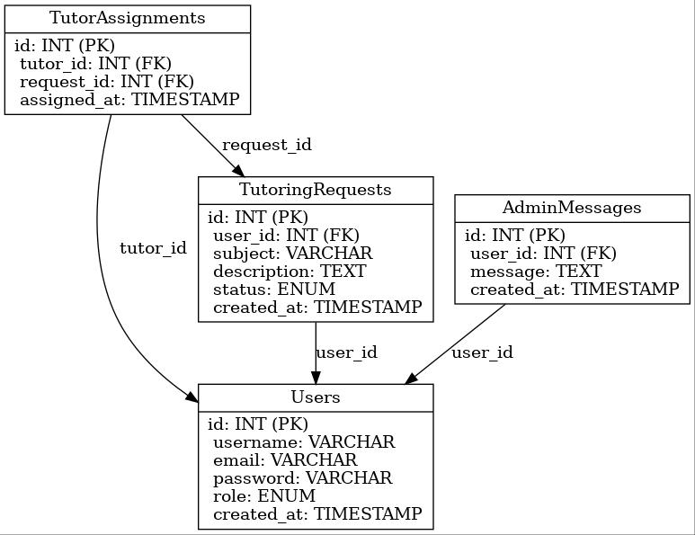
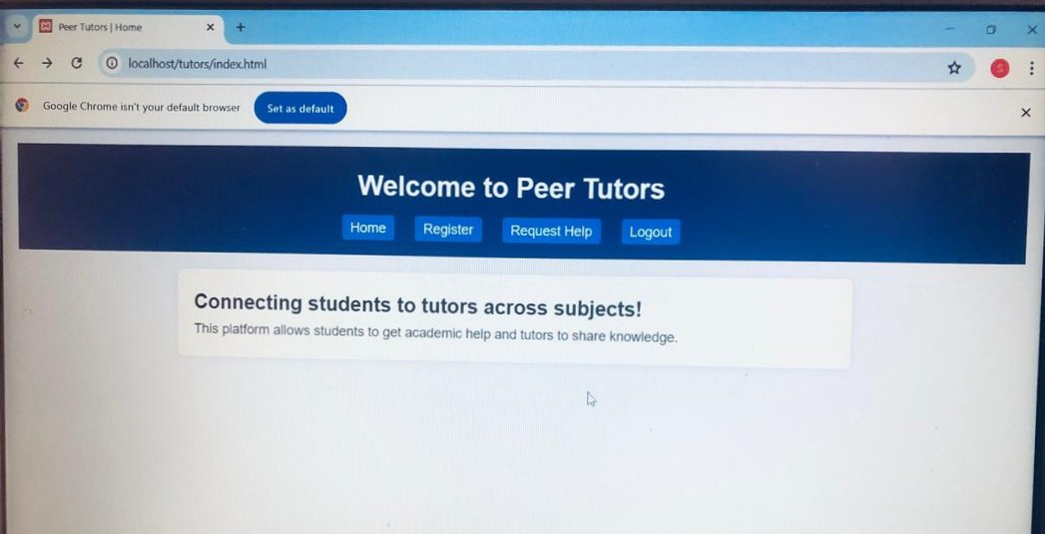
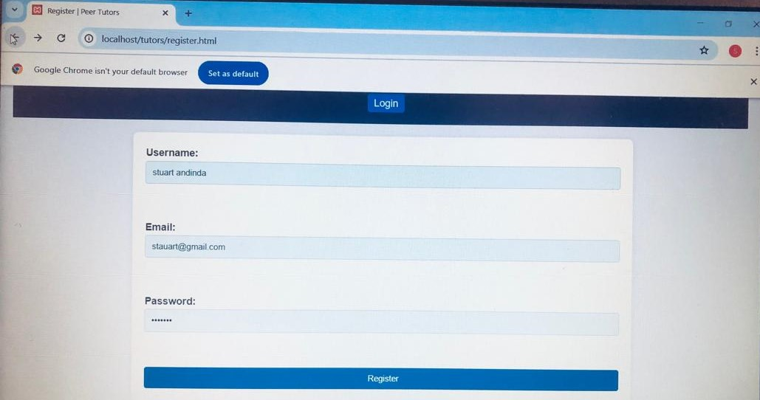

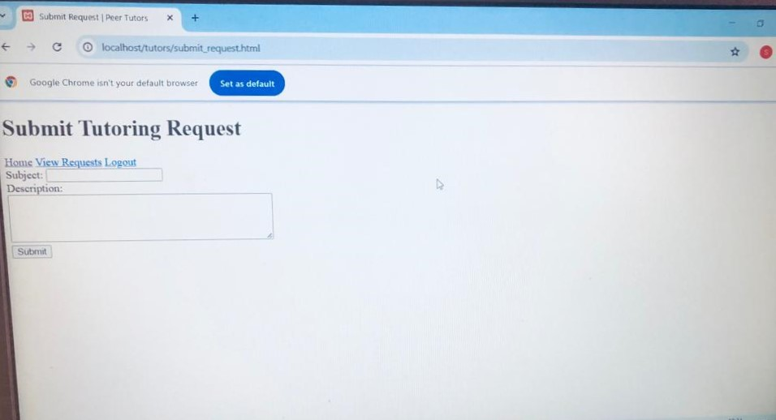
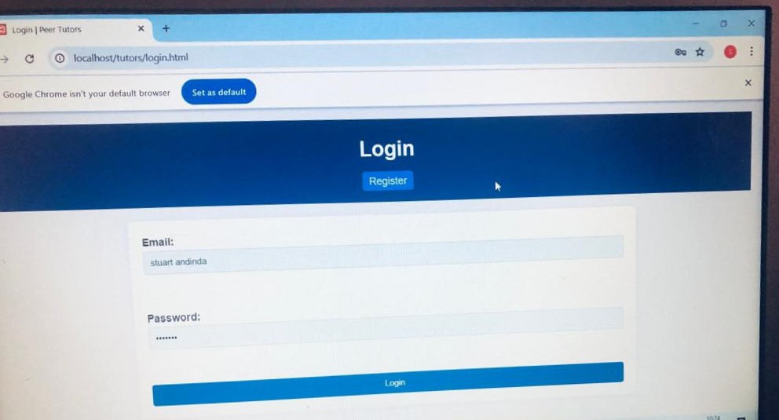

6. Conclusion
This project demonstrates the practical use of web technologies in solving real-life academic collaboration problems. Future improvements could include real-time chat, file uploads, notifications, and tutor rating features.
Page 2

