**Flood Relief and Evacuation Design:**

**Amphibious Bicycle Kit**

Phase Three Progress Report

ME 263 Section 064

Janene Silvers

Priya Seshadri

March 2014

Brittany Stuart __________________ Date _________________

Alex Hein ___________________ Date _________________

Abhijith Ravishankar ___________________ Date _________________

Stephen Burd __________________­­_ Date _________________

**Executive Summary**

The project task for Vision Quest Design Team (VQDT) was to design a product that can assist civilians in a natural disaster. From this, VQDT has developed an amphibious bicycle kit. This product is meant to attach to bicycles and be rapidly deployable in flooding situations to provide transportation. This report focuses on the final design and analysis of the design.

The design is a kit that can be attached to most personal bicycles. The kit consists of four basic systems: a front unit, rear unit, a pump, and a floatation device. The front unit allows for steering in the water and is mounted over the front wheel. The pump is mounted on the back tire and uses the existing bike chain and an attachment to turn the pump fins. The floatation device consists of four pontoons that are inflatable for a compact travel size. The rear unit attaches the pontoons to the bicycle. All together, the kit is designed to be compact and can be driven in water and on land while deployed.

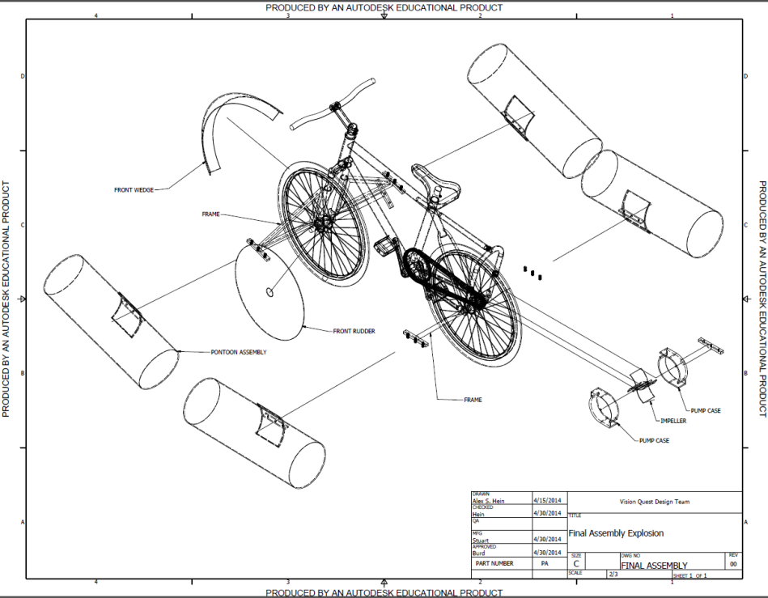During the design of this product, VQDT analyzed specific functions of the bicycle kit using engineering models to ensure its durability and feasibility. For example, the floatation system was analyzed for size and buoyant force and the frame was analyzed for loading strength. Through these models VQDT determined the size and strengths of the materials needed. For example, the pontoons must have a total volume at least 0.3m3 and the material used for the frame will be aluminum-6061 because it is light weight, easy to machine and bend, and it is corrosion resistant.

Figure 1: Full Amphibious Bicycle Kit assembly (Appendix C)

Another analysis VQDT conducted was design for assembly (DFA). Through this, VQDT modified the design to include chamfers on the tubing and hinges to aid in assembly. VQDT also eliminated a few parts by purchasing a pipe hinge instead of manufacturing the hinge. This step was necessary to reduce assembly costs, but also to ensure the correct assembly of the kit since most of the assembly will be done by the user.

After the design analysis was completed, VQDT wanted to ensure that they are designing a product that is still marketable. They did this by comparing their product to the existing products on the market. Amphibious bicycles have been made before, but never heavily marketed. There is only one major amphibious bicycle kit on the market; although it is small and light weight, it costs around $5,000 and cannot be driven on land while deployed. The VQDT amphibious bicycle kit costs $213.56 to manufacture and will sell for $848.64, well below the competitor’s price. Also, according to the VQDT economic model, the payback period will be in the seventh quarter. With this information, VQDT believes that they have designed a product that has a sustainable and competitive advantage in the market.

**CONTENTS**

1 - Introduction………………………………………………………………………………………………………………………….1

2 – Customer and Market Research……………..……………………………………………………………………………1

3 – Amphibious Bicycle Kit…………………………………..………………………………………………………………….…2

4 – Manufacturing and Materials………………………………..……………………………………………..………………3

5 – Engineering Models.…..………………………………………………………………………………………………………..4

6 – Design for Assembly………………………………………………………………………………………………..…..………5

7 - Comparison to Benchmarks…………….……………………………………………………………..…………………….6

8 – Economic Analysis………………………………………………………………………………………………………………..7

9 - Conclusions ……………………………………………………………………………………………………………….…………9

10 - References……………………………………………………………………………………………………………….…….…10

11 - Appendices………………………….…………………………………………………………………………………….……..12

Appendix A: Bill of Materials…….………………………………………………….………………………………12

Appendix B: Part Drawings..…………………………….……………………………………………………..……13

Appendix C: Assembly Drawings…………………………………………………………………………..………17

Appendix D: Engineering Model: Pump…………………………………………………………………..……21

Appendix E: Engineering Model: Front Wedge……………………………………………………………..22

Appendix F: Engineering Model: Floatation Device………………………………………………………24

Appendix G: Engineering Model: Rudder……………………………………………………………………..25

Appendix H: Sustainability Consideration……………………………………………………………………..26

Appendix I: Decision Matrix………………………………………………………………………………………….27

Appendix J: Design for Assembly Chart…………………………………………………………………………28

**1 – Introduction**

The purpose of this report is to summarize the progress of Vision Quest Design Team (VQDT) in phase three. The problem is to finalize the amphibious bicycle model that can be used to help rescue people from flood situations in rural areas. The report contains information about the design, engineering models, comparison to benchmarks, and economic analysis of the device. This phase also contains a manufacturing and materials list with the bill of materials. Phase one had VQDT search for a device for rescue operations regarding a specific disaster whereas phase two contained the different concept generation for attachments to an amphibious bicycle and updating the problem definition.

**2 – Customer and Market Research**

The team defined the problem to be “To aid people trapped in post-flooding situations by designing an attachment to a bicycle to allow transportation through water.” On average 6,750 people die annually due to not being able to transport themselves out of flood areas, the team felt this was a necessary device to design. From doing research, the team found out that 96.8 million people are affected by flooding each year, most of these occurring in underdeveloped countries such as Africa and Indonesia [7]. The team also discovered that the bicycle is the main mode of transportation in these countries and that most families own one, if not more. Since bicycles are so common, they are the perfect device to transform into an amphibious vehicle to help people when they are in need.

Qualitative requirements of problem definition

1. Low cost
2. Low maintenance
3. Durable
4. Waterproof
5. Easy to use
6. Light weight

Quantitative requirements of problem definition

1. Maximum price to manufacture $250
2. Take less than five minutes to install
3. Mean time between failure is greater than 36 months
4. Volumetric space has maximum of 0.5 m3
5. Takes fewer than 60 seconds to deploy
6. Supports up to 115 kilograms
7. Maximum mass of unit is 8 kilograms
8. Operable depth greater than 0.5 meters
9. Minimum speed in water five miles/hour (at maximum rate)
10. No more than five moving pieces
11. Minimum distance travelled in water is 100 kilometers
12. Takes one tool to install device onto bicycle
13. Takes one person to install device onto bicycle
14. Only takes one person to deploy device for water use
15. Can withstand up to two meter waves when hit head on
16. Can withstand up to 0.5 meter waves when hit broadside
17. Has a minimum turning radius of 1.5 meters
18. Less than 10% speed loss on land while kit attached
19. Factor of safety of 2.5
20. Material cost less than $20 per unit
21. Assembly cost less than $20 per unit
22. Less than a minute to transform back to land use
23. Can be deployed and retracted at least 10 times without failure

**3 – Amphibious Bicycle Kit**

VQDT’s current design consists of four pieces: a front unit, a rear unit, the centrifugal pump, and the flotation device. The functions of these units allow the bicycle to perform all necessary functions and fulfill all customer and engineering requirements.

The front unit is a system of support pipes that comes to a point at the very front, acting as a wedge. This will push debris out of the way and protect the user as the bicycle travels. It also has connections to attach the pontoons on each side. The front unit attaches to the bicycle at two points: on the front axle and on the steering column. The last component of the front unit is the front rudder; a thin plastic sheet that is inserted in front tire.

The rear unit’s main purpose is to connect the pontoons to the bicycle. There are attachments on each side of the unit for the pontoons. The rear unit connects to the bicycle on the rear axle and on the seat post.

The centrifugal pump is driven by the chain that the user rotates through pedaling. A secondary gear is added on the main chain that drives an axle. This axle has a gear on the other end which drives the second chain. This chain connects directly to the centrifugal pump. The pump has enclosed fins which increase the pressure of the water inside of the pump case, which forces the water to rotate. The water then exits an outlet hole at maximum velocity, propelling the bicycle in the opposite direction.

The pontoons are inflatable and made of PVC 10 ounce fabric. They have a diameter of 0.25 meters and a length of 0.75 meters. When all four pontoons are fully inflated together, they can support over 150 kilograms, which surpasses the engineering requirement.

The current design costs $213.56. Out of this price, it costs $15.49 for purchased parts, $11.00 to assemble the product, and $185.67 for manufactured parts. Refer to Appendix B for a more detailed look of diagrams of the parts discussed.

**4 – Manufacturing and Materials**

The bicycle kit will be manufactured out of aluminum-6061, ABS, and PVC 10 ounce fabric. The aluminum was selected because it is light weight, corrosion resistant, and easy to manufacture and bend. The aluminum piping will be bent and the attachments to the bicycle will be welded to it. There will also be holes drilled into the frame to attach the pipe hinges. ABS was selected for the pump because it is easy to manufacture and is water resistant, which is important because the pump is consistently submerged. The pump will be manufactured using a CNC mill. The PVC 10 ounce fabric was selected because it is tough and waterproof; most inflatable rafts are made of similar material to avoid punctures or rips. The manufacturing for the floatation device includes cutting and sewing the material to make four pontoons. Since the amphibious bicycle kit will be assembled by the user, there is a relatively low assembly cost. The only item that will be pre-assembled is the pump.

**5 – Engineering Models**

**Floatation Device**

The floatation device keeps the user afloat in water with the help of pontoons connected to the bicycle. With the assumptions of the weight of user to be 115 kilograms and weight of bicycle to be 20 kilograms, VQDT found the volume of the pontoon corresponding to the buoyant force necessary to support the user in water is 0.15 cubic meters. The noise factors are the varying weight of bicycle and user and also the salinity of water, which changes its density. The buoyant force required to hold the user in a balanced state is dependent on mass of user, bicycle, and density of water. The pontoons will be held with A-frame structures connected to the side of the frame and the pontoon is made of PVC 10 ounce fabric. A mass vs. volume graph has been created for further information, found in Appendix F. According to this graph, VQDT found out that volume of the floatation device increases as mass of user and bicycle increase.

**Front Unit**

The front wedge helps clear path and also, in turn, helps increase speed. It is a circular component that comes to an edge in the middle that goes over the top and front part of the wheel. The weight of the wedge is negligible and it must withstand forces from debris. The force due to debris is dependent on the mass and acceleration of the user and bicycle. The front wedge is made of aluminum and will be paint coated to help prevent rust. The front wedge goes down ¾ of the height of the wheel. The front wedge has an outer diameter of 30 inches and spans over an angle of 135 degrees across the wheel. The front wedge is attached to the steering column and the front axle.

The front rudder acts as the steering mechanism and helps in maneuvering. The noise factors include the wave form and the current direction. VQDT assumed that the front rudder is of uniform density. The thickness of the front rudder is 0.063 inches and the material is aluminum.

**Centrifugal Pump**

The centrifugal pump converts angular motion into linear motion. VQDT assumed that the pump is fully submerged and that weight is evenly distributed. Forces in horizontal direction were only taken into consideration and that was equated to the acceleration of the unit. The acceleration of the bicycle in the horizontal direction is dependent on the radius of pump, the volume, and the angular velocity. The pump consists of fins that are attached to a gear that drives the fins. The centrifugal pump is mounted adjacent to the rear wheel. Water enters from the sides of the pump and the rotating fins accelerate the water. When it exits, its velocity propels the bicycle forward.

All these attachments are easy to handle and fix onto the bicycle frame; installation requires little effort. The floatation device takes a maximum of sixty seconds to deploy. The attached parts are all water resistant and can support multiple weights. They each have a low weight per unit.

**6 – Design for Assembly**

The amphibious bicycle has four main components that are needed for assembly, being the front unit, rear unit, the propulsion system, and the flotation system. The front unit requires two welds, which are straight forward. The rear unit also requires two simple welds.

The propulsion system requires several steps of assembly. First, the fins are welded onto the fin center. Second, the fin center is press fitted around an axle. Third, the unit is placed inside of the left and right pump cases. The cases are then mated together with bolts, washer, lock washers, and nuts.

*Chart 1: Pump Assembly Flow Chart*

There were several engineering requirements that the group had to meet so that it will be a successful product. The main three were mass of the unit, time to deploy, and weight supported. In order to keep the weight of the unit below the threshold, the VQDT had to cut down the thickness of the front wedge, front rudder, and the pump case. In order to shorten the deployment time the VQDT decided to add hinges to the frame so that the kit can remain on the bicycle both on land and in water. Lastly, to make sure the weight supported was within the engineering requirement range the VQDT created an engineering model to see the volume needed to displace the correct weight of the rider. Once that was done, the VQDT decide to create four pontoons that displaces water and uses the pontoons on the actual assembly.

After the design for assembly (DFA), there were some changes that were made including a change in the way the pump case was manufactured as well as the type of material used. With the DFA, the team recommended that they proceed forward with the changes after the initial revisions, the first being a change in the diameter for bolts on the pump assembly. The original bolt was 0.25 inches in diameter and it was changed to 0.125 inches in diameter. This did not add extra cost to the product. The lock washers, washers, and nuts have also been changed accordingly on the bill of materials. The cost of the pump case was decreased by using the part machining macro on MS Excel. A change was also made to the bracketing system to eliminate extra components which increased the DFA score. Finally, by increasing the complexity of the mounting bracket, the number of pieces was reduced which did not dramatically change the cost. For a look at the notes taken from the before and after DFA, refer to Appendix J.

**7 – Comparison to Benchmarks**

The team’s original benchmarks were other products that have the same overall function: to transport individuals across water in post-flooding situations. The four benchmarks chosen were helicopters, motor boats, man powered boats, and personal flotation devices (PFDs). When comparing the amphibious bicycle kit to a helicopter, it was found that the bicycle is significantly lighter, less expensive, easier to use, and requires much less maintenance. Drawbacks include less durability and that it is less safe to use. When comparing to the motor boat, the kit is lighter, more storable, and lower in cost, but the motor boat is safer to use, more durable, and can transport many people at once while the bicycle can only transport one person at a time. The comparison to the man powered boat is the exact same as the motor boat, except that the price is similar to that of the kit. When comparing to the PFD, it was found that the PFD is much lighter, easier to store, and less expensive, but it significantly less safe, requires more input from the user to travel, and travel is slower. Overall, it was found that the amphibious bicycle kit works better than all benchmarks in rural situations where floods occur. It transports people in a low cost and safe manor, at a reasonable speed, and last for many reuses.

A similar device to the amphibious bicycle kit is the Shuttle Bike. VQDT determined this device is the most comparable design to the team’s design. It is currently the only major solution on the market. The kit sold fits inside a backpack, weighs eleven kilograms, can be deployed in ten minutes without the use of tools, and has a top speed of ten KPH [15]. The largest problem is the price, which is $5,000. This makes it impractical for members of VQDT’s target market to purchase. VQDT’s product is more applicable to the target market.

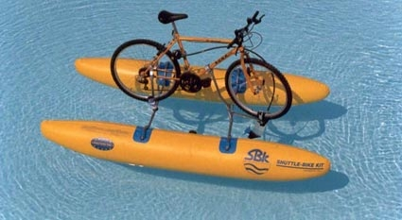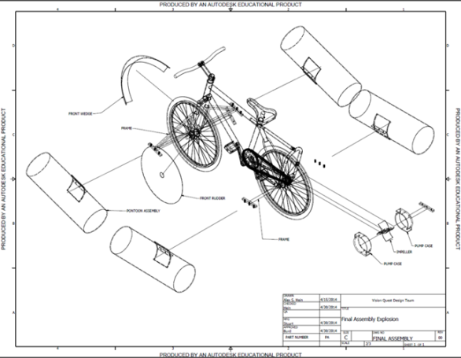

*Image Two: Shuttle Bike [14] Image One:* Amphibious Bicycle Kit

**8 – Economic Analysis**

For the economic analysis, there were quite a few standardized inputs. The first non-standard input was the tooling and fixtures cost, which the VQDT used $105,000 for their analysis. This value was gathered by using a $50,000 and $5,000 additional dollars per dollar of assembly cost. The second was the cost of manufacturing, which is $212.16 per kit. This value dictates the retail cost of the entire product as it is four times that of the manufacturing costs. When it came to calculating the price of the total for purchased parts, 25% of the price of the purchased parts used. This is due to the fact that components can be bought in bulk. The last input was the annual production. The VQDT decided that a reasonable amount of production was 4,000 amphibious bicycle kits. Based on the customer and market research, there is a strong demand for at least this quantity annually. The only reason annual production is not higher is due to the amount of initial capital that is needed.

After the economic analysis calculations and inputs were completed, the analysis returned some measures of profit. At the end of the 15 quarter period, the final net present value, with interest, was about $294,000. This shows that the product was profitable. The payback period, when net present value became profitable, was in the 7th quarter. With those two measures, the VQDT did an analysis to see what the minimum production must be based on all inputs so that the net worth is zero by the end of the 15th quarter. When interest is factored in, the minimum is 1221 kits. Without interest, the minimum production will only need to be 1061 kits. The last two major profit analyzers are rate of return (ROR) and return on investment (ROI). The ROR is a track to see how profitable an investment is over a time period (in this case it was a year). The ROR was calculated to be 98.57%. The ROI describes how profitable the investment was, which was found to be 73.91%. With all of these values being returned in the economic analysis, the VQDT’s product is profitable at the current rate of production.

*Chart 2: Net worth vs Time*

**9 – Conclusion**

When analyzing strengths of the amphibious bicycle kit, there are a few that stand out. The first is the target market size. The VQDT found that on average 96.8 million (M) people are affected by floods annually, in addition to that fact 90% of households in India own bicycles. This shows a strong market. When it comes to the design, the kit is very easy to install and use. Since it is so useable, it makes it more appealing to the user. In addition, compared to the benchmark, the VDQT’s product is relatively inexpensive. Lastly, per the VQDT economic analysis, the product is very profitable and has a high ROR and ROI. With all of these strengths, there is no reason that funding should not be given to move forward and begin production of the VQDT’s amphibious bicycle kit.

**10 – References**

1. Bangkok floods. *MSNBC Media*. Retrieved from http://msnbcmedia.msn.com/j/MSNBC/Components/Photo/_new/pb-111029-bangkok-jb-02b.photoblog900.jpg
2. Bicycle Statistics: Usage, Production, Sales, Import, Export. *International Bicycle Fund*. Retrieved from http://www.ibike.org/library/statistics-data.htm
3. Bihar: 160 people killed, 5.4 million people affected by floods in 2013. (2013, September 3). *IBN Live*. Retrieved from http://ibnlive.in.com/news/bihar-160-people-killed-54-million-people-affected-by-floods-in-2013/419295-3-232.html
4. Facts about life jackets. Personal Floatation Device Manufacturers Association. Retrieved from http://www.pfdma.org/local/downloads/documents/pfdmabrochure.pdf
5. Flood - Data and statistics. (2008). *Prevention* *Web*. Retrieved from http://www.preventionweb.net/english/hazards/statistics/?hid=62
6. Floods in Bangladesh. *Wikipedia*. Retrieved from http://en.wikipedia.org/wiki/Floods_in_Bangladesh
7. Floods-Disaster profile. *World Health Organization.* Retrieved from http://www.who.int/hac/techguidance/ems/floods/en/
8. Guyer, Eric (2011). *Expert Witness Painting Aluminum – Paint Failure and Defects.* Retrieved from <http://www.the-coatings-expert.com/painting-aluminum.htm>
9. India subdivisions flood hit between July 3 and August 15 2007. (2008, April 26) *Wikimedia Commons*. Retrieved from http://commons.wikimedia.org/wiki/File:India_subdivisions_flood_hit_between_July_3_and_August_15_2007.png
10. Koreans Stranded on top of houses. *Telegraph*. Retrieved from http://i.telegraph.co.uk/multimedia/archive/02293/korea-house-roof_2293109k.jpg
11. Natural Hazards-Flooding. *Natural Disasters Association*. Retrieved from http://www.n-d-a.org/flooding.php
12. Ooredoo, Indosat pledge help to flood victims. (2014, January 28). *Gulf Times*. Retrieved from http://www.gulftimes.com/Qatar/178/details/379224/Ooredoo%2c-Indosat-pledge-help-to-flood-victims
13. PFDMA Frequently Asked Questions. Personal Floatation Device Manufacturers Association. Retrieved from <http://www.pfdma.org/faq/default.aspx>
14. Purdue, Joab, Jay . (2000, April 18). Amphibious Bicycle. *Google Patents*. Retrieved from http://www.google.com/patents/US6050864
15. SBK-KIT (2014). *Shuttle Bike*. Retrieved from <http://www.shuttlebike.it/index.html>
16. Vaswani, Karishma. Indonesian capital Jakarta hit by deadly flooding. (2013, January 17) *News Asia*. Retrieved from http://www.bbc.co.uk/news/world-asia-21054769
17. What are the consequences of floods? (2013, March 15) *Queensland Government*. Retrieved from http://www.chiefscientist.qld.gov.au/publications/ understanding-floods/consequences.aspx

**11 – Appendices**

**Appendix A: Bill of Materials:**

The following chart is the Bill of Materials VQDT made to determine the overall cost of manufacturing the amphibious bike kit. It includes assembly cost (A), purchased parts (P) and manufactured parts (M). The total cost of manufacturing was determined to be $213.56.



**Appendix B: Part Drawings:**

The following part drawings are orthographic views of the four major designed parts in the amphibious bicycle kit: floatation device, pump, front mount and rear mount.

Floatation Device:

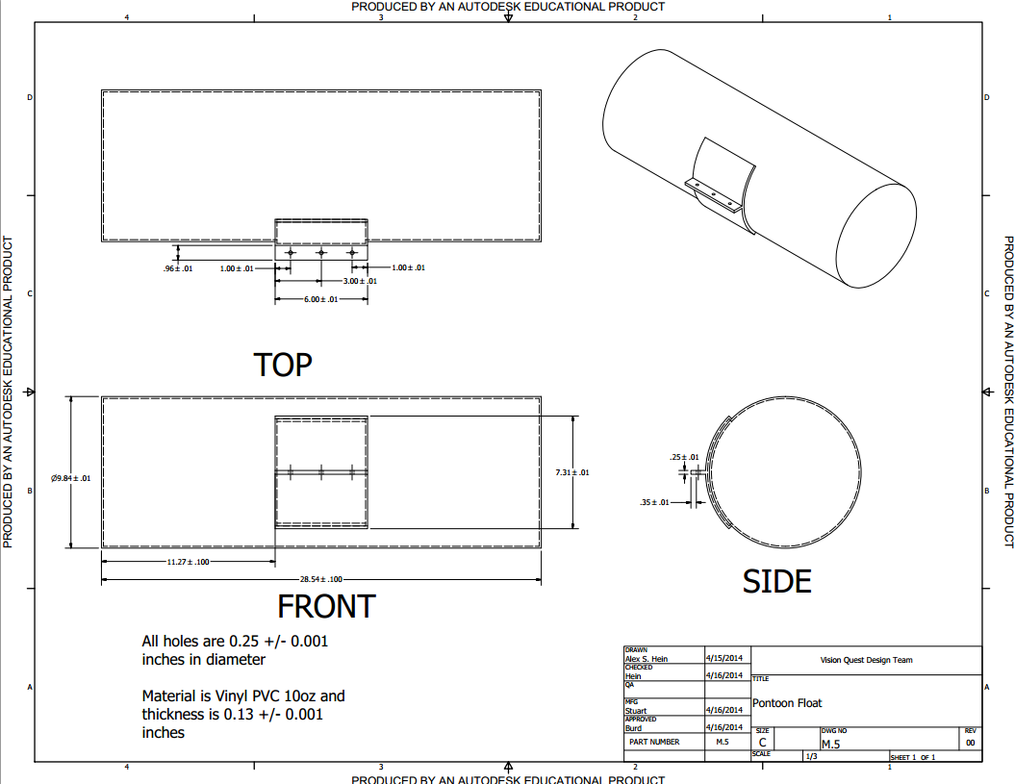

Pump:

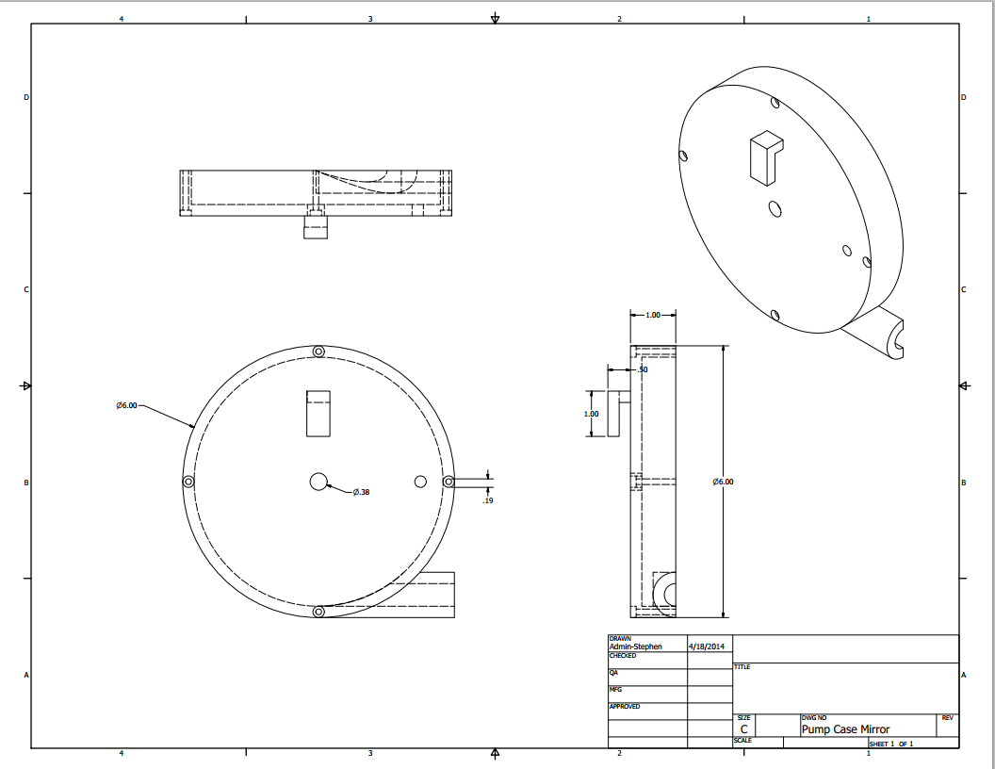

Front Wedge:

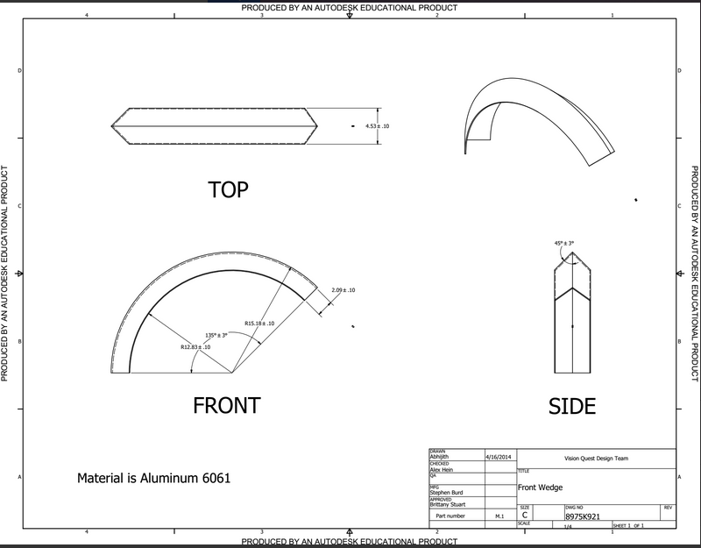

Rear Mount:

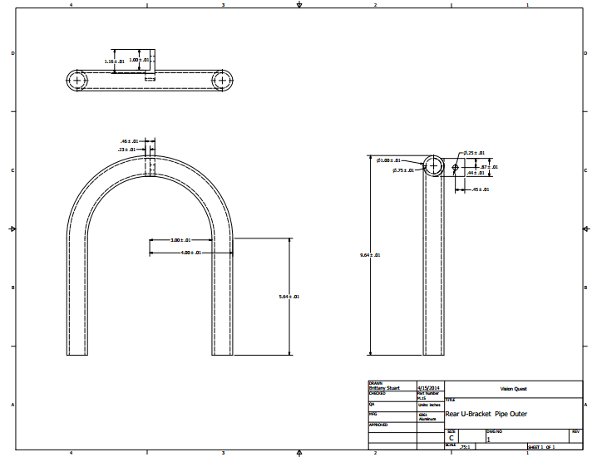

**Appendix C: Assembly Drawings:**

The following assembly drawings are isometric views of the four major systems in the amphibious bicycle kit and the final assembly attached to a bicycle.

Total Assembly:

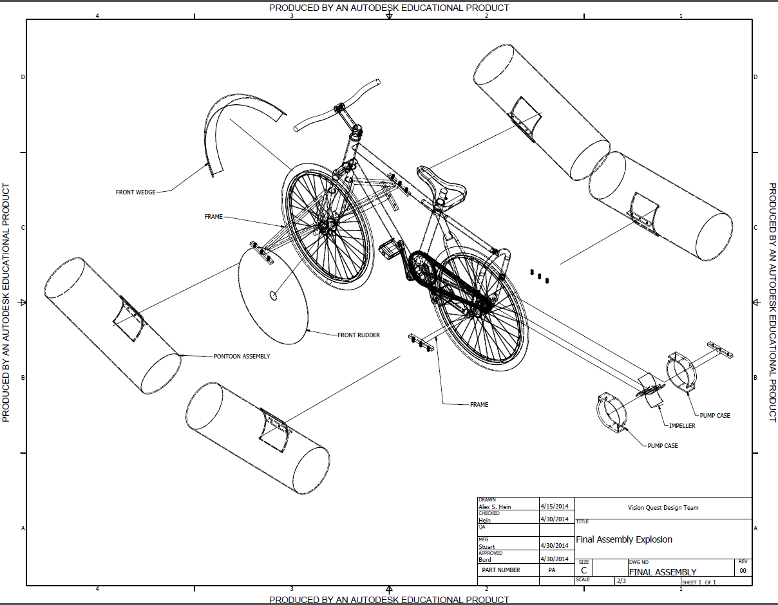

Floatation Device:

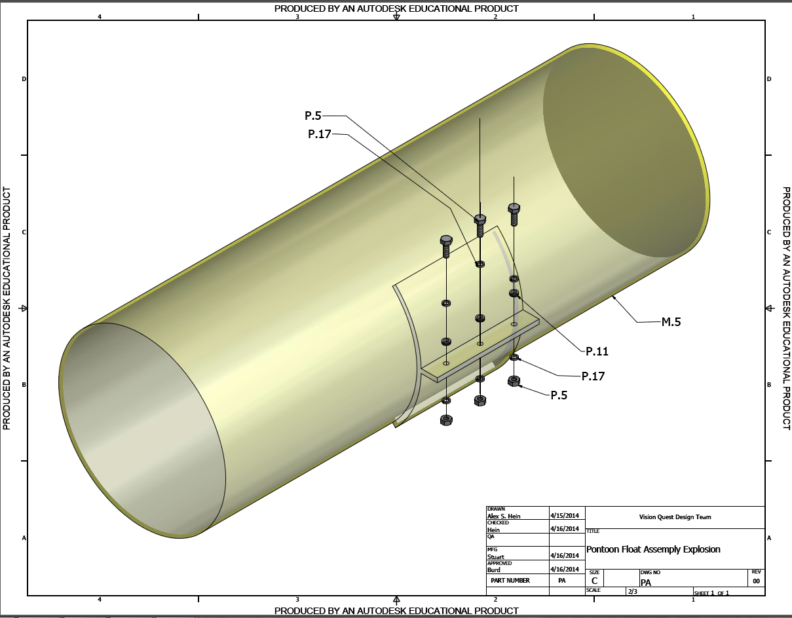

Pump:

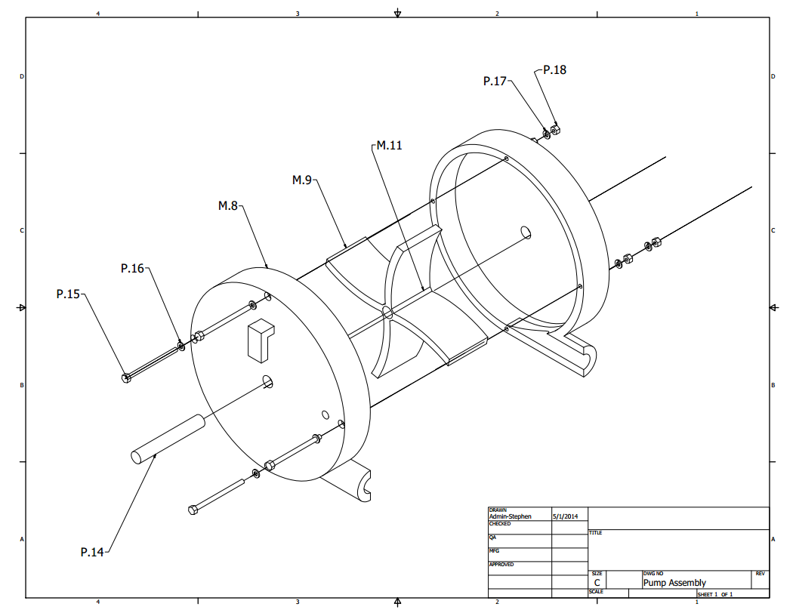

Front Mount and Wedge:

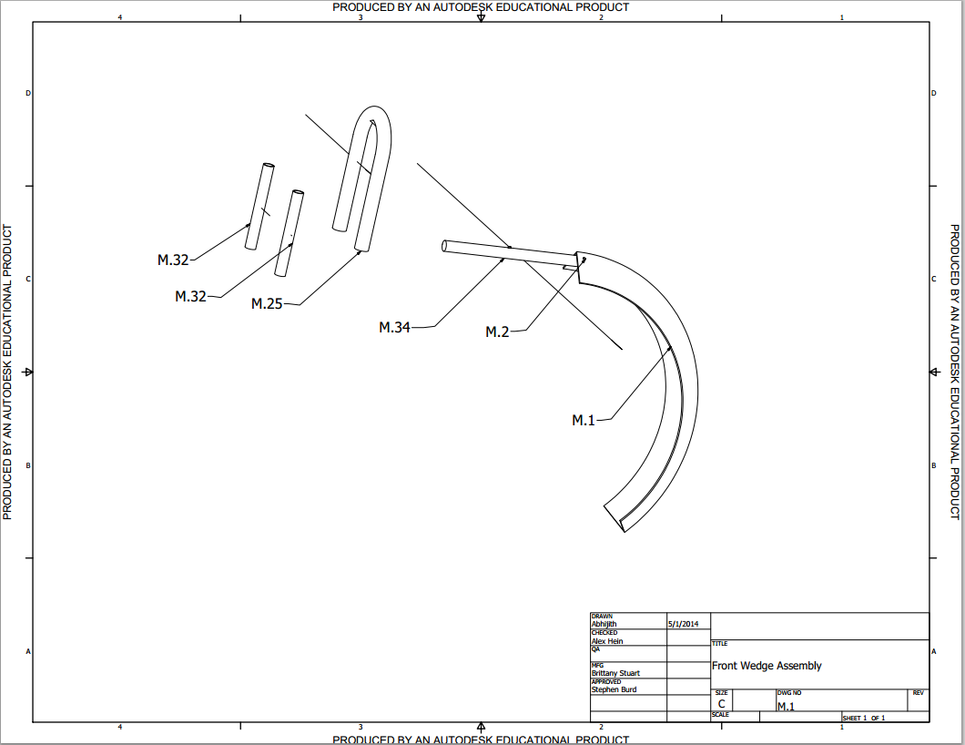

Rear Mount:

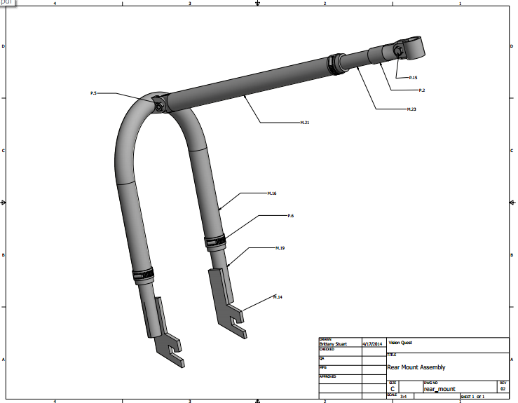

**Appendix D: Engineering Analysis: Pump:**

Purpose: to redirect circular motion into linear motion

Assumptions:

* water only enters inlet and only exits outlet
* pump is completely submerged in water

P-Diagram:

Angular velocity of shaft

Centrifugal Pump

Angular motion Linear motion

Shape of fins

Number of fins

Direction of linear motion

Size of cavity

Variables:

mass (m), radius of fins (r), angular velocity (ω), acceleration of unit (ax = (dvunit/dt)), velocity of unit (vunit), surface area of fin (Afin), length of fin (d),

FH2O NET – Fdrag = max

8*FH2O – Fdrag = max

8*0.5*ρ*vfin2*CD*Afin – 0.5*ρ*vunit2*CD*Aunit = max

4*ρ*(ω*r*0.5)2*1.05*(2π*r*d*0.25) – 0.5*ρ*vunit2*0.42*(2π*r*d*0.5) = m*(dvunit/dt)

r = 3in = 0.25ft, = 0.076m, ρ = 1025 kg/m3, d = 2in = 0.051m

0.0378*ω2 – 2.62*vunit = m*(dvunit/dt)

Velocity of final product is a differential equation based on the angular velocity of the fins, which is dependent on the user.

**Appendix E: Engineering Analysis: Front Wedge:**

Purpose: determine the force acting on the front wedge

Assumptions:

* Fits easily onto the front wheel
* Wedge is of negligible weight
* Wedge does not imbalance bicycle

P-Diagram:

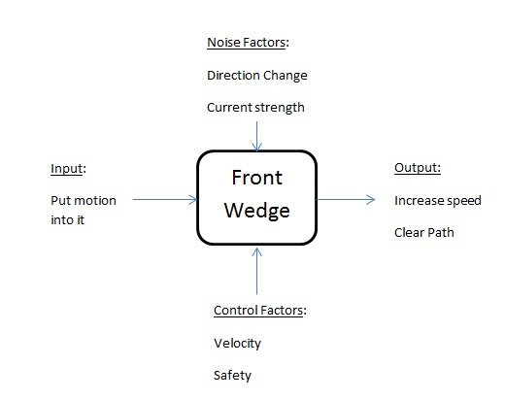

Diagram: Force Body Diagram:

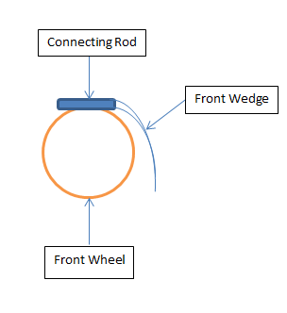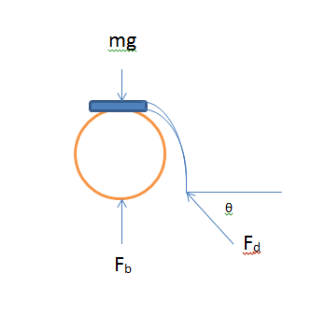

Variables:

ma- force due to acceleration

mg- Weight of front wheel

Fb- Buoyant Force

Fd- Force on wedge due to debris

Final Equation:

Forces in x-direction => ma = -Fdcosθ ------ (1)

Forces in y-direction => 0 = -mg+Fb+Fdsinθ ------(2)

Put (1) in (2),

Fb = mg + matanθ

Fb = m(g + atanθ)

The amount of buoyant force required to handle the front wheel with wedge in place.

**Appendix F: Engineering Model: Floatation Device:**

Purpose: determine the volume of the floatation device needed to keep the user and bike afloat

Assumptions:

* The floatation device can be modeled as a rectangular prism
* The weight of the user will be at most 15 kg
* The weight of the bike will be at most 20 kg
* The bike and the user have a negligible buoyancy force acting on them
* Fresh water

P-Diagram:

Input

Volume of floatation device

Noise

Weight of bicycle

Weight of user

Salinity of water

Temperature of water

Output

Buoyant force

Control Factors

Size of floatation device

Shape of floatation device

Flotation Device

Diagram:

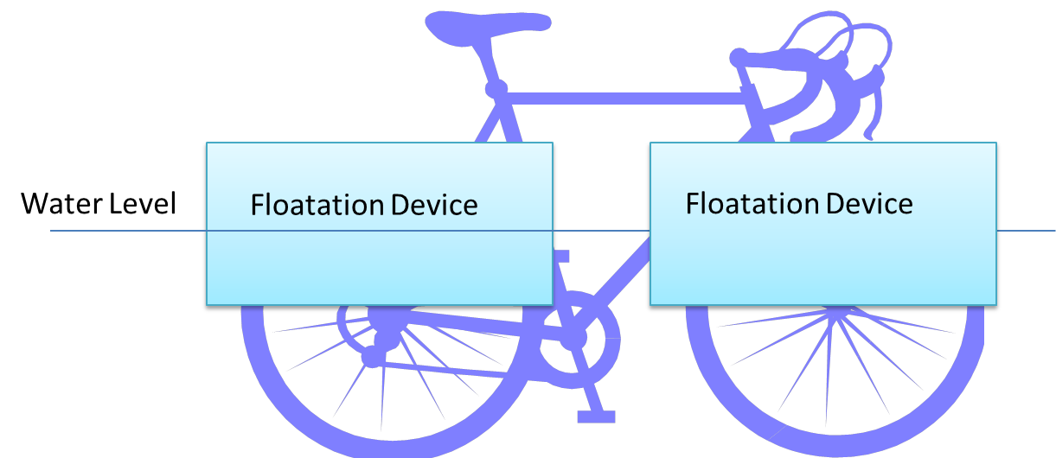

Variables:

V – Volume of pontoons

Mu – Mass of user

MB – Mass of bike

Ρ – Density of water

Final Equation:

Graph:

**Appendix G: Engineering Model: Rudder:**

Purpose: analyze the front rudder and see where improvements need to be made

Assumptions:

* Fresh water
* Water has no velocity

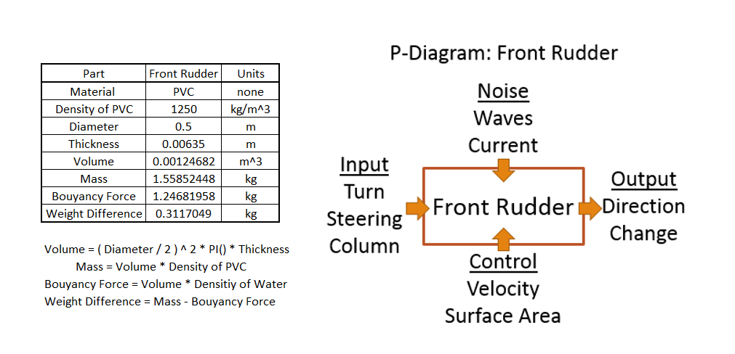

**Appendix H: Sustainability Consideration:**

The product uses aluminum in various parts for its lightweight and high strength properties. Although it is perfect for the applications of the team, it has an impact on the environment. Aluminum requires much effort to obtain for the first time; ore must be mined and washed to get it to its usable form. Mining often destroys the environment rapidly because many trees must be removed to get to the mine, materials from inside the mine is removed and not replaced, and soil erosion and pollutant runoff occur. After the material is produced, it can easily be reused. Recycling of aluminum is a simple process and occurs very often. Recycled aluminum only takes 5% as much energy to manufacture as the original aluminum took, therefore, it is viable to recycle and reuse. The team plans to include notes that encourage the users to recycle the product at the end of its life cycle with the kit so that as much materials is recycled as possible.

http://www.energyauditorhq.com/what-are-environmental-pros-and-cons-to-using-aluminum-as-a-building-material/

PVC (polyvinyl chloride) is used in the pontoons of the amphibious bicycle kit. PVC is a plastic that is not as bad for the environment when it is created because its main component is chlorine, a chemical that does not give off any byproducts when manufactured. It is still a plastic, which means that it hard to work with after its life cycle is over. It cannot be placed in landfills, as it will not biodegrade and it cannot be placed directly in the environment, as it will interfere with the animals living there. PVC also contains the chemical dioxin, which is one of the deadliest chemicals known to man, and cadmium, which is a heavy metal known to cause irreversible brain damage. It is also extremely hard to recycle and currently only 1% is. It is often considered a toxin in recycling systems because it so hard to recycle.

http://www.greenlivingtips.com/articles/PVC-and-the-environment.html

**Appendix I: Weighted Decision Matrix:**

The following image is the weighted decision matrix VQDT made to compare the four main overall design concepts and the datum. The customer requirements (listed on right) are assigned a weight according to its importance to the customer. Each concept is scored a 0, 1, or -1 based on their performance. The scores are totaled at the bottom and compared. The higher the score, the more suited the concept is for the customer.



**Appendix J: Design for Assembly Chart:**

Trial One:

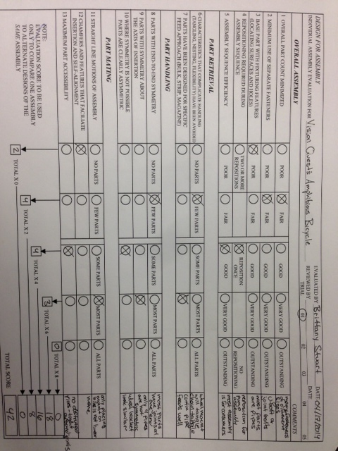

Trial Two:

