
GRAPHICS PACKAGE

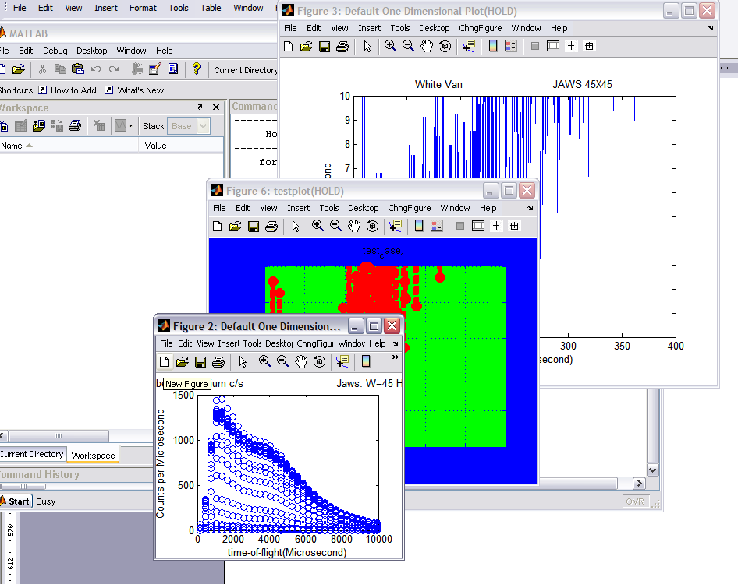

Test Reference

Dean Whittaker
Contents

1. Introduction 3
1.1 Where is the test function? 3
2. The Options 3
2.1 ‘lite’ 3
2.2 ‘full’ 3
2.3 ‘detailed’ 4
2.4 ‘extra only’ 4
3. Sections that are tested 4
4. Adding more tests 5
5. Common Errors That Appear in Testing 6
5.1 Plot colours different than expected 6
5.2 Warning: test failed: graph appears in wrong figure 6
5.3 Error:-->Wrong field name passed ' something ' Please see help 7
5.4 Error using ==> lz… one d data only – lz is not applicable 7

Introduction

This test reference is designed to give an overview of the test procedures contained within the gtk_test function. This function tests the program function as completely as possible. It will produce some ‘odd’ graphs in the process and takes about 250 seconds to complete. Part of the test requires the tester to click on the graphs to test the dxy function.

This test reference also gives some records of tests performed and errors which were encountered. This may help any future development.

These tests are not exhaustive and are always being changed.

Where is the test function?

The test function should be available in a test folder in the libisis folder. It requires that some RAW files be in the parent directory for the test file to access. Open gkt_test_script and the names of the RAW files can be changed to correspond to the files which are available at the time of the test. The file usually uses:

HET15958.RAW
HET16538.RAW
MAP06220.RAW
HET16774.RAW

The Options

There are several options available when the test is run. Any combination of these can be used

‘lite’

>> gtk_test(‘lite’)

This runs the complete test with the data rebinned so that it can run on ‘slower’ machines.

‘full’

>> gtk_test(‘full’)

This runs the complete test – currently the same as no input arguments

‘detailed’

>> gtk_test(‘detailed’)

This runs the test and will stop after each section that has been tested, give keyboard control to the user and allow you to step through the test script. This should be used for the most thourough tests where the details of what is actually being plotted can be explored.

‘extra only’

>>gtk_test(‘extra only’)

Skips some of the tests at the start.

Sections that are tested

1d plotting routines
- Plot to the correct figures
- Plot when given optional arguments
- Plot correctly when given limits
- Plot array data correctly

2d plotting routines
- Plot to the correct figures
- Plot when given optional arguments
- Plot correctly when given limits

keep figure
- Plots choose correct figures when used with kf

Limits
- Check limits can be set on all types of graph with lx, ly, lz, lc
- Check lc and lz work correctly with area and surface plots
- acolor
- acolor works on all plots

amark
- amark works on all plots as expected
- aline
- aline works on all plots

linear / log
- check lin / log works on plots
- check lz has correct operation

dxy
- check dxy works without text
- check dxy works with text
- check dxy works with multiple clicking
- on all graph types

'new functions'
- array of acolor can be set
- array of acolor can be plotted
- dataset_2d arrays into dataset_2d functions
- dataset_2d into dataset_1d functions
- dataset_1d arrays into dataset_2d functions
- overplot arrays

default structures
- check a default structure can be input to each type of graph

dp and de
- check function (same as d1d plotting)

set and get handles tests
- check that set_plot, set_figure, set_axes work correctly
- check get_handles gives the correct figure, axes and plot handles
- check get_handles works with nametags
- check set_xxxx works with all types of handle

Adding more tests

As the program is developed, more tests will be required. These should be added to the end of gkt_test_script, should begin with the lines:

if stop_tag == true
open gtk_test_script
keyboard
end

open any required figures and if required get any additional variables (most of the variables that will be used will already be in place – wd, wdd, wd2, w, w2, ww)

and end with the lines:

display(‘test xxxx complete’)
close all

Common Errors That Appear in Testing

Plot colours different than expected

The plot colours do not follow the pattern expected, for instance acolor(‘blue’,’green’,’red’) may plot a plot in blue green and red, even though it is meant to be a single plot.

Possible Solution
This could be caused by a count problem. Each time the plot command is called, there is an addition to the count. So if the plot command is called several times but only a single plot is made (for instance several different types of plot are overplot but need to be the same colour) the count will still rise by the number of calls. The count value is used to determine where to look in the sequence of colours. This is unless you add the property / value pair

‘counter’, false

to the input of the plot command. In this instance, the plot command will no longer add to the count.

Warning: test failed: graph appears in wrong figure

This message will appear when the plots are not choosing the correct figure to plot into. This can be for many different reasons:

The test script is out of date or two name tags are the same
This is the most likely cause. The window keeping properties have been changed, for instance ds and da now plot into the same window instead of separate ones (have the same name and tag), but the test script hasn’t been changed. Therefore the test script is expecting the plots to go into different windows. This could be by mistake (a default name and tag for a particular type of plot is changed so that it is the same as another, for instance), or on purpose. In which case the test script needs to be changed.

A figure was left open when testing
There was already a figure present when the test commenced.

Name tags are not being checked correctly
A plotting routine has not checked the name tag of the plot before plotting. This error is very unlikely to occur in the current plotting routines. Any new plotting routine should insure the ixf_validate_plot function is called – this chooses the correct window to plot to, assuming that the names and tags are set correctly.

The names and tags should also be set into the figure handle by the plotting routine. If names and tags are not set into the figure, the plots become unidentifiable.

Keep flags are not being checked correctly
The keep flag isn’t being checked before a plot is made or isn’t being set correctly when a plot is being kept.

Error:-->Wrong field name passed ' something ' Please see help

This usually occurs when a property name has been passed to the ixf_setprop function during a plot call (i.e. dl(w,’something’,’value’)) which is not contained within the ixf_setarrayprop or ixf_setprop function. Therefore, the property can’t be set.

Solution
Add ‘something’ to both the ixf_setarrayprop and ixf_setprop (although it is not always necessary or logical to add to both). This may be forgotten if ‘something’ is a valid matlab property. A valid Matlab command does not mean it is recognised by the gtk package.

Error using ==> lz… one d data only – lz is not applicable
Attempt to change the z limits on a plot that the gtk package doesn’t recognise as a graph with a z axis. There are a few reasons for this:

The plot doesn’t have a changeable z axis
Most plots have a z axis, but it shouldn’t be changed. In this instance lz may give an error and this is correct.

The plot has been tagged as a type which does not have a changeable z axis by mistake
If given a oned type, the plot will not have a changeable z axis. This could be done by mistake when the plot is made (i.e. within the plot routine). This requires a change in the plot routine in order for the plot to be used with lz.

