Escape Velocity Traffic Control Guidelines - 2013
Escape Velocity races are held in low traffic areas in the lower mainland. These races are held without road closures and use Traffic Control Personnel where needed to stop traffic as needed to allow race participants to cross intersections or make turns across traffic.

1. Controlled Intersections
Traffic control is required at all intersections where the cyclists will need to have vehicular traffic stopped so that they may proceed through when they do not have the right of way.
Where traffic control is required:
- The standard three signs (see Appendix 1) on all approaches to intersection.
- Two TCP’s (unless an exception is granted for a very low traffic intersection)
- TCP’s must be certified and wear standard safety gear.
- Three standard 18” cones on center line on the course leading into the intersection.
- Three standard 18” cones on center line on the course leading out of the intersection.
- Traffic stoppages are to be kept to a minimum while keeping cyclists safe.

2. Uncontrolled intersections with oncoming traffic
In some cases where the cyclists are making a legal right turn it may be necessary to have a TCP to ensure that on coming from the opposite direction does not make a left turn in front of the
riders.
Where traffic control is required:
- The standard three signs (see Appendix 1) on all approaches to intersection.
- One TCP to stop approaching traffic
- TCP’s must be certified and wear standard safety gear.
- Three standard 18” cones on center line on the course leading into the intersection.
- Three standard 18” cones on center line on the course leading out of the intersection.
- Traffic stoppages are to be kept to a minimum while keeping cyclists safe.

3. Marshaled Intersections
Race marshals are required at any intersections where the cyclists may need guidance on making the correct turn.
Where marshals are required:
- Warning signs (see appendix 2) on all approaches
- Marshal must have safety equipment and yield sign
- Marshals must only signal cyclists
- Marshals are not to control vehicular traffic

4. Other intersections
Roads that intersect the race course where motorists must stop do not require traffic control.
Requirements for other intersections:
- Warning signs (see appendix 2) on all approaches
Notes
- All TCP’s must be certified and carry their certification cards.
- All TCP’s and Marshals must carry a cell phone.

Appendix 1 - The standard three signs
This is the required signage for the traffic controlled intersections.
These are standard 20” orange signs on metal tripods
- Caution Bicycle Race On Road - non-standard
- Prepare to Stop - C-029
- Flagger - C-001-1
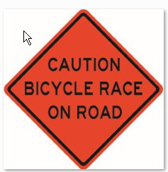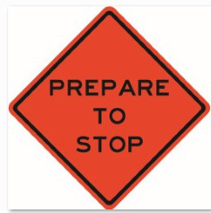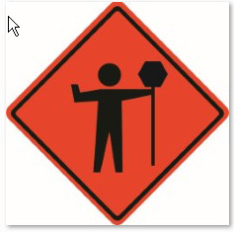

Appendix 2 - Warning signs
This is the required signage roads that intersect the race course where motorists will have a top sign.
Either the old style sandwich boards or two of the above signs on tripods:
- Caution Bicycle Race On Road - non-standard

Appendix 3 - Tripods

