Aldergrove East - Road Race – July 28, 2013
- Start - Park Entrance – neutral to Huntingdon
- Finish – 200m South 8th Ave on 272 St.
- Time: 9:00AM – 2:00PM
- Course Direction – counter-clockwise
- Marshaling location – park entrance on Lafeuvre Rd
- Parking – Aldergrove Park
- Park On Call – 604-290-8516

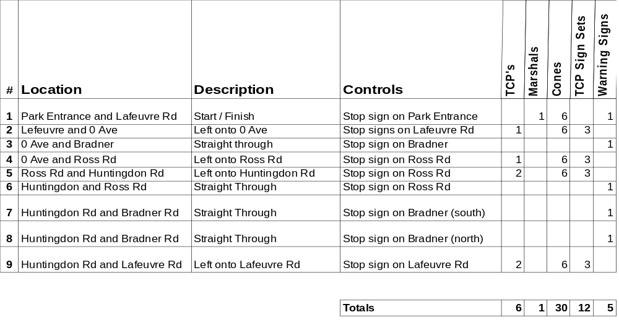

- Standard set of three TCP signs
- Warning signs
- Please setup signs and cones prior to race.
- Please return signs and cones to corner after race.
- Please pick up any litter at your corner.

Race Director - Scott Laliberte – 604-805-2453

