Aldor Acres – Crit – June 15, 2013
- Start / Finish – 80 Ave and 272 St
- Time: 9:00AM – 2:00PM
- Course Direction – Clock Wise
- Marshaling location – Aldor Acres
- Parking – Aldor Acres

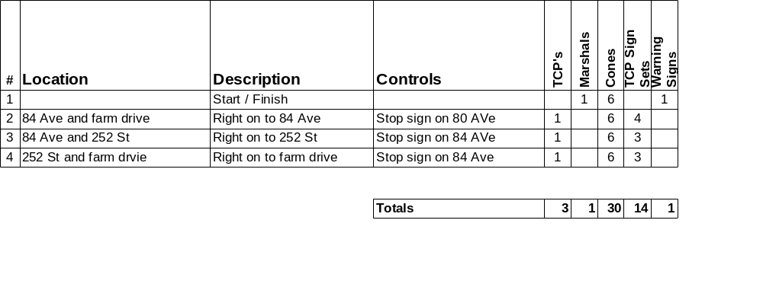

- Standard set of three TCP signs
- Warning signs
- Distances:
- Please setup signs and cones prior to race.
- Please return signs and cones to corner after race.
- Please pick up any litter at your corner.

Race Director – Stuart Lynne – 604-518-1749

