Atomic Long - Road Race – June 9, 2013
- Start / Finish- 100m South of Montesina Ave on Lefeuvre Rd
- Time: 9:00AM – 2:00PM
- Course Direction – clockwise
- Marshaling location – Montensina Ave East of Lafeuvre Rd
- Parking – Along Montensina Rd.

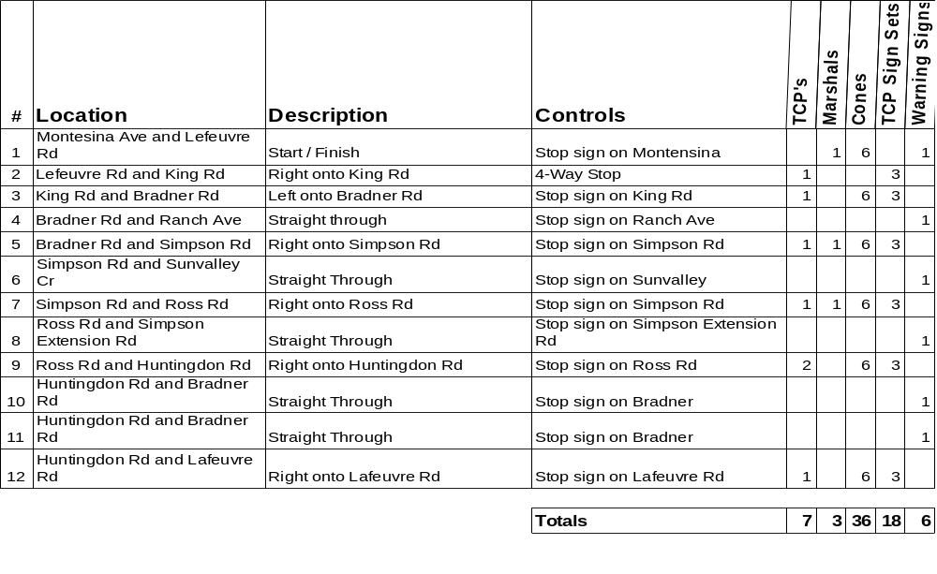
- TCP Sign Sets - Standard set of three TCP signs, Caution Bike Race, Prepare to Stop and Flagger
- Warning signs – Caution Bike Race on Road
- Please setup signs and cones prior to race.
- Please return signs and cones to corner after race.
- Please pick up any litter at your corner.

Race Director - Scott Laliberte – 604-805-2453

