Glen Valley - Time Trial – June 15, 2013
- Start / Finish – 80 Ave and 272 St
- Time: 9:00AM – 12:00AM
- Turn Around – 200m South of rail road on North Bradner
- Course Direction – out and back
- Marshaling location – 80 Ave, East of 272 St
- Parking – North side of 80 Ave, East of 272 St

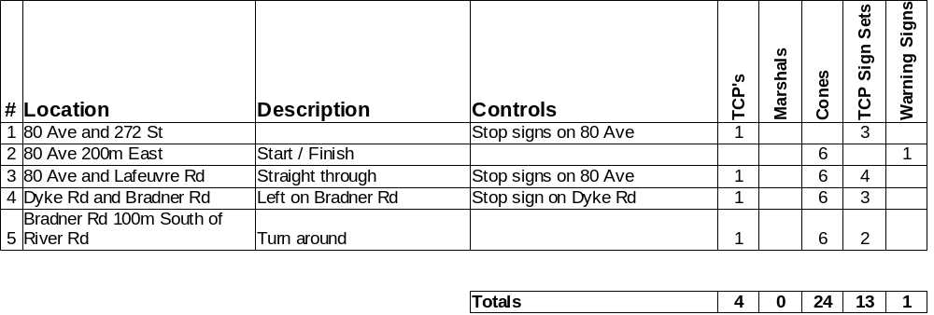

- Standard set of three TCP signs
- Warning signs
- Distances: 4.1km out and back, 8.2km total
- Please setup signs and cones prior to race.
- Please return signs and cones to corner after race.
- Please pick up any litter at your corner.
- Locations #1-#2 are under Township of Langley HUP
- Locations #3-#5 are under City of Abbotsford HUP

Race Director – Stuart Lynne – 604-518-1749

