Glenlyon – Crit – Tuesdays May - August
- Start / Finish - Park Entrance – 9200 block Glenlyon
- Time: Tuesday 6:00PM – 8:00PM
- Course Direction – clockwise
- Marshaling location – Park Area across from 9200 Glenlyon
- Parking – South side of Glenlyon Parkway

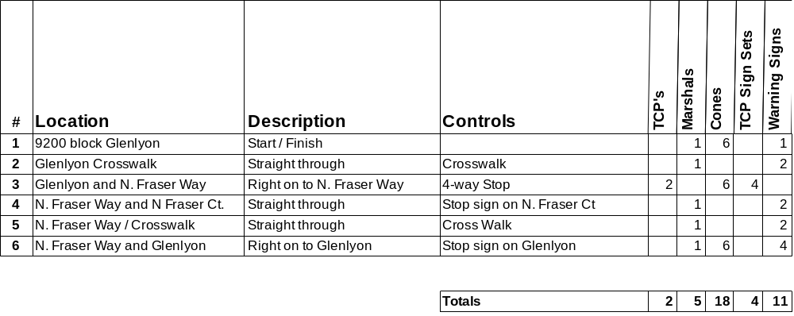

- Standard set of three TCP signs (Caution Bike Race, Be prepared to Stop, Flagger)
- Warning signs (Caution Bike Race)
- Please setup signs and cones prior to race.
- Please return signs and cones to corner after race.
- Please pick up any litter at your corner.

Race Director – Joe Tam – 604-822-6621

