Thunderbird Road Race, May 11, 2013
- Start / Finish – 200m South of 72 Ave on 248 St.
- Time: 9:00AM – 1:30PM
- Course Direction – clockwise
- Marshaling location – Thunderbird Show Park East parking lot
- Parking – Thunderbird Show Park East parking lot

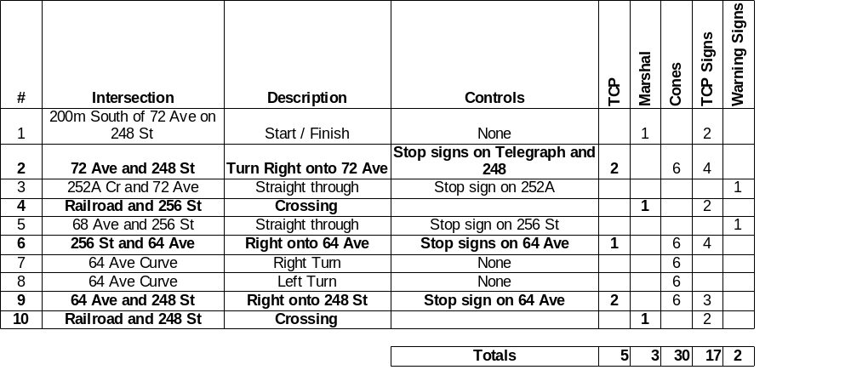
- TCP Signs - Standard set of three TCP signs, Bicycle Race on Road, Be Prepared to Stop and Flagger
- Warning Sign – Bicycle Race on Road
- Distances: B – 18/110km, C – 13/79km
- Please setup signs and cones prior to race.
- Please return signs and cones to corner after race.
- Please pick up any litter at your corner.

Race Director - Scott Laliberte – 604-805-2453
Traffic Control Manager – Stuart Lynne - 604-518-1749

