Battle of Cowpens: sand table kit
Unit markers, grid labels, and phase cards that match the on-screen Cowpens battle study. Phase times and moves follow the Army staff ride guide’s timed maps; positions are approximate.

Set up the table
- Table: a 2 × 4 ft folding table works. The long side runs from the American position (row 1) to the British approach (row 9).
- Grid: 6 columns (A–F) across, 9 rows (1–9) down. On a 2 × 4 ft table each square is 4 in. wide and about 5¼ in. long. Lay string lines and clip the grid labels on the edges.
- Terrain: Cowpens is a gentle rise. Build the high ground across rows 1–3 with one or two thin foam or cardboard layers, highest toward column A, and skin it with about ½ in. of kinetic sand. The ground falls away toward column F.
- Add blue yarn for the ravine in the top-right corner (behind row 1, columns D–F) and brown yarn for Mill Gap Road down the middle (column D). Woods along the edges and the bottom: twigs or green felt.
- Markers: print the marker page on cardstock and tape each to a block. Tilt a block to show “disordered”; lay it on its side for “surrendered.”
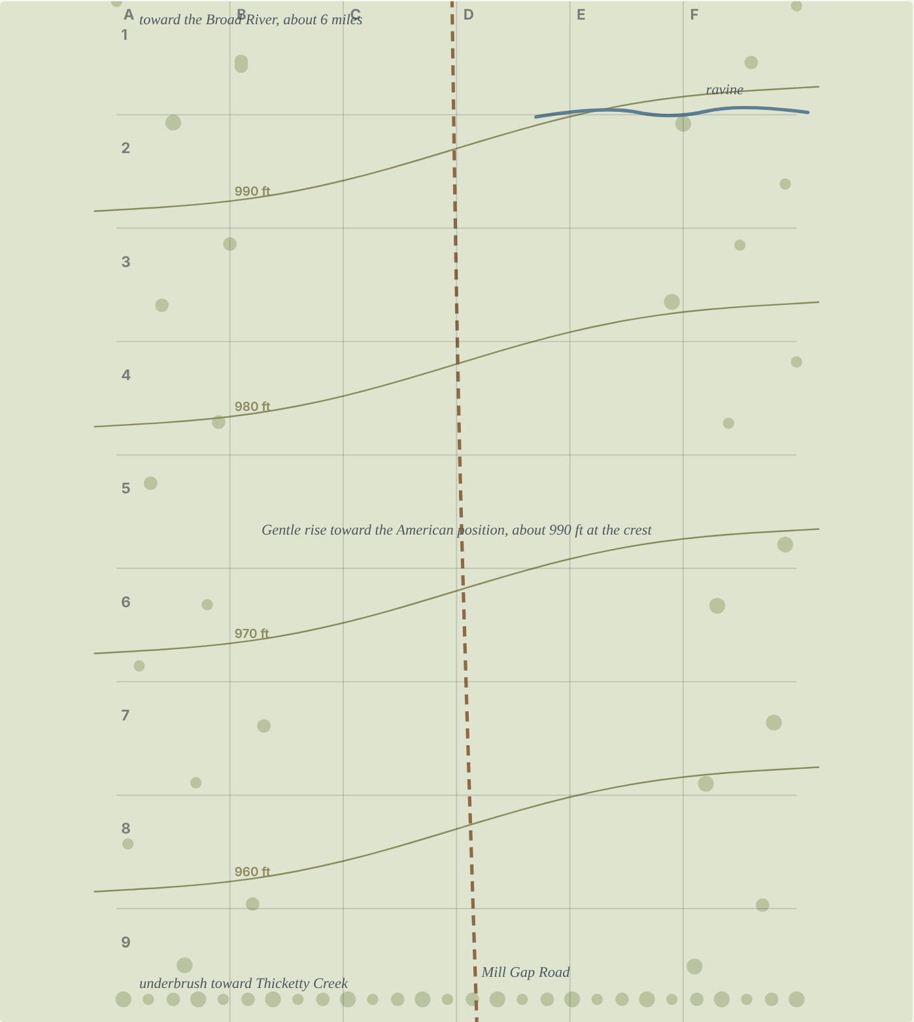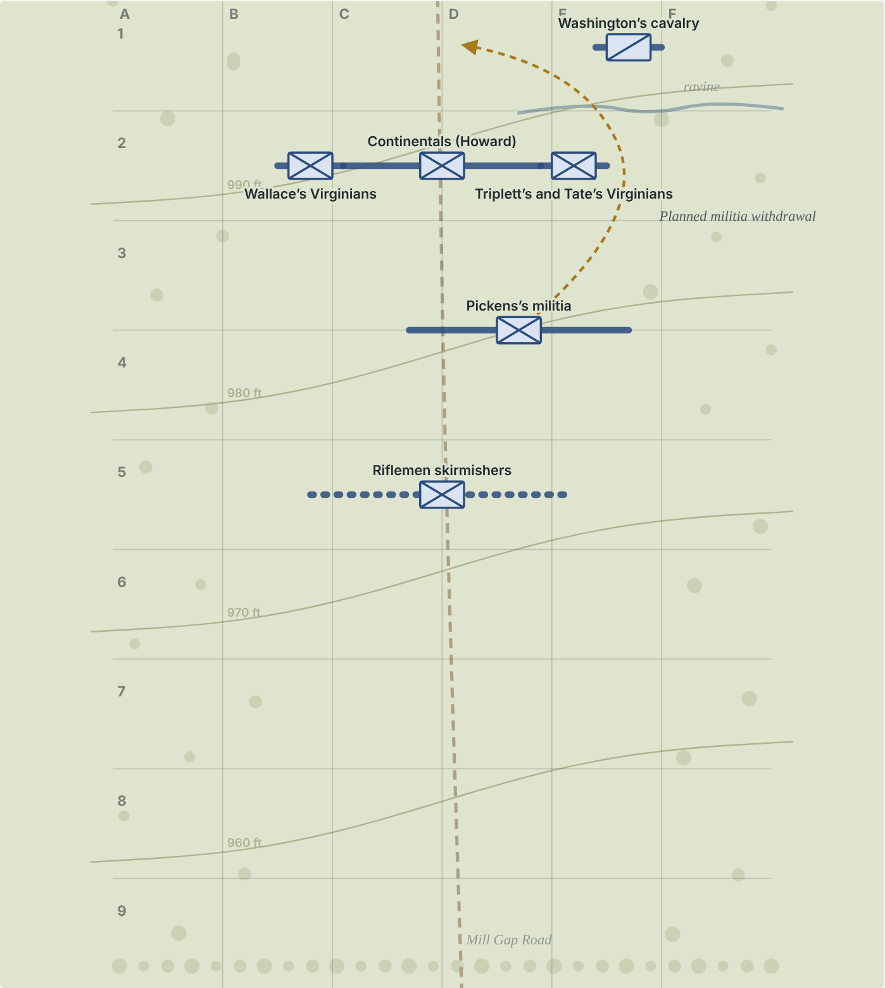
Left: terrain to build (contours illustrative). Right: starting positions before the British arrive.
Unit markers
Print on cardstock. Cut and tape each to a wood block.
American    Riflemen skirmishers | American  Pickens’s militia | American  Continentals (Howard)
American  Wallace’s Virginians | American  Triplett’s and Tate’s Virginians | American    Washington’s cavalry
British  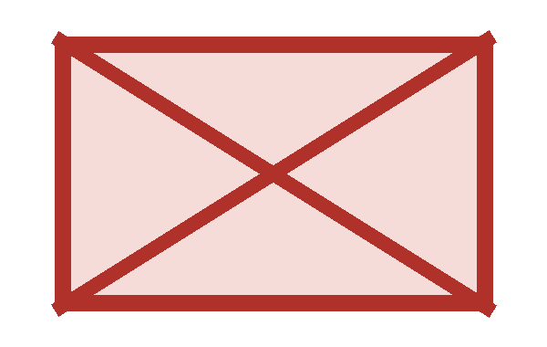  British line | British    3-pounders | British  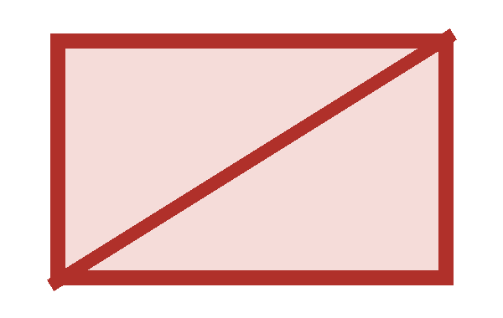  Dragoons (about 50)
British  71st Highlanders | British  Legion cavalry (reserve) | Key  X box: infantry  Slash: cavalry  Dot: artillery  Blue: American  Red: British
Grid labels
Clip letters along the long edges and numbers along the short edge, or tape them to the table rim.
A | B | C | D | E
F | 1 | 2 | 3 | 4
5 | 6 | 7 | 8 | 9
Night Morgan sets a trap
Morgan reaches the Cowpens, a cattle-grazing field, at sundown. He knows Tarleton will attack straight ahead, so he builds three lines that get stronger as the British push in: riflemen in front, militia behind them, and his best troops on the rise. His cavalry waits out of sight. That night he walks among the militia, joking with them and promising that after a few volleys they can fall back.
Table moves
- Place Riflemen skirmishers at D5
- Place Pickens’s militia at D4
- Place Continentals (Howard) at D2
- Place Wallace’s Virginians at B2
- Place Triplett’s and Tate’s Virginians at E2
- Place Washington’s cavalry at E1
- Keep the British markers off the table, in the woods at the bottom edge.
Ask: Morgan put his least-trained troops in front and told them exactly when to leave. Why would a planned retreat make them more reliable, not less?
Capture the flag: Give every player one clear job and a clear point to fall back to. A player who knows the plan doesn’t panic when it happens.
Positions approximate. Staff ride guide, chapter III.
✂ - - - - - - - - - - - - - - - - - - - - - - - - - - - - - - - - - - - - - - - - - - - - - - - - - - - - - - - -
07:00 Tarleton arrives
Ask first. You’re Tarleton. Your men are tired and your reserve is still in the woods. The Americans are formed and waiting. What do you do?
- Attack right away, before more militia arrive
- Rest the men and wait for the reserve
- Send scouts around their flanks first
Tarleton’s men have marched through thick underbrush since 3 a.m. They break out of the woods and form a line two ranks deep, with two small cannon in front and dragoons on the flanks. The 71st Highlanders and the Legion cavalry are still coming up behind. Ahead, 300 to 400 yards away, the Americans are deployed and silent.
Table moves
- Bring on British line at D8
- Bring on 3-pounders at D8
- Bring on Dragoons (about 50) at E9
- Bring on 71st Highlanders at C9
- Bring on Legion cavalry (reserve) at B9
Ask: Morgan’s whole plan depended on Tarleton behaving the way he always had. What did Morgan know about his opponent, and how did he know it?
Capture the flag: Before you plan, ask: what does the other team always do? Plan for that.
Positions approximate. Staff ride guide, map 8: initial dispositions, 0700.
07:10 The British advance
The cannon open fire and the British line moves forward. The riflemen, hidden behind scattered trees, aim at the officers first: the men giving orders. Some raw British recruits fire back too early before they’re brought under control.
Table moves
- Move British line from D8 to D7
- Move 3-pounders from D8 to D7
Ask: Why shoot officers first? What happens to a line when nobody’s giving orders?
Capture the flag: Who’s calling plays for the other team? If you tag their play-caller early, the rest get confused.
Positions approximate. Staff ride guide, map 9: British advance, 0710.
✂ - - - - - - - - - - - - - - - - - - - - - - - - - - - - - - - - - - - - - - - - - - - - - - - - - - - - - - - -
07:20 The skirmishers fall back
Having done their job, the riflemen withdraw on schedule into the militia line. The British see Americans moving backward and keep coming.
Table moves
- Remove Riflemen skirmishers from the table
- Move British line from D7 to D6
- Move 3-pounders from D7 to D6
Ask: The skirmishers merged into the next line instead of running off the field. Why does that matter?
Capture the flag: When your forward players fall back, they should join the next layer of defense, not leave the game.
Positions approximate. Staff ride guide, map 10: skirmish line withdraws, 0720.
07:30 The militia fire and withdraw
Ask first. You’re Tarleton. The militia are streaming to the rear. It looks like the Americans are breaking. What do you do?
- Send dragoons to chase the militia
- Keep the dragoons back in reserve
- Push the whole line forward hard
The British line charges with a shout. Morgan rides among the militia, cheering them on. They fire, then withdraw around the American left as planned. Tarleton sees them going and sends about 50 dragoons after them. Washington’s hidden cavalry thunders out and drives the dragoons back.
Table moves
- Move Pickens’s militia from D4 to D1
- Move Washington’s cavalry from E1 to E2
- Move British line from D6 to D5
- Move 3-pounders from D6 to D4
- Move Dragoons (about 50) from E9 to F6
- Turn Dragoons (about 50) at an angle: disordered
Ask: Washington’s cavalry was hidden until the moment it mattered. What’s the capture the flag version of a hidden reserve?
Capture the flag: Keep one fast player back and out of sight. Send him only when they commit.
Positions approximate. Staff ride guide, map 11: British attack and militia withdrawal, 0730.
✂ - - - - - - - - - - - - - - - - - - - - - - - - - - - - - - - - - - - - - - - - - - - - - - - - - - - - - - - -
07:40 A mistake that helped
Ask first. You’re Morgan. Your main line is marching backward by mistake, and the British are rushing after it. What do you do?
- Stop them where they are
- Let them go back a little, then turn and fire
- Pull everyone off the field
Tarleton sends the 71st Highlanders around the American right. Howard orders the Virginians on that flank to turn and face them. They misunderstand: they face about and march to the rear, and the whole Continental line follows, thinking it missed an order to withdraw. Morgan gallops over, sees they’re still in good order, and picks a spot 80 to 100 yards back to stop and turn.
Table moves
- Move Continentals (Howard) from D2 to D1
- Move Wallace’s Virginians from B2 to B1
- Move Triplett’s and Tate’s Virginians from E2 to E1
- Move British line from D5 to D3
- Turn British line at an angle: disordered
- Move 3-pounders from D4 to D3
- Move 71st Highlanders from C9 to B3
- Move Legion cavalry (reserve) from B9 to B8
Ask: An order got misunderstood, and by luck it helped. Why do armies drill their signals so hard?
Capture the flag: Agree on one silent signal and practice it before the game. Don’t count on luck.
Positions approximate. Staff ride guide, map 12: Continental Line withdrawal and British attack, 0740.
07:45 About face
Believing the Americans are beaten, the British rush forward and lose their formation. Suddenly the Continentals turn around, rifles loaded, and fire a volley from about 30 yards. The British reel back, and Howard orders a bayonet charge.
Table moves
- Move Continentals (Howard) from D1 to D2
- Move Wallace’s Virginians from B1 to B2
- Move Triplett’s and Tate’s Virginians from E1 to E2
- Move 3-pounders from D3 to D2
Ask: Why did the British fall apart at the moment they thought they were winning?
Capture the flag: The moment the other team thinks they’ve won is when they’re most careless. Be ready to turn and hit back.
Positions approximate. Staff ride guide, map 13: Continentals’ counterattack, 0745.
✂ - - - - - - - - - - - - - - - - - - - - - - - - - - - - - - - - - - - - - - - - - - - - - - - - - - - - - - - -
07:50 Surrounded
Washington’s cavalry swings past the American left and behind the British right. At almost the same moment, Pickens’s militia, re-formed behind the line, reappear around the American right and sweep behind the other British flank. Hit from the front and both sides, the British break. Most surrender. The gunners hold out longest before giving up their cannon.
Table moves
- Move Pickens’s militia from D1 to C4
- Move Washington’s cavalry from E2 to E4
- Lay British line on its side: surrendered
- Move 3-pounders from D2 to D3
- Lay 3-pounders on its side: surrendered
- Lay 71st Highlanders on its side: surrendered
Ask: This is called a double envelopment: holding the enemy in front while hitting both sides at once. It’s very hard to pull off. What had to go right for it to work?
Capture the flag: Pin them in the middle, then send players around both sides. Timing matters more than speed.
Positions approximate. Staff ride guide, map 14: envelopment and destruction, 0750.
Before 9:00 Tarleton escapes
Tarleton gathers about 50 loyal horsemen for one more charge, and they’re driven off. In the chase, Washington and Tarleton clash sword to sword; a Black soldier with Washington saves him by firing at one of his attackers. Tarleton gets away, and the Americans pursue for 22 miles. The battle took about an hour, and Tarleton’s force was destroyed.
Table moves
- Move Washington’s cavalry from E4 to D6
- Remove Dragoons (about 50) from the table
- Remove Legion cavalry (reserve) from the table
Ask: Morgan later said he chose ground with the Broad River behind him so his militia couldn’t run. The staff ride guide points out the river was about six miles away and doubts the story. Why might a commander tell a better version afterward?
Capture the flag: After the game, tell what really happened, not the version that makes you look good. That’s what makes the after-action review useful.
Positions approximate. Staff ride guide, chapter III. Losses: see Sources and accuracy.
✂ - - - - - - - - - - - - - - - - - - - - - - - - - - - - - - - - - - - - - - - - - - - - - - - - - - - - - - - -

Morgan’s plan as a patrol order
Reconstructed from the staff ride guide’s account of Morgan’s plan; not a historical document. Use it as the model for the boys’ capture the flag plan.
Part | Morgan’s plan
Situation | Tarleton is chasing us with about 1,100 men. He’s aggressive and attacks head-on. His men have marched since 3 a.m.
Mission | Defeat Tarleton’s force here at the Cowpens.
Commander’s intent | Wear him down in layers. Let him think he’s winning. Finish him with the regulars and the hidden cavalry.
Who does what | Skirmishers shoot the officers, then fall back. Militia fire their volleys, then withdraw around our left and re-form. Continentals and Virginians hold the main line on the rise. Cavalry waits out of sight behind our left.
Signals | Everyone knows the fall-back route before the fight, so a planned retreat never looks like a rout to our own men.

Sources
- John Moncure, The Cowpens Staff Ride and Battlefield Tour, Combat Studies Institute, 1996 (public domain): govinfo.gov.
- American Battlefield Trust, Cowpens: battlefields.org/learn/articles/cowpens.
- Where sources disagree: militia volleys (two vs. “three fires”); British losses (about 850 per the staff ride guide; 868 per the Trust).

