Details | Copy | Notes

Refund/Cancellation Email (Service)
ZAIL owned / managed  Timing: In real time, when policy is cancelled by the customer via the Customer Portal or via the Call Centre.  Description: Automated email sent to customers regarding a refund / cancellation of their policy within the 21-day cooling off period | 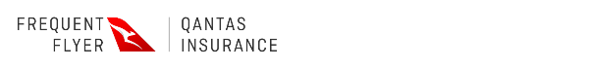  Hi {{First Name}},  As requested, we have cancelled your Qantas Travel Insurance policy {{Policy Number}}, underwritten by Zurich Australian Insurance Limited, on {{DD MMM YYYY}}.  Your premium will be refunded to your original payment method within 15 business days.  If you have any questions, please call us on 1800 954 270 (within Australia) or +61 3 9522 4840 (from overseas), Monday to Friday 8 am to 7 pm AET.  This is an auto generated email, please do not reply.  Qantas Travel Insurance is issued by Zurich Australian Insurance Limited, ABN 13 000 296 640, AFSL 232507 (“ZAIL”). Qantas Airways Limited, ABN 16 009 661 901 (“Qantas”), is ZAIL’s authorised representative (AR 261363). ZAIL engages affiliated entities within the Zurich Insurance Group to provide services in support of this insurance as permitted by applicable laws.  Sent by ZAIL, 118 Mount Street, North Sydney, NSW 2060, on behalf of Qantas Australian headquarters: 10 Bourke Road, Mascot, NSW 2020.

