Legend:
- {{Content}} refers to dynamic inputs that need to be updated/customised for Qantas NZ customers
- Red refers to URLs/hyperlinks
- Purple means notes / reminders
- Yellow highlight refers to ZAIL issuer statement updates
- Orange highlight refers to changes needed to contact details

Copy

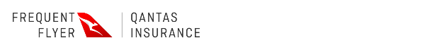

Hi {{First Name}},
As requested, we have cancelled your Qantas Travel Insurance policy {{Policy Number}}, underwritten by Zurich Australian Insurance Limited, on 04 Oct 2023.
Your premium will be refunded to your original payment method within 15 business days.
If you have any questions, please call us on 0800 446 273 (within New Zealand) or +64 9 355 3366 (from overseas), Monday to Friday 10 am to 9 pm (NZT).

This is an auto generated email, please do not reply.

Qantas Travel Insurance is underwritten by Zurich Australian Insurance Limited ACN 000 296 640 (“Zurich New Zealand”). Qantas Airways Limited (“Qantas”) is a distributor of Zurich New Zealand, and it does not provide any financial advice. Qantas may provide relevant information relating to your Qantas booking to Zurich New Zealand. Zurich New Zealand engages affiliated entities within the Zurich Insurance Group to provide services in support of this insurance as permitted by applicable laws.

Sent by Zurich New Zealand, Level 9, 29 Customs Street West, , Auckland 1010, New Zealand on behalf of Qantas, Australian headquarters: 10 Bourke Road, Mascot, NSW 2020.

