With just:
<Bundle-Activator>org.cogchar.osgi.impl.CogcharImplActivator</Bundle-Activator>
we get a 5M zip file containing zips under "modules", and a 94K .jar file, with manifest:
Manifest-Version: 1.0
Export-Package: org.cogchar.bony;uses:="com.jme3.scene,com.jme3.font,c
om.jme3.math,com.jme3.asset,com.jme3.scene.control,com.jme3.animation
,javax.swing,com.jme3.renderer,com.jme3.system,com.jme3.light,com.jme
3.app,com.jme3.input"
Built-By: winston
Tool: Bnd-0.0.357
Bundle-Name: CogcharImpl
Created-By: Apache Maven Bundle Plugin
Build-Jdk: 1.6.0_21
Bundle-Version: 1.0.0.SNAPSHOT
Bnd-LastModified: 1310610051302
Bundle-ManifestVersion: 2
Bundle-Activator: org.cogchar.osgi.impl.CogcharImplActivator
Import-Package: com.jme3.animation,com.jme3.app,com.jme3.asset,com.jme
3.font,com.jme3.input,com.jme3.light,com.jme3.math,com.jme3.renderer,
com.jme3.scene,com.jme3.scene.control,com.jme3.system,javax.swing,org
.cogchar.bony,org.osgi.framework;version="1.5"
Bundle-SymbolicName: org.cogchar.CogcharImpl
config.properties:
felix.auto.install="file:modules/classes file:modules/org.osgi.core-1.4.0.jar file:modules/slf4j-api-1.6.1.jar file:modules/jmonkeyengine3-3.0.jar file:modules/lwjgl-3.0.jar file:modules/lwjgl_natives-3.0.jar file:modules/AppleJavaExtensions-1.4.jar file:modules/org.apache.felix.gogo.commands-0.2.2.jar file:modules/org.apache.felix.gogo.runtime-0.2.2.jar"
felix.auto.start=file:modules/CogcharImpl-1.0-SNAPSHOT.jar
run.properties:
felix.auto.install=file:/C:/Users/winston/.m2/repository/org/apache/felix/org.osgi.core/1.4.0/org.osgi.core-1.4.0.jar file:/C:/Users/winston/.m2/repository/org/slf4j/slf4j-api/1.6.1/slf4j-api-1.6.1.jar file:/C:/Users/winston/.m2/repository/org/jmonkeyengine/mvn/jme3/jmonkeyengine3/3.0/jmonkeyengine3-3.0.jar file:/C:/Users/winston/.m2/repository/org/jmonkeyengine/mvn/jme3/lwjgl/3.0/lwjgl-3.0.jar file:/C:/Users/winston/.m2/repository/org/jmonkeyengine/mvn/jme3/lwjgl_natives/3.0/lwjgl_natives-3.0.jar file:/C:/Users/winston/.m2/repository/com/apple/AppleJavaExtensions/1.4/AppleJavaExtensions-1.4.jar file:/C:/Users/winston/.m2/repository/org/apache/felix/gogo/org.apache.felix.gogo.commands/0.2.2/org.apache.felix.gogo.commands-0.2.2.jar file:/C:/Users/winston/.m2/repository/org/apache/felix/gogo/org.apache.felix.gogo.runtime/0.2.2/org.apache.felix.gogo.runtime-0.2.2.jar
felix.auto.start=file:/P:/_prj/robo/cogchar_trunk/osgi_maven/CogcharImpl/target/CogcharImpl-1.0-SNAPSHOT.jar
org.osgi.framework.storage=P:/_prj/robo/cogchar_trunk/osgi_maven/CogcharImpl/target/felix-cache
org.osgi.framework.bootdelegation=* run.

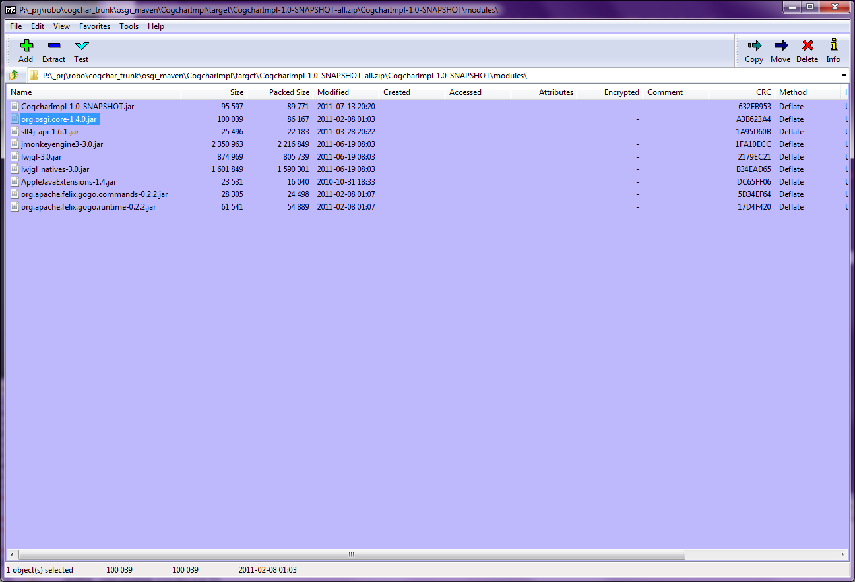
---------------------------------------------

Now we add instruction:
<Import-Package>*;resolution:=optional</Import-Package>

and we get a similar setup, but now the manifest is:

Manifest-Version: 1.0
Export-Package: org.cogchar.bony;uses:="com.jme3.scene,com.jme3.font,c
om.jme3.math,com.jme3.asset,com.jme3.scene.control,com.jme3.animation
,javax.swing,com.jme3.renderer,com.jme3.system,com.jme3.light,com.jme
3.app,com.jme3.input"
Built-By: winston
Tool: Bnd-0.0.357
Bundle-Name: CogcharImpl
Created-By: Apache Maven Bundle Plugin
Build-Jdk: 1.6.0_21
Bundle-Version: 1.0.0.SNAPSHOT
Bnd-LastModified: 1310611017232
Bundle-ManifestVersion: 2
Bundle-Activator: org.cogchar.osgi.impl.CogcharImplActivator
Import-Package: com.jme3.animation;resolution:=optional,com.jme3.app;r
esolution:=optional,com.jme3.asset;resolution:=optional,com.jme3.font
;resolution:=optional,com.jme3.input;resolution:=optional,com.jme3.li
ght;resolution:=optional,com.jme3.math;resolution:=optional,com.jme3.
renderer;resolution:=optional,com.jme3.scene;resolution:=optional,com
.jme3.scene.control;resolution:=optional,com.jme3.system;resolution:=
optional,javax.swing;resolution:=optional,org.cogchar.bony;resolution
:=optional,org.osgi.framework;resolution:=optional;version="1.5"
Bundle-SymbolicName: org.cogchar.CogcharImpl

...and the activator start is at least able to startup (first stacktrace was also present above).

java.lang.NullPointerException
at org.apache.felix.framework.cache.JarRevision.getManifestHeader(JarRevision.java:107)
at org.apache.felix.framework.BundleImpl.createModule(BundleImpl.java:1110)
at org.apache.felix.framework.BundleImpl.<init>(BundleImpl.java:79)
at org.apache.felix.framework.Felix.installBundle(Felix.java:2372)
at org.apache.felix.framework.Felix.installBundle(Felix.java:2277)
at org.apache.felix.framework.BundleContextImpl.installBundle(BundleContextImpl.java:130)
at org.apache.felix.main.AutoProcessor.processAutoProperties(AutoProcessor.java:272)
at org.apache.felix.main.AutoProcessor.process(AutoProcessor.java:75)
at org.apache.felix.main.Main.main(Main.java:295)
Auto-properties install: org.osgi.framework.BundleException: Could not create bundle object. - java.lang.NullPointerException
CogcharImplActivator.start()

-----------------

Now we add to the activator.start():
WomanFaceTest.main(null);

and at runtime we get (after "CogcharImplActivator.start()"):

ClassNotFoundException: com.jme3.animation.AnimEventListener

---------------

So we add to pom.xml instructions:

<Private-Package>org.cogchar.*,com.jme3.*,org.lwjgl.*</Private-Package>

and now we get a zipfile of size 7+ M, still containing all deps as modules, plus a cogchar jar of size 2.7M, containing the com.jme3 and org.lwjgl classes, with manifest like:

Manifest-Version: 1.0
Export-Package: org.cogchar.bony;uses:="javax.swing"
Built-By: winston
Tool: Bnd-0.0.357
Bundle-Name: CogcharImpl
Created-By: Apache Maven Bundle Plugin
Build-Jdk: 1.6.0_21
Bundle-Version: 1.0.0.SNAPSHOT
Bnd-LastModified: 1310611760527
Bundle-ManifestVersion: 2
Bundle-Activator: org.cogchar.osgi.impl.CogcharImplActivator
Import-Package: checkers.quals;resolution:=optional,com.apple.eawt;res
olution:=optional,com.apple.eio;resolution:=optional,com.fluendo.jheo
ra;resolution:=optional,com.jcraft.jogg;resolution:=optional,com.jcra
ft.jorbis;resolution:=optional,com.jme3.bullet;resolution:=optional,c
om.jme3.bullet.collision.shapes;resolution:=optional,com.jme3.bullet.
control;resolution:=optional,de.jarnbjo.ogg;resolution:=optional,de.j
arnbjo.vorbis;resolution:=optional,de.lessvoid.nifty;resolution:=opti
onal,de.lessvoid.nifty.elements.render;resolution:=optional,de.lessvo
id.nifty.input.keyboard;resolution:=optional,de.lessvoid.nifty.render
;resolution:=optional,de.lessvoid.nifty.sound;resolution:=optional,de
.lessvoid.nifty.spi.input;resolution:=optional,de.lessvoid.nifty.spi.
render;resolution:=optional,de.lessvoid.nifty.spi.sound;resolution:=o
ptional,de.lessvoid.nifty.tools;resolution:=optional,de.lessvoid.nift
y.tools.resourceloader;resolution:=optional,javax.imageio;resolution:
=optional,javax.management;resolution:=optional,javax.net.ssl;resolut
ion:=optional,javax.swing;resolution:=optional,javax.swing.event;reso
lution:=optional,javax.xml.parsers;resolution:=optional,jme3tools.con
verters;resolution:=optional,net.java.games.input;resolution:=optiona
l,org.cogchar.bony;resolution:=optional,org.novyon.noise;resolution:=
optional,org.osgi.framework;resolution:=optional;version="1.5",org.w3
c.dom;resolution:=optional,org.xml.sax;resolution:=optional,org.xml.s
ax.helpers;resolution:=optional
Bundle-SymbolicName: org.cogchar.CogcharImpl

and at runtime we get:

CogcharImplActivator.start()
Jul 13, 2011 8:49:23 PM com.jme3.system.JmeSystem initialize
INFO: Running on jMonkey Engine 3 Alpha 0.6
Jul 13, 2011 8:49:23 PM com.jme3.system.Natives extractNativeLibs
INFO: Extraction Directory #1: bundle://9.0:1/com/jme3/system/
Jul 13, 2011 8:49:23 PM com.jme3.system.Natives extractNativeLibs
INFO: Extraction Directory #2: P:\_prj\robo\cogchar_trunk\osgi_maven\CogcharImpl
Jul 13, 2011 8:49:23 PM com.jme3.system.Natives extractNativeLibs
INFO: Extraction Directory #3: P:\_prj\robo\cogchar_trunk\osgi_maven\CogcharImpl
Jul 13, 2011 8:49:23 PM com.jme3.system.Natives extractNativeLib
WARNING: Cannot locate native library: windows/bulletjme64.dll
Jul 13, 2011 8:49:23 PM com.jme3.system.lwjgl.LwjglCanvas$GLCanvas addNotify
INFO: EDT: Creating OGL thread.
Jul 13, 2011 8:49:23 PM com.jme3.system.lwjgl.LwjglCanvas$GLCanvas addNotify
INFO: EDT: Notifying OGL that canvas is visible..
Exception in thread "LWJGL Renderer Thread" java.lang.UnsatisfiedLinkError: Can't load library: P:\_prj\robo\cogchar_trunk\osgi_maven\CogcharImpl\lwjgl.dll
at java.lang.ClassLoader.loadLibrary(Unknown Source)
at java.lang.Runtime.load0(Unknown Source)
at java.lang.System.load(Unknown Source)
at org.lwjgl.Sys$1.run(Sys.java:70)
at java.security.AccessController.doPrivileged(Native Method)
at org.lwjgl.Sys.doLoadLibrary(Sys.java:66)
at org.lwjgl.Sys.loadLibrary(Sys.java:82)
at org.lwjgl.Sys.<clinit>(Sys.java:99)
at com.jme3.system.lwjgl.LwjglAbstractDisplay.run(LwjglAbstractDisplay.java:199)
at java.lang.Thread.run(Unknown Source)

--------------

Now we copy lwjgl64.dll and OpenAL64.dll to the CogcharImpl directory, and those errors are cured, but we still get:

java.lang.IllegalStateException: No loader registered for type "fnt"
at com.jme3.asset.DesktopAssetManager.loadAsset(DesktopAssetManager.java:223)
at com.jme3.asset.DesktopAssetManager.loadFont(DesktopAssetManager.java:339)
at com.jme3.app.SimpleApplication.loadFPSText(SimpleApplication.java:177)
at com.jme3.app.SimpleApplication.initialize(SimpleApplication.java:202)
at com.jme3.system.lwjgl.LwjglAbstractDisplay.initInThread(LwjglAbstractDisplay.java:124)
at com.jme3.system.lwjgl.LwjglAbstractDisplay.run(LwjglAbstractDisplay.java:200)
at java.lang.Thread.run(Unknown Source)

It seems that \com\jme3\asset\Desktop.cfg is not being successfully loaded from the classpath
by this line (75) in DesktopAssetManager.java:

this(Thread.currentThread().getContextClassLoader().getResource("com/jme3/asset/Desktop.cfg"));

So then we add the following to WomanFaceTest, and copy Desktop.cfg to cogchar_jme3.cfg

settings.putString("AssetConfigURL", "file:./cogchar_jme3.cfg");

which allows us to get past the "no loader registered" issue, but then washes us up at:

com.jme3.asset.AssetNotFoundException: Interface/Fonts/Default.fnt
at com.jme3.asset.DesktopAssetManager.loadAsset(DesktopAssetManager.java:236)
at com.jme3.asset.DesktopAssetManager.loadFont(DesktopAssetManager.java:339)
at com.jme3.app.SimpleApplication.loadFPSText(SimpleApplication.java:182)
at com.jme3.app.SimpleApplication.initialize(SimpleApplication.java:207)
at org.cogchar.bony.WomanFaceTest.initialize(WomanFaceTest.java:362)
at com.jme3.system.lwjgl.LwjglAbstractDisplay.initInThread(LwjglAbstractDisplay.java:124)
at com.jme3.system.lwjgl.LwjglAbstractDisplay.run(LwjglAbstractDisplay.java:200)
at java.lang.Thread.run(Unknown Source)

Jmonkey tutorial on asset management:

http://jmonkeyengine.org/wiki/doku.php/jme3:beginner:hello_asset

The meat of ClasspathLocator is:

if (JmeSystem.isLowPermissions()){
url = ClasspathLocator.class.getResource("/" + name);
}else{
url = Thread.currentThread().getContextClassLoader().getResource(name);
}

So, adding this to startup allows us to get past the resource loading issues.

JmeSystem.setLowPermissions(true);

But it actually turns out cleaner to set the context class loader, as shown in question portion here.

http://stackoverflow.com/questions/2198928/better-handling-of-thread-context-classloader-in-osgi

... which also allows the "Desktop.cfg" to be found.

