Introduction to OSGi dependencies.
By Matthew Stevenson (http://www.robokind.org)

This article will look at dependency management in OSGi.

Java Review:
Before we look at OSGi, let's review a couple details of how standard Java applications run on the JVM.

Compiled Java code can be described on three levels: class, package, and jar.

A .class file is the smallest unit of compiled code. Every class is compiled into its own .class file.

A Package is a group of classes with the same namespace. Typically .class files will be grouped together by Package into a folder.

A JAR file is a "Java Archive," which uses the .jar file extension. This is a Zip file, which contains the .class files (organized by package) and resources (images, config files, etc...) of a project or library. All .jar files also have a Manifest.mf file with metadata for using it. Typically this would specify the "main" class to be executed, or the locations of additional libraries to load.

The JVM loads an application and external libraries with a ClassLoader. This loads individual .class files, and makes them available in the runtime environment. A ClassLoader cannot load two classes with the same name. By default the System ClassLoader is used to load classes as they are needed (lazy loading).

When we launch our standard Java application, the Manifest.mf file tells the System ClassLoader which .class file is the main class. This class is loaded and its public static main method to called. As the program runs, the System ClassLoader loads the additional classes we need.

In large projects with lots of dependencies, this approach can cause significant problems.
Here is an example of one common problem that can occur:
Our application depends on library A and library B. Library A depends on library C v1.0, and library B depends on library C v2.0.

As our program runs, it uses library A, which uses class Foo from library C v1.0. Later our program uses library B which wants to create an instance of Foo from library C v2.0. When the System ClassLoader attempts to load the class, it see that there is already a class with the same name and throws an exception.

A central goal of OSGi is to solve problems like these, known as JAR hell.

Running OSGi:
With OSGi, we package our code into a JAR file as usual, but we declare it to be an OSGi Bundle in the manifest file. OSGi uses the manifest file for additional metadata, such as defining a Bundle Activator. This is the OSGi equivalent of a Main Class, it implements start and stop methods to be called when the bundle is started and stopped.

OSGi Bundles do not run directly on the JVM as our standard Java application. Instead, they run inside an OSGi Container. I am using the Apache Felix OSGi implementation for my OSGi Container. The container itself is a JAR file which is launched as a standard Java application.

Once we have an OSGi container, we are able to install a bundle. This copies the bundle's JAR file to a local bundle cache. An installed bundle can then be started and its Activator will be called.

As I mentioned, OSGi was introduced to solve the JAR hell problem of different dependencies needing the different versions of the same class. We solve this by starting each bundle in its own Class Space, where it can only see the classes it needs. This is done by giving each bundle its ClassLoader, and defining string rules for delegating to other ClassLoaders.

Let's revisit our example, but have our dependencies be separate bundles.
Our bundle depends on bundle A and bundle B. Bundle A depends on library C v1.0, and Bundle B depends on library C v2.0.

Bundles A and B are each started in separate Class Spaces with their own ClassLoaders. When A get called, it loads Foo from C v1.0 into its ClassLoader. Likewise, B will load Foo from C v2.0 into its own ClassLoader. This separation of ClassLoaders allows our OSGi container to load different versions of the same class into different bundles' Class Spaces.

Solving that problem comes at the risk of hitting a ClassCastException. When a class is actually used it is given a Run-time Type, which consists of the fully qualified class name and a reference to the ClassLoader it came from. If we load class Bar in Bundle A, and class Bar (of the same version) in Bundle B, they will have the same class, but different run-time types. Attempting to use these instances together (i.e. assign one instance to the other), will result in a ClassCastException.

We can do more with OSGi, but we also have to balance the other problems that come with this freedom. In a Bundle's manifest file, OSGi lets us strictly define which classes are accessible to our Bundle's ClassLoader. We can also define when to delegate to a different ClassLoader in order to avoid ClassCastExceptions. This class access filtering is done at the Package level.

Class access is controlled between bundles by using these Bundle Manifest Header manifest headers: Import-Package, Export-Package, Bundle-ClassPath, Require-Bundle, Fragment-Host, and DynamicImport-Package.

Import-Package tells OSGi to delegate to the ClassLoader of another bundle for the listed packages. OSGi resolves these dependencies during activation.

Export-Package tells OSGi to allow other bundles to delegate to its ClassLoader for the listed bundles.

Bundle-ClassPath adds the given paths to the bundle's Class Path. JAR files on the class path will be searched for imported bundles which have not been exported.

Fragment-Host declares this bundle to be the fragment of the given host bundle. A fragment does not have an Activator. Instead, it attaches itself to a host bundle, and starts up as the host is activated. All of the fragment's bundle manifest headers are added to the host. A fragment does not have a ClassLoader, it shares a ClassLoader with its host.

DynamicImport-Package this is the same as Import-Package, but the export dependency is not resolved at during activation. OSGi does not look for an exporting bundle until a class is needed.

Here is a diagram from the OSGi Specifications describing ClassLoader resolution process:

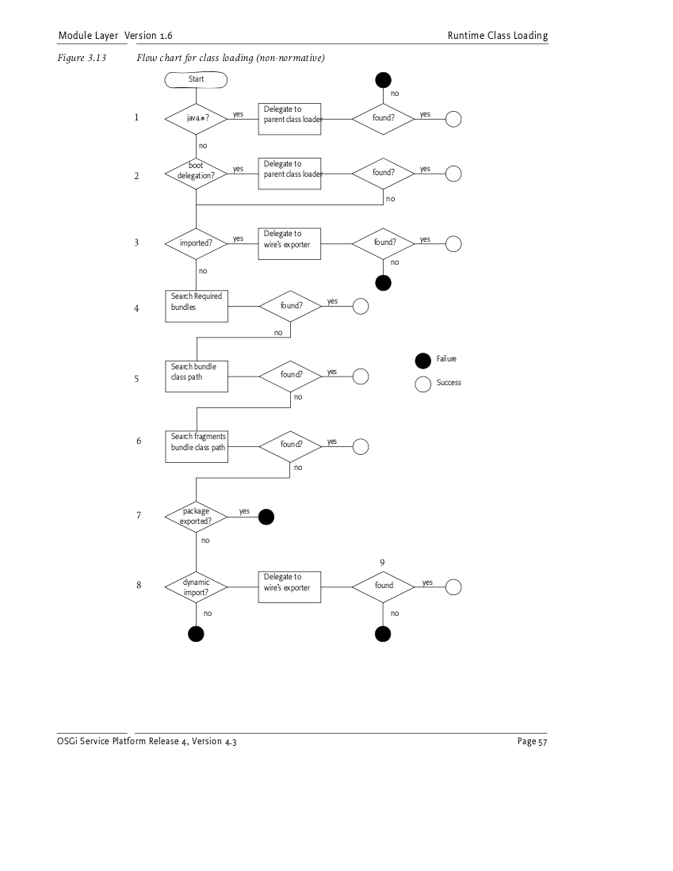
(full size: http://www.robokind.org/posts/osgi_dependencies/osgi_deps/images/osgi-spec-r4v4_3-pg57.png)
(OSGi spec r4 v4.3 pg. 57)

This diagram is accompanied with the follow description from page 56:

Frameworks must adhere to the following rules for class or resource loading. When a bundle’s class
loader is requested to load a class or find a resource, the search must be performed in the following
order:
- If the class or resource is in a java.* package, the request is delegated to the parent class loader; otherwise, the search continues with the next step. If the request is delegated to the parent class loader and the class or resource is not found, then the search terminates and the request fails.
- If the class or resource is from a package included in the boot delegation list (org.osgi.framework.bootdelegation), then the request is delegated to the parent class loader. If the class or resource is found there, the search ends.
- If the class or resource is in a package that is imported using Import-Package or was imported dynamically in a previous load, then the request is delegated to the exporting bundle’s class loader; otherwise the search continues with the next step. If the request is delegated to an exporting class loader and the class or resource is not found, then the search terminates and the request fails.
- If the class or resource is in a package that is imported from one or more other bundles using Require-Bundle, the request is delegated to the class loaders of the other bundles, in the order in which they are specified in this bundle’s manifest. This entails a depth-first strategy; all required bundles are searched before the bundle classpath is used. If the class or resource is not found, then the search continues with the next step.
- Search the bundle’s embedded classpath, see Bundle Class Path on page 52. If the class or resource is not found, then continue with the next step.
- If the class or resource is in a package that is exported by the bundle or the package is imported by the bundle (using Import-Package or Require-Bundle), then the search ends and the class or resource is not found.
- Otherwise, if the class or resource is in a package that is imported using DynamicImport Package, then a dynamic import of the package is now attempted. An exporter must conform to any implied package constraints. If an appropriate exporter is found, a wire is established so that future loads of the package are handled in Step 3. If a dynamic wire is not established, then the request fails.
- If the dynamic import of the package is established, the request is delegated to the exporting bundle’s class loader. If the request is delegated to an exporting class loader and the class or resource is not found, then the search terminates and the request fails.
When delegating to another bundle class loader, the delegated request enters this algorithm at Step 4.

This document is licensed under a Creative Commons Attribution 3.0 Unported License.

