测试源码

**package** GameOfLife;

**import** java.awt.*;

**import** java.awt.event.MouseEvent;

**import** java.awt.event.MouseMotionListener;

**import** java.util.Random;

**import** javax.swing.*;

**public** **class** lifegame {

**int** rows;

**int** columns;

JLabel record;

**boolean** diy=**false**;

**boolean** clean=**false**;

**private** **int** speed=8;

**private** **int** lnum;

**private** **static** **int** *shape*[][]=**new** **int** [40][50];

**private** **static** **int** *zero*[][]=**new** **int** [40][50];

**static** **int** *pauseshape*[][]=**new** **int** [40][50];

**private** CellStatus[][] currentGeneration;

**private** CellStatus[][] nextGeneration;

**static** **int** *generation1*[][];

**static** **int** *generation2*[][];

**int** generation[][];

**private** **volatile** **boolean** isChanging = **false**;

@Before

**public** **void** setUp() **throws** Exception {

}

**public** **void** World() {

**this**.rows=rows;

**this**.columns=columns;

record = **new** JLabel();

**for**(**int** i=0;i<rows;i++)

{

**for**(**int** j=0;j<columns;j++)

{

*generation1*[i][j]=100;

}

}

**for**(**int** i=0;i<rows;i++)

{

**for**(**int** j=0;j<columns;j++)

{

*generation2*[i][j]=100;

}

}

}

**public** **void** SetRandom() {

Random a=**new** Random();

**for**(**int** i=0;i<rows;i++)

{

**for**(**int** j=0;j<columns;j++)

{

*shape*[i][j]=Math.*abs*(a.nextInt(2));

*pauseshape*[i][j]=*shape*[i][j];

}

}

}

**public** **void** SetZero() {

**for**(**int** i=0;i<rows;i++)

{

**for**(**int** j=0;j<columns;j++)

{

*zero*[i][j]=0;

}

}

}

}

测试所用的插件为junit

安装步骤为

添加junit

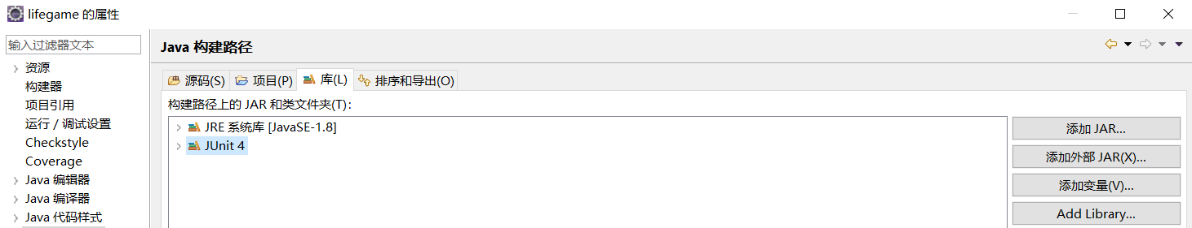

右击代码，新建测试用例

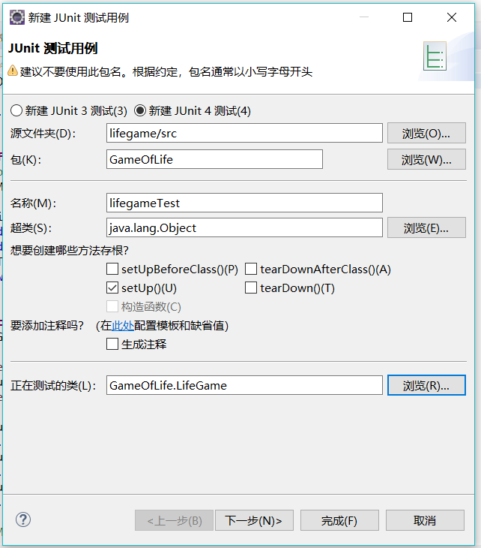

测试代码为

**package** GameOfLife;

**import** **static** org.junit.Assert.*;

**import** java.util.Random;

**import** javax.swing.JLabel;

**import** org.junit.Before;

**import** org.junit.Test;

**import** GameOfLife.World.CellStatus;

**public** **class** lifegameTest {

**int** rows;

**int** columns;

JLabel record;

**boolean** diy=**false**;

**boolean** clean=**false**;

**private** **int** speed=8;

**private** **int** lnum;

**private** **static** **int** *shape*[][]=**new** **int** [40][50];

**private** **static** **int** *zero*[][]=**new** **int** [40][50];

**static** **int** *pauseshape*[][]=**new** **int** [40][50];

**private** CellStatus[][] currentGeneration;

**private** CellStatus[][] nextGeneration;

**static** **int** *generation1*[][];

**static** **int** *generation2*[][];

**int** generation[][];

**private** **volatile** **boolean** isChanging = **false**;

@Before

**public** **void** setUp() **throws** Exception {

}

@Test

**public** **void** testWorld() {

**this**.rows=rows;

**this**.columns=columns;

record = **new** JLabel();

**for**(**int** i=0;i<rows;i++)

{

**for**(**int** j=0;j<columns;j++)

{

*generation1*[i][j]=100;

}

}

**for**(**int** i=0;i<rows;i++)

{

**for**(**int** j=0;j<columns;j++)

{

*generation2*[i][j]=100;

}

}

}

@Test

**public** **void** testSetRandom() {

Random a=**new** Random();

**for**(**int** i=0;i<rows;i++)

{

**for**(**int** j=0;j<columns;j++)

{

*shape*[i][j]=Math.*abs*(a.nextInt(2));

*pauseshape*[i][j]=*shape*[i][j];

}

}

}

@Test

**public** **void** testSetZero() {

**for**(**int** i=0;i<rows;i++)

{

**for**(**int** j=0;j<columns;j++)

{

*zero*[i][j]=0;

}

}

}

}

测试结果成功

