show databases;

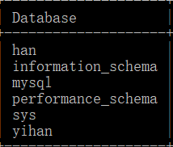

6 rows in set (0.01 sec)

use han;

Database changed

mysql> show tables;



7 rows in set (0.01 sec)

mysql> select * from jobs;



19 rows in set (0.00 sec)

mysql> select distinct job_id from jobs;



19 rows in set (0.00 sec)

mysql> select * from jobs where MIN_SALARY>=3000;

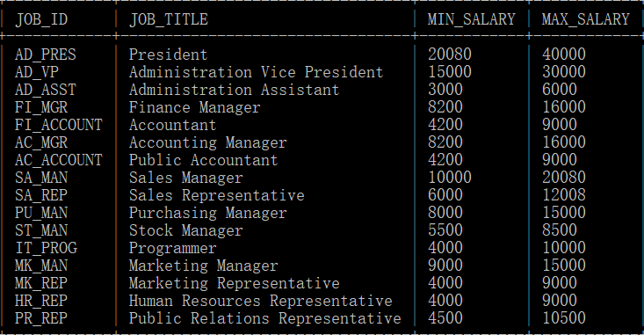

16 rows in set (0.00 sec)

mysql> select * from jobs order by MIN_SALARY;

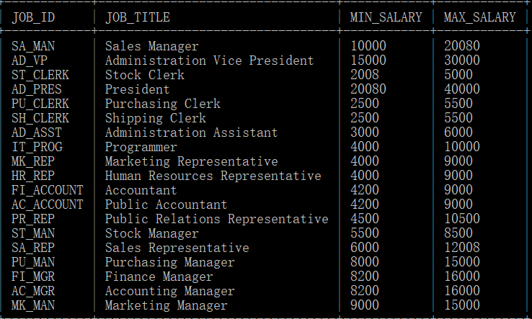

19 rows in set (0.00 sec)

mysql> select * from jobs order by MIN_SALARY desc;

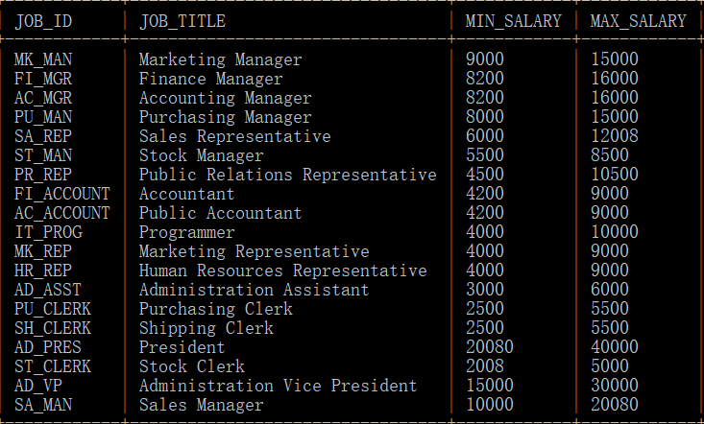

19 rows in set (0.00 sec)

mysql> select * from jobs order by MIN_SALARY limit 4;

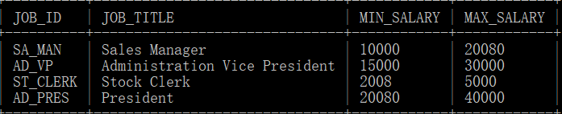

4 rows in set (0.00 sec)

mysql> select * from jobs order by MIN_SALARY limit 2,4;

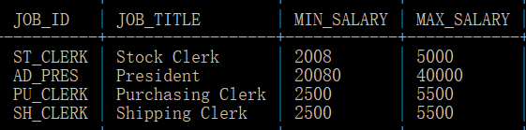

4 rows in set (0.00 sec)

mysql> select sum(MIN_SALARY) from jobs;

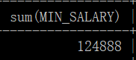

1 row in set (0.00 sec)

mysql> select sum(MIN_SALARY),sum(MAX_SALARY) from jobs;

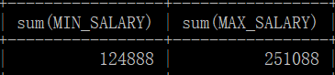

1 row in set (0.00 sec)

mysql> select max(MIN_SALARY) from jobs;



1 row in set (0.00 sec)

mysql> select min(MIN_SALARY) from jobs;

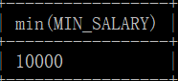

1 row in set (0.00 sec)

mysql> select MIN_SALARY,count(MIN_SALARY) from jobs group by MIN_SALARY;

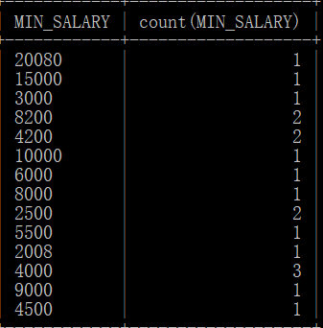

14 rows in set (0.00 sec)