Problem statement and hypothesis
Every day people all over the world wake up in the morning, go to work, then come home and spend time with their families. Across all the different types of people, types of jobs, locations and hours, despite all of our individual differences the one thing that is shared by everyone is the use of transportation. Without transportation nothing or no one could move from place to place. New York City is a global hub of commerce and culture, and it is world famous for its traffic. More effective transportation are sorely needed to reduce waste and increase efficiency. What sets NYC apart from other cities is its population density. The high population density makes for an ideal environment for alternative modes of transportation. For this project, I'd like to investigate how taxi demand changes according to season, which poses profound implications for managing and maintaining a flexible, on-demand transportation fleet. I hypothesize that the number of rides hailed does have a seasonal component and will fluctuate according to the season., with more rides being hailed in the winter.
Description of your data set and how it was obtained
My dataset came from the NYC open data project. It is published by the NYC taxi and limousine commission.
Description of any pre-processing steps you took
- Parse date from datetime field
- Create a response variable, which is where a pickup and dropoff datetime are present.
- Check for a discrepancy between column values.
- Parse the day and month from the datetime field.
- Convert passenger count, trip distance, revenue, and response variable to numeric.
- Aggregate data by day, which reduces the row count from 16.3M to 355 rows.
- Convert ‘pickup_timestamp’ to datetime and set it as the index
- Plot the autocorrelations across a variety of lags
- Run an AR(1) model to determine if the dataset is stationary or not
- Plot the errors or residuals
- Explore various MA’s
- Run a full ARIMA model
- Finally, find the accuracy of the model
What you learned from exploring the data, including visualizations
The data came fairly clean, with no missing values from my response variables.
I was missing values from my latitude and longitude columns, which points towards an equipment error. All features had the same number of row entries. (Row counts of all columns in appendix)
After the data was aggregated the data appears cyclical, which would suggest a highly auto regulated dataset.
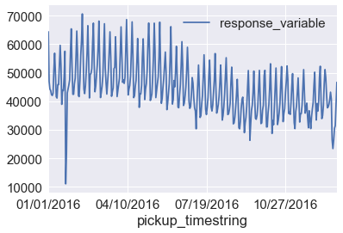
[Figure 1- Line graph of response variable by day. The regular patterns show a consistent trend, which suggests the dataset might be stationary]
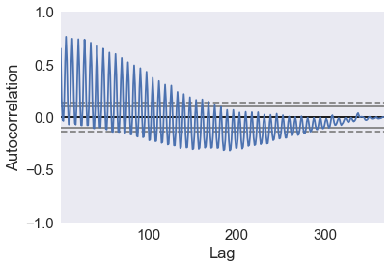
[Figure 2- Typical pattern found in autocorrelation plots. It should decrease to 0 as lag increases.]
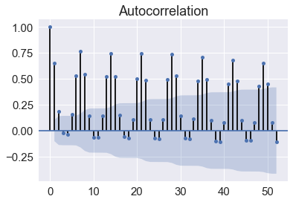
[Figure 3- Regular spikes in autocorrelation values implies an impact by previous values and that an AR model would be useful]
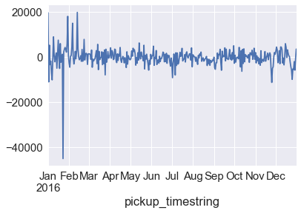
[Figure 4- Plotting the residuals shows that the model does a decent job of accounting for everything. There is only one outlier period]
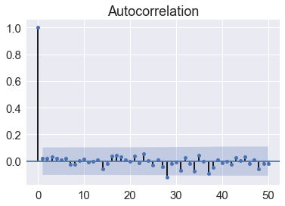
[Figure 5- Plotting the residuals after running an ARIMA(28,1,1) time series, shows residuals being both random and near zero.]

How you chose which features to use in your analysis
I chose the features that made the most sense. Passenger count, demand, and day and month were my chosen features. I chose them because they were all numeric, continuous, and the relationship between them and time is not readily apparent. As a counter example, running a predictive model based on trip distance and demand would be pointless, because they are 100% correlated.
Details of your modeling process, including how you selected your models and validated them
I chose an ARIMA model because I was looking into seasonality and how the response variable changes over time. It is a continuous variable and a supervised learning problem. Order matters in this case, so that left with a variety of time series models. After running some exploratory analysis, and seeing that the data set was highly autocorrelated, and had a few sudden spikes or drops, I decided to use an ARIMA model. It addresses the autocorrelative aspects and by using the moving average, I can account for sudden changes.
Your challenges and successes
My biggest challenge was parsing my datefield. Once the date had been parsed out, I could aggregate the dataset to the day level. By doing so, I could reduce the rows from 16.3M to 366 rows.
Possible extensions or business applications of your project
Predicting rides hailed based on season, and if the number of passengers also goes up, then the business could change to a larger car fleet. It would help predict maintenance costs and to have flexible supply.
Conclusions and key learnings

Appendix:

Out[9]:
VendorID 16385532
lpep_pickup_datetime 16385532
Lpep_dropoff_datetime 16385532
Store_and_fwd_flag 16385532
RateCodeID 16385532
Pickup_longitude 9018030
Pickup_latitude 9018030
Dropoff_longitude 9018030
Dropoff_latitude 9018030
Passenger_count 16385532
Trip_distance 16385532
Fare_amount 16385532
Extra 16385532
MTA_tax 16385532
Tip_amount 16385532
Tolls_amount 16385532
Ehail_fee 0
improvement_surcharge 16385532
Total_amount 16385532
Payment_type 16385532
Trip_type 16385060
PULocationID 7367502
DOLocationID 7367502
pickup_timestring 16385532
dropoff_timestring 16385532
dtype: int64

