**Exhaust System**

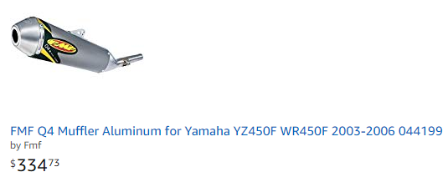  
[FMF Q4 Muffler Aluminum for Yamaha YZ450F WR450F 2003-2006 044199](https://www.amazon.com/Muffler-Aluminum-Yamaha-2003-2006-044199/dp/B000VJPKEG/ref=sr_1_6?s=automotive&ie=UTF8&qid=1531152110&vehicle=2004-1210-20384-20-----14041------1-0&sr=1-6&ymm=2004%3Ayamaha%3Awr450f)  
  
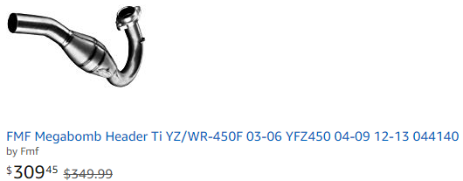  
[FMF Megabomb Header Ti YZ/WR-450F 03-06 YFZ450 04-09 12-13 044140](https://www.amazon.com/Megabomb-Header-WR-450F-YFZ450-044140/dp/B000WMTGL0/ref=sr_1_5?s=automotive&ie=UTF8&qid=1531152110&vehicle=2004-1210-20384-20-----14041------1-0&sr=1-5&ymm=2004%3Ayamaha%3Awr450f&dpID=41gtpDJQJrL&preST=_SX300_QL70_&dpSrc=srch)

**Electrical**

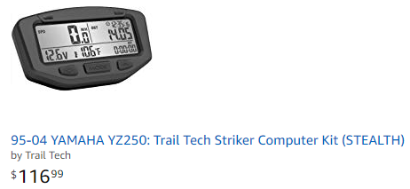  
PURCHASED! Vapor 700 series instead 125.00 10Jul2018  
[95-04 YAMAHA YZ250: Trail Tech Striker Computer Kit (STEALTH)](https://www.amazon.com/95-04-YAMAHA-YZ250-Striker-Computer/dp/B008C7PCSI/ref=sr_1_4?s=automotive&ie=UTF8&qid=1531152545&vehicle=2004-1210-20384-20-----14041------1-0&sr=1-4&ymm=2004%3Ayamaha%3Awr450f)  
  
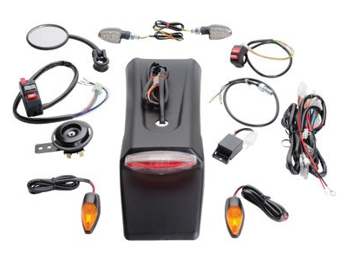$164.50   
PURCHASED 10Jul2018

[Tusk Enduro Street Legal Lighting/Horn/Mirror/Signals Kit -YAMAHA WR250F WR450F 2003-2018](https://www.amazon.com/Enduro-Lighting-Signals-YAMAHA-2003-2018/dp/B075ZJR82S/ref=pd_rhf_ee_p_img_6?_encoding=UTF8&psc=1&refRID=Y3DYW2R5Y5HP39HWXVMG)

**Engine**

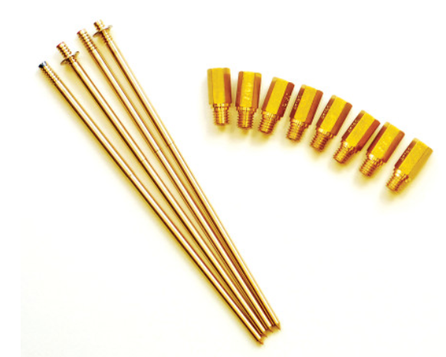  
[JD Jetting Jet Kit $84.95](https://www.motosport.com/product/?adpos=1o1&cc=us&creative=188670675970&device=c&gclid=EAIaIQobChMIrITu_7WS3AIVBDJpCh1a2wsoEAQYASABEgKi__D_BwE&key=JD-Jetting-Jet-Kit&matchtype=&mrkgadid=3193665158&mrkgcl=500&network=g&product_id=JDJ0004-X001-Y029&pssource=true&rkg_id=0&segment=badger)

[Keihin Main Jets $20.99  
Keihin Pilot Jets $20.99](https://www.motosport.com/product/?adpos=1o1&cc=us&creative=188670675970&device=c&gclid=EAIaIQobChMIrITu_7WS3AIVBDJpCh1a2wsoEAQYASABEgKi__D_BwE&key=JD-Jetting-Jet-Kit&matchtype=&mrkgadid=3193665158&mrkgcl=500&network=g&product_id=JDJ0004-X001-Y029&pssource=true&rkg_id=0&segment=badger)

**Gear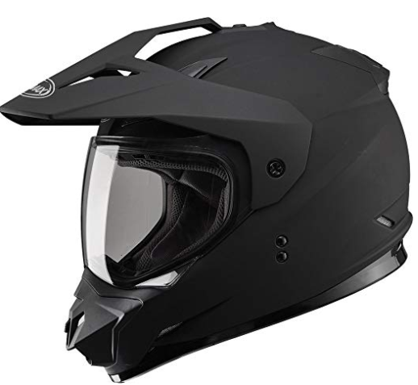$112.50**

[**Gmax GM11D Dual Sport Full Face Helmet (Flat Black, Large)**](https://www.amazon.com/Gmax-GM11D-Sport-Helmet-Black/dp/B015QDKDPW/ref=pd_sbs_263_1?_encoding=UTF8&pd_rd_i=B015QDKDPW&pd_rd_r=e599e425-839a-11e8-aafc-3933c5359799&pd_rd_w=0MSXV&pd_rd_wg=13p4w&pf_rd_i=desktop-dp-sims&pf_rd_m=ATVPDKIKX0DER&pf_rd_p=5825442648805390339&pf_rd_r=9KB4NYK79G0RCAN3PV42&pf_rd_s=desktop-dp-sims&pf_rd_t=40701&psc=1&refRID=9KB4NYK79G0RCAN3PV42)

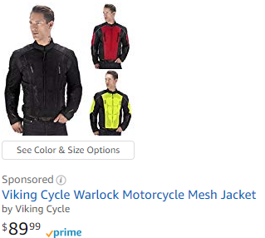

[**Viking Cycle Warlock Motorcycle Mesh Jacket**](https://www.amazon.com/s/ref=nb_sb_ss_i_2_5?url=search-alias%3Dautomotive&field-keywords=motorcycle+jackets+mens&sprefix=jacke%2Cautomotive%2C124&crid=3GBCVJBRJT5PT)

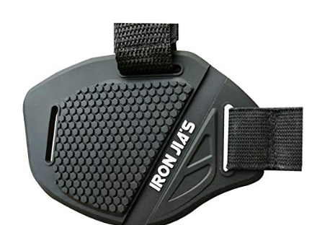**$8.00**[**Motorcycle Shoes Protector Shifter Boots Cover Protective Shift Pad**](https://www.amazon.com/dp/B075N9KN1R?aaxitk=aXyDPe0VJmm89Pb8BFgDfQ&pd_rd_i=B075N9KN1R&pf_rd_m=ATVPDKIKX0DER&pf_rd_p=3930100107420870094&pf_rd_s=desktop-sx-top-slot&pf_rd_t=301&pf_rd_i=motorcycle+gloves+men&hsa_cr_id=1953011980501)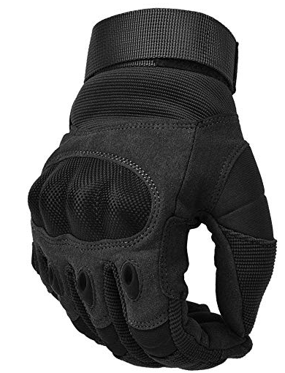**$16.00**

[**REEBOW TACTICAL Military Hard Knuckle Tactical Gloves Motorcycle Gloves**](https://www.amazon.com/REEBOW-TACTICAL-Military-Motorcycle-Motorbike/dp/B07BJ2PKW3/ref=pd_day0_hl_200_3?_encoding=UTF8&pd_rd_i=B07BJ2PKW3&pd_rd_r=e932fe41-839c-11e8-abf4-0dab813930ac&pd_rd_w=DNLZ9&pd_rd_wg=TNQQ0&pf_rd_i=desktop-dp-sims&pf_rd_m=ATVPDKIKX0DER&pf_rd_p=4014010564823900592&pf_rd_r=PX41J03EDHS4EG5RJ455&pf_rd_s=desktop-dp-sims&pf_rd_t=40701&refRID=PX41J03EDHS4EG5RJ455)

**Gear total:**

**$250.00**

**Mod total:**

**650.00 (exhaust) 3rd**

**\*285.00 (Lights and speed/tach) immediate!**

**1200.00 (Moto wheel kit) 4th**

**$127.00 (carb upgrade) 2nd**

**$2262.00**