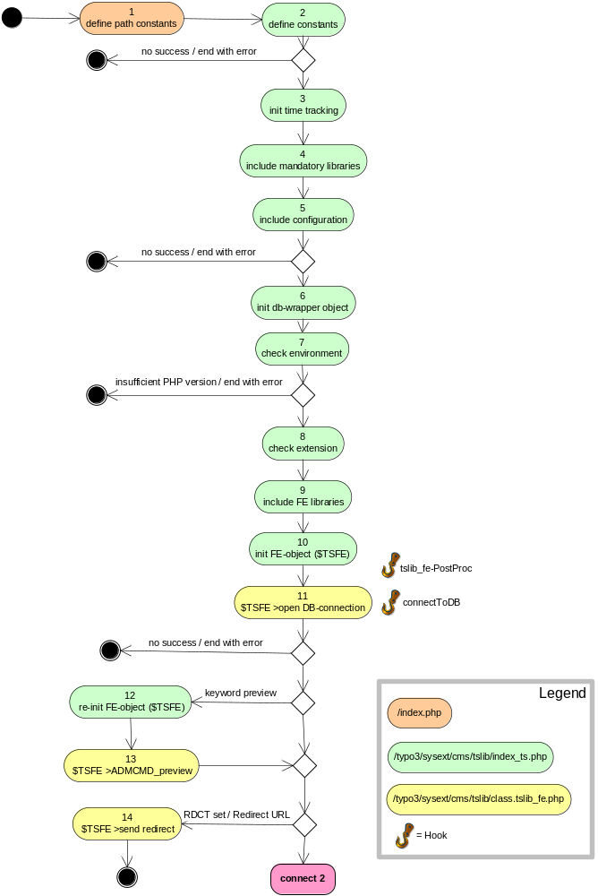
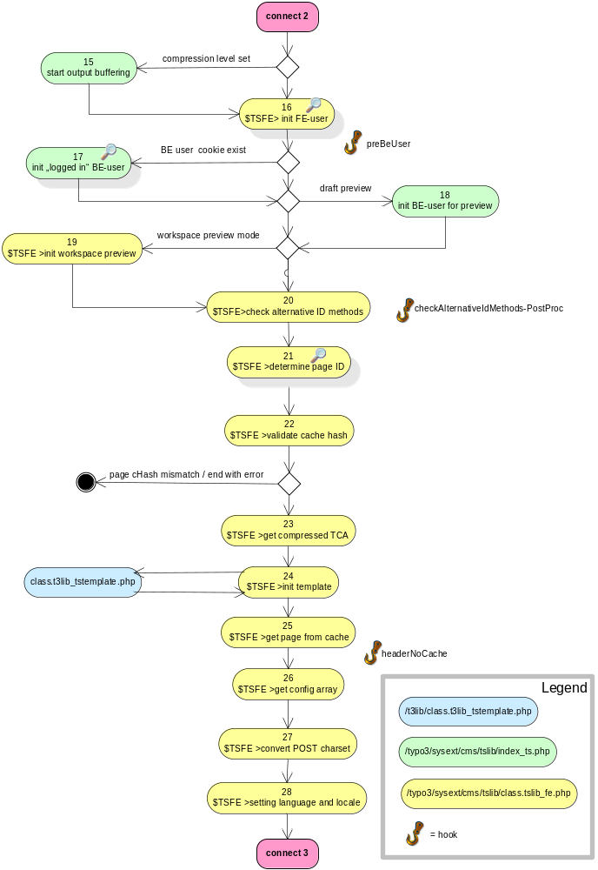
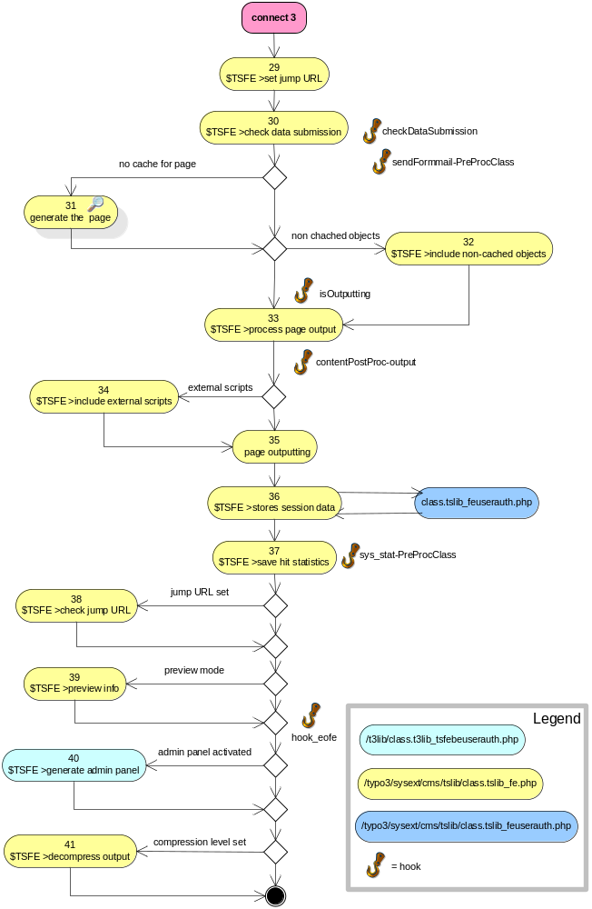

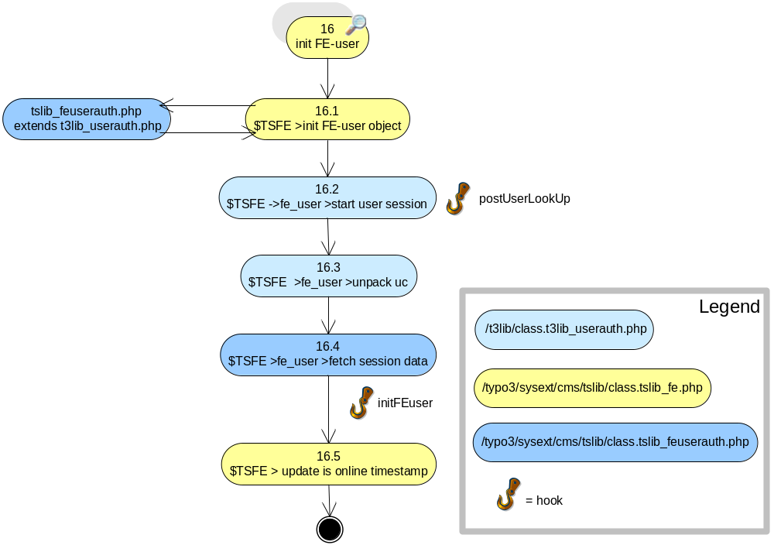

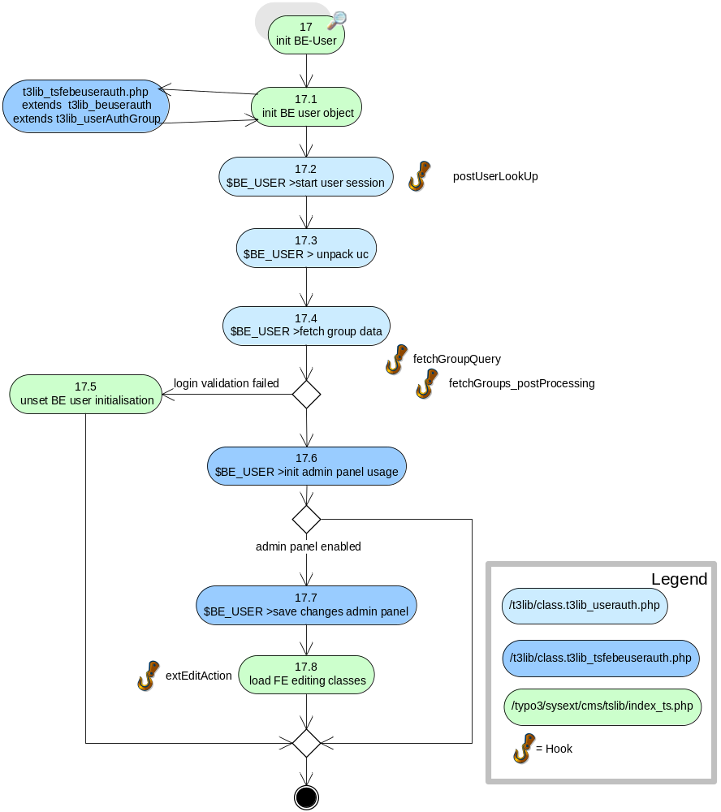
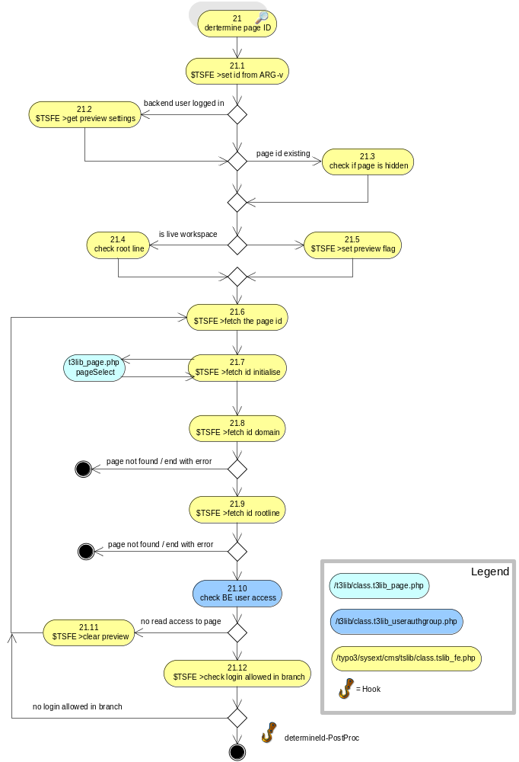
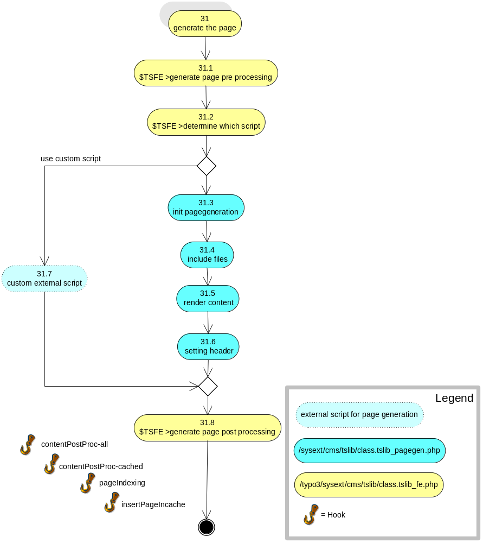

Frontend Rendering Process (Ver 4.1.1)

No | Action Title | Filename | Function | Description
1 | define path constants | index.php |  | -Path constants for this site and tslib  - include index_ts.php
2 | define constants | index_ts.php |  | TYPO3_OS, TYPO3_MODE  - various path constants if not already set
3 | init time tracking | index_ts.php | new t3lib_timeTrack | init time tracking object ($TT)
4 | include mandatory libs | index_ts.php |  | class.t3lib_div.php, class.t3lib_extmgm.php
5 | include configuration | index_ts.php |  | config_default.php, class.t3lib_db.php  generated from localconf.php and ext_localconf.php
6 | init db object | index_ts.php | t3lib_div::makeInstance  ('t3lib_DB') | init db wrapper object ($TYPO3_DB)
7 | check environment | index_ts.php |  | - php version, $GLOBALS  - Add slashes to GET/POST arrays
8 | check extension | index_ts.php |  | look for extension id to launch alternative output engine
9 | include fe libraries | index_ts.php |  | tslib_fe.php;  t3lib_page.php;  3lib_userauth.php;  class.tslib_feuserauth.php;  t3lib_tstemplate.php;  t3lib_cs.php;
10 | init fe object | index_ts.php | t3lib_div::makeInstance  ClassName('tslib_fe') | init TypoScript front end object ($TSFE)
 | tslib_fe-PostProc | class.tslib_fe.php | tslib_fe() | Hook
11 | Open db connection | class.tslib_fe.php | connectToDB() | Open database connection
 | connectToDB | class.tslib_fe.php | connectToDB() | Hook
12 | re-Init FE-object | index_ts.php |  | keyword authenticated preview genereates a temporary  preview URL which is accessible without BE login
13 | $TSFE>ADMCMD_preview | class.tslib_fe.php | ADMCMD_preview_postInit() | - unsets BE user cookie  - force BE user settings according preview configuration
14 | $TSFE>send redirect | class.tslib_fe.php | sendRedirect() | Redirect to a different page (location)
15 | Start output buffering | index_ts.php | ob_start() | Data will not be sent to screen until output buffering ends
16 | Init FE user | class.tslib_fe.php | See separate diagram | Init the frontend user object ($TSFE>fe_user)
 | preBeUser | index_ts.php |  | Hook
17 | Init BE user | index_ts.php | See separate diagram | Init the backend user object ($BE_USER)
18 | Init BE user for preview | index_ts.php |  | Init a “dummy” backend user for preview only
19 | Init workspace preview | class.tslib_fe.php | workspacePreviewInit() | Init workspace preview functions
20 | Check alternative page id | class.tslib_fe.php | checkAlternativeIdMethods() | Resolve alternative request URL such as “simulate static documents” or “Real URL”
 | checkAlternativeIdMethods-PostProc | class.tslib_fe.php | checkAlternativeIdMethods | Hook
21 | Determine page id | class.tslib_fe.php | See separate diagram | class.tslib_fe.php Determine the page id
22 | validate cache hash | class.tslib_fe.php | makeCacheHash() | Create the hash string based on additional parameters in the URL if  get parameter cHash is set
23 | Get compressed TCA | class.tslib_fe.php | getCompressedTCarray() | getting a compressed version of the TCA for the frontend editing
24 | Init template | class.tslib_fe.php | initTemplate() | Init the TypoScript template parser  > t3lib/class.t3lib_tstemplate.php
25 | Get page from cache | class.tslib_fe.php | getFromCache() | Query the cache tablesfor the requested page
 | headerNoCache | class.tslib_fe.php | headerNoCache() | Hook
26 | Get config array | class.tslib_fe.php | getConfigArray() | Getting the TypoScript config array if not yet existing
27 | Convert POST charset | class.tslib_fe.php | convPOSTCharset() | Convert POST data to internal "renderCharset" if different from the metaCharset:
28 | Setting language and  locales | class.tslib_fe.php | settingLanguage()  settingLocale() | Setting the internal var,  sys_language_uid + locale settings
29 | set jump URL | class.tslib_fe.php | setExternalJumpUrl()  checkJumpUrlReferer() | - set the jump URL for page type "External URL"  - Checks the jumpurl referer if required  Jumpurl is a concept where external links are redirected from the index_ts.php script.
30 | Check data submission | class.tslib_fe.php | checkDataSubmission() | Process form input data
 | checkDataSubmission | class.tslib_fe.php | checkDataSubmission() | Hook
 | sendFormmail-PreProcClass | class.tslib_fe.php | sendFormmail() | Hook
31 | Generate the page | class.tslib_fe.php | See separate diagram | ..)
32 | include non-cached objects | class.tslib_fe.php | INTincScript() | Uncached user functions (USER_INT), php or java scripts
 | isOutputting | class.tslib_fe.php | isOutputting() | Hook
33 | process page output | class.tslib_fe.php | processOutput() | process the page before output
 | contentPostProc-output | class.tslib_fe.php | processOutput() | Hook
34 | Include external scripts | class.tslib_fe.php |  | Include external php scripts
35 | Page outputting | index_ts.php | Echo $content | Generate output
36 | Store session data | class.tslib_fe.php | storeSessionData() | Store session data for FE user  >class.tslib_feuserauth.php
37 | Save hit statistics | class.tslib_fe.php | statistics() | Save hit statistics for page
 | sys_stat-PreProcClass | class.tslib_fe.php | Statistics() | Hook
38 | Check Jump URL | class.tslib_fe.php | jumpurl() | Sends a header 'Location' to jumpurl, if jumpurl is set
39 | Preview info | class.tslib_fe.php | previewInfo() | Generate red preview information box
 | hook_eofe | index_ts.php |  | Hook
40 | Generate admin panel | class.t3lib_tsfebeuserauth.php | extPrintFeAdminDialog() | Generate admin panel options if applicable
41 | Uncompress output | class.tslib_fe.php | gzip_encode() | Uncompress output if compression level set

Initialise Frontend User

No | Action Title | Filename | Function | Description
16.1 | Init FE use object | class.tslib_feuserauth | $TSFE>initFEuser() | Init object $TSFE>fe_user
16.2 | Start user session | class.t3lib_userauth.php | Start() | - check and set login security level  (normal, challenged, superchallenged)  - check if a password/username was sent and if so, try to authenticate the user  - Lookup a session attached to a user and check timeout etc.  - Garbage collection, setting of no-cache headers.
 | postUserLookUp | class.t3lib_userauth.php | start() | Hook
16.3 | Unpack uc | class.t3lib_userauth.php | unpack_uc() | Unpack user configuration. Contains various user specific settings for page.  (e.g state of pagetree, adminpanel)
16.4 | Fetch session data | class.tslib_feuserauth | fetchSessionData() | - Fetches the session data for the user (from the fe_session_data table) based on the ->id of the current user-session  - delete old session data (older than 24 hrs).
 | initFEuser | class.tslib_fe.php | initFEuser() | Hook
16.5 | Update “is online” timestamp | class.tslib_fe.php | initFEuser() | Update timestamp every 60 seconds

Initialise Backend User

No | Action Title | Filename |  | Function | Description
17.1 | Init BE user | index_ts.php  class.t3lib_tsfebeuserauth.php |  | makeInstance ('t3lib_tsfeBeUserAuth') | Init object SBE_user
17.2 | Start user session |  | class.t3lib_userauth.php | Start() | - check and set login security level  (normal, challenged, superchallenged)  - check if a password/username was sent and if so, try to authenticate the user  - Lookup a session attached to a user and check timeout etc.  - Garbage collection, setting of no-cache headers.
 | postUserLookUp | class.t3lib_userauth.php |  | start() | Hook
17.3 | Unpack uc | class.t3lib_userauth.php |  | unpack_uc() | Unpack user configuration
17.4 | Fetch group data | class.tslib_feuserauth |  | fetchGroupData() | - fetch FE groups which the current FE user is member of  - accumulate user and group TS config
 | fetchGroupQuery | class.t3lib_userauthgroup.php |  | fetchGroups() | Hook
 | fetchGroups_post  Processing | class.t3lib_userauthgroup.php |  | fetchGroups() | Hook
17.5 | Unset BE user | index_ts.php |  |  | Unset BE user initialisation if login validation failed  - check lock to ip  - check backend access settings
17.6 | init admin panel usage | class.t3lib_tsfebeuserauth.php |  | extInitFeAdmin()
17.7 | Save changes admin panel | class.t3lib_tsfebeuserauth.php |  | extSaveFeAdminConfig() | Save any changes in admin panel settings
17.8 | Load FE editing classes | index_ts.php |  |  | class.t3lib_tcemain.php, class.t3lib_tceforms.php, class.t3lib_iconworks.php, class.t3lib_loaddbgroup.php, class.t3lib_transferdata.php
 | extEditAction | class.t3lib_tsfebeuserauth.php |  | extEditAction()

Determine Page ID

No | Action Title | Filename | Function | Description
21.1 | set id from ARG-v | class.tslib_fe.php | setIDfromArgV()s | This checks if there are ARGV-parameters in the QUERY_STRING and if so, those are used for the id
21.2 | get BE user preview settings | class.tslib_fe.php |  | If there is a Backend login check for any preview settings:
21.3 | check if page is hidden | class.tslib_fe.php |  | Now it's investigated if the raw page-id points to a hidden page and if so, the flag is set.
21.4 | check root line | class.tslib_fe.php | makeInstance  ('t3lib_pageSelect')  Init() | For Live workspace: Check root line for proper connection to tree root (done because of possible preview of page / branch versions)
21.5 | set preview flag | class.tslib_fe.php |  | - The preview flag will be set if a backend user is in an offline workspace  -If the front-end is showing a preview, caching MUST be disabled.
21.6 | fetch the page id | class.tslib_fe.php | fetch_the_id() | This gets the id of the page, checks if the page is in the domain and if the page is accessibl
21.7 | fetch id initialise | class.tslib_fe.php | initUserGroups()  setSysPageWhereClause() | - init pageSelect object, preview settings  - init user groups  - extract id from URL
21.8 | fetch id domain | class.tslib_fe.php | findDomainRecord()  getFirstWebPage() | - check the first visible page of the current domain
21.9 | fetch id rootline | class.tslib_fe.php | getPageAndRootlineWithDomain() | - get page and rootline arrays  - if page is not accessible, fetch previous page in rootline  - if page type is shortcut, fetch rootline of shortcut target page
21.10 | check be user access | t3lib_userauthgroup.php | doesUserHaveAccess() | Check if backend user has read access to this page. If not, recalculate the id.
21.11 | Clear preview | class.tslib_fe.php
21.12 | Check login allowed in branch | class.tslib_fe.php | checkIfLoginAllowedInBranch() | Checks if user logins are blocked for a certain branch and if so, will unset user login and re-fetch ID
 | determineId-PostProc

Generate Page
No | Action Title | Filename | Function | Description
31.1 | Generate page pre  processing | class.tslib_fe.php | generatePage_preProcessing() | store temporary temporary user message in cache table. ( Page is being generated..)
31.2 | Determine which script | class.tslib_fe.php | generatePage_whichScript() | Determines to include custom or pagegen.php script.  Returns script-filename if a TypoScript (config) script is defined and should be include instead of pagegen.php
31.3 | Init pagegen | class.tslib_pagegen.php | pagegenInit() | Setting some vars in TSFE, primarily based on TypoScript config settings.
31.4 | Include files | class.tslib_pagegen.php | getIncFiles() | Returns an array with files to include. These files are the ones set up in TypoScript config.
31.5 | Render content | class.tslib_pagegen.php | renderContent() | Rendering the page content
31.6 | Setting header | class.tslib_pagegen.php | TSpagegen::renderContentWithHeader | rendering normal HTML-page with header by wrapping the generated content ($pageContent) in body-tags and setting the header accordingly.
31.7 | Custom script | class.tslib_fe.php |  | Generate from custom external script
31.8 | Generate page post processing | class.tslib_fe.php | generatePage_postProcessing() | caching and indexing the page
 | contentPostProc-all | class.tslib_fe.php | generatePage_postProcessing() | Hook
 | contentPostProc-cached | class.tslib_fe.php | generatePage_postProcessing() | Hook
 | pageIndexing | class.tslib_fe.php | generatePage_postProcessing() | Hook
 | insertPageIncache | class.tslib_fe.php | realPageCacheContent() | Hook

