Explanation of the Scroll Page Code

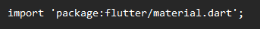
- Imports the Flutter Material library, providing access to widgets, themes, and the overall design system for Material-based apps.

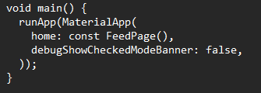
- main() function: The entry point of the application.
- runApp: Boots up the application with the provided widget.
- MaterialApp: The root of the widget tree, using Material Design.
  - home: Specifies the widget to display when the app starts (in this case, FeedPage).
  - debugShowCheckedModeBanner: false: Disables the debug banner.

Creating the Feed Page

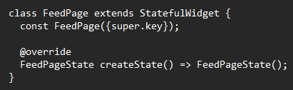
- FeedPage: A stateful widget representing the main feed screen.
  - Uses a StatefulWidget because it contains dynamic content that updates (e.g., loading new posts).

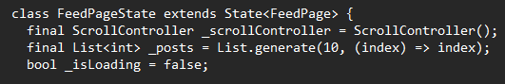
- FeedPageState: Manages the internal state of the feed page.
- _scrollController: Tracks user scrolling.
- _posts: List storing post identifiers (initially 10 posts).
- _isLoading: Boolean to manage the loading state.

Lifecycle Method (initState)

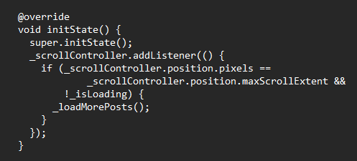
- initState(): Initializes state variables and sets up the scroll listener.
- The listener triggers _loadMorePosts() when the user scrolls to the bottom.

Loading More Posts
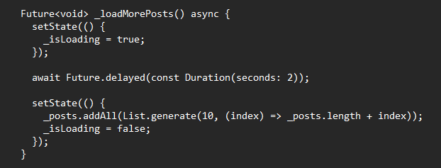
- _loadMorePosts(): Asynchronously loads more posts.
- Adds 10 new posts after a 2-second delay to simulate a network request.
- setState(): Updates the state, triggering a UI rebuild.

Building the UI (Scaffold)

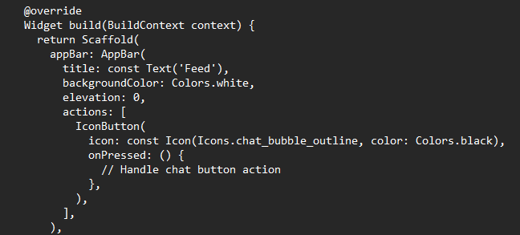
- Scaffold: Provides a structure for the page, including an app bar, body, and bottom navigation.
- AppBar: Displays the title "Feed" and a chat icon.
- IconButton: Interactive button with a chat icon.

Post List and Loading Indicator

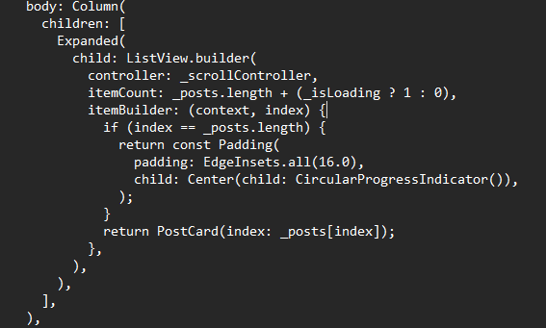
- ListView.builder: Dynamically builds the list of posts.
- itemCount: Includes an extra item if loading.
- CircularProgressIndicator: Displayed when loading new posts.
- PostCard: Displays individual posts.

Bottom Navigation Bar

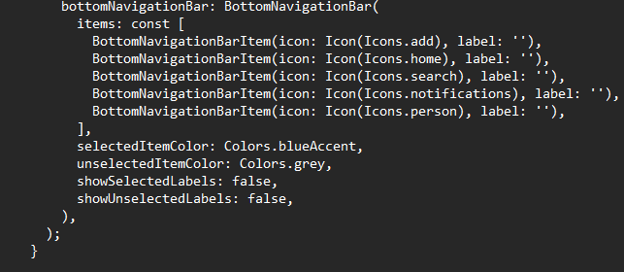
- BottomNavigationBar: Provides navigation options at the bottom of the screen.
- Icons for "Add," "Home," "Search," "Notifications," and "Profile."

Disposing Resources

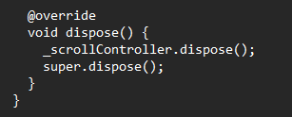
- dispose(): Frees up the resources used by _scrollController to prevent memory leaks.

PostCard Widget

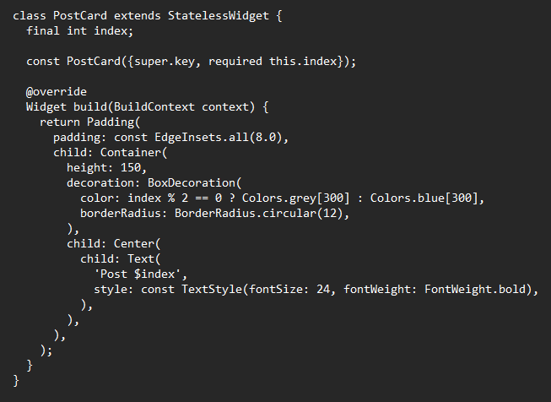
- PostCard: Represents a single post.
- Alternates background colors based on the post index.
- Displays the post identifier (Post $index).

