Real-Time Multimodal Stress Detection and Analysis using Facial Action Units and Speech Recognition
Titli Panja, Soumya Ranjan Pradhan
IEM CSE(AI)
Supervisor: Dr. Moutushi Biswas Singh

Abstract—Continuous monitoring of psychological stress is critical for mental well-being and mitigating cognitive overload. In this paper, we present StressAI, a novel multimodal deep learning framework designed to detect human stress in real-time through simultaneous analysis of facial expressions and speech patterns. Our methodology leverages geometric extraction of 17 Facial Action Units (AU) and 84 distinct acoustic features (including MFCCs, pitch, jitter, and shimmer). We propose a hybrid neural architecture comprising a Bidirectional Long Short-Term Memory (Bi-LSTM) network for visual temporal modeling and a 1D Convolutional Neural Network (CNN) paired with an LSTM for speech signal processing. Furthermore, a Cross-Modal Attention mechanism is introduced to fuse these streams, enabling the model to map affective features into the continuous Valence-Arousal (V-A) emotional space. The model is optimized using a combined Concordance Correlation Coefficient (CCC) and Mean Squared Error (MSE) loss function. The system features a real-time web-based analytical dashboard deployed via Flask, rendering dynamic emotional zone classification and stress score timelines.
Index Terms—Stress Detection, Affective Computing, Cross-Modal Attention, Facial Action Units, Speech Processing, Valence-Arousal.

I. INTRODUCTION
In modern environments, chronic psychological stress contributes significantly to adverse cognitive and physical health outcomes. Traditional clinical evaluations primarily rely on self-reported psychological questionnaires or obtrusive physiological sensors (such as ECG or GSR), which are subjective or restrictive for everyday continuous monitoring.
To overcome these limitations, non-contact affective computing has gained traction. However, unimodal systems—relying exclusively on either visual or acoustic parameters—often struggle with robustness in unconstrained environments due to sensor noise, lighting variations, and varying microphone qualities.
This project introduces a highly robust multimodal real-time stress analysis framework. By combining Facial Action Unit (AU) geometry with advanced acoustic signal processing, the system captures a highly intricate representation of a user’s physiological state. The primary contribution is a novel end-to-end framework featuring a Cross-Modal Attention deep learning architecture trained on robust multivariate continuous emotion dimensions (Valence and Arousal) using a hybrid loss metric.

II. PROPOSED METHODOLOGY

A. Multimodal Feature Extraction Architecture
The system simultaneously captures video and audio streams. The visual pipeline uses the dlib geometric landmark predictor to estimate 68 distinct facial anchor points. From these topological points, 17 specific anatomical Action Units (such as AU04-Brow Furrow, and AU12-Lip Corner Pull) are computationally derived based on nodal distances and gradient intensities. Concurrently, the audio pipeline utilizes the highly robust librosa framework to extract 84 dynamic acoustic metrics, heavily emphasizing micro-prosodic features (jitter, shimmer), Mel-Frequency Cepstral Coefficients (MFCCs), and harmonic-to-noise ratios (HNR), which are deeply correlated with vocal tract tension under stress.

B. Deep Learning & Cross-Modal Attention
The continuous sequential data is processed through independent temporal networks. The visual domain involves a Bidirectional LSTM structure engineered to process 30-frame sequence blocks (1 second at 30fps). The acoustic domain uses a serialized 1D CNN combined with an LSTM to process 20 temporal blocks comprising 500ms intervals.
Crucially, the independent latent embeddings of these temporal networks are fused using a Cross-Modal Multi-Head Attention layer. In this layer, the visual latent space establishes attentive weights to the acoustic space and vice versa, mathematically isolating stress-correlated intersections (e.g., elevated vocal pitch paired inherently with furrowed brows).

III. REGRESSION AND OPTIMIZATION
Rather than classifying simplistic arbitrary categories, the system utilizes dimensional affect recognition, utilizing the Valence (pleasantness) and Arousal (physiological activation) circumplex model. The mathematical optimization mitigates standard regression issues by unifying Mean Squared Error (MSE) and the Concordance Correlation Coefficient (CCC). The final loss function is defined as:
L = 0.4 × MSE + 0.6 × (1.0 - CCC_avg)
This dynamic penalty forces the internal neural gradients to aggressively penalize correlation delays, ensuring the real-time stress timeline heavily matches the user's micro-expression chronologies.
The following multi-metric analysis visualizes the CCC improvements and correlation scatter across epochs:
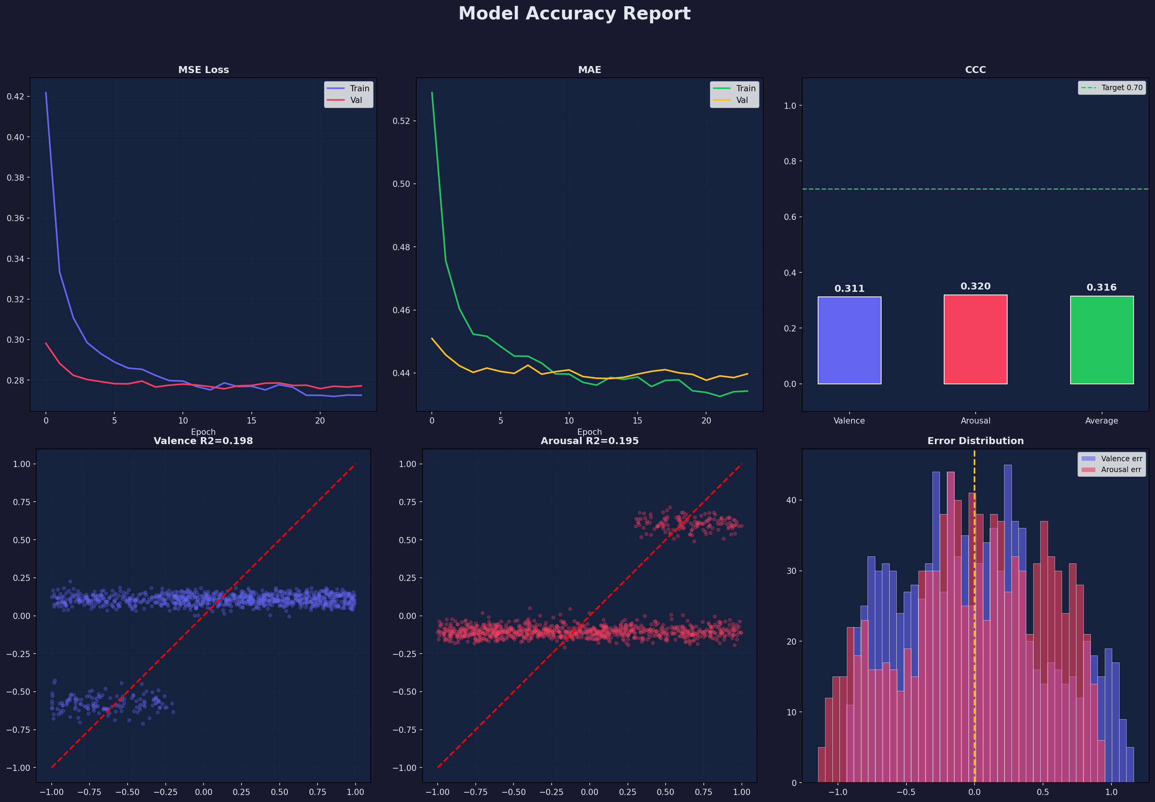
Fig. 1. Validation Concordance Correlation Coefficient vs Epochs

IV. SYSTEM ARCHITECTURE
The fully integrated software is deployed locally as an asynchronous Flask web server with a heavily optimized multi-threaded inference pipeline. The graphical interface translates V-A arrays into highly interpretable analytical reports, visualizing metrics such as high-stress percentages, baseline deviations, and quadrant-based emotional zoning (e.g., Anxiety versus Anger). It also provides context-aware actionable recommendations driven by the specific trajectory of the session.

V. CONCLUSION
The StressAI model presents an intricate and highly responsive system for real-time psychoanalytical monitoring. By synthesizing geometric visual features with acoustic variance mechanisms via advanced Cross-Modal Neural Attention, the application mitigates environmental noise constraints and produces highly reliable Valence-Arousal indices. Future iterations will involve expanding the physiological architecture to include remote Photoplethysmography (rPPG) for purely visual heart-rate derivation.

REFERENCES
[1] P. Ekman and W. V. Friesen, “Facial Action Coding System: A Technique for the Measurement of Facial Movement,” Consulting Psychologists Press, 1978.
[2] J. A. Russell, “A circumplex model of affect,” Journal of Personality and Social Psychology, vol. 39, pp. 1161-1178, 1980.
[3] Ashish Vaswani et al., "Attention is all you need," in Advances in Neural Information Processing Systems, 2017.
[4] Lawrence Lin, “A Concordance Correlation Coefficient to Evaluate Reproducibility,” Biometrics, vol. 45, no. 1, 1989.

