Software Architecture & Design Specification
for
Student Record System
Version 1.0
Prepared by:
Aadhavan Muthusamy (PES1UG24CS002)
Aakash Desai (PES1UG24CS006)
Aashlesh P (PES1UG24CS011)
Abhiraam Adiga (PES1UG24CS015)

PES UNIVERSITY: SOFTWARE ENGINEERING (UE24CS341A)
Based on: Student Record System SRS, Version 1.1; Software Test Plan, Version 1.0; Test Cases Related Update for Test Plan, Version 1.0
Created: 28/09/2026

Revision History
Date | Reason for Changes | Version
28/09/2026 | Initial release of the Software Architecture & Design Specification, based on SRS v1.1 | 1.0

Table of Contents
No. | Section | Page
1. | Introduction | 4
1.1 | Purpose | 4
1.2 | Scope | 4
1.3 | References | 4
1.4 | Definitions and Acronyms | 3
2. | Architecture Overview and Goals | 6
2.1 | Architectural Goals and Drivers | 6
2.2 | Architectural Style: Layered Monolithic Client-Server Architecture | 7
2.3 | Architecture Rationale | 7
3. | System Architecture | 8
3.1 | Layers | 8
3.2 | Component Diagram | 8
3.3 | Component Descriptions | 9
3.3.1 | Presentation / UI Layer | 9
3.3.2 | Controller / API Layer | 9
3.3.3 | Business / Service Layer | 9
3.3.4 | Data Access Layer | 10
3.3.5 | Relational Database | 10
3.4 | Layer Interactions | 10
3.5 | Data / Storage Architecture | 10
3.6 | Security Architecture | 11
3.7 | Architecture-to-Requirement Traceability | 12
3.8 | Deployment View | 13
3.9 | Architectural Constraints and Assumptions | 13
4. | Detailed Design | 14
4.1 | Design Overview | 14
4.2 | Sequence Diagrams | 14
4.2.1 | Sequence Diagram 1: User Login and Role-Based Access (FR-1, SO-3) | 14
4.2.2 | Sequence Diagram 2: Faculty Records/Updates Attendance (FR-7) | 16
4.3 | API Design | 17
4.3.1 | Authentication (FR-1, FR-14) | 18
4.3.2 | Student Records (FR-2) | 18
4.3.3 | Faculty Records (FR-3) | 18
4.3.4 | Courses (FR-4) | 19
4.3.5 | Faculty-Course Assignment and Student Enrollment (FR-5, FR-6) | 19
4.3.6 | Attendance (FR-7, FR-8) | 20
4.3.7 | Marks (FR-9, FR-10) | 20
4.3.8 | Profile and Dashboard (FR-11, FR-12, FR-13) | 21
4.4 | Error Handling | 21
4.5 | Security Considerations at the Design Level | 23
4.6 | Data / Database Design Considerations | 23
4.7 | Design-to-Requirement Traceability | 24
5. | References | 25

1. Introduction

1.1 Purpose
This Software Architecture & Design Specification (SADS) defines the architecture and detailed design of Version 1.0 of the Student Record System, strictly derived from the Software Requirements Specification (SRS), Version 1.1. It describes the selected architectural pattern, system components, data organization, security architecture, sequence-level design, API design, and error handling needed to implement the functional requirements (FR-1 to FR-14) and non-functional requirements (NFR-1 to NFR-8) defined in the SRS, without introducing functionality outside that scope.

1.2 Scope
This document covers the internal architecture and design of the system described in SRS Section 1.4 (Product Scope): record management by the Administrator, attendance and marks handling by Faculty for their assigned courses, and read-only academic views for Students, together with role-specific dashboards. Consistent with SRS Section 2.5 and Appendix D, this document does not introduce microservices, distributed infrastructure, message queues, additional user roles, or any of the explicitly excluded features (fee/payment, hostel, transport, library, placement, timetable generation, 2FA/SSO, parent/guardian accounts, messaging, or analytics).

1.3 References
- Software Requirements Specification for Student Record System, Version 1.1, PES University, 26/09/2026.
- Software Test Plan for Student Record System, Version 1.0, PES University, 28/09/2026.
- Test Cases Related Update for Test Plan, Version 1.0, PES University, 28/09/2026.
- IEEE Std. 1016-2009, IEEE Standard for Information Technology; Systems Design - Software Design Descriptions.

1.4 Definitions and Acronyms
Term | Description
SADS | Software Architecture & Design Specification (this document)
SRS | Software Requirements Specification, Version 1.1
RBAC | Role-Based Access Control
DAL | Data Access Layer
DTO | Data Transfer Object
API | Application Programming Interface
REST | Representational State Transfer
Admin | Administrator, the highest-privilege role defined in the SRS

2. Architecture Overview and Goals

2.1 Architectural Goals and Drivers
The architecture is driven directly by the non-functional requirements and constraints in the SRS rather than by general best practice. The table below traces each architectural goal to its source.
Goal | Driven By | Architectural Response
Fast, predictable page loads for a class-sized dataset | NFR-1 | Simple request/response path through a small number of in-process layers; no network hops between layers
Confidentiality, integrity, and access control of academic data | SO-1, SO-2, SO-3, NFR-2, NFR-7, NFR-8 | Centralized RBAC enforcement, hashed credentials, and server-side session/authorization checks (Section 3.6)
Usable by non-technical Administrator/Faculty/Student users | NFR-3 | Thin, form-based Presentation/UI Layer with no client-side business logic
Graceful handling of invalid input, no data corruption | NFR-4 | Validation at the Controller/API Layer and constraint enforcement at the Data Access Layer / database
Maintainable by a 4-person student team | NFR-5 | Layered separation of presentation, business logic, and data access, organized by feature area
Runs on at least two current browsers, no native app | NFR-6 | Server-rendered or standard browser-based client with no browser-specific APIs
Referential integrity across students, courses, enrollments, attendance, marks | SRS 2.5, Appendix B | A single relational database, accessed only through the Data Access Layer
Deliverable within an academic team's time and skill constraints | SRS 2.5, TBD-1 | A single deployable application (monolith) instead of distributed services

2.2 Architectural Style: Layered Monolithic Client-Server Architecture
The Student Record System is built as a single deployable, monolithic application, organized internally into the strict layers shown in Section 3, and accessed by browser-based clients over HTTP/HTTPS in a client-server configuration, consistent with SRS Section 2.1 and Section 2.4. There is one presentation tier (the browser), one application/server tier hosting all four internal layers, and one relational database tier; no additional tiers or distributed services are introduced.

2.3 Architecture Rationale
A layered monolith was selected, rather than a microservice or distributed architecture, for the following project-specific reasons:
- Scope and team size: the system is built by a four-person student team within a single academic term (SRS 2.5); a monolith has one codebase, one build, and one deployment, which is realistic for this team size and timeline.
- Dataset and load: NFR-1 targets a few hundred student records and standard page loads under 3 seconds, a workload well within what a single application instance and a single relational database can serve without horizontal scaling or service decomposition.
- Data integrity: SRS Section 2.5 requires a relational database to preserve referential integrity between students, courses, enrollments, attendance, and marks. Keeping all access behind one Data Access Layer against one database is the simplest way to guarantee this, whereas splitting data across services would reintroduce integrity problems the SRS explicitly asks to avoid.
- Operational simplicity: the SRS leaves the hosting environment to the team's discretion (TBD-3) and does not require independent scaling, independent deployment, or fault isolation between features; the stated justifications for microservices or message queues do not apply here.
- Maintainability without the overhead of distribution: NFR-5 asks for a modular, functionally organized codebase, not for independently deployable services. A layered monolith gives module-level separation (by layer and by feature) without the network, versioning, and deployment overhead a distributed architecture would add for no corresponding benefit at this scale.
Accordingly, this architecture does not use microservices, distributed services, or message queues; all communication between layers is in-process, within a single running application.

3. System Architecture

3.1 Layers
The system is organized into five strict layers plus one cross-cutting security concern. Each layer depends only on the layer directly below it; the Presentation/UI Layer never accesses the Business/Service Layer or database directly, and the Business/Service Layer never issues SQL directly (all persistence goes through the Data Access Layer).
Layer | Responsibility
Presentation / UI Layer | Renders role-specific screens (login, dashboards, record forms, attendance/marked views); collects user input; sends requests to the Controller/API Layer and renders its responses. Contains no business rules.
Controller / API Layer | Exposes the REST API (Section 4.3); parses and validates request shape; establishes the authenticated user's identity and role for each request; delegates to the Business/Service Layer; maps results/errors to HTTP responses.
Business / Service Layer | Implements the functional requirements and business rules (SRS Section 5.5): record lifecycle rules, RBAC/authorization decisions, attendance/marks scoping to assigned/enrolled courses, password verification.
Data Access Layer (DAL) | One repository per entity (Student, Faculty, Course, Enrollment, Assignment, Attendance, Marks, Account); translates service-layer calls into database queries; the only layer permitted to communicate with the database.
Relational Database | Persistent storage for all entities, with foreign-key constraints enforcing referential integrity (SRS 2.5, Appendix B).

3.2 Component Diagram
Figure 1 shows the layered component view: the three actors (Administrator, Faculty, Student, per SRS 2.3) at the Presentation/UI Layer, the four internal layers, the database, and the Security/RBAC concern that is enforced across the Controller and Service layers rather than being a separate service.
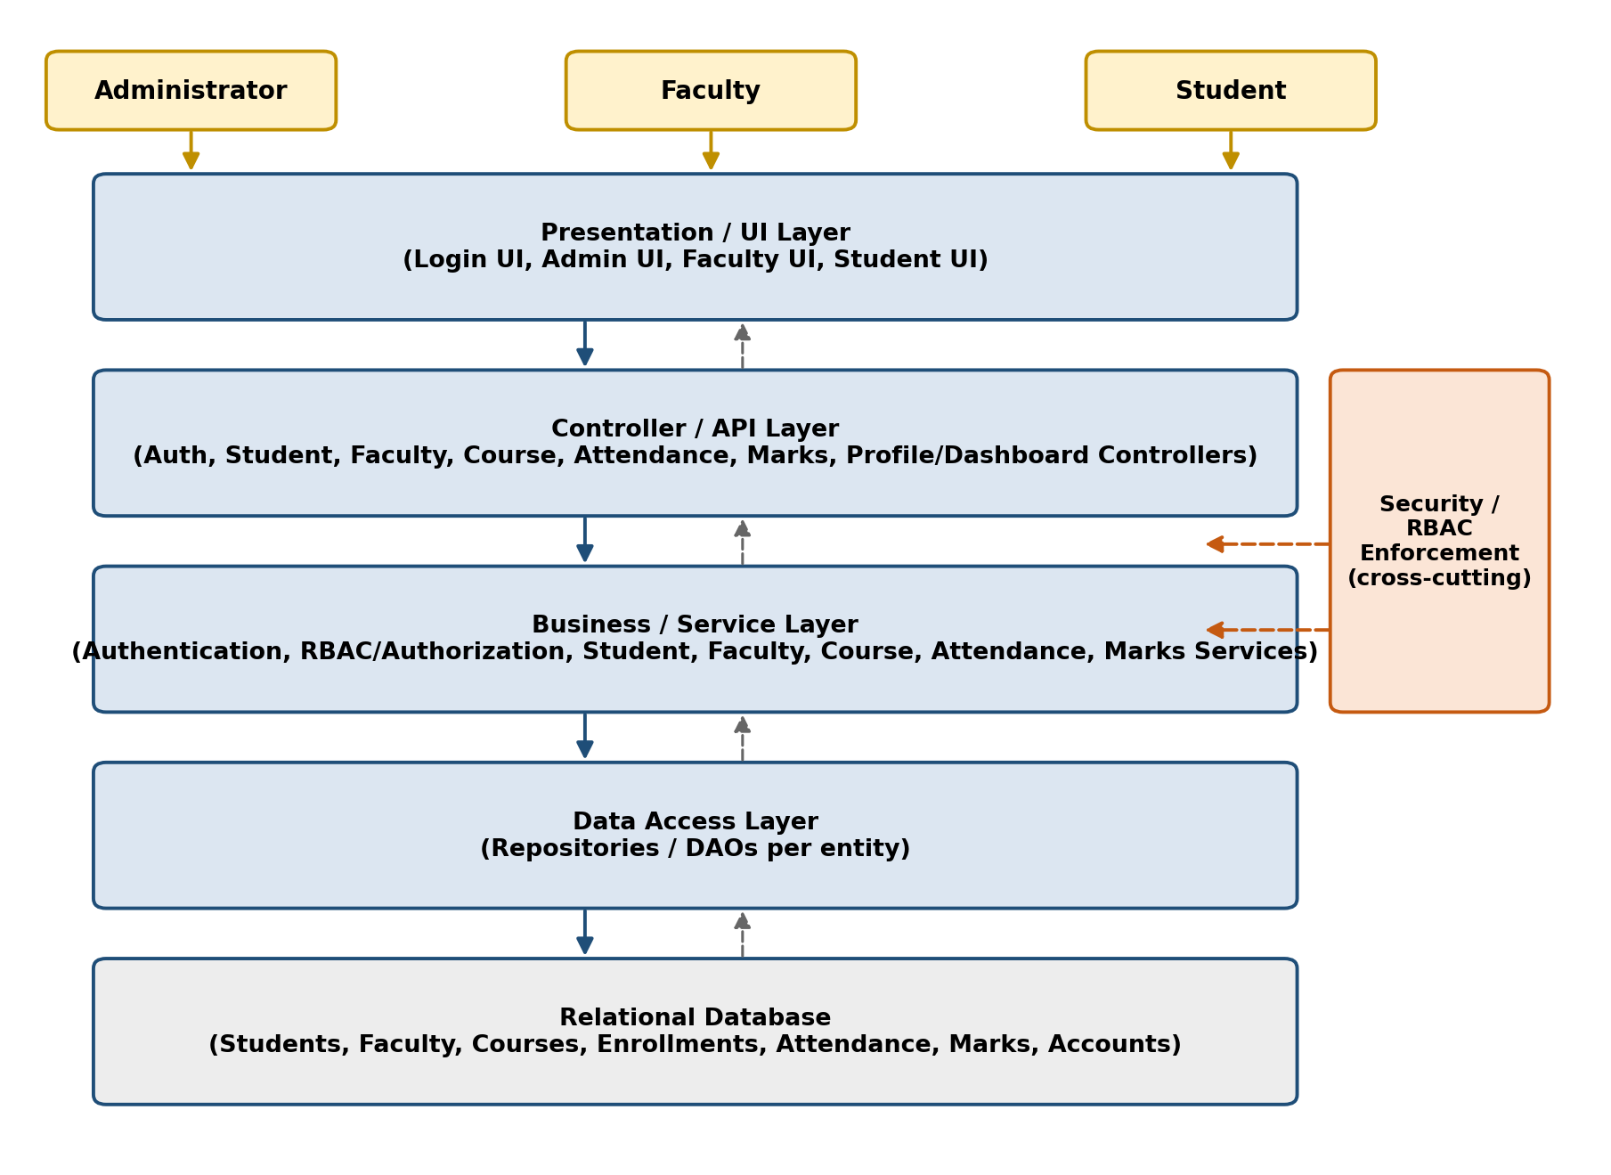
Figure 1: Layered component diagram — Student Record System

3.3 Component Descriptions

3.3.1 Presentation / UI Layer
Provides distinct screens for each role (SRS 3.1): a shared Login UI, and role-specific screens for the Administrator (record and association management), Faculty (attendance and marks entry, assigned-course views), and Student (read-only attendance, marks, profile, and dashboard views). It calls the Controller/API Layer over HTTP and contains no validation or authorization logic beyond basic form checks.

3.3.2 Controller / API Layer
One controller group per feature area: Authentication, Student, Faculty, Course, Assignment/Enrollment, Attendance, Marks, and Profile/Dashboard controllers. Each controller exposes the REST endpoints in Section 4.3, authenticates the request (via the session established at login), and enforces that the caller's role is permitted to invoke that endpoint before delegating to the Business/Service Layer (SO-3, NFR-7).

3.3.3 Business / Service Layer
Implements the functional requirements: Authentication Service (FR-1, FR-14), Student/Faculty/Course Services (FR-2–FR-4), Assignment/Enrollment logic (FR-5, FR-6), Attendance Service (FR-7, FR-8), Marks Service (FR-9, FR-10), and Profile/Dashboard aggregation (FR-11–FR-13). This layer enforces the business rules in SRS Section 5.5, e.g., a Faculty member may only record attendance or marks for a course they are assigned to, and a Student may only view their own data.

3.3.4 Data Access Layer
One repository per entity (Account, Student, Faculty, Course, Assignment, Enrollment, Attendance, Marks). Repositories translate service calls into parameterized queries against the relational database and return plain data records to the Business/Service Layer; they contain no business rules.

3.3.5 Relational Database
A single relational database stores all persistent data, with foreign-key relationships as summarized in SRS Appendix B (Student–Course via Enrollment; Faculty–Course via Assignment; Course–Attendance/Marks; Enrollment–Attendance/Marks). The specific RDBMS product is left to the development team's discretion, consistent with SRS TBD-1.

3.4 Layer Interactions
A typical request flows top to bottom through exactly one layer at a time: Presentation/UI → Controller/API → Business/Service → Data Access → Database, with the response returning back up the same path (Figure 1). No layer is skipped, and no layer calls back up to a layer above it. This strict, one-directional dependency chain is what keeps the codebase modular (NFR-5) and keeps every protected operation passing through the Controller/API Layer's authorization check (NFR-7) before it can reach the data.

3.5 Data / Storage Architecture
The system uses a single relational database (SRS 2.5) as the sole persistent store, accessed only via the Data Access Layer. Core entities and relationships, consistent with SRS Appendix B, are:
Entity | Key Relationships
Account | One per Administrator, Faculty, or Student user; stores a hashed password and role (NFR-2).
Student | Linked to Account; many-to-many with Course via Enrollment.
Faculty | Linked to Account; one-to-many with Course via Assignment.
Course | One-to-many with Attendance sessions and Marks entries, scoped through Enrollment.
Enrollment | Student–Course association; one-to-many with Attendance and Marks records for that pairing.
Attendance | Per-session, per-enrollment present/absent record (FR-7, FR-8).
Marks | Per-assessment-component, per-enrollment mark against a configured maximum (FR-9, FR-10).

Student and Faculty deactivation (FR-2, FR-3) and Course deactivation (FR-4) are implemented as a status flag on the record rather than a row deletion, so that historical attendance and marks remain intact, per SRS Section 5.5. A Course row is only physically deleted when no Assignment or Enrollment references exist; the Data Access Layer checks this before permitting a delete.

3.6 Security Architecture
Security is implemented as a cross-cutting concern enforced primarily at the Controller/API and Business/Service layers, directly implementing the SRS security objectives and requirements rather than as a separate service.
SRS Objective / Requirement | Architectural Mechanism
SO-1 - Confidentiality | Every read operation in the Business/Service Layer filters results to the caller's own scope (a Student's own records; a Faculty member's assigned courses) before returning data, so unauthorized data is never fetched from the Data Access Layer in the first place.
SO-2 - Integrity | Only the Administrator's controllers expose create/update/deactivate operations for Student, Faculty, and Course records (SRS 5.5); the Business/Service Layer re-checks the caller's role on every write, independent of what the Presentation/UI Layer allows the user to click.
SO-3 - Access Control | A single RBAC check, applied in the Controller/API Layer for every incoming request, maps the authenticated session's role to the set of endpoints/operations it may invoke (Section 4.3), before any request reaches the Business/Service Layer.
NFR-2 | Passwords are hashed (not stored or transmitted in plain text) by the Authentication Service before being persisted via the Account repository; the Presentation/UI Layer never receives a password back from the server.
NFR-7 | The Controller/API Layer performs an authorization check, is this role, and this specific user, permitted to perform this operation on this record, before delegating to the Business/Service Layer for every protected operation.
NFR-8 | The Authentication Service invalidates the server-side session on logout (FR-14); the Controller/API Layer rejects any request carrying a session token that has been invalidated.

3.7 Architecture-to-Requirement Traceability
Requirement(s) | Architectural Element
FR-1, FR-14 | Presentation/UI Login screen → Authentication Controller → Authentication Service → Account Repository (Section 4.2, Sequence Diagram 1)
FR-2, FR-3, FR-4 | Admin UI → Student/Faculty/Course Controllers → corresponding Services → corresponding Repositories
FR-5, FR-6 | Admin UI → Course Controller (assignment/enrollment endpoints) → Course Service → Assignment/Enrollment Repositories
FR-7, FR-8 | Faculty/Student UI → Attendance Controller → Attendance Service → Attendance Repository (Section 4.2, Sequence Diagram 2)
FR-9, FR-10 | Faculty/Student UI → Marks Controller → Marks Service → Marks Repository
FR-11, FR-12, FR-13 | Profile/Dashboard Controller → aggregating calls into Student/Faculty/Course Services
NFR-1 | In-process layered monolith (Section 2.3) — no network hops between layers
NFR-2, NFR-7, NFR-8, SO-1, SO-2, SO-3 | Security architecture (Section 3.6)
NFR-4 | Request validation at the Controller/API Layer; constraints enforced at the Data Access Layer/database
NFR-5 | Strict layering and per-feature component organization (Sections 3.1–3.3)
NFR-6 | Browser-based Presentation/UI Layer with no browser-specific dependencies
Section 5.5 (Business Rules) | Enforced in the Business/Service Layer (Section 3.3.3) and re-validated independently of the Presentation/UI Layer

3.8 Deployment View
The system deploys as a single server-side application (hosting the Controller/API, Business/Service, and Data Access layers) plus a relational database, accessed by standard web browsers over HTTP/HTTPS (SRS 2.4, 3.4). Local development may use HTTP; any network-accessible deployment uses HTTPS (SRS 3.4). No load balancer, message broker, or additional service tier is required at this scale.

3.9 Architectural Constraints and Assumptions
- Exactly three roles are supported: Administrator, Faculty, Student (SRS 2.5), the architecture has no extension point for additional roles in Version 1.0.
- Single-tenant, single-institution deployment (SRS 2.5); no multi-tenancy support.
- The specific programming language, framework, and database product are left to the development team (SRS TBD-1); this document specifies layer responsibilities and interfaces, not a specific technology.
- Accounts are provisioned only by the Administrator; there is no self-registration flow (SRS 2.7).

4. Detailed Design

4.1 Design Overview
This section refines the architecture in Section 3 into concrete interfaces: two representative sequence diagrams covering authentication/RBAC and a Faculty-initiated write operation, the REST API surface for every functional requirement, and the error-handling design that applies uniformly across all endpoints.

4.2 Sequence Diagrams

4.2.1 Sequence Diagram 1: User Login and Role-Based Access (FR-1, SO-3)
Covers the normal login flow for any of the three roles and the invalid-credentials alternative path.
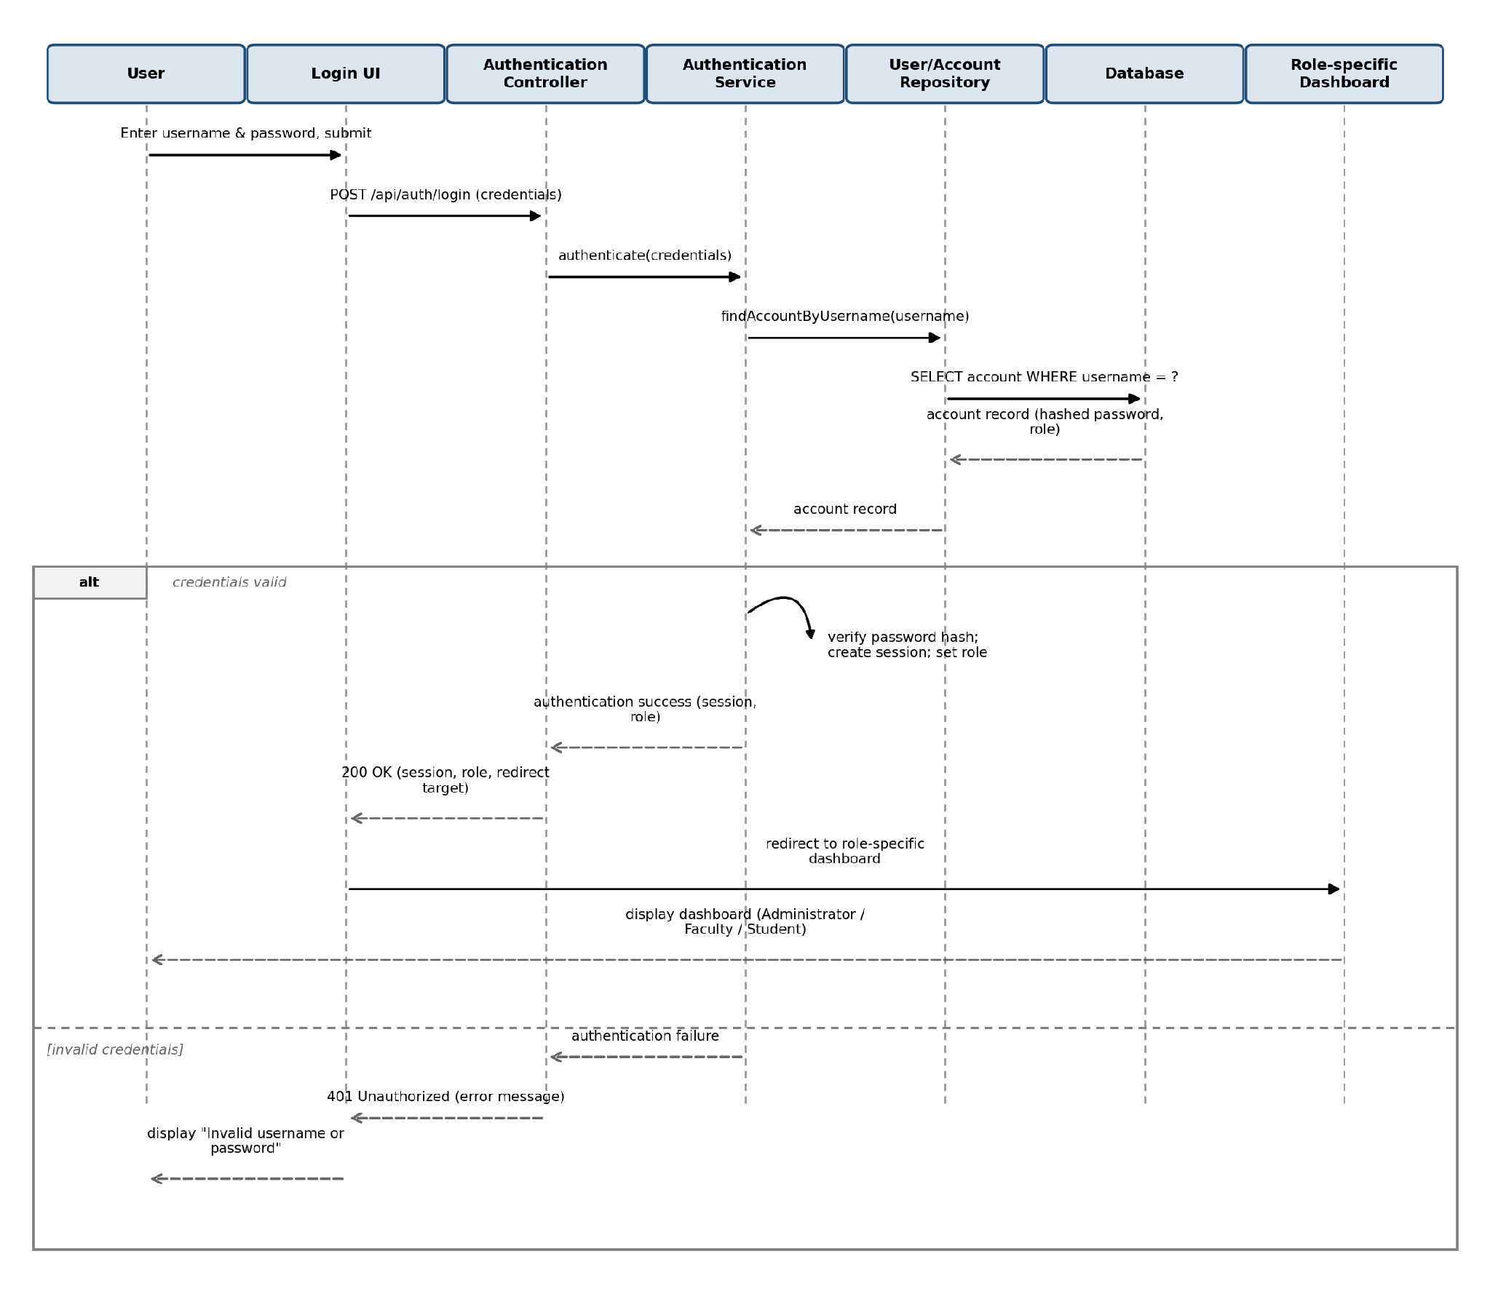
Figure 2: Sequence diagram — User login and role-based dashboard redirect
PlantUML source:
@startuml
actor User
participant "Login UI" as UI
participant "Authentication Controller" as AC
participant "Authentication Service" as AS
participant "User/Account Repository" as REPO
database "Database" as DB
participant "Role-specific Dashboard" as DASH
User -> UI : Enter username & password, submit
UI -> AC : POST /api/auth/login (credentials)
AC -> AS : authenticate(credentials)
AS -> REPO : findAccountByUsername(username)
REPO -> DB : SELECT account WHERE username = ?
DB --> REPO : account record (hashed password, role)
REPO --> AS : account record
alt credentials valid
AS -> AS : verify password hash; create session; set role
AS --> AC : authentication success (session, role)
AC --> UI : 200 OK (session, role, redirect target)
UI -> DASH : redirect to role-specific dashboard
DASH --> User : display dashboard (Administrator / Faculty / Student)
else invalid credentials
AS --> AC : authentication failure
AC --> UI : 401 Unauthorized (error message)
UI --> User : display "Invalid username or password"
end
@enduml

4.2.2 Sequence Diagram 2: Faculty Records/Updates Attendance (FR-7)
Covers the normal attendance-recording flow and the alternative path where the Faculty member is not assigned to the course, enforcing the business rule in SRS Section 5.5.
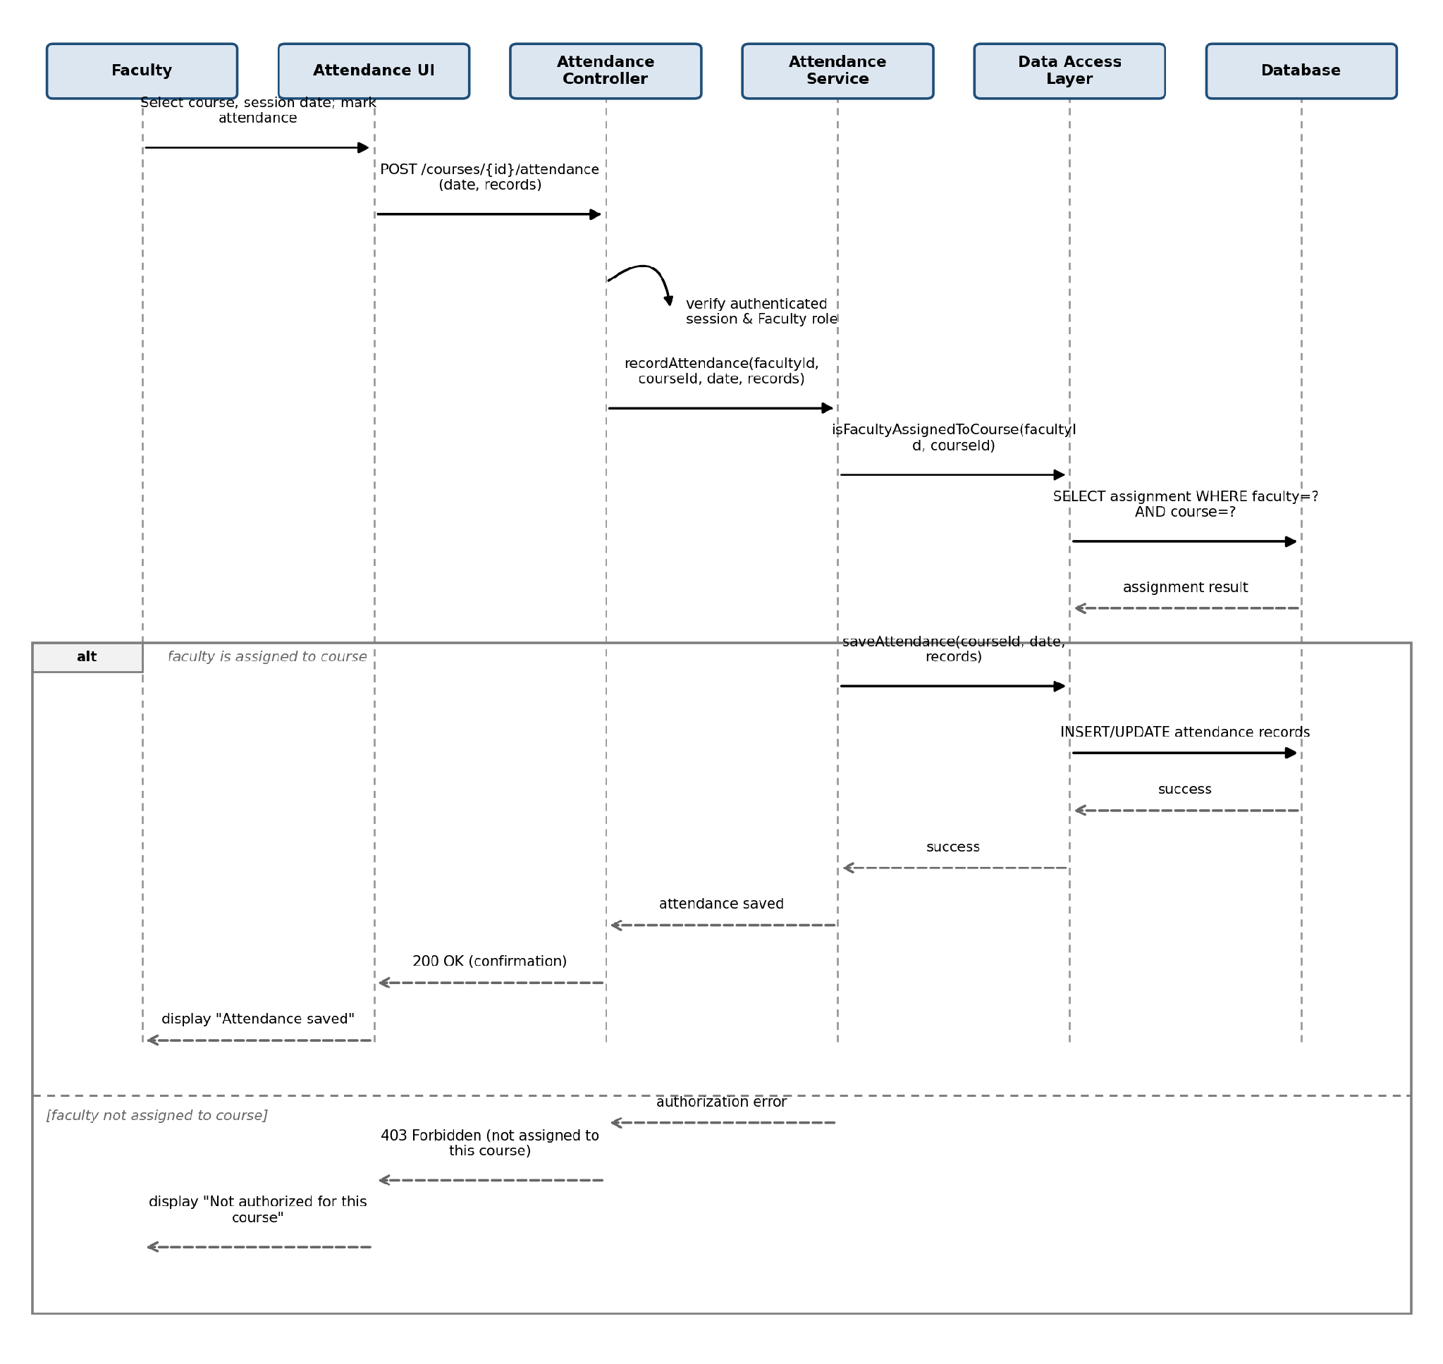
Figure 3: Sequence diagram — Faculty records/updates attendance

PlantUML source:
@startuml
actor Faculty
participant "Attendance UI" as UI
participant "Attendance Controller" as AC
participant "Attendance Service" as AS
participant "Data Access Layer" as DAL
database "Database" as DB
Faculty -> UI : Select course, session date, mark attendance
UI -> AC : POST /api/courses/{courseId}/attendance (sessionDate, records)
AC -> AC : verify authenticated session and Faculty role
AC -> AS : recordAttendance(facultyId, courseId, sessionDate, records)
AS -> DAL : isFacultyAssignedToCourse(facultyId, courseId)
DAL -> DB : SELECT assignment WHERE faculty=? AND course=?
DB --> DAL : assignment result
alt faculty is assigned to course
AS -> DAL : saveAttendance(courseId, sessionDate, records)
DAL -> DB : INSERT/UPDATE attendance records
DB --> DAL : success
DAL --> AS : success
AS --> AC : attendance saved
AC --> UI : 200 OK (confirmation)
UI --> Faculty : display "Attendance saved"
else faculty not assigned to course
AS --> AC : authorization error
AC --> UI : 403 Forbidden (not assigned to this course)
UI --> Faculty : display "You are not authorized for this course"
end
@enduml

4.3 API Design
The Controller/API Layer exposes a REST-style API over HTTPS (HTTP in local development, per SRS 3.4). All endpoints below require an authenticated session established via /api/auth/login, and each is restricted to the role(s) shown, consistent with SRS Section 5.5. No endpoints are defined for functionality outside the SRS scope.

4.3.1 Authentication (FR-1, FR-14)
Method & Endpoint | Description | Allowed Role(s)
POST /api/auth/login | Authenticate with username/email and password; returns session and role-based redirect target | All (unauthenticated)
POST /api/auth/logout | Terminate the current session | Administrator, Faculty, Student

4.3.2 Student Records (FR-2)
Method & Endpoint | Description | Allowed Role(s)
GET /api/students | List/search student records | Administrator
POST /api/students | Create a student record | Administrator
GET /api/students/{id} | View a student record | Administrator
PUT /api/students/{id} | Update a student record | Administrator
PATCH /api/students/{id}/deactivate | Deactivate a student record (retained, excluded from enrollment) | Administrator

4.3.3 Faculty Records (FR-3)
Method & Endpoint | Description | Allowed Role(s)
GET /api/faculty | List/search faculty records | Administrator
POST /api/faculty | Create a faculty record | Administrator
GET /api/faculty/{id} | View a faculty record | Administrator
PUT /api/faculty/{id} | Update a faculty record | Administrator
PATCH /api/faculty/{id}/deactivate | Deactivate a faculty record | Administrator

4.3.4 Courses (FR-4)
Method & Endpoint | Description | Allowed Role(s)
GET /api/courses | List/search courses | Administrator, Faculty, Student
POST /api/courses | Create a course | Administrator
GET /api/courses/{id} | View a course | Administrator, Faculty, Student
PUT /api/courses/{id} | Update a course | Administrator
DELETE /api/courses/{id} | Delete the course if it has no assignment/enrollment; otherwise deactivate it (SRS 5.5) | Administrator

4.3.5 Faculty-Course Assignment and Student Enrollment (FR-5, FR-6)
Method & Endpoint | Description | Allowed Role(s)
POST /api/courses/{id}/assignment | Assign a faculty member to the course | Administrator
GET /api/courses/{id}/assignment | View the course's faculty assignment | Administrator, Faculty (own), Student (own course)
PUT /api/courses/{id}/assignment | Modify the existing assignment | Administrator
DELETE /api/courses/{id}/assignment | Remove the assignment | Administrator
POST /api/courses/{id}/enrollments | Enroll a student in the course | Administrator
GET /api/courses/{id}/enrollments | View the course's enrolled students | Administrator, Faculty (own course)
DELETE /api/courses/{id}/enrollments/{studentId} | Remove a student's enrollment | Administrator

4.3.6 Attendance (FR-7, FR-8)
Method & Endpoint | Description | Allowed Role(s)
POST /api/courses/{id}/attendance | Record attendance for a session (present/absent per enrolled student) | Faculty (assigned course only)
PUT /api/courses/{id}/attendance/{sessionDate} | Update a previously recorded session | Faculty (assigned course only)
GET /api/courses/{id}/attendance | View session-wise attendance for the course | Faculty (assigned course), Administrator
GET /api/students/{id}/attendance | View own attendance and percentage across enrolled courses | Student (self only)

4.3.7 Marks (FR-9, FR-10)
Method & Endpoint | Description | Allowed Role(s)
POST /api/courses/{id}/marks | Enter marks for a component for enrolled students | Faculty (assigned course only)
PUT /api/courses/{id}/marks/{componentId} | Update previously entered marks for a component | Faculty (assigned course only)
GET /api/courses/{id}/marks | View marks for the course | Faculty (assigned course), Administrator
GET /api/students/{id}/marks | View own marks by course and component | Student (self only)

4.3.8 Profile and Dashboard (FR-11, FR-12, FR-13)
Method & Endpoint | Description | Allowed Role(s)
GET /api/profile | View own profile: Student — enrolled courses (FR-11); Faculty — assigned courses and enrolled students (FR-12) | Faculty, Student
GET /api/dashboard | Role-specific summary dashboard with quick links (FR-13) | Administrator, Faculty, Student

4.4 Error Handling
Every endpoint returns a consistent JSON error envelope and HTTP status code, so the Presentation/UI Layer can display a clear message without crashing, consistent with NFR-4.
{
"error": {
"code": "VALIDATION_ERROR",
"message": "Roll number is required.",
"details": [ { "field": "rollNumber", "issue": "missing" } ]
}
}
Condition | HTTP Status | Example | Handling Layer
Validation error (missing/invalid field) | 400 Bad Request | Required field missing when creating a student/faculty/course record | Controller/API Layer, before invoking the service
Not authenticated | 401 Unauthorized | Request without a valid session, or an expired/terminated session (NFR-8) | Controller/API Layer
Authenticated but not authorized (RBAC) | 403 Forbidden | A Student calling an Administrator endpoint; a Faculty member acting on a course not assigned to them (SRS 5.5) | Controller/API Layer and Business/Service Layer
Record not found | 404 Not Found | GET /api/students/{id} for a non-existent or already-deleted id | Business/Service Layer
Duplicate / conflicting operation | 409 Conflict | Creating a course with a code that already exists; enrolling a student already enrolled in the course | Business/Service Layer, backed by a unique constraint at the database
Invalid state transition | 409 Conflict | Attempting to permanently delete a course that still has an assignment or enrollment (FR-4); the system deactivates instead, per SRS 5.5 | Business/Service Layer
Database/connection failure | 503 Service Unavailable | The Data Access Layer cannot reach the database | Data Access Layer, surfaced by the Controller/API Layer without leaking internal details
Unexpected server error | 500 Internal Server Error | Any unhandled exception | API Layer logged for diagnosis, generic message returned to the client

In all cases, the underlying data is left unchanged on failure (no partial writes), consistent with NFR-4's requirement that invalid input be handled without corrupting stored data; write operations are only committed after every validation and authorization check for that operation has passed.

4.5 Security Considerations at the Design Level
- Passwords are hashed by the Authentication Service before being persisted, and are never included in any API response body (NFR-2).
- Every request to a protected endpoint is authenticated (401 if not) and then authorized against the caller's role and, where applicable, their specific assignment/enrollment (403 if not), before the Business/Service Layer executes any logic (NFR-7, SO-3).
- Logout invalidates the session server-side; a request presenting an invalidated session token receives 401 Unauthorized rather than being served (NFR-8, FR-14).
- Attendance and marks endpoints resolve the Faculty member's assigned courses and the Student's enrolled courses server-side from the session identity, the client cannot widen its own access by supplying a different id in the request (SO-1, SO-2).
- Error responses (Section 4.4) do not leak internal details (stack traces, query text, schema information) to the client.

4.6 Data / Database Design Considerations
- All tables use surrogate primary keys and foreign keys enforcing the relationships in Section 3.5, so the database itself rejects orphaned attendance/marks/enrollment rows.
- Student, Faculty, and Course records carry a status field (Active/Inactive) rather than being deleted, per SRS Section 5.5; queries used for new enrollment/assignment exclude inactive records.
- A course row is physically deleted only when a database-level check confirms zero associated Assignment and Enrollment rows (FR-4); otherwise the delete is converted to a deactivation by the Business/Service Layer.
- Assessment components and their maximum marks are configured per course at course setup (SRS TBD-2) and referenced by Marks entries, rather than hard-coded, so the schema does not assume a fixed grading scheme.
- Unique constraints (e.g., one Account per username, one Enrollment per Student-Course pair) back the 409 Conflict responses in Section 4.4.

4.7 Design-to-Requirement Traceability
Requirement(s) | Design Element
FR-1, SO-3 | Sequence Diagram 1 (Section 4.2.1); POST /api/auth/login (Section 4.3.1)
FR-14, NFR-8 | POST /api/auth/logout; session invalidation (Section 4.5)
FR-2, FR-3 | Student/Faculty endpoints (Section 4.3.2, 4.3.3); status-flag design (Section 4.6)
FR-4 | Course endpoints incl. conditional delete/deactivate (Section 4.3.4); 409 Conflict handling (Section 4.4)
FR-5, FR-6 | Assignment/Enrollment endpoints (Section 4.3.5)
FR-7 | Sequence Diagram 2 (Section 4.2.2); POST/PUT attendance endpoints (Section 4.3.6)
FR-8 | GET attendance endpoints, scoped to Student's own enrollment (Section 4.3.6)
FR-9, FR-10 | Marks endpoints (Section 4.3.7)
FR-11, FR-12, FR-13 | GET /api/profile, GET /api/dashboard (Section 4.3.8)
NFR-2 | Password hashing (Section 4.5)
NFR-4 | Standard error envelope and validation handling (Section 4.4)
NFR-7 | Authorization check before every protected operation (Section 4.5)
SO-1, SO-2 | Server-side scoping of attendance/marks/profile queries (Section 4.5)

5. References
- Software Requirements Specification for Student Record System, Version 1.1, PES University, 26/09/2026.
- Software Test Plan for Student Record System, Version 1.0, PES University, 28/09/2026.
- Test Cases Related Update for Test Plan, Version 1.0, PES University, 28/09/2026.
- IEEE Std. 1016-2009, IEEE Standard for Information Technology; Systems Design — Software Design Descriptions.
- IEEE Std. 42010-2011, Systems and Software Engineering; Architecture Description.

