Software Requirements Specification
for
Student Record System
Version 1.1
Prepared by :
Aadhavan Muthusamy(PES1UG24CS002),
Aakash Desai(PES1UG24CS006),
Aashlesh P(PES1UG24CS011) and
Abhiraam Adiga(PES1UG24CS015)
PES UNIVERSITY:SOFTWARE ENGINEERING(UE24CS341A)
Created:05/09/2026

Table of Contents
Revision History
1. Introduction
1.1 Purpose
1.2 Document Conventions
1.3 Intended Audience and Reading Suggestions
1.4 Product Scope
1.5 References
2. Overall Description
2.1 Product Perspective
2.2 Product Functions
2.3 User Classes and Characteristics
2.4 Operating Environment
2.5 Design and Implementation Constraints
2.6 User Documentation
2.7 Assumptions and Dependencies
2.8 Use Case Model
3. External Interface Requirements
3.1 User Interfaces
3.2 Hardware Interfaces
3.3 Software Interfaces
3.4 Communications Interfaces
4. System Features
4.1 User Authentication and Session Management
4.2 Student Record Management
4.3 Faculty Record Management
4.4 Course Management
4.5 Faculty-Course Assignment and Student Enrollment
4.6 Attendance Management
4.7 Marks Management
4.8 Profile and Dashboard Viewing
5. Other Nonfunctional Requirements
5.1 Performance Requirements
5.2 Safety Requirements
5.3 Security Requirements
5.3.1 Security Objectives
5.3.2 Security Requirements
5.4 Software Quality Attributes
5.5 Business Rules
6. Other Requirements
Appendix A: Glossary
Appendix B: Analysis Models
Appendix C: To Be Determined List
Appendix D: Future Enhancements

Revision History
Date | Reason For Changes | Version
05/09/2026 | Initial SRS release | 1.0
26/09/2026 | Added UML use-case diagrams (Section 2.8) and expanded security objectives and requirements (Section 5.3.1/5.3.2) | 1.1

1. Introduction

1.1 Purpose
This Software Requirements Specification (SRS) describes the requirements for Version 1.0 of the Student Record System, a web-based application for managing academic information for students, faculty, and administrators. This document covers the complete scope of the system as developed for this Software Engineering mini-project.There are no separate subsystems or partial-system SRS documents associated with this project.

1.2 Document Conventions
Throughout this document, the keyword “shall” denotes a mandatory requirement (e.g., “The system shall …”). Functional requirements are uniquely identified using the prefix FR- (e.g., FR-1, FR-2); non-functional requirements are identified using the prefix NFR- (e.g., NFR-1, NFR-2). Each System Feature in Section 4 is assigned a priority of High, Medium, or Low to indicate its relative importance unless stated otherwise, the functional requirements within a feature share that feature's priority.

1.3 Intended Audience and Reading Suggestions
This document is intended for the members of the project team, the course instructor/evaluator, and any other reviewer of the project. Readers seeking a general understanding of the system should read Sections 1 and 2. The appendices are provided for reference and may be consulted as needed.

1.4 Product Scope
The Student Record System is a simplified, web-based academic information management system.
The system will allow:
- Administrators to manage student records, faculty records, courses, and the associations between them (faculty-course assignment and student-course enrollment).
- Faculty to view their assigned courses and enrolled students, and to record attendance and enter marks for those courses.
- Students can view their own profile, enrolled courses, attendance records, and academic marks.
The system will provide role-specific dashboards summarizing relevant information for each user type.
The following are explicitly out of scope for Version 1.0 and are listed only under Appendix D (Future Enhancements) where applicable: fee/payment management, hostel management, transport management, library management, placement management, timetable generation.

1.5 References
- IEEE Std. 830-1998, IEEE Recommended Practice for Software Requirements Specifications, Institute of Electrical and Electronics Engineers, 1998.
- Software Engineering course material and SRS template (UE23CS341A), Department of CSE — slide deck provided by the course instructor, current academic term.
- Wiegers, Karl E., Software Requirements Specification template, 1999 (used as the structural template for this document; distributed for use and modification by the author).

2. Overall Description

2.1 Product Perspective
The Student Record System is a self-contained, standalone web application. It is not a replacement for or extension of any existing institutional software. The system follows a typical client-server architecture, with a browser-based front end interacting with a back-end application server and a relational database. It is developed as an academic project to demonstrate the application of Software Engineering principles including requirements engineering, design, implementation, testing, and version-controlled collaborative development.

2.2 Product Functions
At a high level, the system provides the following functions:
- Secure login and role-based access for Administrators, Faculty, and Students.
- Management of student and faculty records by the Administrator.
- Management of course records and their association with faculty and students by the Administrator.
- Recording of attendance by Faculty for their assigned courses.
- Viewing of attendance by Students for their enrolled courses.
- Entry of marks/academic records by Faculty for their assigned courses.
- Viewing of marks/academic records by Students for their enrolled courses.
- Role-specific dashboards providing a summary view relevant to each user type.

2.3 User Classes and Characteristics
User Class | Characteristics
Administrator | Assumed to be a non-technical or semi-technical staff member responsible for institutional record-keeping. Requires a simple, form-based interface for managing users and courses. Has the highest privilege level in the system.
Faculty | Assumed to have basic computer literacy. Requires straightforward screens to record attendance and marks for the courses they teach. Access is scoped to courses assigned to them.
Student | Assumed to have basic computer literacy. Primarily requires read-only, easy-to-navigate views of personal academic information. Access is scoped to their own records only.

2.4 Operating Environment
The system is a web-based application deployed in a client-server configuration. The client side requires a modern web browser (e.g., Chrome, Firefox) running on a standard desktop or laptop computer with internet access,no native mobile application is required. The server side requires an environment capable of running the chosen back-end application stack and a relational database management system. The exact hosting environment (local development machine, cloud, or institutional server) is left to the discretion of the development team for this academic project.

2.5 Design and Implementation Constraints
• The system is developed as an academic mini-project by a team of four students within a limited timeframe and is scoped accordingly.
• The system supports only three user roles - Administrator, Faculty, and Student - in Version 1.0; no additional roles (e.g., parent, super-admin) are supported.
• The system is a single-institution system and does not support multi-tenancy.
• The exact technology stack (programming language, framework, and database product) is not finalized at the time of writing this document and is left to the development team's discretion, provided it supports the stated requirements.
• The system should follow a layered architecture (separating presentation, business logic, and data storage concerns) to the extent practical, to support maintainability and ease of testing; the specific architectural pattern and its degree of separation are left to the development team's judgment.
• The system shall use a relational database to preserve referential integrity between related entities (e.g., students, courses, enrollments, attendance, marks).
• The system is accessed through standard modern web browsers,no native mobile application is provided.
• The project shall be developed using Git for version control, with collaborative development managed through a shared GitHub repository, as required by the course.

2.6 User Documentation
No formal end-user manual is planned for Version 1.0, given the scope of an academic mini-project. Basic in-application guidance (field labels, tooltips, and confirmation/error messages) shall be provided in place of a separate manual. Project documentation - including this SRS, design documents, and a README - shall be maintained in the project's GitHub repository for reference by the team and evaluators.

2.7 Assumptions and Dependencies
• It is assumed that user accounts (Administrator, Faculty, Student) are created and provisioned by the Administrator; there is no public self-registration.
• It is assumed that each course is taught by a single assigned faculty member for the purposes of this system.
• It is assumed that a working internet connection and a modern web browser are available to all users.
• The system depends on the availability of a relational database for persistent storage of records.
• It is assumed that each course has a small, fixed set of assessment components (e.g., Internal Assessment 1, Internal Assessment 2, Assignment), each with a maximum mark defined when the course is set up. Faculty enter marks obtained by each student against these predefined components; complex or configurable grading schemes (e.g., weighted GPA computation) are not part of Version 1.0.

2.8 Use Case Model
This section presents the use case model for the Student Record System, illustrating how the Administrator, Faculty, and Student actors interact with the functionality defined in this SRS. Figure 1 shows the overall system use case diagram covering all major functions described in Sections 2.2 and 4. Figure 2 focuses on the academic-records and course-management workflows defined in Sections 4.2 through 4.7. No actors or functionality beyond those already specified elsewhere in this document are introduced.
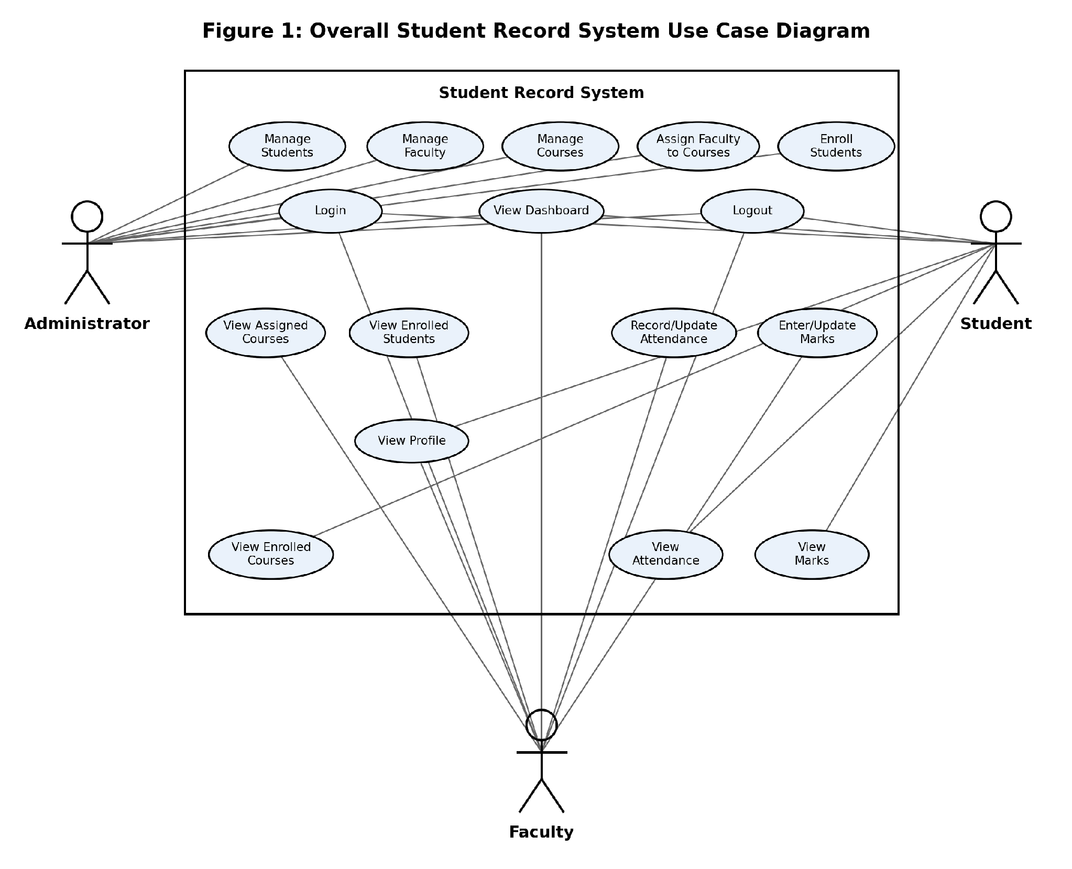
Figure 1: Overall Student Record System Use Case Diagram
As shown in Figure 1, the Administrator, Faculty, and Student actors share the Login, Logout, and View Dashboard use cases (FR-1, FR-13, FR-14); Faculty and Student additionally share the View Profile use case (FR-11, FR-12). The Administrator use cases correspond to Sections 4.2–4.5, the Faculty use cases to Sections 4.6–4.7, and the Student use cases to Sections 4.6–4.8.
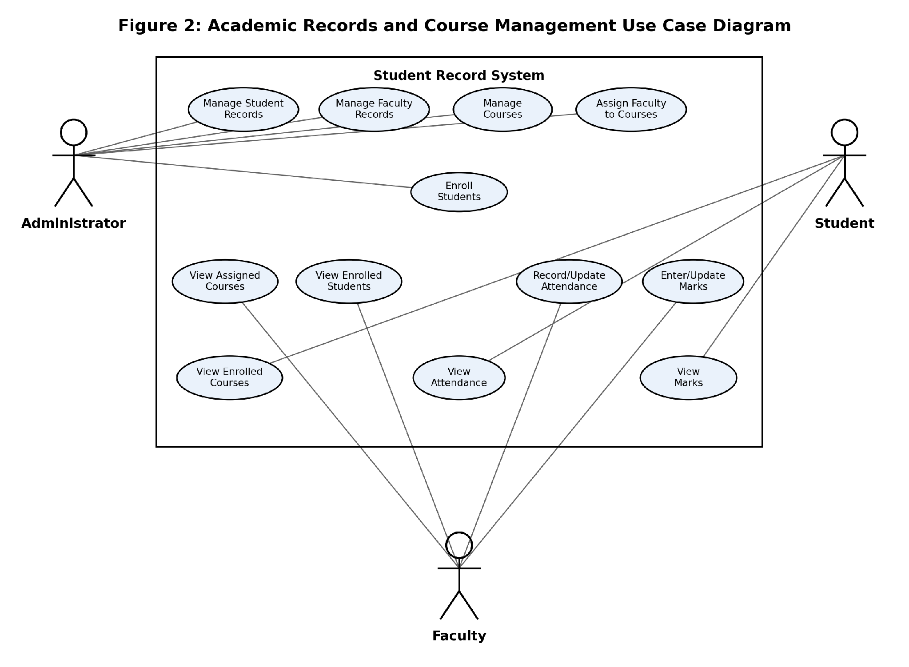
Figure 2: Academic Records and Course Management Use Case Diagram
Figure 2 focuses specifically on the academic-records and course-management workflows already defined in Sections 4.2 through 4.7 of this SRS: record management and association by the Administrator, and attendance/marks recording and viewing by Faculty and Students. It does not introduce any actor, use case, or functionality beyond those already specified in this document.

3. External Interface Requirements

3.1 User Interfaces
The system shall provide a web-based graphical user interface accessible through standard web browsers. It shall provide distinct, role-specific views for Administrator, Faculty, and Student users, including login screens, dashboards, and forms for data entry and viewing, following consistent navigation and layout conventions across all screens.

3.2 Hardware Interfaces
The system does not require any specialized hardware. It shall run on standard computing devices (desktop/laptop) capable of running a modern web browser.

3.3 Software Interfaces
The system shall interface with a relational database management system for data storage and retrieval. The back-end application shall communicate with the front end using standard web protocols (e.g., HTTP/HTTPS) and a well-defined API layer.

3.4 Communications Interfaces
Where the system is deployed to a network-accessible environment, all client-server communication shall use HTTPS to protect data in transit. In local development and testing environments, plain HTTP may be used for convenience, provided no real student or faculty data is transmitted.

4. System Features

4.1 User Authentication and Session Management ( Priority: High )

4.1.1 Description and Priority
Provides secure login for all user roles and controls session access and termination.

4.1.2 Stimulus/Response Sequences
- User enters valid credentials and submits the login form → System authenticates the user and redirects to the role-appropriate dashboard.
- User enters invalid credentials → System displays an error message and does not grant access.
- User selects “Logout” → System terminates the active session and returns the user to the login screen.

4.1.3 Functional Requirements
ID | Requirement
FR-1 | The system shall allow registered users (Administrator, Faculty, Student) to log in using a username/email and password, and shall redirect each user to a dashboard appropriate to their role. The system shall restrict access to features and data based on the logged-in user's role (RBAC).
FR-14 | The system shall allow a logged-in user to log out of the system, terminating their active session.

4.2 Student Record Management ( Priority: High )

4.2.1 Description and Priority
Allows the Administrator to maintain the master list of student records.

4.2.2 Stimulus/Response Sequences
- Administrator submits a new student's details → System creates a new student record.
- Administrator selects an existing student and edits their details → System updates the corresponding record.
- Administrator deactivates a student → System marks the record inactive and excludes the student from new course enrollments.

4.2.3 Functional Requirements
ID | Requirement
FR-2 | The system shall allow the Administrator to create, view, update, and deactivate student records, including basic personal and academic details (e.g., name, roll number, contact information, and department/batch). Deactivated students shall be retained in the system but excluded from active course enrollment.

4.3 Faculty Record Management ( Priority: High )

4.3.1 Description and Priority
Allows the Administrator to maintain the master list of faculty records.

4.3.2 Stimulus/Response Sequences
- Administrator submits a new faculty member's details → System creates a new faculty record.
- Administrator selects an existing faculty member and edits their details → System updates the corresponding record.
- Administrator deactivates a faculty member → System marks the record inactive and excludes them from new course assignments.

4.3.3 Functional Requirements
ID | Requirement
FR-3 | The system shall allow the Administrator to create, view, update, and deactivate faculty records, including basic personal details and department information. Deactivated faculty shall be retained in the system but excluded from new course assignments.

4.4 Course Management ( Priority: High )

4.4.1 Description and Priority
Allows the Administrator to maintain the catalog of courses offered.

4.4.2 Stimulus/Response Sequences
- Administrator submits a new course's details → System creates a new course record.
- Administrator selects an existing course and edits its details → System updates the corresponding record.
- Administrator removes a course with no assignments/enrollments → System permanently deletes the record; otherwise, the system deactivates it.

4.4.3 Functional Requirements
ID | Requirement
FR-4 | The system shall allow the Administrator to create, view, and update course records, including course code, course name, and credits. A course record may be permanently deleted only if it has no faculty assignment or student enrollment associated with it; otherwise, it shall be deactivated.

4.5 Faculty-Course Assignment and Student Enrollment ( Priority: High )

4.5.1 Description and Priority
Allows the Administrator to associate faculty with the courses they teach and students with the courses they take.

4.5.2 Stimulus/Response Sequences
- Administrator selects a faculty member and one or more courses → System records the faculty-course assignment(s).
- Administrator selects a student and one or more courses → System records the student-course enrollment(s).
- Administrator modifies or removes an existing assignment or enrollment → System updates the corresponding association.

4.5.3 Functional Requirements
ID | Requirement
FR-5 | The system shall allow the Administrator to assign one or more courses to a faculty member, and to view or modify existing faculty-course assignments.
FR-6 | The system shall allow the Administrator to enroll students in courses, and to view or modify existing student-course enrollments.

4.6 Attendance Management ( Priority: High )

4.6.1 Description and Priority
Allows Faculty to record attendance for their assigned courses and Students to view their own attendance.

4.6.2 Stimulus/Response Sequences
- Faculty selects a course and session date, then marks each enrolled student present or absent → System saves the attendance record for that session.
- Faculty reopens a previously recorded session and edits it → System updates the saved attendance record.
- Student opens the attendance view for an enrolled course → System displays session-wise records and an overall attendance percentage.

4.6.3 Functional Requirements
ID | Requirement
FR-7 | The system shall allow a Faculty member to record and update attendance (present/absent) for students enrolled in the courses assigned to them, on a per-session basis.
FR-8 | The system shall allow a Student to view their attendance records for each course they are enrolled in, including an attendance summary/percentage per course.

4.7 Marks Management ( Priority: High )

4.7.1 Description and Priority
Allows Faculty to enter marks for predefined assessment components in their assigned courses, and Students to view their own marks.

4.7.2 Stimulus/Response Sequences
- Faculty selects a course and assessment component, then enters the marks obtained by each enrolled student → System saves the marks.
- Faculty edits previously entered marks for a component → System updates the saved values.
- Student opens the marks view for an enrolled course → System displays the marks obtained for each assessment component.

4.7.3 Functional Requirements
ID | Requirement
FR-9 | The system shall allow a Faculty member to enter and update marks for a predefined set of assessment components (e.g., Internal Assessment 1, Internal Assessment 2, Assignment) for each course they are assigned, for every student enrolled in that course.
FR-10 | The system shall allow a Student to view their marks for each assessment component, for each course they are enrolled in.

4.8 Profile and Dashboard Viewing ( Priority: Medium )

4.8.1 Description and Priority
Provides each user with a view of their own profile information and a role-appropriate summary dashboard upon login.

4.8.2 Stimulus/Response Sequences
- Student logs in → System displays a dashboard summarizing enrolled courses, attendance, and marks, with links to detailed views.
- Faculty logs in → System displays a dashboard summarizing assigned courses and enrolled student counts, with links to detailed views.
- Administrator logs in → System displays a dashboard summarizing counts of students, faculty, and courses, with links to management screens.

4.8.3 Functional Requirements
ID | Requirement
FR-11 | The system shall allow a Student to view their own profile information and the list of courses they are currently enrolled in.
FR-12 | The system shall allow a Faculty member to view their own profile information and the list of courses assigned to them, along with the list of students enrolled in each such course.
FR-13 | The system shall provide a role-specific dashboard for each user upon login, presenting a brief summary relevant to that user's role (e.g., record counts for the Administrator, assigned courses for Faculty, enrolled courses for Students) along with quick links to the corresponding detailed views.

5. Other Nonfunctional Requirements

5.1 Performance Requirements
ID | Requirement
NFR-1 | The system shall load standard pages (e.g., dashboards, record lists) within 3 seconds under normal usage conditions with a class-sized dataset (up to a few hundred student records).

5.2 Safety Requirements
The Student Record System does not control any physical equipment or safety-critical process. No safety requirements beyond the data-protection considerations described in Section 5.3 apply to this system.

5.3 Security Requirements

5.3.1 Security Objectives
The following security objectives apply to all data and functionality described in this SRS, in particular the student, faculty, course, attendance, and marks data referenced throughout Sections 4 and 5.5:
ID | Security Objective
SO-1 | Confidentiality: protect student, faculty, course, attendance, and marks data from unauthorized access.
SO-2 | Integrity: prevent unauthorized modification of academic and administrative records.
SO-3 | Access Control: ensure users can access only the functionality and data permitted by their assigned role.

5.3.2 Security Requirements
The following security requirements implement the objectives in Section 5.3.1 and are consistent with FR-1 and FR-14 (Section 4.1) and with the access rules defined in Section 5.5 Business Rules.
ID | Requirement
NFR-2 | The system shall store user passwords in a securely hashed form and shall not display or transmit passwords in plain text. Access to data and functionality shall be restricted according to the authenticated user's role.
NFR-7 | The system shall verify that the authenticated user is authorized for the requested operation or data access before performing any protected operation, consistent with the role-based access rules in Section 5.5.
NFR-8 | The system shall terminate a user's authenticated session upon logout (FR-14) and shall prevent any further access to protected functionality or data using a session that has been terminated.

5.4 Software Quality Attributes
ID | Attribute | Requirement
NFR-3 | Usability | A first-time user in each role shall be able to complete their core task (e.g., a Student viewing attendance, a Faculty member recording marks) without external help. This shall be verified through a usability walkthrough in which at least three representative users each complete the relevant core task on their first attempt.
NFR-4 | Reliability | The system shall handle invalid user input (e.g., empty required fields, invalid data formats) gracefully by displaying clear error messages without crashing or corrupting stored data.
NFR-5 | Maintainability | The system's codebase shall be modular and organized by functional area (e.g., authentication, student management, attendance, marks) to facilitate independent development, debugging, and future enhancement by different team members.
NFR-6 | Portability | The system's web-based front end shall function correctly on current versions of at least two major web browsers (e.g., Chrome and Firefox) without requiring browser-specific modifications.

5.5 Business Rules
• Only the Administrator may create, modify, or deactivate student, faculty, and course records.Faculty and Students have read-only or narrowly scoped access to their own relevant data, as defined in Section 4.
• A Faculty member may record attendance and enter marks only for courses to which they have been assigned by the Administrator.
• A Student may view attendance and marks only for courses in which they are currently enrolled.
• Student and Faculty records shall only be deactivated, never permanently deleted, in order to preserve the integrity of historical attendance and marks data.
• A Course record may be permanently deleted only if it has no faculty assignment or student enrollment associated with it otherwise, it shall be deactivated.

6. Other Requirements
• Database requirement: the system shall use a relational database management system (RDBMS) to store all persistent data, in order to preserve referential integrity across related entities (students, faculty, courses, enrollments, attendance, and marks).
• Version control requirement: all source code and project documentation shall be developed under Git version control, with collaborative development managed through a shared GitHub repository, as required by the course.
• No internationalization, localization, or external regulatory compliance requirements apply to this academic project.

Appendix A: Glossary
Term | Description
SRS | Software Requirements Specification
SDLC | Software Development Life Cycle
Admin | Administrator, a user role/class with system-wide management privileges
Faculty | A user role/class representing a teaching staff member
Student | A user role/class representing an enrolled student
FR | Functional Requirement
NFR | Non-Functional Requirement
SO | Security Objective
CRUD | Create, Read, Update, Delete
UI | User Interface
DB | Database
RBAC | Role-Based Access Control
RDBMS | Relational Database Management System

Appendix B: Analysis Models
An Entity-Relationship (ER) diagram and the corresponding relational schema for the system have been developed separately as part of the project's design artifacts and are maintained in the project's GitHub repository (design/ directory). The core entities and their relationships are summarized below for quick reference; refer to the repository artifacts for full attribute lists, keys, and cardinalities.
Entity | Related To | Nature of Relationship
Student | Course (via Enrollment) | Many-to-many: a student enrolls in multiple courses; a course has multiple enrolled students.
Faculty | Course (via Assignment) | One-to-many: a faculty member may be assigned multiple courses; each course has one assigned faculty member.
Course | Attendance, Marks | One-to-many: each course has many attendance sessions and marks entries, scoped by enrollment.
Enrollment | Attendance, Marks | One-to-many: each enrollment (student-course pair) has associated attendance records and marks records.

Appendix C: To Be Determined List
ID | Description | Related Section
TBD-1 | Final technology stack (programming language, framework, and database product) to be used for implementation. | 2.5 Design and Implementation Constraints
TBD-2 | Exact set of assessment components and their maximum marks per course. | 2.7 Assumptions and Dependencies
TBD-3 | Hosting/deployment environment for the completed system (local, cloud, or institutional server). | 2.4 Operating Environment

Appendix D: Future Enhancements
The following features were considered but are explicitly excluded from Version 1.0. They may be considered in future iterations of the system:
• Fee/payment management
• Hostel management
• Transport management
• Library management
• Placement management
• Two-factor authentication / single sign-on

