**RAG Evaluation Process and Metrics**

**Introduction to the RAG Process**

**RAG (Retrieval-Augmented Generation)** is a hybrid approach that combines **information retrieval** with **text generation** to provide accurate and contextually relevant answers to user queries. It leverages the power of large language models (LLMs) while grounding their responses in factual, retrieved information from a document or knowledge base.

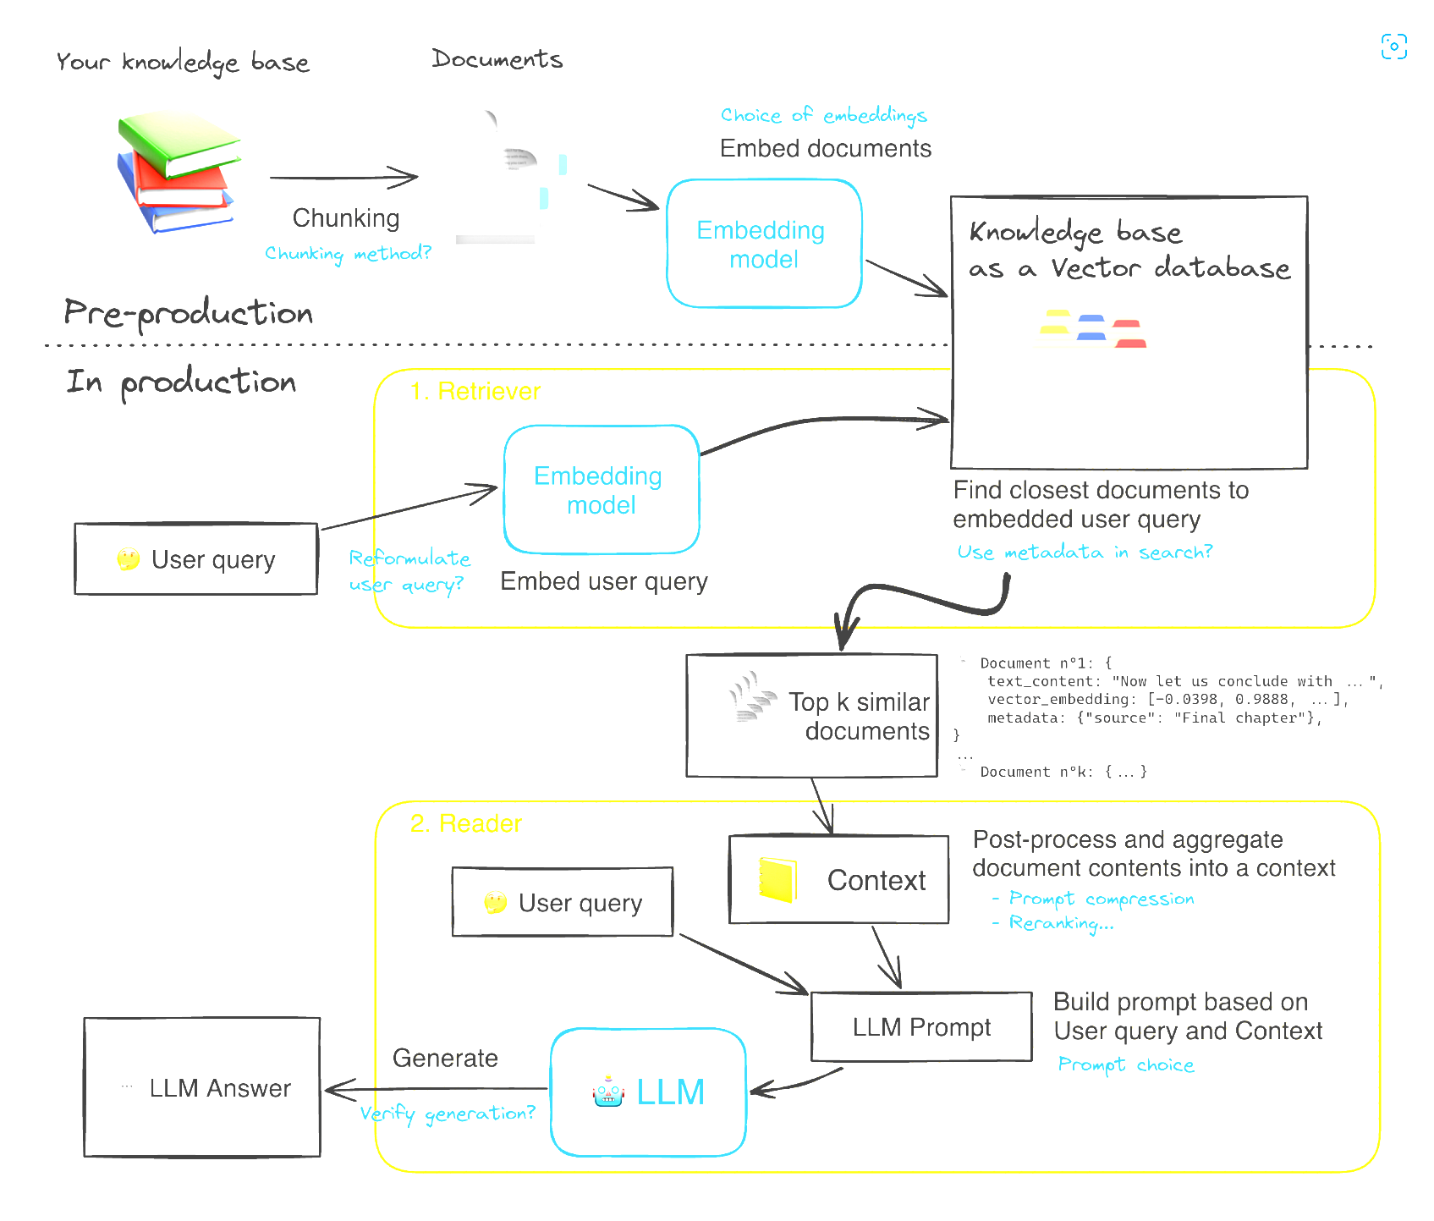

**RAG Pipeline Architecture**

**1. Key Concepts in RAG**

1. **Retrieval Component**:
   * Focuses on fetching relevant documents, chunks, or data from a knowledge base.
   * Uses methods like **vector search**, **keyword-based search (e.g., BM25)**, or **hybrid approaches** to identify content related to the query.
2. **Augmentation**:
   * Combines retrieved documents with the user's query to provide context for the generative model.
   * Prevents the generative model from hallucinating or producing irrelevant responses.
3. **Generation Component**:
   * Uses an LLM (e.g., GPT-4) to generate natural language answers.
   * Relies on the context provided by retrieved documents to enhance accuracy and relevance.

**2. How RAG Works?**

The RAG process operates in two main stages:

1. **Retrieve**:
   * Query embedding is generated and matched with document embeddings in a vector database.
   * Retrieved results are ranked based on semantic similarity, contextual relevance, or additional criteria like temporal relevance.
2. **Generate**:
   * The retrieved documents are combined with the query to create a well-structured input (prompt).
   * The generative model produces the final answer, enriched by the factual content from the retrieved documents.

**3. Why RAG is Important?**

* **Fact-Based Answers**: Helps reduce hallucination by grounding answers in trusted sources.
* **Scalable Knowledge Integration**: Combines static knowledge bases with real-time data (e.g., web search).
* **Versatile Applications**: Useful in domains like customer support, research, healthcare, and education, where accuracy and context matter.

In summary, **RAG bridges the gap between static information retrieval and dynamic text generation**, making it a powerful tool for AI-driven knowledge systems.

**Key Steps in a RAG Pipeline**

**1. Document Loading**

* Use loaders like **pypdf, unstructured**, or similar tools to parse raw documents into textual content.
* Supports multiple file types, e.g., PDFs, Word docs, images, etc.

**2. Text Splitting**

* Divide content into manageable chunks using tools like **RecursiveTextSplitter** or advanced **semantic chunkers**.
* Splitting methods (character, text, or sentence) ensure chunks are coherent and aligned with query needs.

**3. Embedding Creation**

* Convert textual chunks into vector representations using embedding models (e.g., **OpenAI embeddings**, **SentenceTransformers**, or other LLM-based embeddings).

**4. Vector Indexing**

* Store these embeddings in **vector databases** like:
  + **ChromaDB**, **FAISS**, **Pinecone** (real-time operations).
  + **Quadrant**, **LanceDB** (customized indexing).
  + **Neo4j** or graph databases (structured graph queries).

**5. Query Processing**

* When a query is received:
  + Generate the query embedding using the same embedding model as for documents.
  + Perform a **vector search** to identify the most relevant chunks.

**6. Hybrid Search**

* Combine multiple retrieval approaches:
  + **Dense Vector Search**: Semantic similarity via embeddings.
  + **Sparse Search**: Keyword-based relevance using BM25, TF-IDF.
  + Optionally, use **graph-based search** or **web search** for enhanced coverage.

**7. Re-ranking**

* Reorder the retrieved documents using techniques like:
  + **Cross-encoder** models.
  + LLM-based scoring for contextual relevance and better-ranked results.

**8. Context Preparation**

* Merge retrieved documents and the query into a single structured prompt for the generative model.
* Perform effective **prompt engineering** to enhance accuracy and minimize hallucinations.

**9. Answer Generation**

* Send the prompt to a generative model (e.g., **GPT-4**, **GPT-4-mini**) to produce the final response.

**Optional Enhancements**

**1. Web Search Integration**

* Supplement local data by fetching external information via web-based searches when required.

**2. Adaptive Querying**

* Dynamically adapt between retrieval methods (vector, hybrid, graph, or web search) based on query complexity.

**2-Stage Evaluation Process for RAG Pipeline**

* The **2-stage evaluation process for a RAG pipeline** focuses on ensuring both the retrieval and generation components perform effectively.
* In first stage, **Retrieval evaluation** stage, the goal is to assess the relevance and quality of the documents retrieved in response to the user query. Metrics such as precision, recall, and relevance are used, often supported by techniques like human judgment, cosine similarity, or re-ranking performance analysis.
* The second stage, **RAG Answer Evaluation**, examines the accuracy, coherence, and completeness of the answers generated by the model. This involves checking how well the response aligns with the retrieved content using metrics like BLEU, ROUGE, and factual faithfulness tests. Together, these stages ensure the pipeline delivers relevant information and generates accurate, context-aware responses.

### Evaluation Procedure for RAG Retrieval with Dual Comparison

#### ****Dual Comparison Framework****

This framework compares the retrieved documents with both the user query and the ground truth to assess the performance of the retrieval system. The goal is to ensure that the system is semantically relevant, factually accurate, and contextually aligned.

##### **User Query ↔ Retrieved Document**

* **Purpose**: Assess semantic alignment and contextual relevance.
* **Metrics**:
  + **Cosine Similarity**: Measures the semantic similarity between the query and the retrieved document.
  + **nDCG (Normalized Discounted Cumulative Gain)**: Evaluates the rank-order quality of the retrieved documents.

##### **Ground Truth ↔ Retrieved Document**

* **Purpose**: Measure the factual and contextual accuracy of the retrieved documents.
* **Metrics**:
  + **Cosine Similarity**: Ensures factual correctness and relevance with the ground truth.
  + **Precision**: Fraction of relevant documents retrieved among all retrieved documents.
  + **Recall**: Fraction of relevant documents retrieved among all relevant documents in the ground truth.
  + **F1-Score**: Balances precision and recall for a holistic retrieval quality score.
  + **BLEU/ROUGE**: Measures syntactic and semantic overlap between the retrieved document and the ground truth.

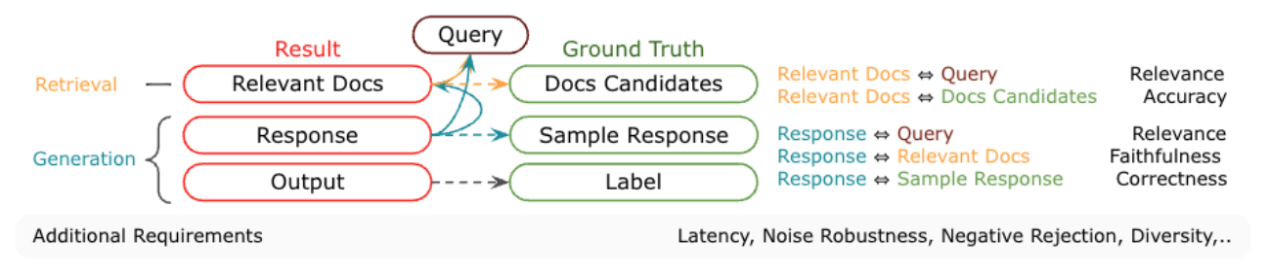

### ****Key Evaluation Criteria for RAG Retrieval****

### 1. ****Relevance****

* **Comparison**: Query ↔ Retrieved Document, Ground Truth ↔ Retrieved Document.
* **Purpose**: Relevance ensures that the retrieved documents align with the user's query and the ground truth in meaning and context.
* **Metrics**:
  + **Cosine Similarity**: Measures the semantic similarity between the query and the retrieved document.
  + **nDCG (Normalized Discounted Cumulative Gain)**: Assesses the rank-order quality of the retrieved documents.

### 2. ****Accuracy****

* **Comparison**: Retrieved Document ↔ Ground Truth.
* **Purpose**: Accuracy ensures that the retrieved documents contain factual, correct, and relevant information.
* **Metrics**:
  + **Precision**: Fraction of relevant documents retrieved among all retrieved documents.
  + **Recall**: Fraction of relevant documents retrieved among all relevant documents in the ground truth.
  + **F1-Score**: Balances precision and recall for a comprehensive accuracy measure.

### 3. ****Coverage****

* **Comparison**: Query ↔ Retrieved Document.
* **Purpose**: Coverage ensures that the retrieval includes all essential information related to the query.
* **Metrics**:
  + **Recall**: Measures how well the retrieval captures all relevant aspects of the query.

### 4. ****Diversity****

* **Comparison**: Retrieved Document ↔ Retrieved Document (within the same retrieval batch).
* **Purpose**: Diversity ensures that the retrieved documents cover a range of perspectives, especially in cases where the query is complex or has multiple interpretations.
* **Metrics**:
  + **Clustering-Based Diversity Scoring**: Ensures varied perspectives across the retrieved documents.

### 5. ****Sentiment Alignment****

* **Comparison**: Query ↔ Retrieved Document (for sentiment-driven queries).
* **Purpose**: Sentiment alignment ensures that the retrieved documents reflect the emotional tone or sentiment of the user query.
* **Metrics**:
  + **Sentiment Analysis Scores**: Measures how well the sentiment of the retrieved document matches the sentiment of the query.

### 6. ****Specificity****

* **Comparison**: Retrieved Document ↔ Ground Truth.
* **Purpose**: To measure how well the retrieved document is specific and avoids generalizations. This helps ensure that the document addresses the exact aspects of the query.
* **Metrics**:
  + **Precision**: Measures how well the retrieved document aligns with the specific information in the ground truth.

### 7. ****Temporal Relevance****

* **Comparison**: Retrieved Document ↔ Timestamp.
* **Purpose**: To assess if the retrieved document is current and relevant to time-sensitive queries. This is especially important for topics that evolve over time (e.g., news, trends, and updates).
* **Metrics**:
  + **Timestamp Analysis**: Compares the timestamp of the retrieved document with the query's time context to check if it's up-to-date.

### 8. ****Language and Readability****

* **Comparison**: Retrieved Document ↔ Query.
* **Purpose**: To ensure that the retrieved document is written in a way that is easily understood by the user, improving overall accessibility.
* **Metrics**:
  + **Flesch**
  + **Reading Ease**: Measures the readability of the retrieved document. Higher scores indicate easier readability.

### 9. ****Handling Ambiguity****

* **Comparison**: Query ↔ Retrieved Documents (for ambiguous queries).
* **Purpose**: To evaluate if the retrieval system handles ambiguous queries by providing diverse results. This ensures that multiple interpretations or perspectives of an ambiguous query are considered.
* **Metrics**:
  + **Diversity Scoring**: Measures the diversity of the retrieved documents, ensuring that they provide different perspectives on the query.

### 10. ****Novelty****

* **Comparison**: Retrieved Document ↔ Retrieved Document (within the same retrieval batch).
* **Purpose**: To ensure that the retrieved documents offer new or unique information, preventing redundancy in the results.
* **Metrics**:
  + **Cosine Similarity**: Measures how similar a retrieved document is to the others in the batch, where lower similarity indicates novelty.

### ****Evaluation of Web-Based Retrieval****

* Evaluating the retrieval from web-based search tools like Wikipedia or Tavily involves a slightly different approach because the retrieved data is often dynamic, unstructured, and context-sensitive.

### ****Key Steps to Evaluate Web-Based Retrieval****

1. **Relevance**
   * **Comparison**: Query ↔ Retrieved Snippets.
   * **Purpose**: To ensure the retrieved web content aligns semantically with the query context.
   * **Metrics**:
     + **Cosine Similarity**: Between query embeddings and snippet embeddings.
     + **Human Judgment**: Random sampling of search results for manual verification.
2. **Coverage**
   * **Comparison**: Query ↔ Retrieved Snippets.
   * **Purpose**: To ensure the system retrieves diverse and comprehensive snippets from the web.
   * **Metrics**:
     + **Recall**: Comparing snippet content coverage against known ground truth (if available).
     + **Top-k Document Analysis**: Analyzing the top results for redundancy or gaps.
3. **Diversity**
   * **Comparison**: Snippet ↔ Snippet (within the same batch).
   * **Purpose**: To prevent retrieval of redundant or overly similar web snippets.
   * **Metrics**:
     + **Jaccard Similarity**: Measures content overlap between snippets.
     + **Clustering-Based Diversity Scoring**: Groups retrieved snippets and ensures representation from diverse clusters.
4. **Specificity**
   * **Comparison**: Snippet ↔ Query.
   * **Purpose**: To evaluate whether the snippets provide specific, actionable answers to the query rather than general information.
   * **Metrics**:
     + **Precision**: The fraction of specific, query-focused snippets.
     + **Human Annotation**: Experts score specificity for nuanced queries.
5. **Temporal Relevance**
   * **Comparison**: Snippet Timestamp ↔ Query Context.
   * **Purpose**: Ensures retrieved web data is up-to-date for time-sensitive queries.
   * **Metrics**:
     + **Timestamp Analysis**: Checks document metadata (if available).
     + **Temporal Coverage**: Evaluates results spanning relevant periods.
6. **Authority and Credibility**
   * **Comparison**: Retrieved Source ↔ Trusted Sources List.
   * **Purpose**: To ensure that the retrieved snippets come from reliable and authoritative sources.
   * **Metrics**:
     + **Domain Credibility Score**: A scoring mechanism based on source reputation (e.g., Wikipedia, peer-reviewed sites).
     + **Fact-Check Pass**: Cross-verifies key information with trusted databases.
7. **Readability**
   * **Comparison**: Snippet ↔ User.
   * **Purpose**: To ensure the retrieved text is user-friendly and readable.
   * **Metrics**:
     + **Flesch Reading Ease**: Measures text complexity.
     + **Sentence Length Analysis**: Checks for clarity.
8. **Sentiment Alignment (Optional)**
   * For sentiment-based queries, measure how well the tone of the retrieved web snippets aligns with the sentiment of the query.

### ****RAG Answer Evaluation****

### ****Evaluation Framework for RAG Answer Validation****

In this stage, the **query**, **ground truth answer** (reference), and **model-generated answer** (candidate) are compared to ensure the answer is accurate, relevant, and linguistically coherent. The comparison happens in two dimensions:

* **Query ↔ Candidate**: To check relevance and contextual alignment.
* **Reference ↔ Candidate**: To validate correctness and factual accuracy.

#### ****1. Correctness and Factual Accuracy****

* **Metrics**:
  + **Exact Match**: Binary check for exact agreement between candidate and reference.
    - **Purpose**: Ensures the candidate answer provides the exact correct information without any errors.
  + **F1-Score**: Combines precision and recall to measure overlap with reference.
    - **Purpose**: Measures how well the candidate captures both the completeness and precision of the reference.
  + **ROUGE (Recall-Oriented Understudy for Gisting Evaluation)**: Measures lexical overlap for recall-heavy evaluation.
    - **Purpose**: Assesses how much of the relevant information from the reference is retained in the candidate.
  + **BLEU (Bilingual Evaluation Understudy)**: Evaluates n-gram overlap, particularly for concise responses.
    - **Purpose**: Ensures the candidate answer covers the key phrases and ideas from the reference.

#### ****2. Semantic and Contextual Relevance****

* **Metrics**:
  + **METEOR**: Captures synonyms, stemming, and paraphrasing to assess semantic similarity between candidate and reference.
    - **Purpose**: Measures how well the candidate answer semantically matches the reference, accounting for paraphrasing and word variations.
  + **Cosine Similarity**: Measures semantic alignment between query embeddings and candidate embeddings.
    - **Purpose**: Checks if the candidate is contextually aligned with the query by comparing vector representations.
  + **nDCG (Normalized Discounted Cumulative Gain)**: Evaluates relevance based on ranked importance of information in the candidate.
    - **Purpose**: Ensures that the most important parts of the candidate answer align well with the query.

#### ****3. Linguistic Fluency and Coherence****

* **Metrics**:
  + **Perplexity**: Assesses fluency by determining how well the candidate aligns with natural language probabilities.
    - **Purpose**: Measures how natural and fluent the candidate’s language is, ensuring it reads like a human-written response.
  + **Flesch Reading Ease**: Measures readability for user-friendliness.
    - **Purpose**: Ensures that the candidate answer is easy to read and comprehend.
  + **Grammar Checks**: Automated tools like Grammarly can assess sentence structure and grammar.
    - **Purpose**: Ensures the grammatical correctness and fluency of the candidate answer.

#### ****4. Structural Alignment****

* **Metrics**:
  + **TER (Translation Edit Rate)**: Calculates the number of edits needed to transform the candidate into the reference.
    - **Purpose**: Measures how close the candidate answer is to the reference in terms of structure and content.
  + **Levenshtein Distance**: Measures the number of character-level edits required for alignment.
    - **Purpose**: Checks for spelling or structural errors by counting how much the candidate needs to change to match the reference.

#### ****5. Coverage****

* **Metrics**:
  + **Recall**: Measures how much of the relevant information from the reference is captured in the candidate.
    - **Purpose**: Ensures the candidate answer captures all critical details from the reference.
  + **Top-k Coverage Analysis**: Ensures the candidate covers essential parts of the query.
    - **Purpose**: Validates whether the most important aspects of the query are covered by the candidate.

#### ****6. Diversity and Specificity****

* **Metrics**:
  + **Precision**: Evaluates how specific and relevant the content of the candidate is to the query.
    - **Purpose**: Measures how well the candidate answer is focused on the key aspects of the query without introducing irrelevant information.
  + **Jaccard Similarity**: Measures content uniqueness across overlapping segments.
    - **Purpose**: Ensures that the candidate doesn’t repeat or overlap too much with irrelevant content, offering diverse and specific answers.

#### ****7. Temporal and Contextual Validity****

* **Metrics**:
  + **Temporal Relevance**: Checks for timeliness of the answer, particularly for dynamic queries.
    - **Purpose**: Ensures that the answer is up-to-date and relevant for time-sensitive queries.
  + **Contextual Validity Score**: Ensures alignment with the query context.
    - **Purpose**: Ensures that the candidate answer stays within the bounds of the query’s context, avoiding drift or irrelevant information.

#### ****8. Authority and Credibility****

* **Metrics**:
  + **Source Validation**: Verifies factual content against trusted sources.
    - **Purpose**: Confirms that the candidate answer is credible and sourced from reliable information.
  + **Credibility Score**: Evaluates reliability of the generated answer based on established facts.
    - **Purpose**: Validates the trustworthiness of the source used in generating the candidate answer.

**Python based RAG evaluation frameworks**

1. **RAGAs Framework for Performance Evaluation of RAG Applications**

**RAGAs (Retrieval-Augmented Generation Assessment)** is a framework designed to evaluate RAG pipelines, leveraging LLMs for a reference-free, efficient, and cost-effective process. Key metrics provided by RAGAs include:

1. **Context Relevancy**: Evaluates the quality of retrieved context.
2. **Context Recall**: Assesses the completeness of relevant information in the context.
3. **Faithfulness**: Measures the factual accuracy of the generated response.
4. **Answer Relevancy**: Checks how well the answer addresses the query.
5. **Response Precision**: Determines how precisely the answer answers the question.
6. **Contextual Consistency**: Measures consistency between the response and provided context.
7. **Factual Correctness**: Assesses the factual accuracy of the generated answer.
8. **Context Entities Recall**: Evaluates retrieval of relevant entities like names and dates.
9. **Semantic Similarity**: Measures similarity between the generated response and expected answers.
10. **BLEU Score**: Evaluates text quality based on overlap with reference text.
11. **ROUGE Score**: Measures the overlap between generated and reference text, focusing on recall.
12. **Exact Match**: Assesses if the generated response matches the expected answer.

# **RAGChecker: A Fine-grained Framework for Diagnosing RAG**

**RAGChecker** is a specialized evaluation framework for **Retrieval-Augmented Generation (RAG)** systems, designed to provide comprehensive insights into their performance. It offers a suite of metrics and tools to evaluate both the retrieval and generation components of RAG systems.

Key features of RAGChecker include:

* **Holistic Evaluation:** It provides overall metrics to assess the entire RAG pipeline, offering a complete view of system performance.
* **Diagnostic Metrics:** Separate metrics are available for analyzing the **retriever** and **generator** components, helping pinpoint areas for improvement.
* **Fine-grained Analysis:** Claim-level entailment operations enable in-depth evaluation of individual outputs.
* **Benchmark Dataset:** A collection of 4,000 questions across 10 domains serves as a standardized benchmark for testing RAG systems.
* **Meta-Evaluation:** A human-annotated dataset compares RAGChecker’s automated results with human judgments, ensuring alignment with real-world expectations.

RAGChecker helps developers and researchers assess and enhance RAG systems, providing a structured approach to diagnosing issues and improving system performance.

1. **LLM as Judge for RAG evaluation**

The **LLM-as-a-Judge** approach is increasingly being leveraged to evaluate the performance of models in **Retrieval-Augmented Generation (RAG)** tasks, especially in contexts such as content generation, customer support, and educational tools. This approach utilizes large language models (LLMs) to autonomously assess the quality of generated responses, comparing them with retrieved information to determine their relevance, coherence, and overall helpfulness. Below are key metrics and frameworks used for evaluating RAG performance through LLM-as-a-Judge.

### 1. ****Accuracy and Relevance****

* **Description**: LLMs are used to assess how accurately and relevantly the content retrieved from external sources (e.g., documents, knowledge bases) is utilized in generating a response. This ensures that the generated answers are not only correct but also align closely with the user's needs.
* **Metrics**: Precision, Recall, F1-Score.
* **Example**: In a healthcare RAG scenario, an LLM judges whether the retrieved medical articles lead to a response that provides an accurate diagnosis or treatment suggestion based on user queries.

### 2. ****Coherence and Fluency****

* **Description**: This metric evaluates the linguistic quality of the generated response. The LLM ensures that the content is grammatically correct, coherent, and logically flows from the retrieved documents.
* **Metrics**: BLEU, ROUGE, Perplexity, and Human-Like Grammatical Structure.
* **Example**: When generating an answer for a legal query, the LLM-as-a-Judge evaluates whether the legal explanations drawn from various documents are articulated in a fluent and logically sound manner.

### 3. ****Contextual Understanding****

* **Description**: LLM-as-a-Judge checks the consistency and relevance of responses across multiple turns in a conversation. This is crucial in RAG tasks where context plays a significant role in determining the appropriateness of the retrieved information.
* **Metrics**: Contextual Coherence, Token Overlap, Relevance Scoring.
* **Example**: In a customer service RAG application, an LLM checks if the generated answers maintain consistency with prior queries, avoiding contradictions or irrelevant information.

### 4. ****Diversity and Creativity****

* **Description**: In open-ended applications such as creative writing or brainstorming tasks, the LLM judges how varied and creative the generated responses are. It encourages models to explore different angles or generate unique solutions rather than repeating the same responses.
* **Metrics**: Diversity Score, Novelty Index, Intra-Cluster Diversity.
* **Example**: For a content generation task, an LLM-as-a-Judge might compare different story generation models, assessing whether the generated content offers fresh perspectives rather than being overly repetitive or formulaic.

### 5. ****Helpfulness and User Satisfaction****

* **Description**: One of the most critical aspects of any AI system is its ability to assist the user. LLM-as-a-Judge can be used to evaluate how helpful and satisfying the generated response is to the user’s query, particularly in customer support and educational contexts.
* **Metrics**: Helpfulness Score, User Feedback Surveys, Response Utility.
* **Example**: In an educational RAG task, the LLM would evaluate if the response generated from a tutor's knowledge base effectively addresses the student’s question, providing a clear and useful explanation.

### 6. ****Win Rate and Comparison with Other Models****

* **Description**: The LLM-as-a-Judge can compare different models or responses, determining which one is more effective in answering a query or generating content. The comparison can be based on factors such as clarity, accuracy, and relevance.
* **Metrics**: Win Rate, Pairwise Comparison, Model Performance Ranking.
* **Example**: In a RAG-based chatbot evaluation, the LLM-as-a-Judge compares responses from different chatbots to assess which one provides a better, more accurate answer, considering multiple factors like response time and clarity.

### Retrieval Metrics

Different targets in retrieval systems can be evaluated using various metrics tailored to the requirements of the datasets in question. Below is an overview of commonly employed metrics for evaluating retrieval and generation targets, with a focus on their practical application in RAG systems.

#### Key Metrics for Retrieval Evaluation

Retrieval evaluation emphasizes metrics that accurately assess **relevance, accuracy, diversity, and robustness**. These metrics ensure the precision of the retrieved information and its resilience against the dynamic and often misleading nature of large datasets.

* **Misleading Rate**, **Mistake Reappearance Rate**, and **Error Detection Rate** are vital metrics for understanding the intricacies of RAG systems.
* The application of metrics like **MAP@K**, **MRR@K**, and **Tokenization with F1** in retrieval benchmarks highlights the comprehensive evaluation of traditional systems.
* It is noted that ranking-based evaluations, while informative, may not fully address the needs of RAG systems. New, RAG-specific retrieval evaluation metrics are suggested for deeper insights.

#### Non-Rank-Based Metrics

Non-rank-based metrics focus on binary evaluations, determining if a retrieved item is relevant without considering its position in a ranked list –

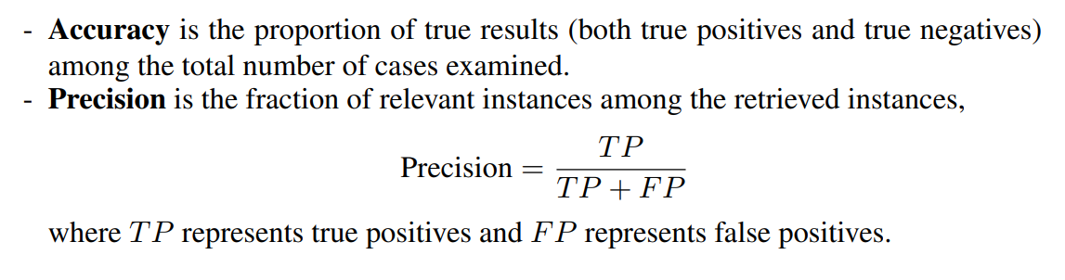 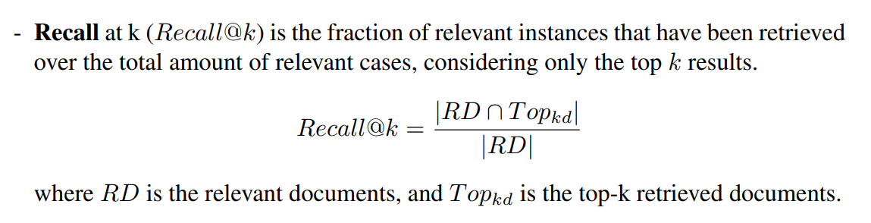

1. **Rank-Based Metrics**

Rank-Based Metrics evaluate the order in which relevant items are presented, with higher importance placed on the positioning of relevant items at the ranking list .

### 

### Generation Metrics

#### ROUGE (Recall-Oriented Understudy for Gisting Evaluation)

ROUGE evaluates the quality of summaries by comparing them to human-generated references. It is indicative of content overlap and is useful for assessing how much of the reference content is captured in the generated text. Variants include:

* **ROUGE-N and ROUGE-W**: Focus on n-gram overlap.
* **ROUGE-L and ROUGE-S**: Measure word subsequences and word pairs, respectively.

#### BLEU (Bilingual Evaluation Understudy)

BLEU is widely used to assess machine translation quality by comparing generated text to reference translations.

* It computes the precision of n-grams between the generated and reference text.
* A **brevity penalty** discourages overly short outputs.
* **Limitations**: BLEU does not account for fluency or grammatical correctness, focusing solely on surface-level similarity.

#### BertScore

BertScore leverages pre-trained transformer models like BERT to measure semantic similarity between generated and reference texts.

* It calculates token-level similarity based on contextual embeddings, producing **precision**, **recall**, and **F1 scores**.
* Unlike n-gram-based metrics, BertScore evaluates meaning in context, making it robust against paraphrasing and semantic equivalence.

#### LLM as a Judge

The use of **LLMs as judges** represents an advanced method for assessing text quality. This approach uses pre-trained language models to score text based on coherence, relevance, and fluency. Key features include:

* The ability to fine-tune LLMs on human-labelled data to predict unseen text quality.
* Zero-shot or few-shot settings to generate evaluations without extensive training.
* Providing **detailed scoring guidelines** (e.g., scales from 1 to 5) to standardize evaluations.  
  This methodology ensures nuanced assessments of text quality, covering aspects like coverage, diversity, detail, and the contextual accuracy of both answers and queries.

### Additional Requirements for Evaluating RAG Systems

In real-world applications, RAG (Retrieval-Augmented Generation) systems must meet various practical criteria to align with human preferences. These additional evaluation metrics ensure the system's robustness, relevance, and user-centric performance.

#### 1. ****Latency****

Latency measures the response time of a RAG system, a crucial factor for user satisfaction in interactive applications like chatbots and search engines.

* **Single Query Latency**: Captures the average time required to process a single query, including retrieval and generation phases.
* Ensuring minimal latency is vital for maintaining a seamless user experience.

#### 2. ****Diversity****

Diversity evaluates the range of information retrieved or generated by the system. It ensures that responses are comprehensive and free from redundancy.

* **Cosine Similarity/Distance**: This metric assesses the embeddings of retrieved or generated content, where lower cosine similarity scores indicate higher diversity.
* High diversity ensures that the system provides varied perspectives rather than repetitive information.

#### 3. ****Noise Robustness****

This metric assesses the system's ability to handle irrelevant or misleading data without degrading response quality.

* Metrics such as **Misleading Rate** and **Mistake Reappearance Rate** quantify the system's resistance to noisy inputs.
* A robust system maintains high-quality outputs even in the presence of noise.

#### 4. ****Negative Rejection****

Negative rejection measures the system's ability to refrain from providing answers when insufficient or ambiguous information is available.

* **Rejection Rate**: Indicates how often the system opts not to generate a response, prioritizing accuracy over completeness.
* This capability prevents the dissemination of misleading or incorrect information.

#### 5. ****Counterfactual Robustness****

Counterfactual robustness evaluates the system’s effectiveness in identifying and excluding incorrect or counterfactual content within retrieved documents.

* **Error Detection Rate**: Measures the proportion of counterfactual information detected and omitted.
* A robust system ensures factual integrity by mitigating the impact of erroneous data.

### Short Conclusion

Evaluating Retrieval-Augmented Generation (RAG) systems requires moving beyond traditional QA datasets and metrics to address the unique interplay between retrieval and generation. The following key points summarize the challenges and proposed directions:

1. **RAG-Specific Benchmarks**: Diverse benchmarks tailored to multi-hop questions, structural outputs, content moderation, hallucination detection, and dynamic requirements like robustness, latency, and diversity are essential.
2. **Dataset Challenges**: Universal datasets are impractical; domain-specific, tailored datasets are necessary but increase evaluation complexity and resource needs.
3. **Advanced Metrics**: Metrics should analyse retrieval’s impact on generation, leveraging both human and LLM-based evaluations. However, aligning LLM judgments with human preferences remains a challenge.
4. **Resource Optimization**: Evaluations should balance thoroughness with computational efficiency, emphasizing smaller, adaptable datasets for real-world applications.

Overall, effective evaluation methodologies must consider dynamic interactions within RAG systems, practical constraints, and evolving LLM capabilities to align with user needs and real-world applicability.