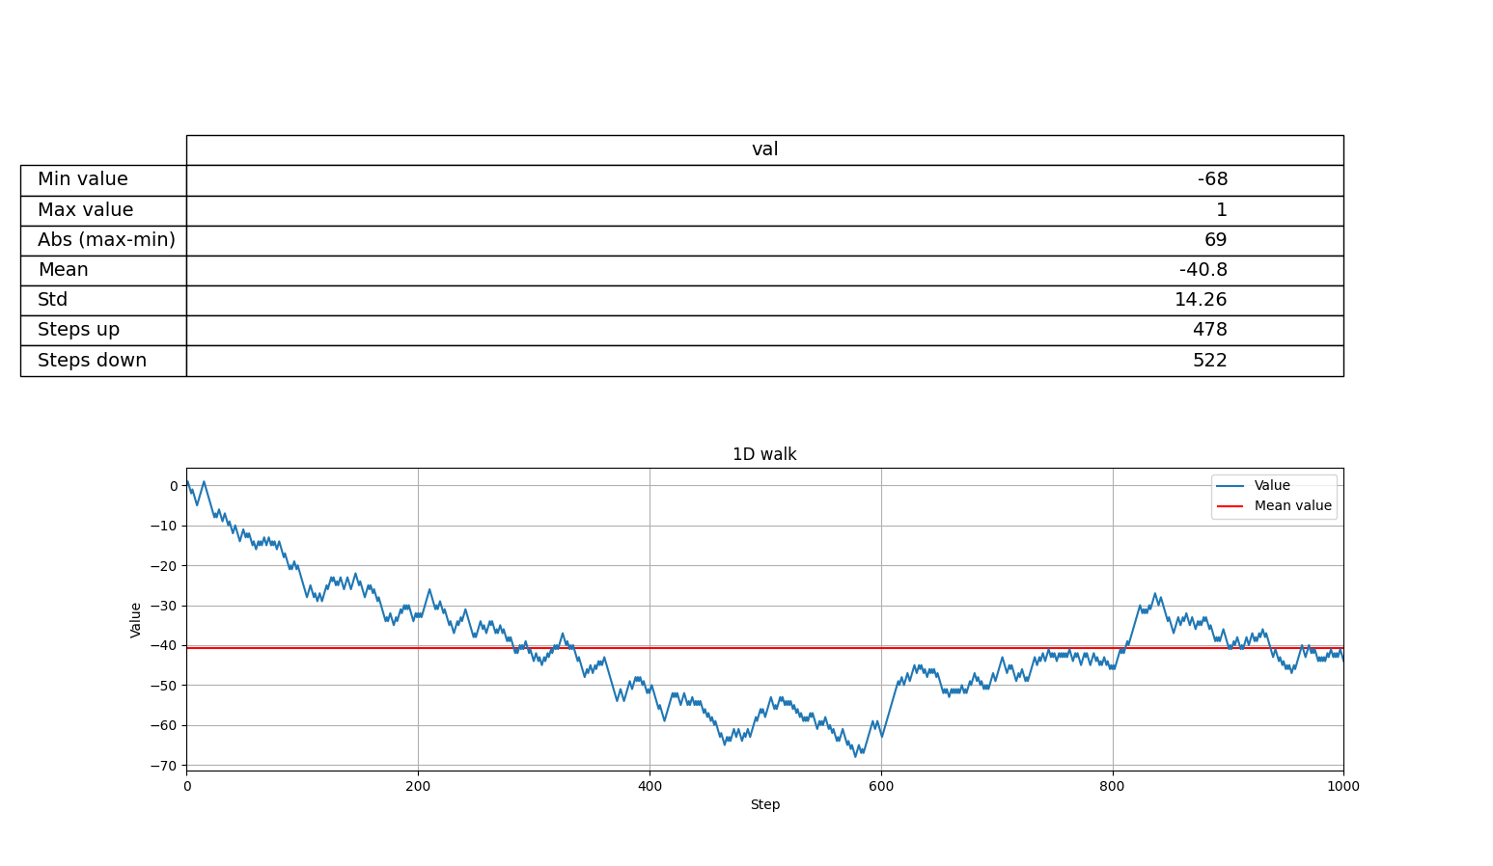
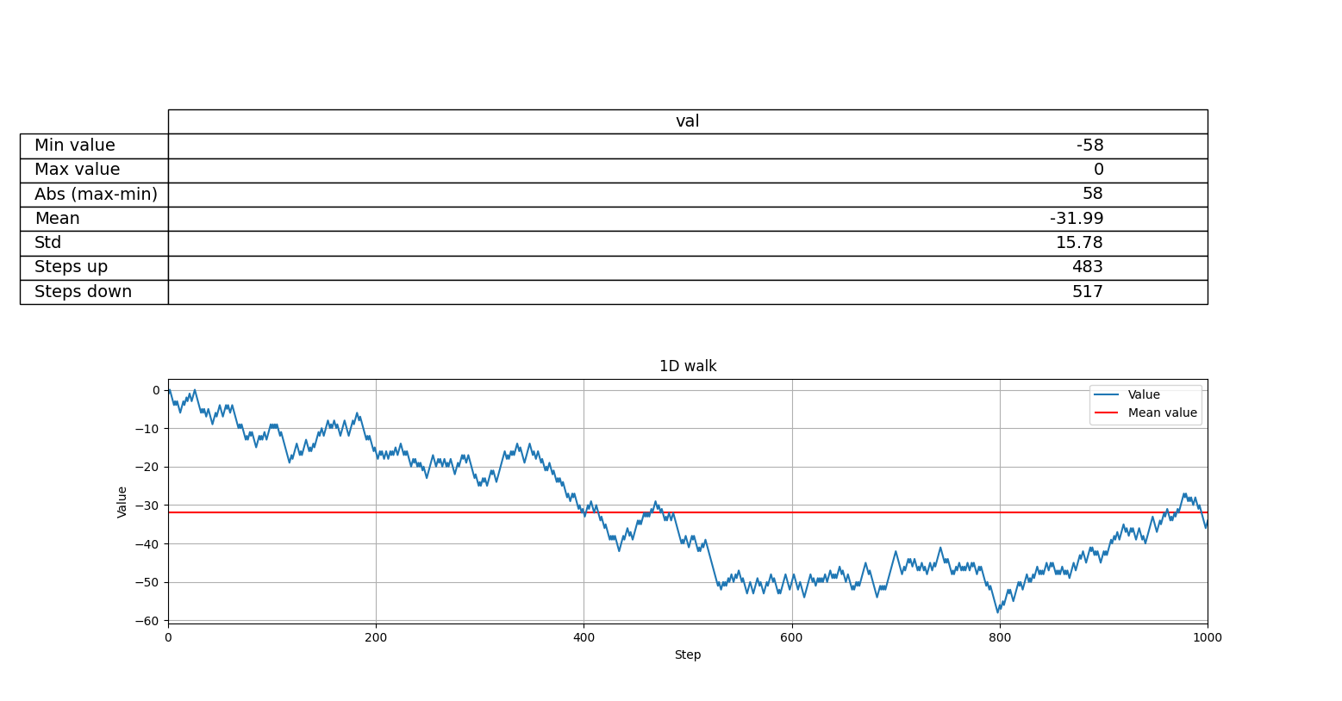
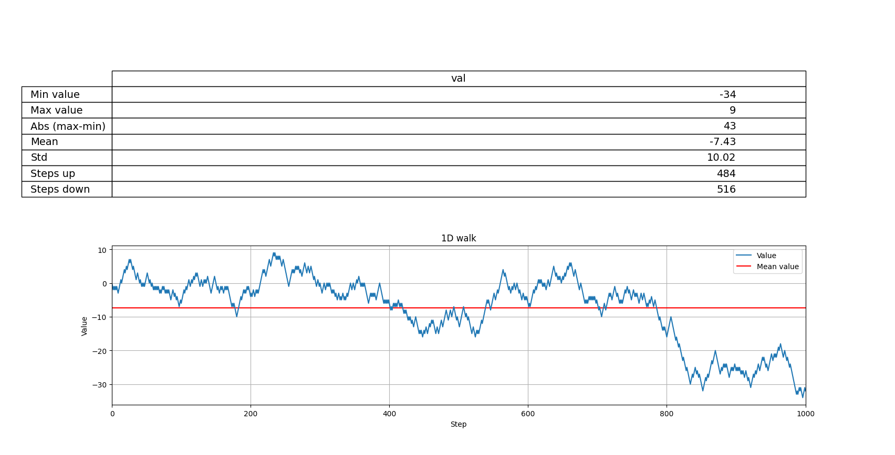
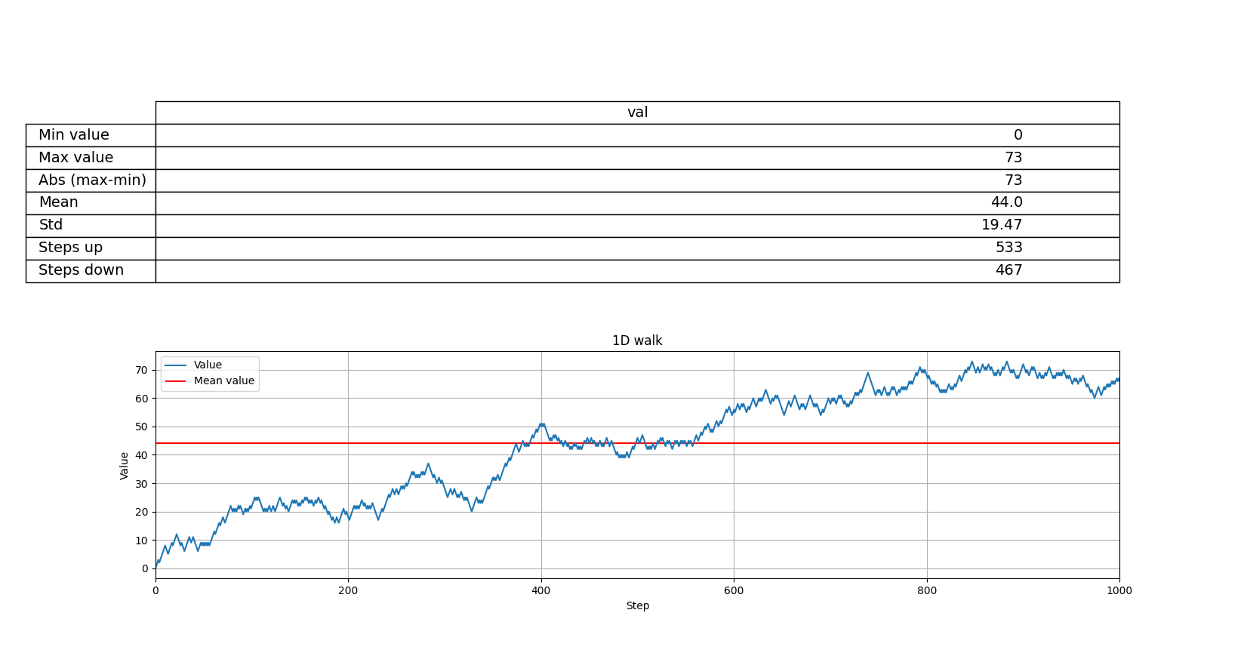
Conclusions
Graphs differ from each other with the shape. There are observed situations when 0 was the highest value – an initial value was there and each following was lower. The opposite situation was presented too. Params like: mean, standard deviation and difference between the highest and lowest value are divergent. But there is an observation, that for each program run, amount of steps done to upper and lower come near the half of the total steps amount. So it confirms the main law of the theory of probability, that if the number of experiment replies is big enough a mean will get closer to the expected value – in this case it is ½, because where are only two possible directions to move.

