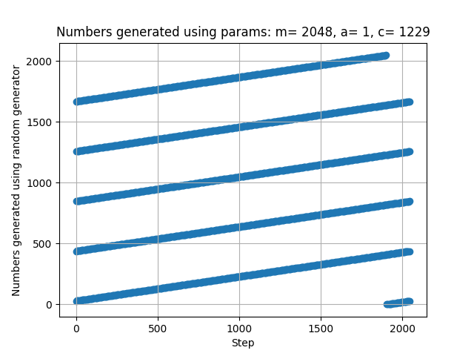
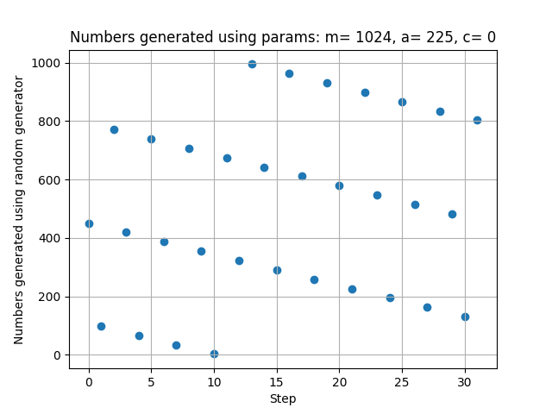

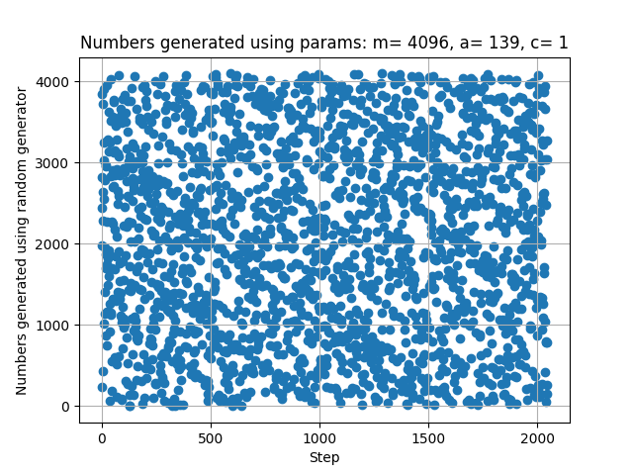
Conclusions:
For each run start index was chosen randomly, using current second from the system time. Only for some combinations of parameters there are no repeated patterns of received values. So this generator is not random at all.

